Entry Point:

<http://rmz840/reports/report/RSinR/SKExperiments>

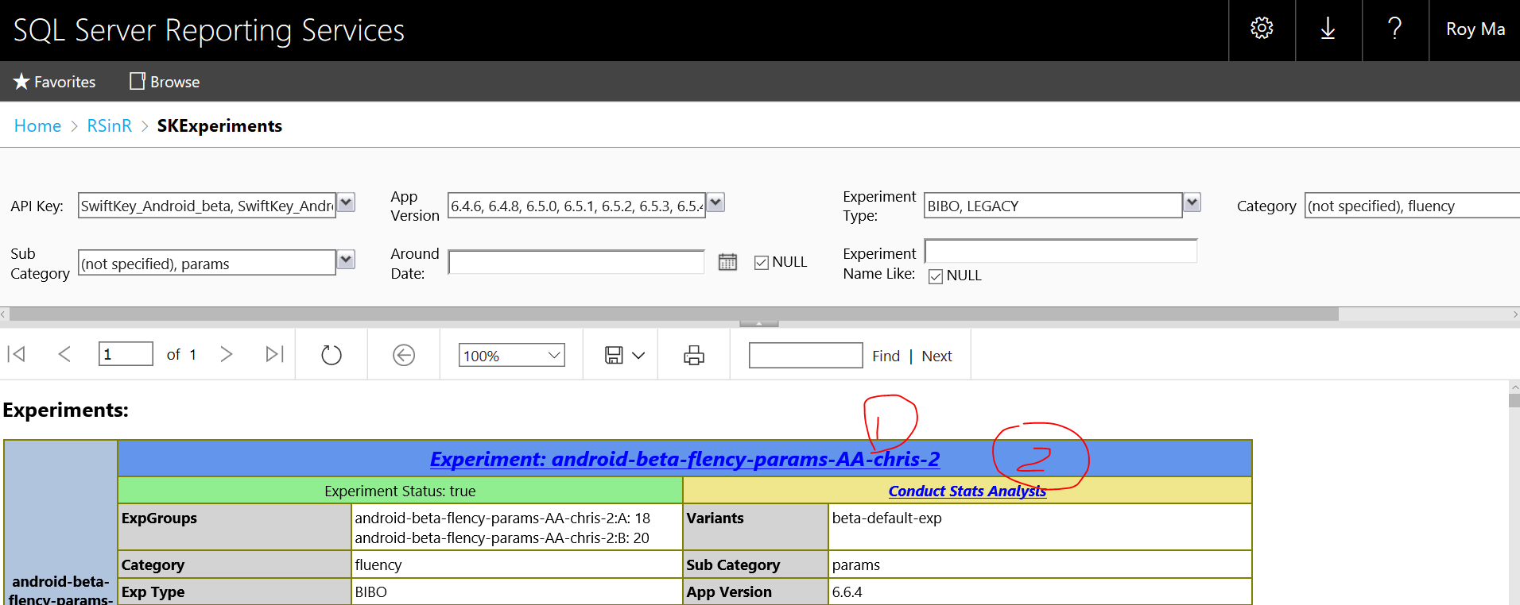

Click on Experiment to view Experiment Details (including all annotation analysis). Click on “Conduct Stats Analysis to initiate the whole sampling and stats testing procedures.