# Requirements for the Project: **Computer Fundamentals Auto Marking**

## Requirements:

1- The Auto Marking configuration is saved in a text file with an extension “.config”

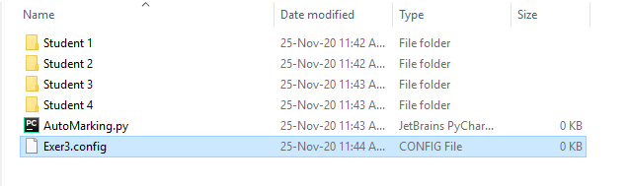

2- The program “AutoMarking.py” doesn’t need any modification whatsoever. All the necessary information is gathered from the configuration file “Exer3.config”

3- After “AutoMarking.py” finished execution, one folder and one excel file will be generated.

* The folder will have a detailed feedback for each student
* The excel file will contains the results for each student

|  |  |
| --- | --- |
|  | |
| Exer3 results | Feedback sample |
|  |  |

4- The configuration file should be easy to read, easy to edit, and flexible enough to accommodate all the exercises. Hence, we can use **YAML** or **XML**.

|  |  |
| --- | --- |
| **YAML** | **XML** |
|  |  |