LED stands for "Light Emitting Diode."

In short, LEDs are like tiny lightbulbs. However, LEDs require a lot less power to light up

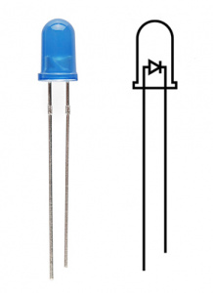

The positive side of the LED is called the **"anode"** and is marked by having a longer "lead," or leg. The other, negative side of the LED is called the **"cathode."** Current flows from the anode to the cathode

Components Required

You will need the following components −

* 1 × Breadboard
* 1 × Arduino Uno R3
* 1 × LED
* 2 × Jumper

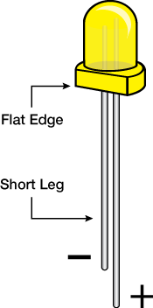

**A breadboard** is a simple device designed to let you create circuits without the need for soldering. They come in various sizes, and the design can vary, but as a general rule they look something like this:

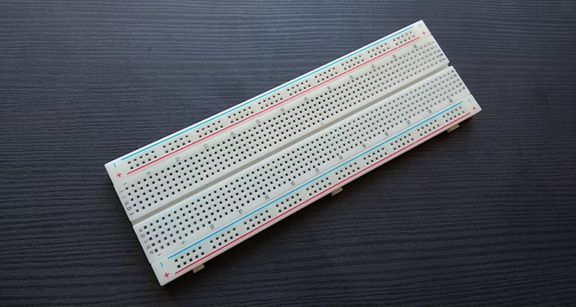

If you've never seen a breadboard circuit before, you might wonder how to tell which holes do what. It becomes a little easier to understand what's going on when you see one from the bottom.

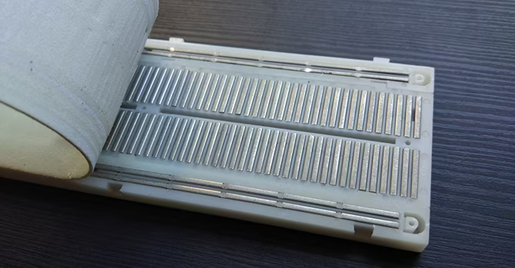

**Jumper wires** are simply wires that have connector pins at each end, allowing them to be used to connect two points to each other without soldering. Jumper wires are typically used with [breadboards](https://blog.sparkfuneducation.com/what-is-a-breadboard) and other prototyping tools in order to make it easy to change a circuit as needed. Fairly simple. In fact, it doesn’t get much more basic than jumper wires.

