FINDING THE SPACE REQUIRED TO STORE AN ARRAY

AIM: To find the space required to store an array in the memory.

Mathematical Background:

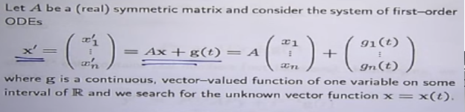

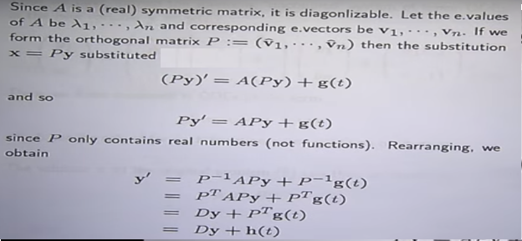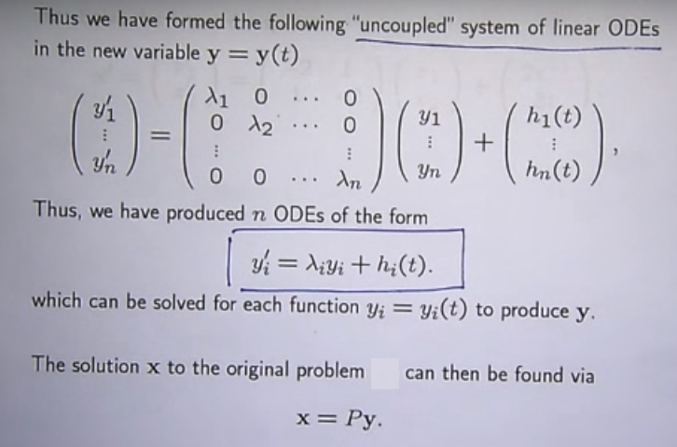

MATLAB CODE:

clc

clear all

close all

syms x1 x2

A=input('Enter the coefficient matrix A:');

lambda=eig(A);

fprintf('eigen values of A are %f, %f\n\n',lambda);

for i=1:length(lambda)

temp = null(A-lambda(i)*eye(size(A)),'r');

P(:,i)=temp./min(temp);

end

disp('The model matrix is:');

disp(P);

d=inv(P)*A*P;

X=[x1,x2];

sol1=dsolve(strcat('D2x1+',num2str(d(1)),'*x1=0'))

sol2=dsolve(strcat('D2x2+',num2str(d(4)),'*x2=0'))

disp('The solution of the system diff(X,2)+DX=0 is:');

disp(sol1);

disp(sol2);

disp('The solution of the given system is:');

Y=P*[sol1;sol2]

OUTPUT:

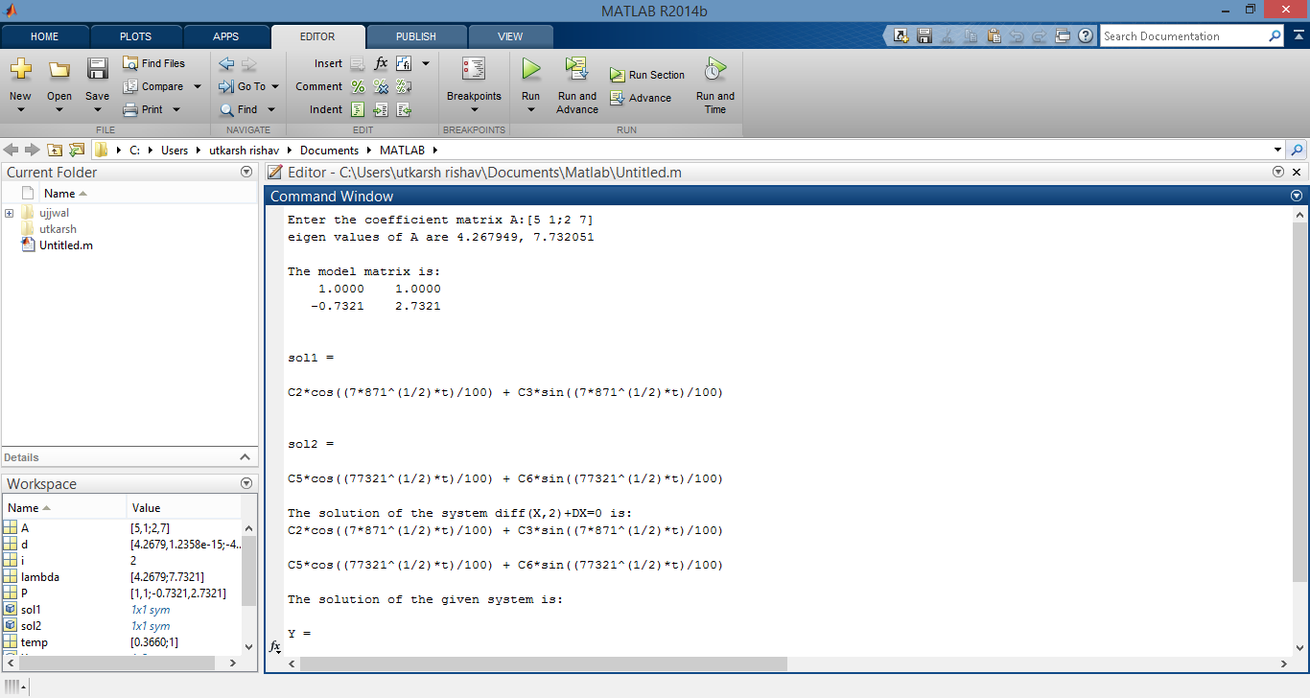

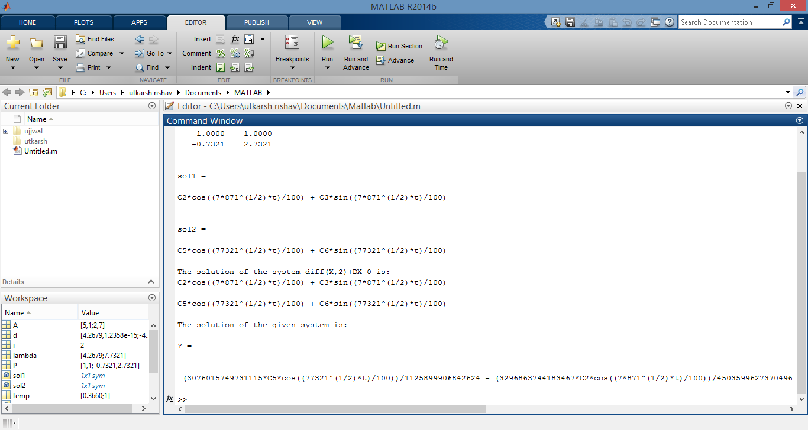

Engineering Interpretation:

Differential equations is used by compiler to allocate enough memory space in memory drive.The first row entities denote the number of array elements and the size of data type.

The second row indicates the starting position and final position of memory to be allocated contiguously .Based on this, the differential equation obtained,the compiler starts allocating space in primary memory.

Apart from this, differential equations are also used int the dynamic memory allocation and memory deallocation operations. Differential equation is definitely an important part in games.Apart from jumping and moving,it is also used to do many other movements like shooting a gun(where bullet position is calculated on the basis of differential equations),driving a car(car’s position based on acceleration and deceleration is calculated by differential equations),running,etc.In each and very case,there are different differential equations and different constraints, and in each and every case the final output is finding the new position of the object.One can also use them for complex movements like fighting etc. where a lot of differential equations are required to be solved simultaneously

Example:

Y1’=5y1-2y2

Y2’=-2y1+5y2

[y1]’=[5 -2][y1]

[y2]’=[-2 5][y2]

A=[5 -2;-2 5]

Computing eigen values of A,

[5-**λ -2;-2 5-λ]=0**

=>(5-**λ)^2-2^2=0**

**=>(λ-5)^2-2^2=0**

**=>(λ-7)(λ -3)=0**

**Λ=3,7**

For **λ=3**

**[ 5-3 -2][x1]=[0]**

**[-2 5-3][x2]=[0]**

**[2 -2][x1]=[0]**

**[-2 2][x2] [0]**

**=>2x1-x2=0 and -2x1 +x2=0;**

**=>x1=x2**

**So eigen vector=[1]**

**[1]**

For **λ=7**

**[ 5-7 -2][x1]=[0]**

**[-2 5-7][x2]=[0]**

**[-2 -2][x1]=[0]**

**[-2 -2][x2] [0]**

**=>-2x1-x2=0 and -2x1 -x2=0;**

**=>x1=-x2**

**So eigen vector=[-1]**

**[1]**

**So general solution is: [y1]’=C1[1]*e^3t+C2[-1]*e^7t**

**[y2]’ [1] [1]**