FINDING RUNNING TIME OF AN ALGORITHM

AIM: To find the running time of any computational algorithm using Bessel function

MATHEMATICAL BACKGROUND:

The differential equation

 x^2(d^2y)/(dx^2)+x(dy)/(dx)+(x^2-n^2)y=0 

where *ν* is a real constant, is called Bessel's equation, and its solutions are known as Bessel functions.

*Jν*(*z*) and *J*–*ν*(*z*) form a fundamental set of solutions of Bessel's equation for non integer *ν*. *Jν*(*z*) is defined by

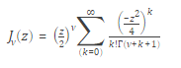

where Γ(*a*) is the gamma function.

Also bessel functions of the first kind, denoted as Jα(x), are solutions of Bessel's differential equation that are finite at the origin (x = 0) for integer or positive α, and diverge as xapproaches zero for negative non-integer α. It is possible to define the function by its series expansion around x = 0, which can be found by applying the [Frobenius method](https://en.wikipedia.org/wiki/Frobenius_method" \o "Frobenius method) to Bessel's equation

 J_\alpha(x) = \sum_{m=0}^\infty \frac{(-1)^m}{m! \, \Gamma(m+\alpha+1)} {\left(\frac{x}{2}\right)}^{2m+\alpha} 

MATLAB CODE:

x=input(‘Enter number of digits in input’);

n=input(‘enter complexity of algorithm’);

z = (1:1:x);

abs(besselj(n,z))

J = zeros(5,201);

for i = 0:4

J(i+1,:) = besselj(i,z);

end

plot(z,J,'LineWidth',1.5)

axis([0 20 -.5 1])

grid on

legend('J\_0','J\_1','J\_2','J\_3','J\_4')

title('Bessel Functions of the First Kind for v = 0,1,2,3,4')

xlabel('X')

ylabel('J\_v(X)')]

OUTPUT:

Enter number of digits in input5

enter complexity of algorithm2

ans =

   0.114903   0.352834   0.486091   0.364128   0.046565

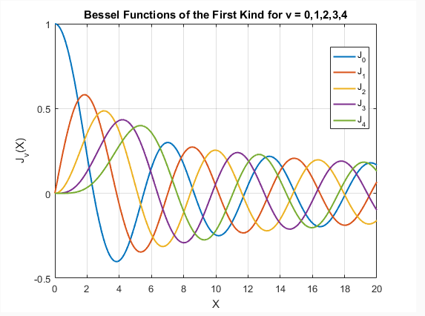

ENGINEERING INTERPRETATION:

Bessel function is a very useful function in the field of computer science.It is used by almost all of computer programming languages like c ,c++,python,java,php etc.Its main use is to compute the running time for a given algorithm (computer program).Apart from computing the running time it is also used in game designing (game theory) for various purposes .