Connect the usergrid with Apigee_127

Venkateswarlu Kandukuri
API M Developer
Miracle Software Systems, Inc.

Apigee_127:

Apigee-127 is a model-first toolkit for building rich,enterprise-class API's in Node.js on your laptop.

Step 1:Install the Apigee_127

For installing the apigee_127 use the following commands:

a127 install -g apigee-127(for windows users).
$sudo npm install -g apigee-127(Installing with sudo).

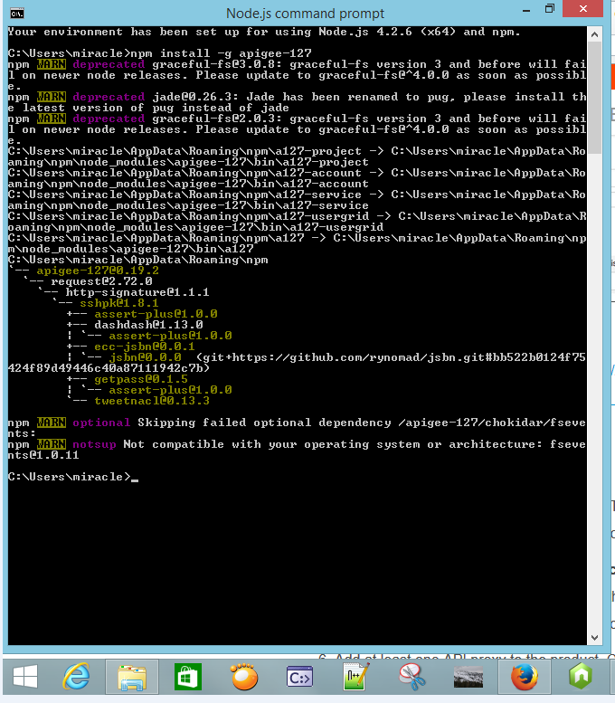

Step 2:Create a project

Create a project by using the command

a127 project create project-name.

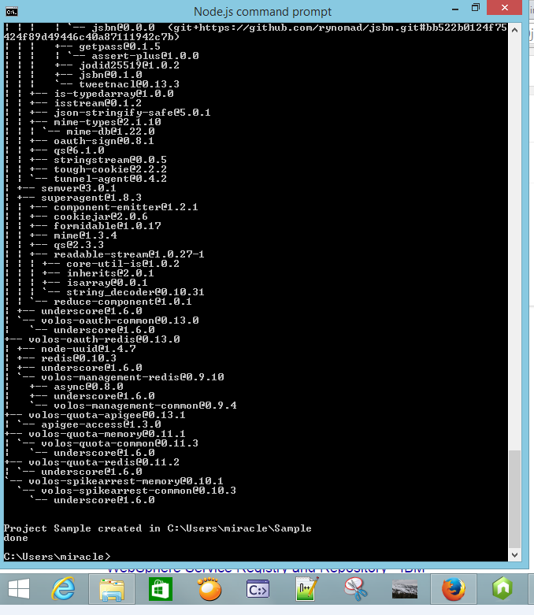

Step 3:Create a directory

Create a directory for a project like cd Sample.

Step 4:

For some versions of npm in windows have some problems on the
npm install step of a127 project-create.

The following steps resolve this issue.

1.npm install yamljs.

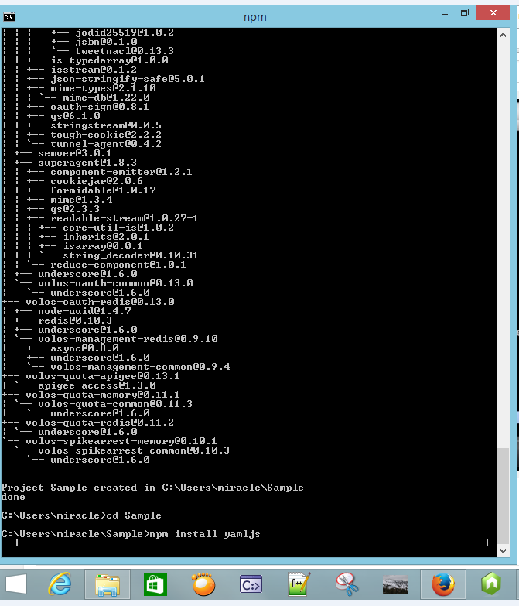

2.npm install debug.

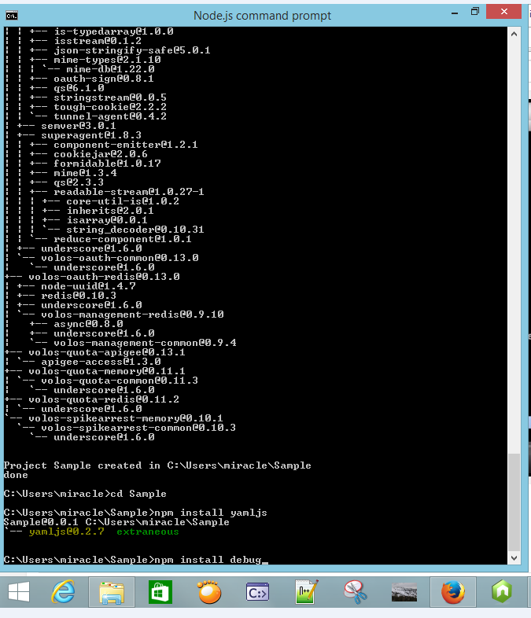
3.npm install swagger-tools.

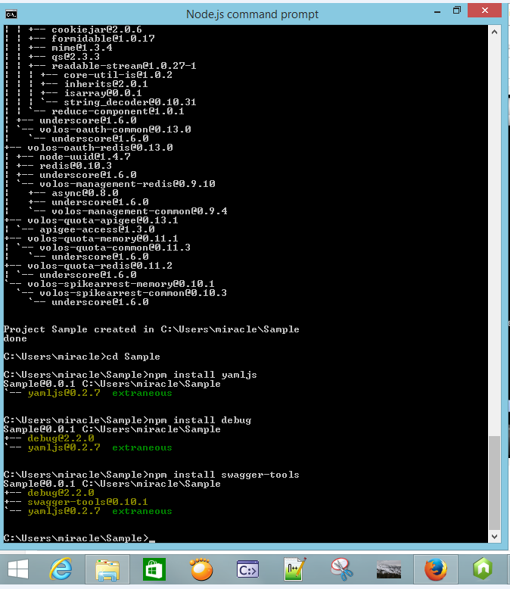

Step 5:Start the Project

Start the project by giving the command as follows:

npm project start

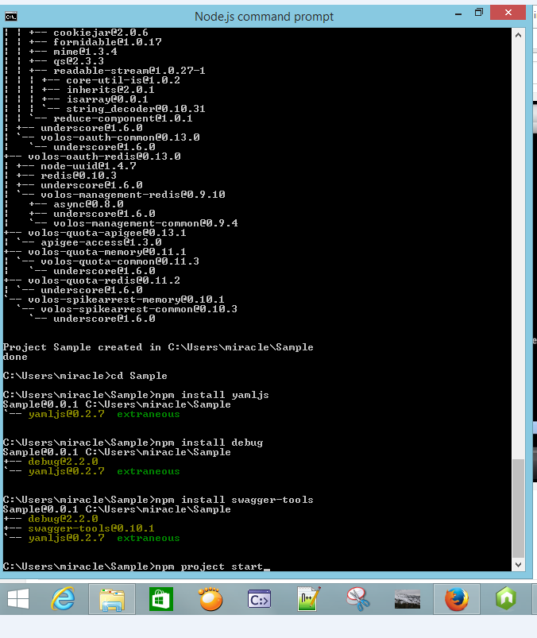

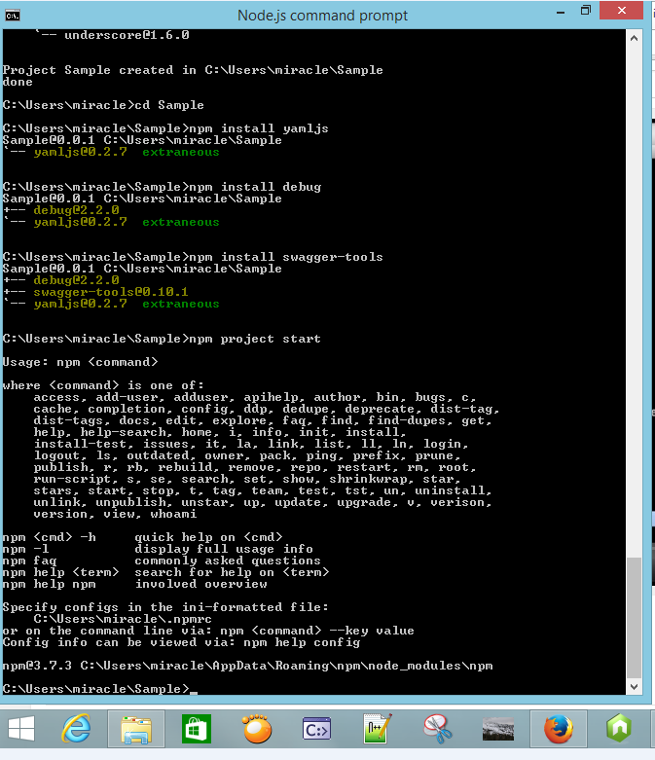

Step 6:Edit the Project

we can edit the project by using command

a127 project edit.

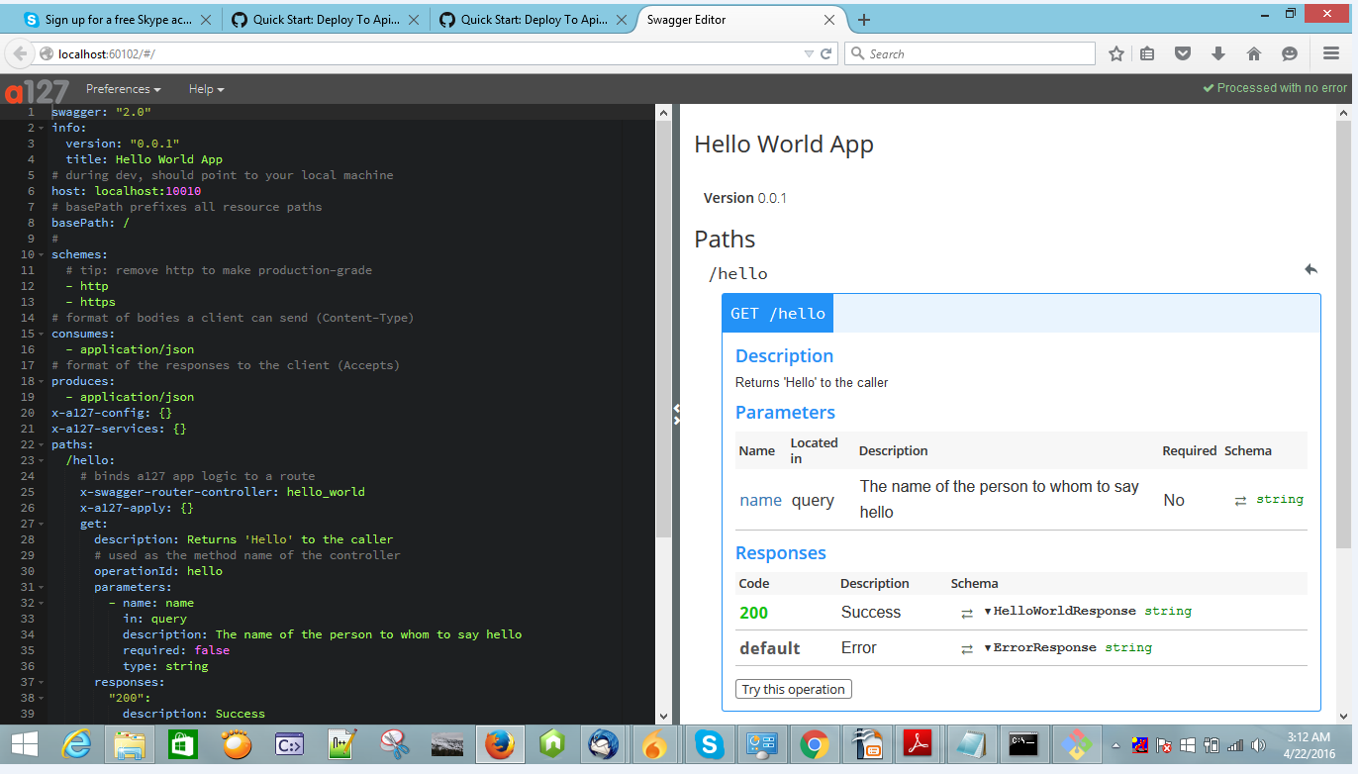

Step 7:Create an account

Here we can create apigee account.

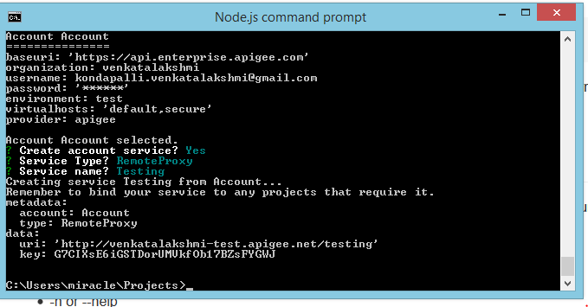
Step 8:Deploy the Project

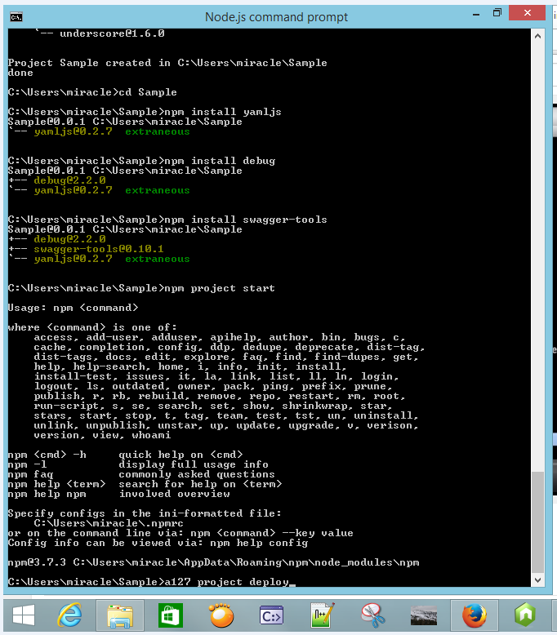

Step 9:Download the Usergrid

for usergrid run this command in cmd.

A127 usergrid download.

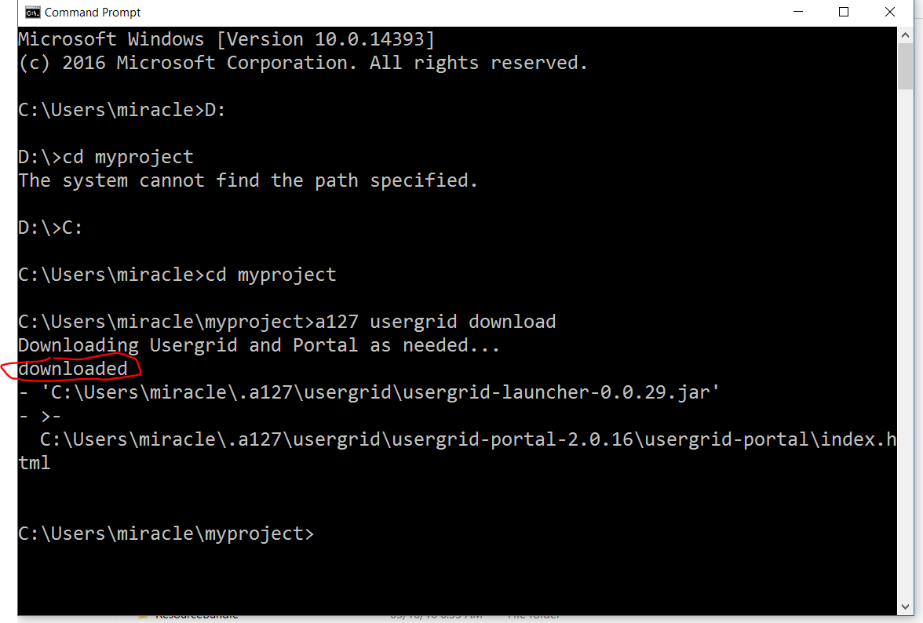

Step 10:

Start the usergrid

Step 11:Open the Usergrid Portal

open the usergrid portal

For usergrid portal run this command
a127 usergrid portal

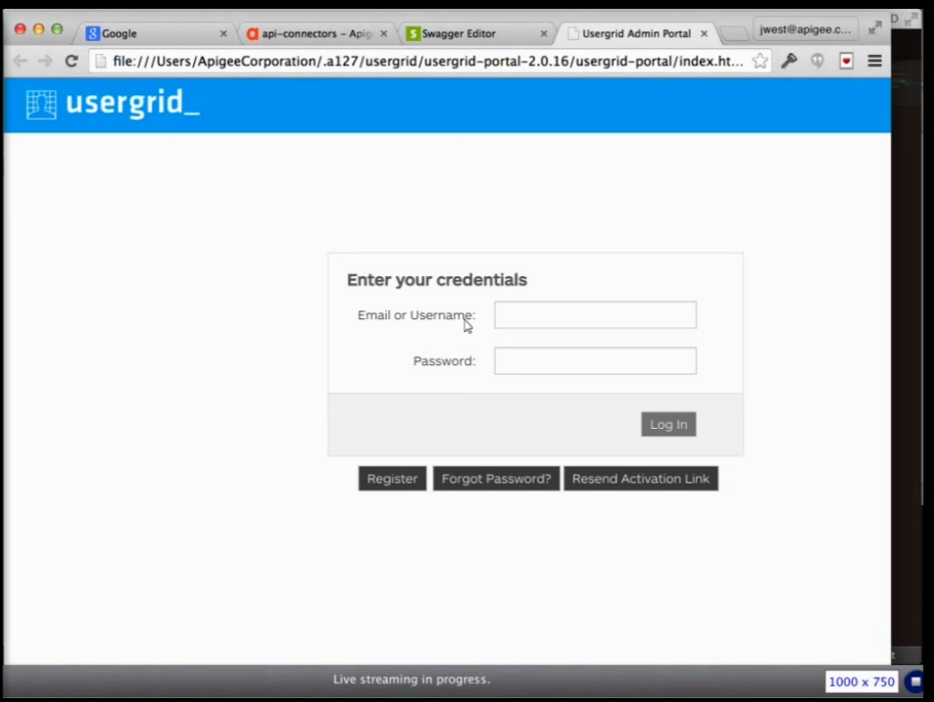

Step 3:Login to the Usergrid

login to the usergrid with credentials.(appers when usergrid starts).

