Fish_plastic_ingestion_figures.R

test

Thu Jun 20 16:49:58 2019

######################  
#  
######################  
  
# load packages and data ----  
library(tidyverse)

## ── Attaching packages ───────────────────

## ✔ ggplot2 3.2.0 ✔ purrr 0.2.4  
## ✔ tibble 1.4.2 ✔ dplyr 0.7.8  
## ✔ tidyr 0.8.0 ✔ stringr 1.3.1  
## ✔ readr 1.1.1 ✔ forcats 0.3.0

## Warning: package 'ggplot2' was built under R version 3.5.2

## ── Conflicts ─── tidyverse_conflicts() ──  
## ✖ dplyr::filter() masks stats::filter()  
## ✖ dplyr::lag() masks stats::lag()

library(gbm)

## Loading required package: survival

## Loading required package: lattice

## Loading required package: splines

## Loading required package: parallel

## Loaded gbm 2.1.3

library(dismo)

## Loading required package: raster

## Loading required package: sp

##   
## Attaching package: 'raster'

## The following object is masked from 'package:dplyr':  
##   
## select

## The following object is masked from 'package:tidyr':  
##   
## extract

library(mgcv)

## Loading required package: nlme

##   
## Attaching package: 'nlme'

## The following object is masked from 'package:raster':  
##   
## getData

## The following object is masked from 'package:dplyr':  
##   
## collapse

## This is mgcv 1.8-23. For overview type 'help("mgcv-package")'.

library(lme4)

## Loading required package: Matrix

##   
## Attaching package: 'Matrix'

## The following object is masked from 'package:tidyr':  
##   
## expand

##   
## Attaching package: 'lme4'

## The following object is masked from 'package:nlme':  
##   
## lmList

library(gamm4)

## This is gamm4 0.2-5

library(readxl)  
library(readr)  
library(ggplot2)  
  
d = read.csv("Plastics ingestion records fish master_UDPATED_AGM-MSS2.csv") %>%   
 mutate(WeightedProp = Prop.w.plastic*N,  
 Found = as_factor(case_when(Habitat %in% c("demersal", "reef-associated", "benthopelagic", "bathydemersal") ~ "demersal",  
 Habitat %in% c("pelagic-neritic", "pelagic-oceanic", "mesopelagic", "bathypelagic") ~ "pelagic")))  
  
d1 = read_xlsx("Plastics ingestion records fish master_updated.xlsx") %>%   
 mutate(Found = case_when(Habitat %in% c("demersal", "reef-associated", "benthopelagic", "bathydemersal") ~ "demersal",  
 Habitat %in% c("pelagic-neritic", "pelagic-oceanic", "mesopelagic", "bathypelagic") ~ "pelagic")) %>%   
 filter(!is.na(`Prop w plastic`))  
  
   
# summary tables ----  
d_sp_summ <- d1 %>% filter(N > 500 & Found == "pelagic") %>%   
 group_by(`Species name`, Order) %>%   
 summarize(Sp_mean = mean(`Prop w plastic`),  
 Sample_size = sum(N),  
 num_studies = n_distinct(Source)) %>%   
 arrange(-Sp_mean)  
  
Fisheries_summ <- d1 %>%   
 filter(`Prop w plastic` > 0) %>%   
 group_by(Commercial) %>%   
 summarize(Sp_mean = mean(NwP/N),  
 Sample_size = sum(N),  
 num_species = n_distinct(`Species name`))  
  
# fish of concern for humans  
concern_fish <- d1 %>%   
 group_by(`Species name`) %>%   
 filter(Commercial %in% c("commercial", "highly commercial") & N > 50 & `Prop w plastic` > 0.25)  
  
  
# preliminary plots ----  
p <- ggplot(d1,   
 aes(`Trophic level via fishbase`, `Prop w plastic`, size= N, weight = N)) +   
 geom_point(alpha = 0.4) + # Eventually add in foraging behavior here   
 geom_smooth(col = "blue", method = "loess") +  
 xlab("Trophic level") +  
 ylab("Proportion of individuals with ingested plastic") +  
 annotate("text", x = c(2.75, 3.9), y= -0.05,   
 label = c("planktivorous", "piscivorous")) +  
 theme_classic() +  
 theme(axis.text.x = element_text(size=12),  
 axis.text.y = element_text(size=12),  
 axis.title=element_text(size=13, face="bold"))   
p + guides(size = FALSE)

## Warning: Removed 11 rows containing non-finite values (stat_smooth).

## Warning: Removed 11 rows containing missing values (geom_point).

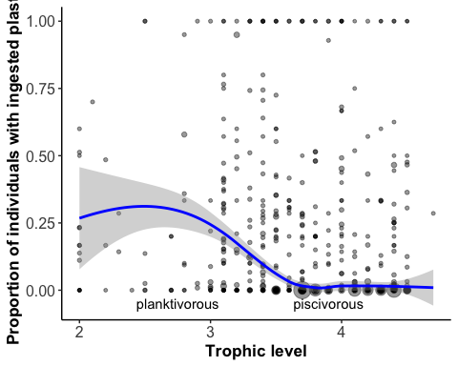

p2 <- ggplot(d, aes(Habitat, Prop.w.plastic, size=N)) +  
 #geom_jitter() +   
 geom_boxplot() +  
 theme(axis.text.x = element_text(angle = 90, hjust = 1))  
p2

## Warning: Removed 1048105 rows containing non-finite values (stat_boxplot).

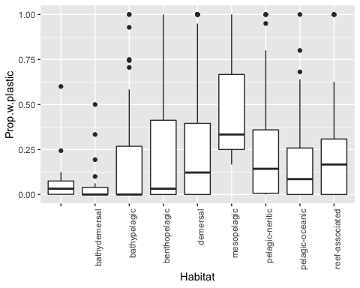

# proportion ingestion plastic with depth (perhaps remove demersal here)  
p3 <- ggplot(filter(d1, Habitat %in% c("demersal", "pelagic-neritic", "pelagic-oceanic", "reef-associated", "benthopelagic")),  
 aes(-`Average depth`, `Prop w plastic`, size=N, weight = N)) + #col=Family  
 geom_point(alpha = 0.4, aes(color = Basin)) +   
 geom_smooth(col = "grey20", method = "loess") +  
 geom_hline(yintercept = 0, linetype = "dashed") +  
 facet_wrap(~ Habitat, scales = "free_y", ncol = 1) +  
 #ylim(0,1) +   
 #xlim(-500,0) +  
 coord_flip() +  
 theme_classic()  
p3

## Warning: Removed 32 rows containing non-finite values (stat_smooth).

## Warning: Removed 32 rows containing missing values (geom_point).

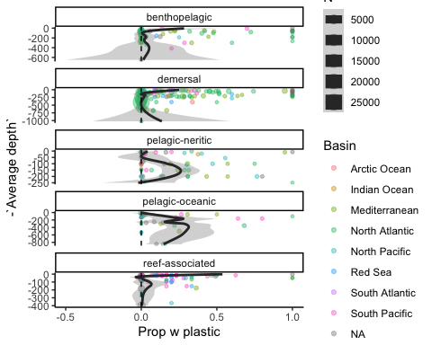

p3_b <- ggplot(filter(d1, Found != "NA"),   
 aes(-`Average depth`, `Prop w plastic`, size=N, weight = N)) +  
 geom_point(alpha = 0.4) +   
 geom_smooth(col = "blue", method = "loess") +  
 geom_hline(yintercept = 0, linetype = "dashed") +  
 facet_wrap(~ Found, scales = "free_y", ncol = 1) +  
 #ylim(0,1) +   
 xlim(-1500,0) +  
 coord_flip() +  
 xlab("Average depth") +  
 ylab("Proportion of individuals with ingested plastic") +  
 theme_classic() +  
 theme(axis.text.x = element_text(size=12),  
 axis.text.y = element_text(size=12),  
 axis.title=element_text(size=13, face="bold"),  
 strip.text = element_text(size = 10))   
p3_b + guides(size = FALSE)

## Warning: Removed 39 rows containing non-finite values (stat_smooth).

## Warning: Removed 39 rows containing missing values (geom_point).

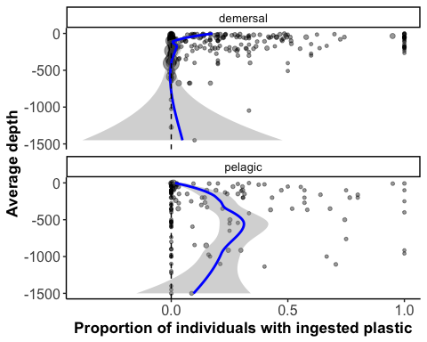

p4 <- ggplot(filter(d1, `Oceanographic province (from Longhurst 2007)` != "NA"),   
 aes(`Oceanographic province (from Longhurst 2007)`, `Prop w plastic`)) +  
 geom_jitter() +   
 geom_boxplot(alpha = 0.1, outlier.shape = NA) +  
 theme(axis.text.x = element_text(angle = 90, hjust = 1))  
p4

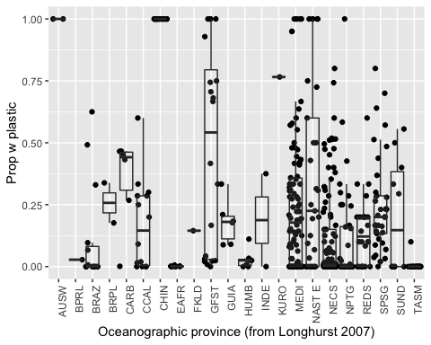

p5 <- ggplot(d, aes(Order, Prop.w.plastic)) +  
 #geom_jitter() +   
 geom_boxplot() +  
 theme(axis.text.x = element_text(angle = 90, hjust = 1))  
p5

## Warning: Removed 1048105 rows containing non-finite values (stat_boxplot).

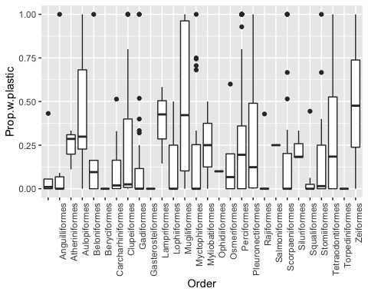

p6 <- ggplot(d1,   
 aes(`Vulnerability score (via fishbase from Cheug et al 2005)`, `Prop w plastic`,  
 weight = N)) +  
 geom_point() +   
 geom_smooth(method = "lm") +  
 theme_classic() +  
 theme(axis.text.x = element_text(size=12),  
 axis.text.y = element_text(size=12),  
 axis.title=element_text(size=13, face="bold"))  
p6

## Warning: Removed 8 rows containing non-finite values (stat_smooth).

## Warning: Removed 8 rows containing missing values (geom_point).

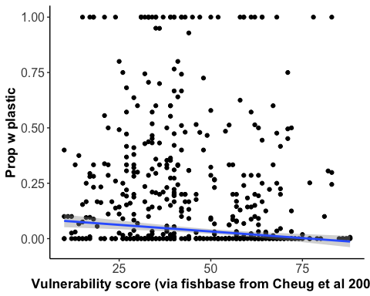

p7 <- ggplot(filter(d1, `Prime_forage` != "NA"),   
 aes(`Prime_forage`, `Prop w plastic`)) +  
 geom_jitter() +   
 geom_boxplot(alpha = 0.1, outlier.shape = NA) +  
 theme(axis.text.x = element_text(angle = 90, hjust = 1))  
p7

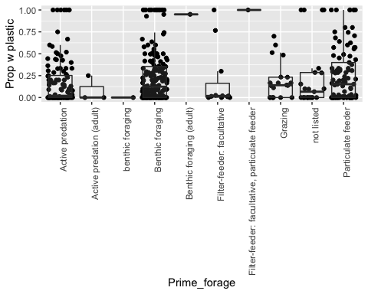

p8 <- ggplot(filter(d1, `Commercial` != "NA"),   
 aes(`Commercial`, `Prop w plastic`)) +  
 geom_jitter() +   
 geom_boxplot(alpha = 0.1, outlier.shape = NA) +  
 theme(axis.text.x = element_text(angle = 90, hjust = 1))  
p8

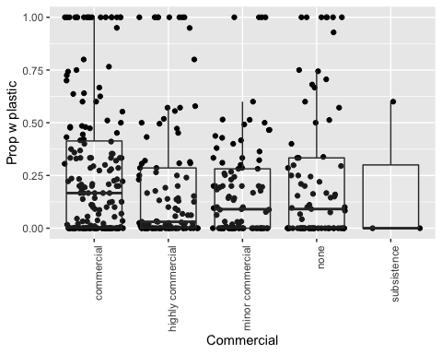

# # GLMM ----  
# glmm_FwP <- glmer(cbind(NwP, N-NwP) ~ `Trophic level via fishbase` + `Average depth`*Found + `Oceanographic province (from Longhurst 2007)` +  
# (1|Source) + (1|Order), data = d1, family = binomial)  
# summary(glmm_FwP)  
#   
#   
# # trying a gamm ----  
# gamm_FwP <- gamm(Prop.w.plastic*N ~ s(Trophic.level.via.fishbase,k=5)+s(Average.depth, k=5)+Found,   
# random=list(Order=~1), data=d)  
# ### $gam to look at gam effects. $lme to look at random effects.  
# summary(gamm_FwP$gam)  
# plot(gamm_FwP$gam)  
#   
#   
# # this seems to be working  
# gamm_lmer_FwP <- gamm4(cbind(NwP, N-NwP) ~ s(Trophic.level.via.fishbase, k=5) + s(Average.depth, k=5) + Habitat,   
# random = ~(1|Order) + (1|Source), data = d, family = binomial)  
# summary(gamm_lmer_FwP$gam)  
# plot(gamm_lmer_FwP$gam)  
#   
#   
# # playing with a BRT ----  
#   
# ## I think this is what I want, check with Steph  
# gbmFwP <- gbm.step(data=d,   
# gbm.x = c(3,6,16,18,27,34),   
# gbm.y = 7, # this is NwP  
# weights = 8, # weighted by sample size  
# family = "poisson",   
# tree.complexity = 5,  
# learning.rate = 0.001, bag.fraction = 0.5)  
# summary(gbmFwP)  
# gbm.plot(gbmFwP)  
#   
#   
#   
#   
# # testing phylogenetic analyses ----  
# library(rotl) #for phylogenetic analyses, get all the species? from Hinchliff et al. 2015 PNAS  
# library(phytools)  
#   
#   
# #gets the species names  
# taxa <- d_sp_sum$`Species name`[1:20] # this is just a subset, will eventually include all species  
#   
# resolved_names <- tnrs_match_names(taxa)  
#   
# #plots species  
# my_tree <- tol_induced_subtree(ott_ids = resolved_names$ott_id)  
# plot(my_tree, no.margin=TRUE)  
#   
# tree<-read.tree(my_tree) # not working, but doesnt seem to matter atm  
#   
# plot.tree <- compute.brlen(my_tree, method = "Grafen", power = 1/2) #add branch lengths to my tree using the Grafen (1989) method  
# plot.tree <- ladderize(plot.tree, right = TRUE)  
#   
# tree.angle <- 270  
# tree.start <- 180  
# treeheight <- max(nodeHeights(plot.tree))  
#   
# # consider adding in colors or bars next  
#   
# # This tree plots, but has issues  
# plot(plot.tree, type = "fan", open.angle = 360 - tree.angle, rotate = 270,   
# root.edge = TRUE,   
# show.tip.label = TRUE, label.offset = .36, cex = 0.6, #tip.color = col1, add back in when we have color working  
# edge.width = 1.5, font = 3,   
# x.lim = c(-1 * treeheight, 1.2 * treeheight),   
# y.lim = c(-1 * treeheight, 1.2 * treeheight))  
#   
#   
#   
#   
# ## Trying a plot with ggtree  
#   
# # jumping through hoops to install ggtree  
# # if (!requireNamespace("BiocManager", quietly = TRUE))  
# # install.packages("BiocManager")  
# #   
# # BiocManager::install("ggtree")  
#   
# library(ggtree)  
#   
# try <- ggtree(plot.tree) +  
# geom_text2(aes(subset=!isTip, label=node), hjust=-.3) + geom_tiplab(size = 2)  
# try