My first R Markdown doc

Matt Savoca

1/31/2018

## R Markdown

This is an R Markdown document. Markdown is a simple formatting syntax for authoring HTML, PDF, and MS Word documents. For more details on using R Markdown see <http://rmarkdown.rstudio.com>.

When you click the **Knit** button a document will be generated that includes both content as well as the output of any embedded R code chunks within the document. You can embed an R code chunk like this:

library(shiny)

## Warning: package 'shiny' was built under R version 3.4.1

library(rmarkdown)

## Warning: package 'rmarkdown' was built under R version 3.4.2

library(DT)

## Warning: package 'DT' was built under R version 3.4.3

##   
## Attaching package: 'DT'

## The following objects are masked from 'package:shiny':  
##   
## dataTableOutput, renderDataTable

library(devtools)

## Warning: package 'devtools' was built under R version 3.4.2

library(flexdashboard)

## Warning: package 'flexdashboard' was built under R version 3.4.3

library(gapminder)

## Warning: package 'gapminder' was built under R version 3.4.2

library(rticles)  
library(shinydashboard)

##   
## Attaching package: 'shinydashboard'

## The following objects are masked from 'package:flexdashboard':  
##   
## renderValueBox, valueBox, valueBoxOutput

## The following object is masked from 'package:graphics':  
##   
## box

library(shinythemes)  
library(tidyverse)

## Warning: package 'tidyverse' was built under R version 3.4.2

## ── Attaching packages ───────────────────────────────── tidyverse 1.2.1 ──

## ✔ ggplot2 2.2.1 ✔ purrr 0.2.4  
## ✔ tibble 1.4.2 ✔ dplyr 0.7.4  
## ✔ tidyr 0.7.2 ✔ stringr 1.2.0  
## ✔ readr 1.1.1 ✔ forcats 0.2.0

## Warning: package 'tibble' was built under R version 3.4.3

## Warning: package 'tidyr' was built under R version 3.4.2

## Warning: package 'purrr' was built under R version 3.4.2

## Warning: package 'dplyr' was built under R version 3.4.2

## ── Conflicts ──────────────────────────────────── tidyverse_conflicts() ──  
## ✖ dplyr::filter() masks stats::filter()  
## ✖ dplyr::lag() masks stats::lag()

library(tufte)

## Warning: package 'tufte' was built under R version 3.4.3

##   
## Attaching package: 'tufte'

## The following object is masked from 'package:rmarkdown':  
##   
## tufte_handout

library(xaringan)

summary(cars)

## speed dist   
## Min. : 4.0 Min. : 2.00   
## 1st Qu.:12.0 1st Qu.: 26.00   
## Median :15.0 Median : 36.00   
## Mean :15.4 Mean : 42.98   
## 3rd Qu.:19.0 3rd Qu.: 56.00   
## Max. :25.0 Max. :120.00

## Including Plots

You can also embed plots, for example:

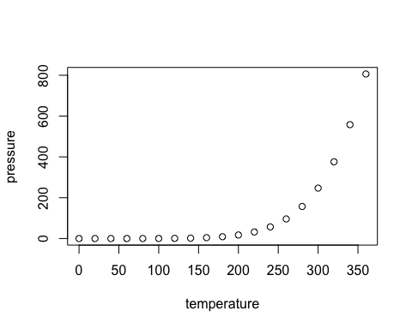

Note that the echo = FALSE parameter was added to the code chunk to prevent printing of the R code that generated the plot.