Experiment Report

**Name: Muhammad Shahzaib**

**Std Number: 32221423**

## Impact of Language Model:

|  |  |  |  |  |
| --- | --- | --- | --- | --- |
| 1 digit | 3 digits | 5 digits | unknown Digit  count (loop) | Ngram |
| 0.5 ±1.0% | 1.7 ±2.5% | 1.0 ±2.0% | 27.3 ±1.6% | 2.8±1.6% |

Rule with Known Digit count works 27 times better than rule with unknown digit count loop. Which shows that to use this approach we need to define the structure of the speak precisely. but in real it is a really difficult task. Another insight is the WER of 1, 3 and 5 digits is, for 3 digits the WER is slightly more than 5 digits and 1 digit. In case of Ngram, the WER is way better than digit loop

## Effect of Variability with respect to gender group:

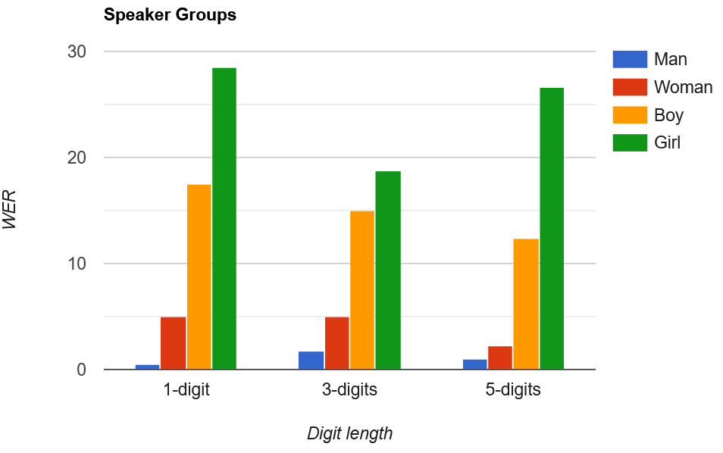

|  |  |  |  |
| --- | --- | --- | --- |
|  | 1 digit | 3 digits | 5 digits |
| BOY | 17.0 ±5.2% | 15.0 ±7.0% | 12.4 ±6.5% |
| GIRL | 28.5 ±6.3% | 18.7 ±7.6% | 26.6 ±8.0% |
| MAN | 0.5 ±1.0% | 1.7 ±2.5% | 1.0 ±2.0% |
| WOMAN | 5.0 ±3.0% | 5.0 ±4.3% | 2.2 ±2.9% |

In Speaker groups, its clearly visible that man and woman were Transcripted more accurately. **MAN** little more accurate than **WOMAN**. But there is no specific pattern for digit sequence length. In Boy, WER improves with increase in sequence length but in **GIRL**, **3-digits** has better WER than **1 and 5 digits**. **GIRL** with **1-digit** has worst WER and **MAN** with **1-digit** has best WER.

## Effect of Length of the digit sequence:

|  |  |  |
| --- | --- | --- |
| 1 digit | 3-digits | 5-digits |
| 2.75 ±1.6% | 3.33 ±2.5% | 1.60 ±1.7% |

With the variation in digit sequence length, Best WER is with **5-digits** that is 1.6% and worst for 3.33% for **3-digits.**  As the Audio used here is combined of all speaker groups and previously, we observed that WER is different for each group and digit sequence length. which can be reason for no pattern in WER with increasing digit length.

## Impact of Noise Level:

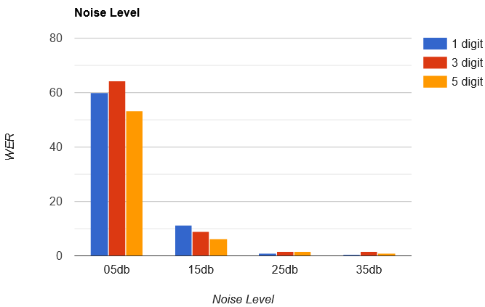

|  |  |  |  |  |
| --- | --- | --- | --- | --- |
|  | 05db | 15db | 25db | 35db |
| 1 digit | 60.0 ±6.8% | 11.5 ±4.4% | 1.0 ±1.4% | 0.5 ±1.0% |
| 3 digits | 64.3 ±9.4% | 9.0 ±5.6% | 1.7 ±2.5% | 1.7 ±2.5% |
| 5 digits | 53.4 ±9.8% | 6.2 ±4.7% | 1.8 ±2.6% | 1.0 ±2.0% |

The WER improves with the decrease in the Noise level where as the WER is almost similar for 25 db and 35 db noise level. Another important insight is that change in noise level effects the WER differently for different digit sequence length. For example, WER for 3-digits (5 db) is greater than 1-digit (5 db) but in case of 15 db, WER of 1-digit is greater that 3-digits WER.