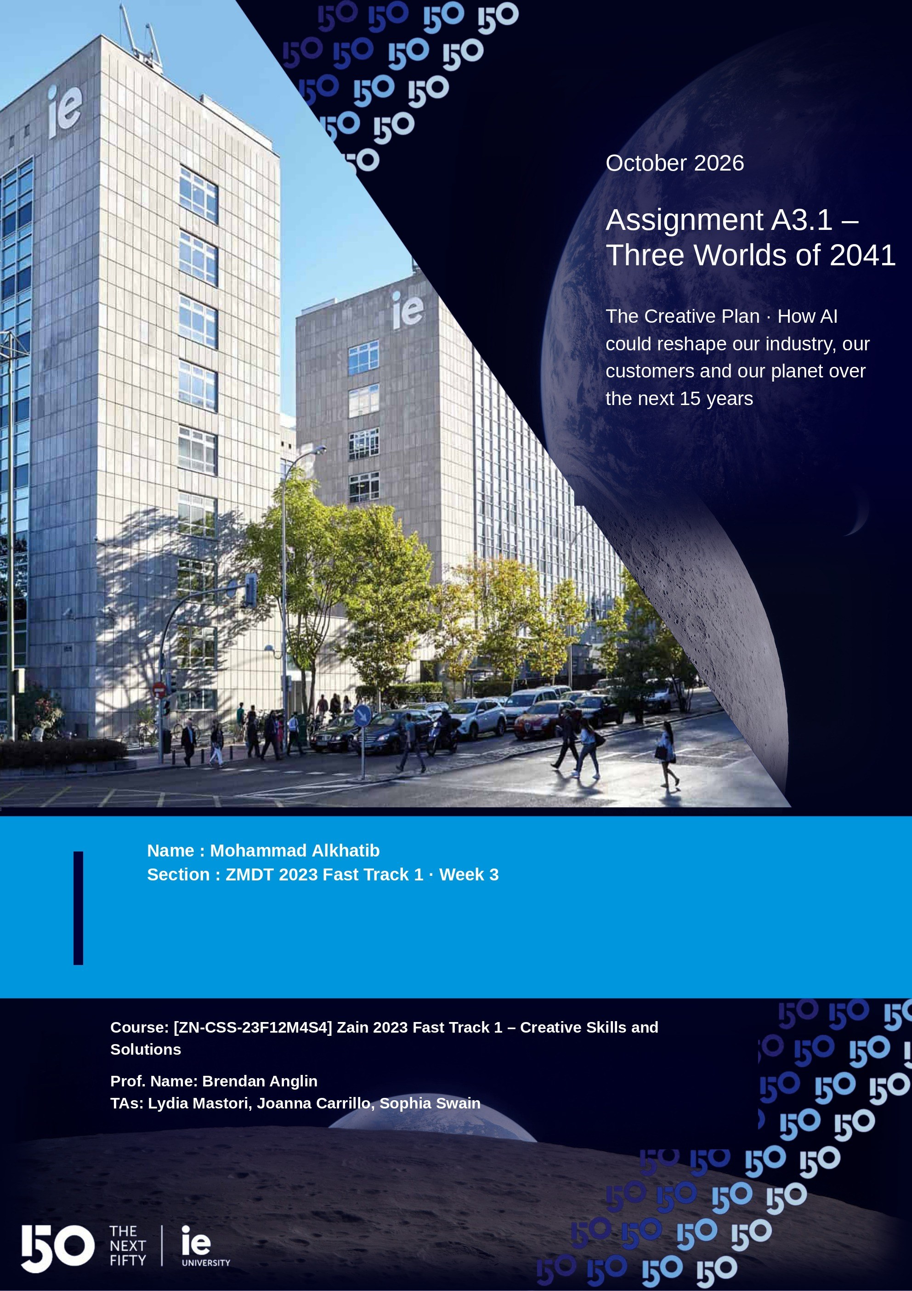
EM, OLI & TIMMONDS | FUTURES BRIEFING | OCTOBER 2026
Three Worlds of 2041
How AI could reshape our industry, our customers and our planet over the next 15 years
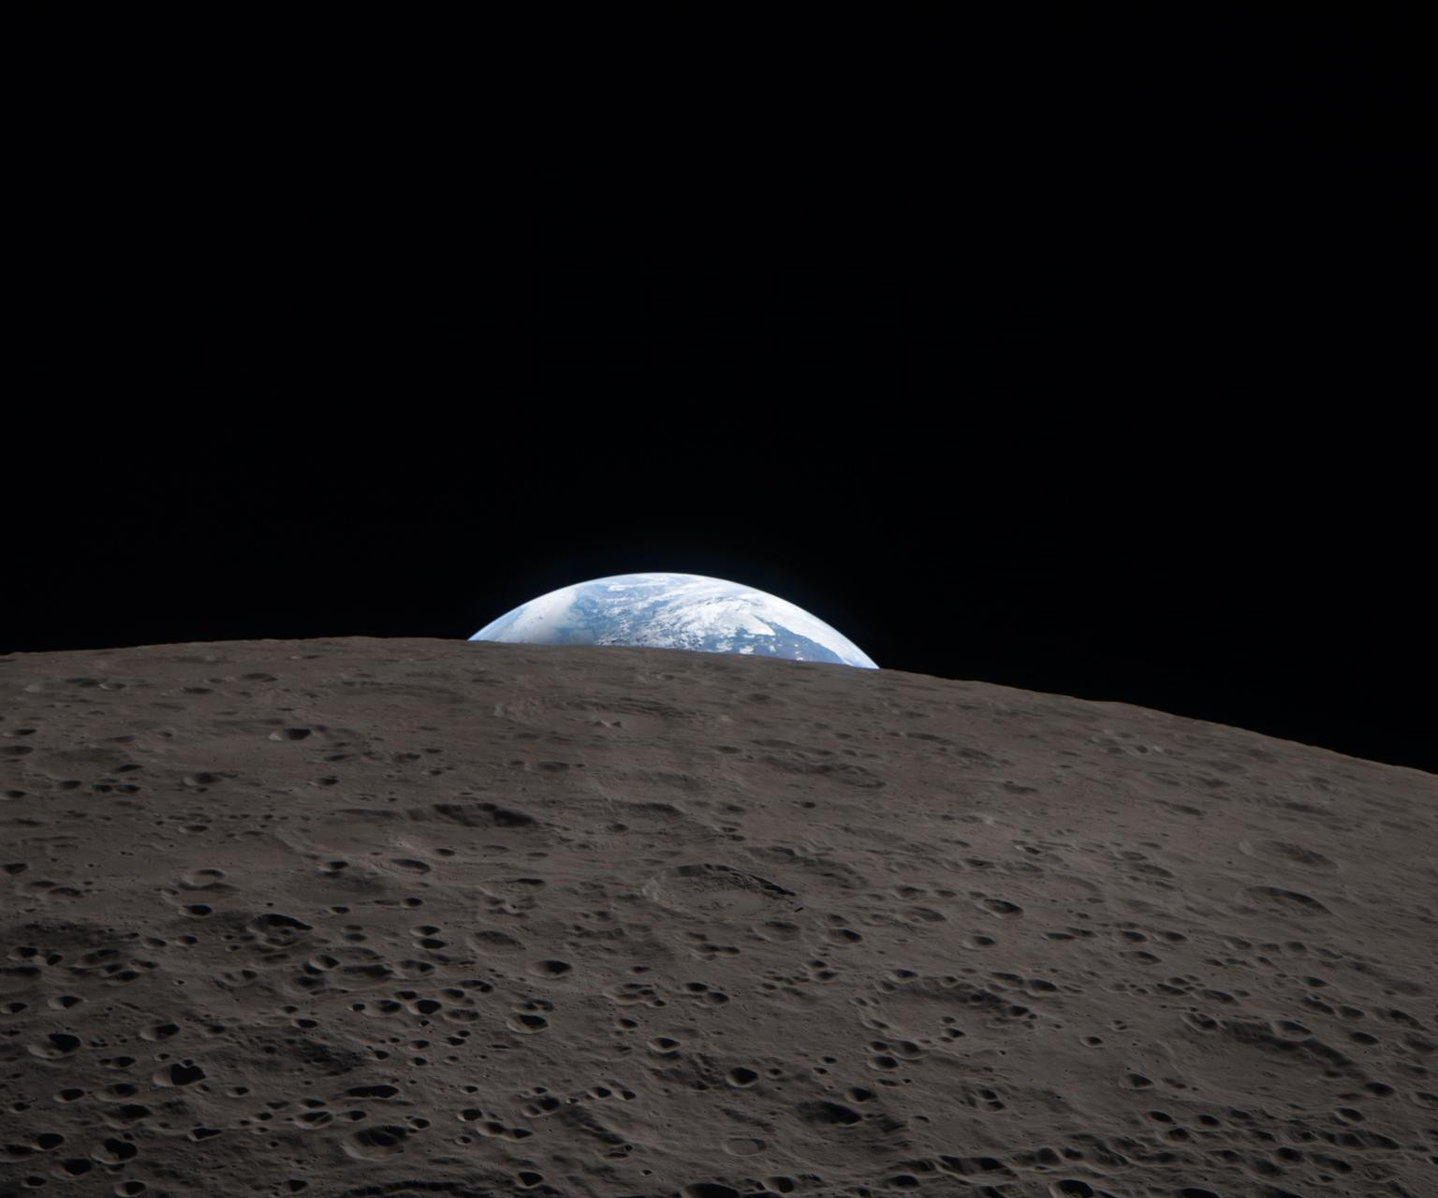
Earth sets behind the Moon, photographed by the Artemis II crew, 6 April 2026. Image: NASA
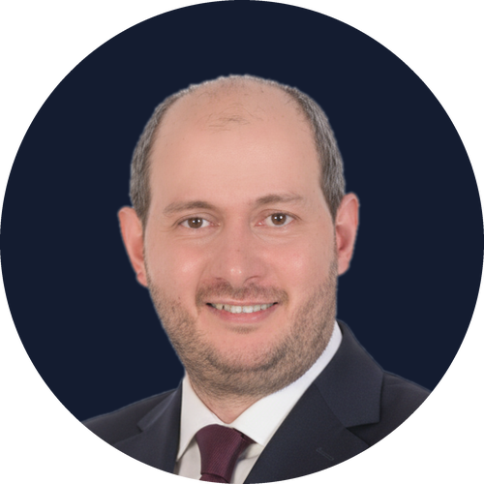 | Mohammad  Senior Futures Consultant, Em, Oli & Timmonds  Assignment A3.1, The Creative Plan | Creative Skills and Solutions | IE Business School
IN THIS ASSIGNMENT
Part 1 Today's signals, the Futures Engine, three worlds of 2041, the odds, and a plan from Monday
Part 2 My personal reflection and plan

Introduction
STORY SPINE ONCE UPON A TIME
In April 2026, four astronauts on Artemis II watched Earth set behind the Moon, on the first crewed lunar flight since 1972. Fifteen years from now, the Moon may be a place where people go to work. What looked impossible a generation ago is now on the calendar, and the same will be true of many things that read like science fiction today.
Em, Oli & Timmonds has advised entire industries for more than 30 years on how to imagine the futures that could reshape their sectors. In this assignment I act as a Senior Futures Consultant at the firm. The brief is to imagine the world in 15 years' time, in 2041, considering the impact of AI on the industry and on the whole world, through at least three different scenarios.
Rather than guessing, I built the scenarios with a set of creative tools working together. The 4 lenses of innovation find today's signals. Counterfactual thinking and Tick-Tock generate distinct worlds. Moonshot thinking and hard empathy make them vivid and human. A possibility tree weighs them, and working backwards turns them into action. The result is three worlds: Symbiosis, the best case; Overheat, the worst case; and Patchwork, the most likely middle path.
The central question is what E,O&T should build now, without betting everything on one forecast. The scope is concrete: our industry is strategic consulting; our clients are in energy, logistics and digital services; and the world dimension covers work, daily life, infrastructure and the space frontier.
The assignment is told as one story using an adapted, branching Story Spine, a classic storytelling structure: the three "Because of that" steps are alternative worlds rather than one sequence. Each section answers one question and leads into the next, as the map below shows. Sourced facts and projections are tagged with their source; the 2041 worlds are imagined scenarios. Part 1 presents the creative solution and Part 2 my personal reflection.
Section | Story Spine step | Question it answers | Main tool
Section 2 | Every day | What is already changing? | 2 of the 4 lenses
Section 3 | But one day | How do we turn signals into futures? | Seven creative tools
Section 4 | Because of that (1) | What is the best world we can imagine? | Moonshot, upward What if
Section 5 | Because of that (2) | What is the worst world, honestly told? | Downward What if
Section 6 | Because of that (3) | What is the most likely middle path? | Tick-Tock
Section 7 | Zoom in (1) | How does a delivery network reach orbit? | Moonshot, exaptation
Section 8 | Zoom in (2) | What becomes the new gold? | Tick-Tock, all 4 lenses
Section 9 | Until finally | Which world is coming? | Possibility tree
Section 10 | Until finally: watch | Which lights change our action? | Contingency planning
Section 11 | Ever since: respond | What does E,O&T sell? | Decision Passport
Section 12 | Story in one world | How does one story unfold causally? | Story Spine, 5 Cs
Section 13 | And ever since then | What do we do from Monday? | Working backwards
Section 14 | Ever since: first test | How do we prove it is useful? | Working backwards, gates
Section 15 | Ever since: keep creating | How does the team stay creative? | Safety, Octalysis, stimuli
Section 16 | Carry-out message | What should we remember? | 5 Cs of storytelling

The story begins with what we can already measure.
STORY SPINE EVERY DAY

2. The Future Is Already Leaking In
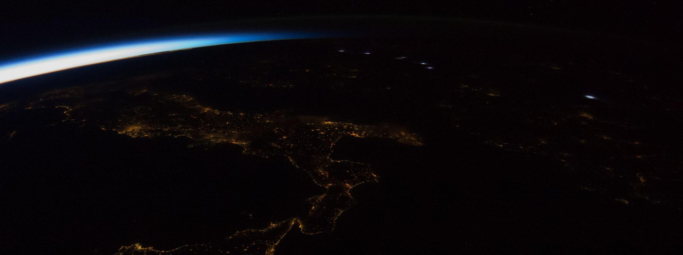
City lights and sunrise seen from the International Space Station. Image: NASA
Good scenarios start from facts, not fantasy. Using two of the 4 lenses of innovation, harnessing trends and challenging orthodoxies, I selected four signals that can be measured today, each from a public source. Together they show where the pressure on the next 15 years will come from.
  415 TWh  Electricity used by data centres in 2024, about 1.5% of the world total, with about 945 TWh by 2030 as a base-case projection (IEA).  Energy becomes AI's ceiling. |  |   170M new jobs  Created by 2030 and 92 million displaced, across major economic and technological trends including AI; 39% of core skills change (WEF).  Skills, not jobs, become the scarce asset.
  54,000  Debris objects larger than 10 cm circle Earth, plus about 1.2 million between 1 and 10 cm (ESA).  Orbit is a finite resource we can pollute. |  |   April 2026  Artemis II flies four astronauts around the Moon, the first crewed lunar flight since 1972 (NASA).  Space moves from exploration to economy.

 | Challenging orthodoxies. The old belief that "AI is software" no longer holds. AI behaves like an energy, materials and orbit industry, and that is exactly where our three worlds split apart: on energy, on trust and on space.

Signals alone are not futures, so the next question is how to turn them into scenarios.
STORY SPINE BUT ONE DAY

3. The E,O&T Futures Engine
To turn signals into worlds, I combined seven creative tools into one engine. Each tool covers the blind spot of the one before, and together they give a more creative form of scenario planning with contingency built in.
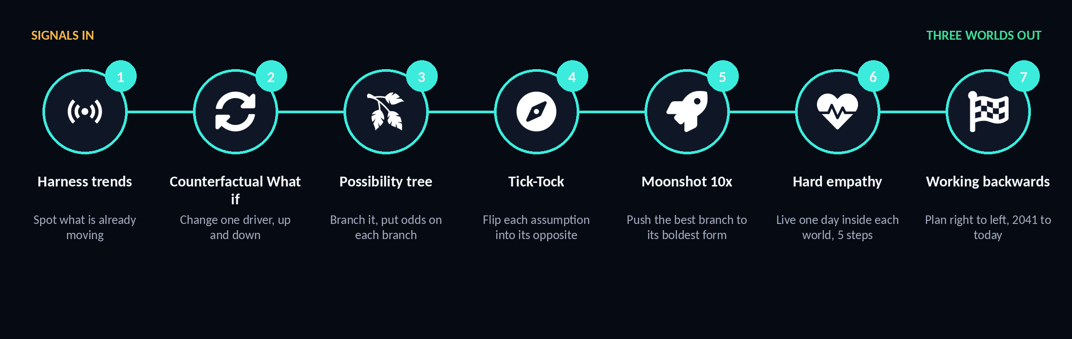
Figure 1. The E,O&T Futures Engine: seven creative tools linked in sequence
Harnessing trends shows what is already moving. Counterfactual thinking asks "What if?" in both directions, upward and downward, to avoid both wishful thinking and pessimistic spirals. A possibility tree branches the drivers and gives each branch a probability. Tick-Tock flips an assumption into its opposite. Moonshot thinking pushes the best branch to its 10x version. Hard empathy lets us live one day inside each world through five steps: set the scene, feel the moment, make sense of what is happening, identify worries and take action. Working backwards then plans the road from 2041 to today.
Before combining anything, I ran a controlled What if: keep AI access fixed and change only energy headroom, upward and downward. Only then were both uncertainties combined into three worlds.
Two critical uncertainties set the axes of the scenarios: whether AI is shared and verified or concentrated and opaque, and whether energy is abundant and clean or scarce and polluting. Each world sits in a different part of this space.
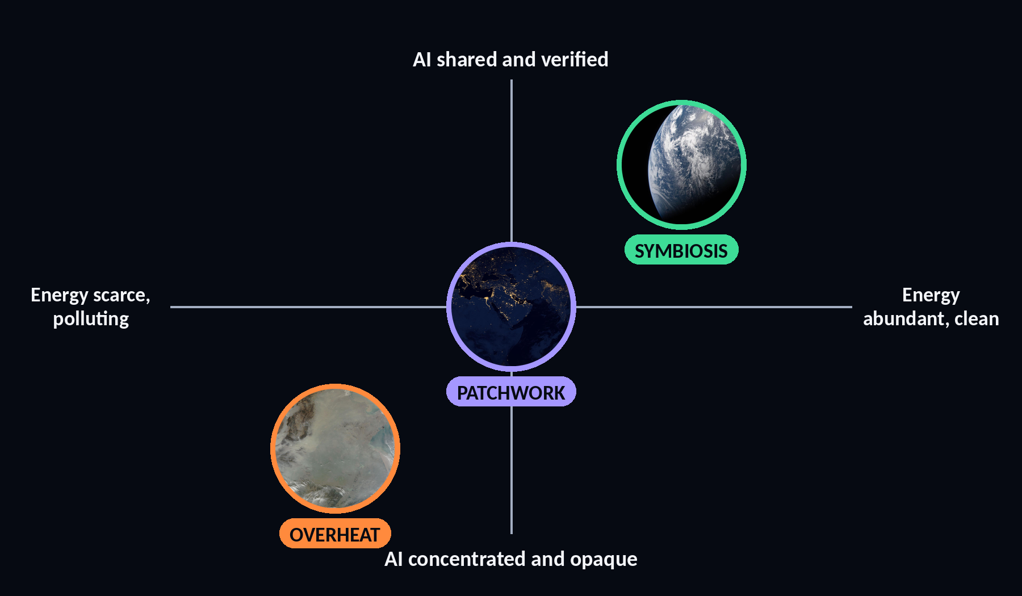
Figure 2. The two critical uncertainties and where each world sits
 AI "bad copying"  We asked AI for dozens of variants of each world and kept the strange ones. Its mistakes and hallucinations became raw material for new ideas. |  |  Exaptation  We borrowed from other fields: air traffic control (one network, many vehicles) and multiplayer game design (rules that shape behaviour).

The engine produces three worlds, and the first is the best one we can imagine.
STORY SPINE BECAUSE OF THAT (1)

4. World 1: Symbiosis 2041
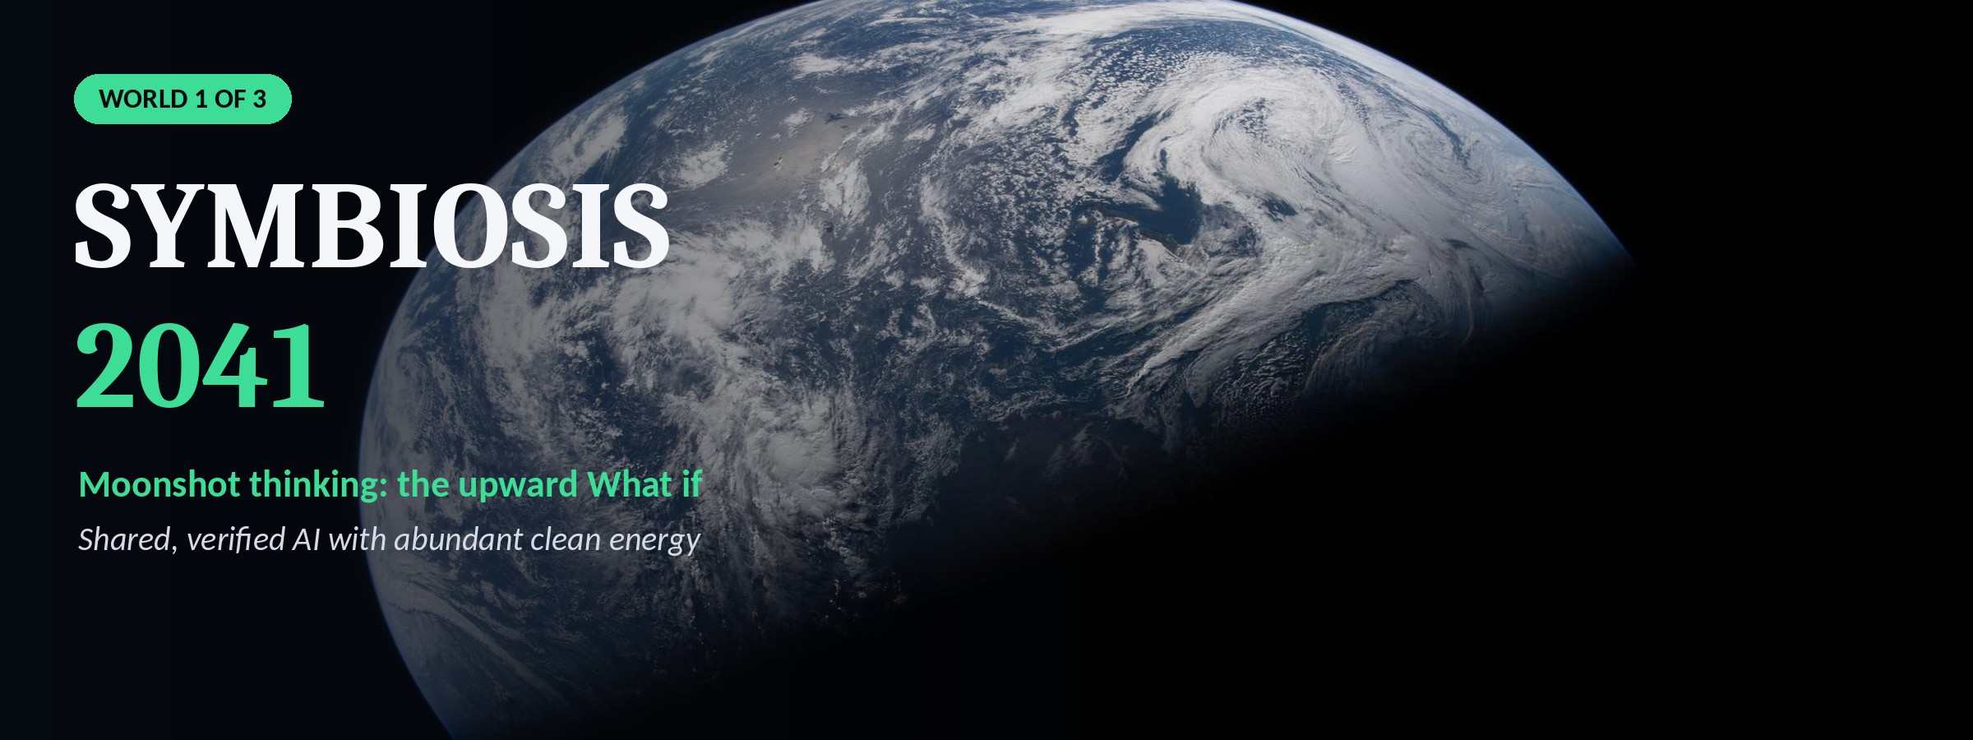
Symbiosis is the upper branch of the engine pushed to a moonshot: a utopia we would want to live in, built on shared, verified AI and abundant clean energy. It answers the question of what the best possible 2041 looks like, and it stays believable because new problems remain.
 | A DAY IN 2041 | HARD EMPATHY IN 5 STEPS  Layla, 34, grid engineer, Riyadh  Scene: 6 am. My AI agent has already sold my solar surplus and drafted my report.  Feel: free, and strangely idle.  Make sense: the machines now do the routine half of my job.  Worry: what am I still for?  Act: I join the council that designs our city's digital twin.
STORY SPINE SYMBIOSIS 2041, CONTINUED

Life in Symbiosis 2041: customers, transport, space and our industry
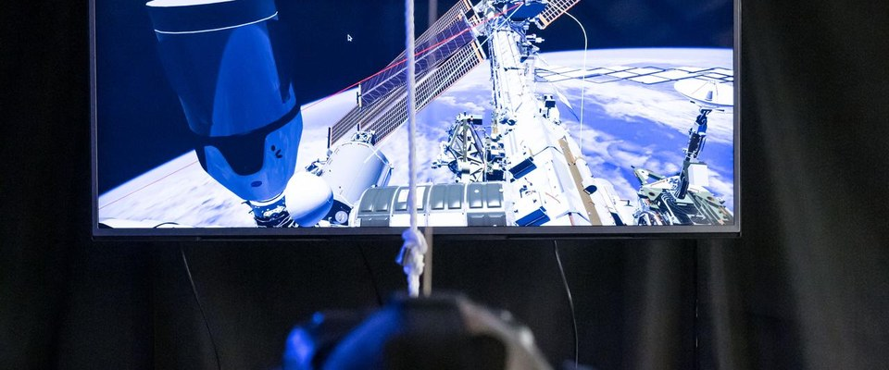   Customers in Mirror Cities  Live digital twins let customers try a flat or a lunar hotel room before buying. Brands host instead of advertise. Loyalty uses white-hat Octalysis drives: epic meaning (purchases plant real trees), accomplishment (levels for repair) and social influence. |  | 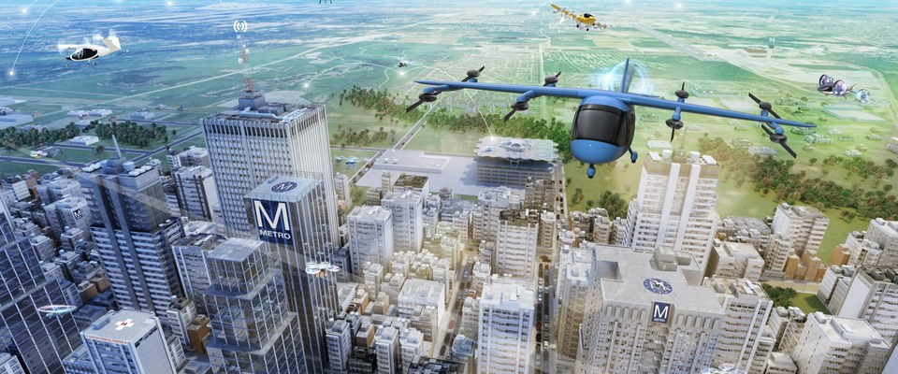   Life and transport  Shared electric pods on demand turn car parks into parks. One AI network runs pods and air taxis together, borrowed from air traffic control.
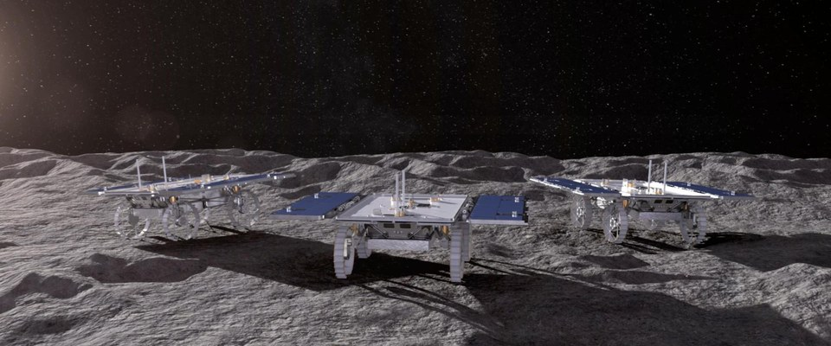   Space and the Moon  A crewed outpost at the lunar south pole mines ice for fuel. The first lunar tourists arrive, and clean-up tugs keep low orbit usable. |  | 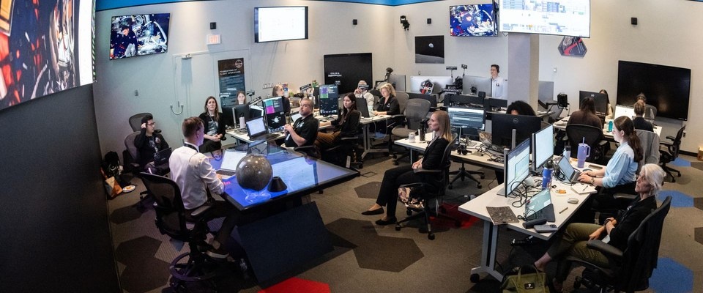   Our industry  AI writes the analysis in minutes. Consultants become future designers who run empathy sessions, tell the story and own the judgement. E,O&T move: launch a future-design practice.

5 Cs | Character  Layla, and every client like her | Conflict  AI's hunger for energy | Cure  Clean power, efficient chips | Change  Abundance, shared widely | Carry-out  Build the future we want

Still hard here: e-waste from constant upgrades, attention overload and disputes over lunar mining.
Every utopia has a shadow, so the same engine must also run downward.
STORY SPINE BECAUSE OF THAT (2)

5. World 2: Overheat 2041
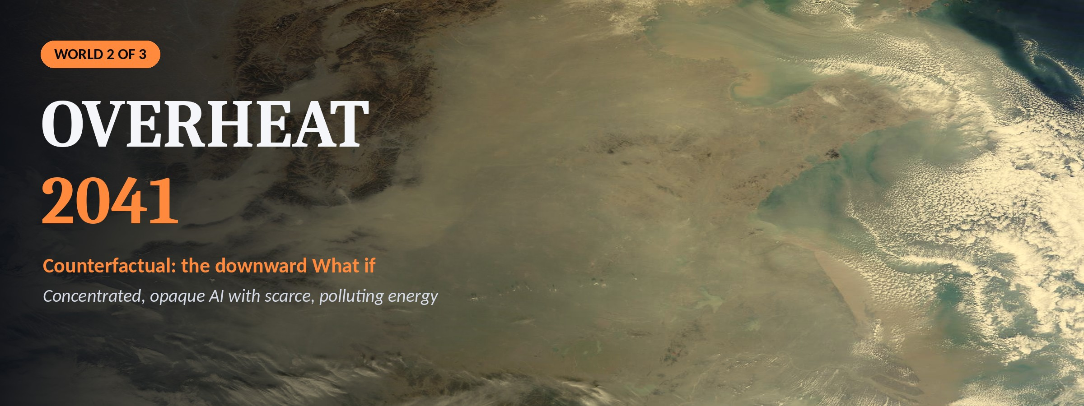
Overheat is the downward counterfactual and the honest shadow of Symbiosis: concentrated, opaque AI combined with scarce, polluting energy. Thinking only upward leads to wishful thinking, so this world is told as a chain of cause and effect.
1 It began  AI demand outran clean power, so fossil plants kept running. | 2 Because of that  Heat and pollution rose, and power was rationed. | 3 Because of that  A few players owned the models; deepfakes broke trust. | 4 Because of that  A debris cascade took out navigation and broadband satellites.

A DAY IN 2041 | HARD EMPATHY IN 5 STEPS
Omar, 41, logistics manager
Scene: in the depot, two delivery alerts contradict each other.
Feel: anxious; the rationing app also limits when I can charge the vans.
Make sense: one of the alerts may be synthetic.
Worry: I could send a driver onto an unsafe route.
Act: I verify both alerts through our data cooperative before dispatch.
STORY SPINE OVERHEAT 2041, CONTINUED

Life in Overheat 2041: customers, transport, space and our industry
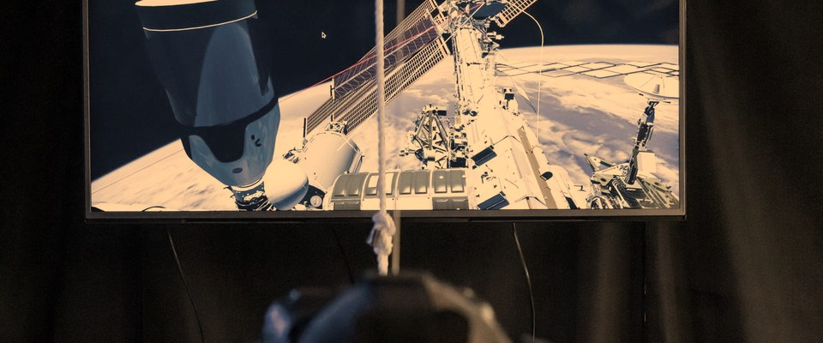  Customers in the metaverse  An escape, not a service. Cheap virtual luxury replaces real life, and black-hat Octalysis drives such as scarcity and loss avoidance keep people hooked. |  | 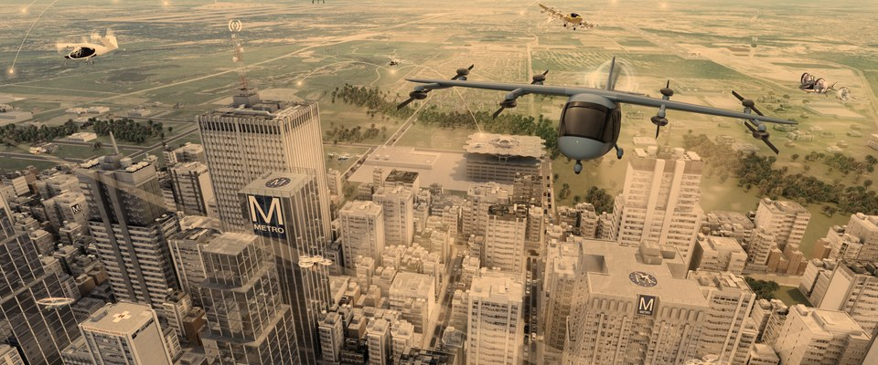  Life and transport  Empty robotaxis circle to dodge parking fees and cities gridlock. The rich fly over it; everyone else waits.
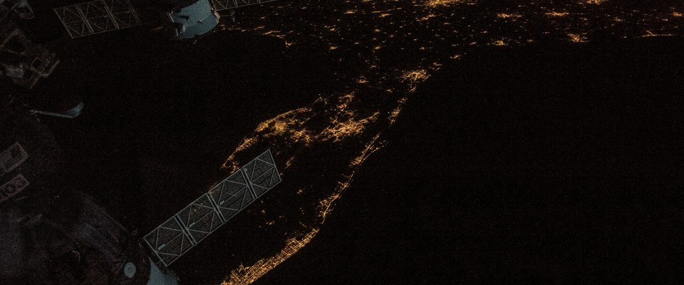  Space and the Moon  Low orbit turns into a junkyard. Launch windows shrink and the lunar outpost is postponed. |  |   Our industry  AI reports sell for pennies, and firms without human trust disappear. E,O&T move: verification and resilience services.

5 Cs | Character  Omar | Conflict  AI outgrows clean power | Cure  None, in time | Change  Trust and orbit lost | Carry-out  Plan for the shadow first

Between heaven and collapse sits the world we consider most likely.
STORY SPINE BECAUSE OF THAT (3)

6. World 3: Patchwork 2041
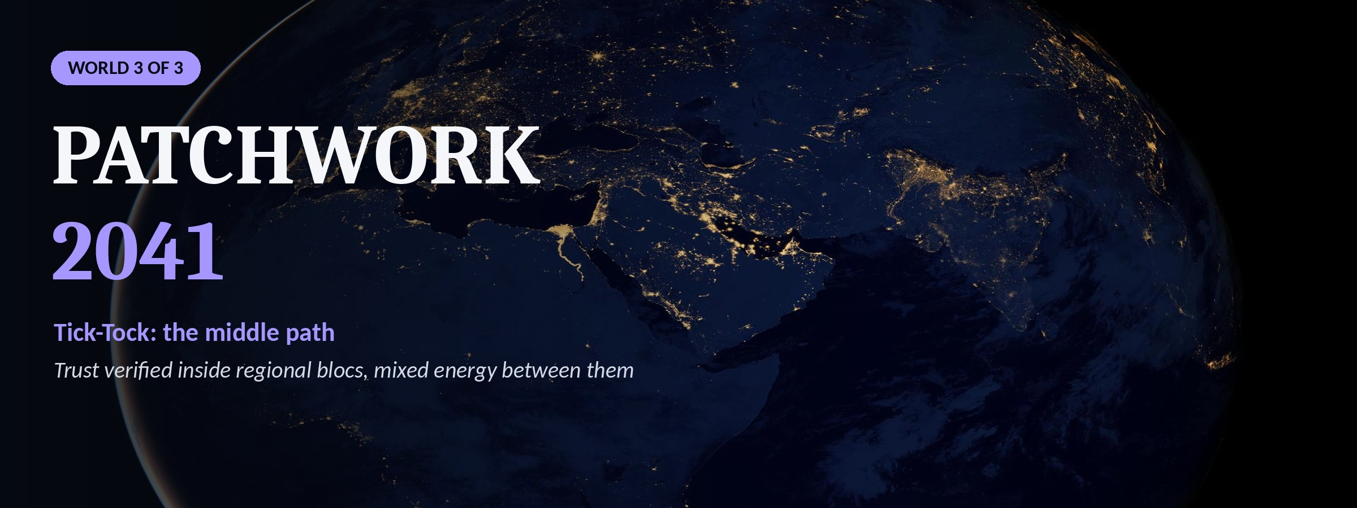
Patchwork is built with Tick-Tock: state a fact, then imagine its opposite. Two flips are enough to produce a very different world, split into regional blocs, each with its own AI rules. One planet, three rulebooks.
TICK People buy from companies.  TOCK AI agents buy from AI agents, so firms must design for machine customers. |  | TICK Data is free.  TOCK Data is owned and paid for, like energy.

A DAY IN 2041 | HARD EMPATHY IN 5 STEPS
Sara, 29, product designer, Stockholm
Scene: my AI agent is doing my weekly shopping.
Feel: relaxed, until it refuses my favourite app.
Make sense: that app has no trust seal in our bloc.
Worry: my own product could be locked out the same way.
Act: I design one product that passes all three blocs' trust rules.
STORY SPINE PATCHWORK 2041, CONTINUED

Life in Patchwork 2041: customers, transport, space and our industry
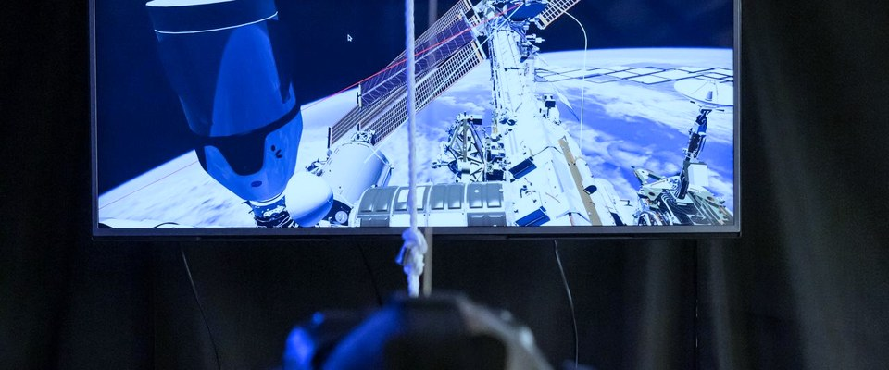   Customers in the metaverse  Regional metaverses never fully connect. One digital identity lets customers cross between them, so trust becomes the product. |  | 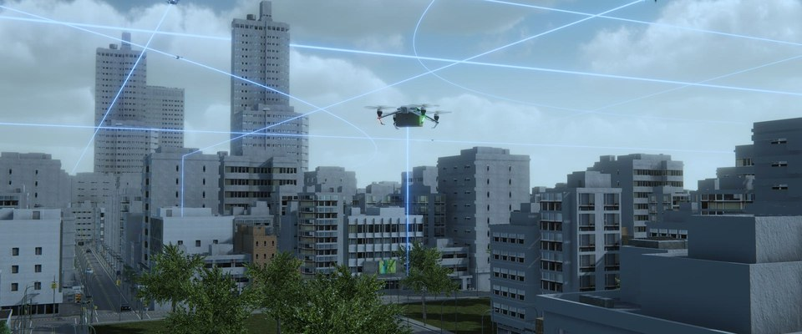  Life and transport  Uneven. Some regions run driverless public transport, others still drive. The best cities blend both in one app.
  Space and the Moon  Shared on paper through agreements, while blocs compete quietly for lunar ice and landing sites. |  | 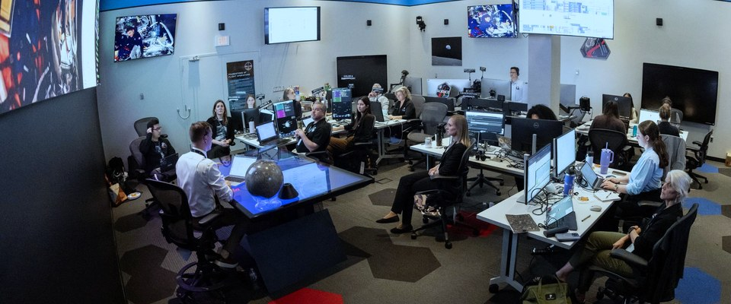  Our industry  The winners translate between blocs on standards, AI ethics and trust. E,O&T move: a cross-bloc standards advisory.

5 Cs | Character  Sara | Conflict  One world, many rulebooks | Cure  Shared trust seals | Change  Identity is the product | Carry-out  The future is a negotiation

Before weighing the worlds, two zoom-ins show how specific the change will be.
STORY SPINE BECAUSE OF THAT: ZOOM IN

7. Zoom In: From Your Door to Orbit
To show how today becomes 2041, I follow one concrete chain. The rule is to borrow the delivery-network logic, not the aircraft: a model that brings dinner today, adapted for orbital logistics, could help feed astronauts in 2041. This is moonshot thinking combined with exaptation: a consumer delivery model borrowed for space logistics.
2026 OBSERVED  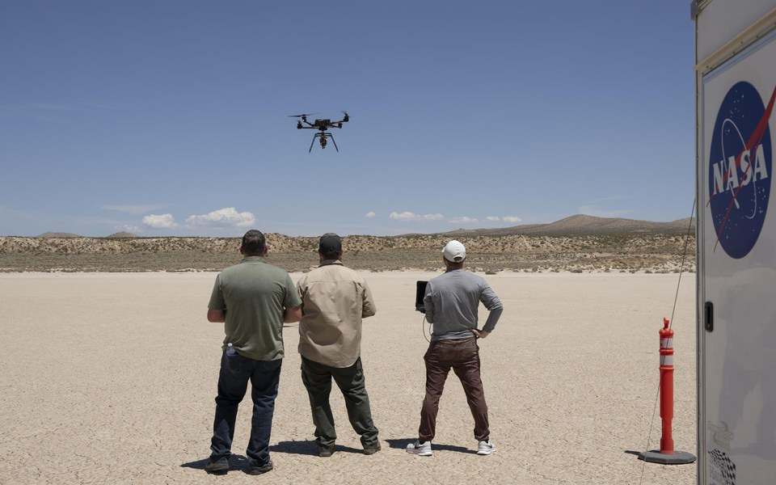  Drones deliver food now  One delivery network passed 2 million commercial drone deliveries in January 2026, with a median flight of 3 minutes (Food On Demand, 2026). Transfer: scheduling, tracking, exception handling. |  | 2030s PROPOSED TEST  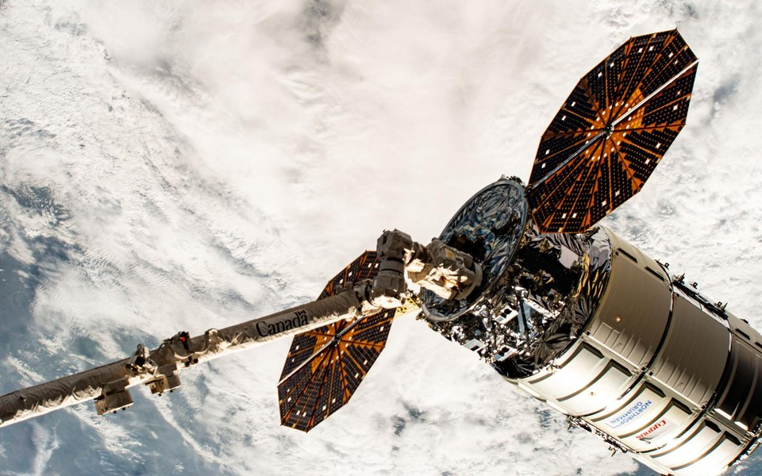  Autonomy reaches orbit  Robotic freighters already berth at the station using its robotic arm. Next: test AI scheduling with qualified space partners. Gate: safety, communication delay, payload limits. |  | 2041 MOONSHOT  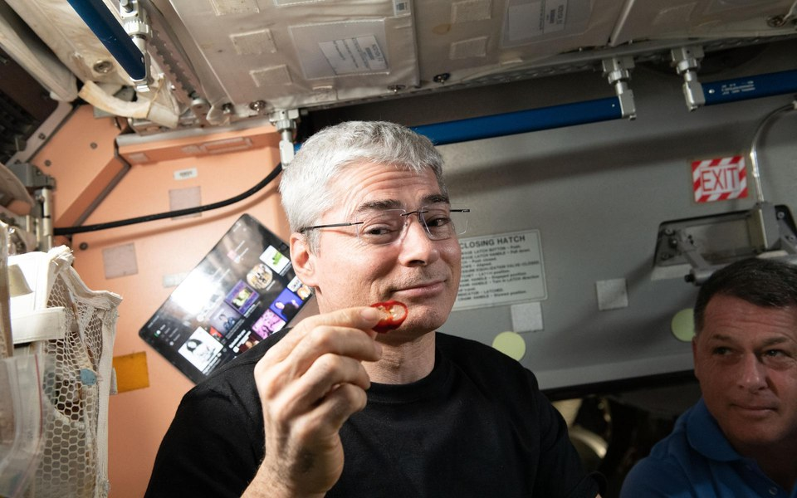  Feeding the crew in space  Each astronaut needs about 1.7 kg of food a day; fresh produce arrives every three months (NASA). Imagine cargo and orbital crops supporting a lunar outpost. 10x ambition: on-demand, not occasional, resupply.

E,O&T test. Start with a logistics simulation and a partner review, not launch infrastructure. For clients in logistics and food, the last mile becomes the last orbit.

A second zoom-in shows what becomes valuable in that world.
STORY SPINE BECAUSE OF THAT: ZOOM IN

8. Zoom In: The New Gold
TICK Gold is the treasure. TOCK Water, air, sand and plants are.

Applying Tick-Tock to value itself, the most precious things in 2041 may be the ones that keep systems alive. Each card applies one of the 4 lenses of innovation and ends with an E,O&T opportunity.
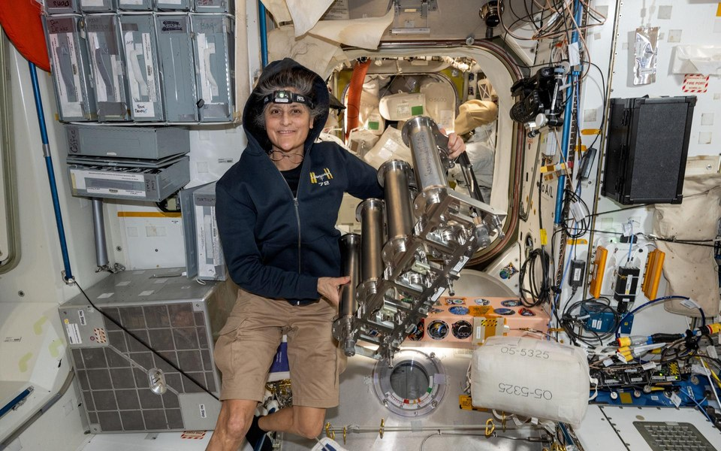  Water  Training GPT-3 was estimated to evaporate about 700,000 litres of fresh water (Li et al., 2023). The space station recycles 98% of its water (NASA, 2023).  LEVERAGE RESOURCES  Adapt closed-loop thinking to a client water audit. |  | 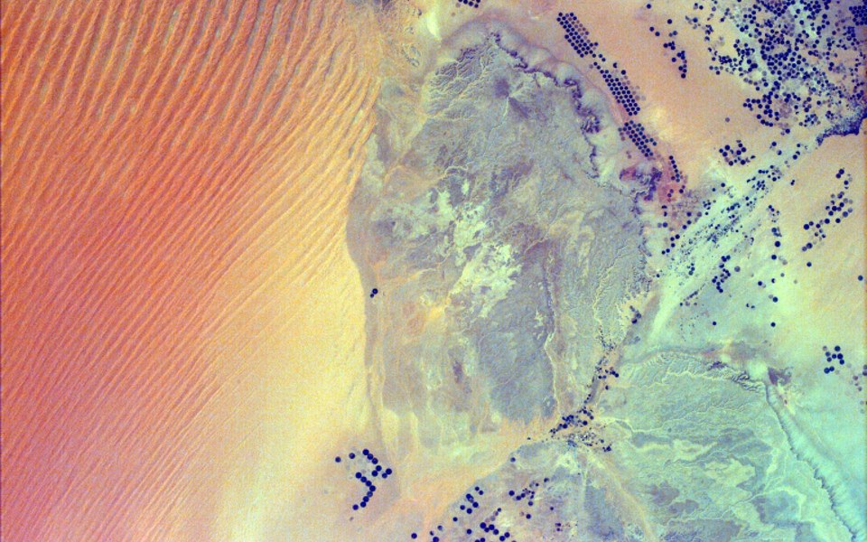  Sand  Sand and gravel use is about 50 billion tonnes a year, 17 kg per person per day (UNEP, 2022). Desert sand is too round for concrete.  CHALLENGE ORTHODOXIES  Replace "abundant means disposable" with reuse by design.
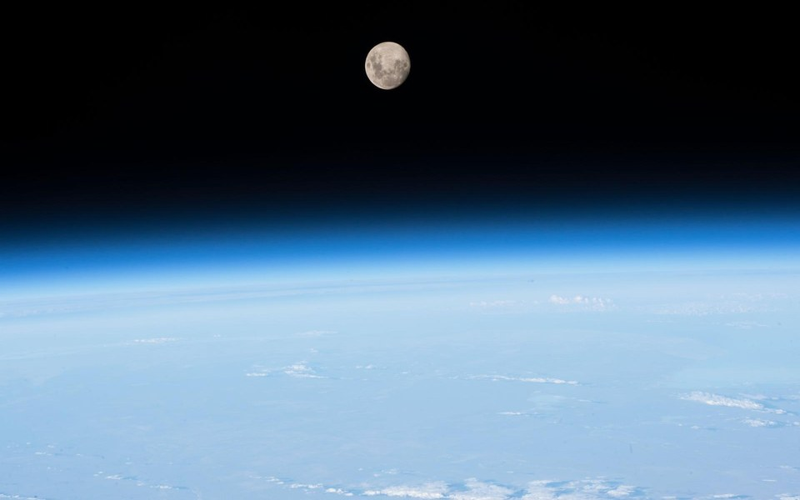  Air  Lunar soil is 40 to 45% oxygen by weight (ESA), but it is chemically bound and not breathable until extracted.  HARNESS TRENDS  Track extraction tests, energy needs and readiness. |  | 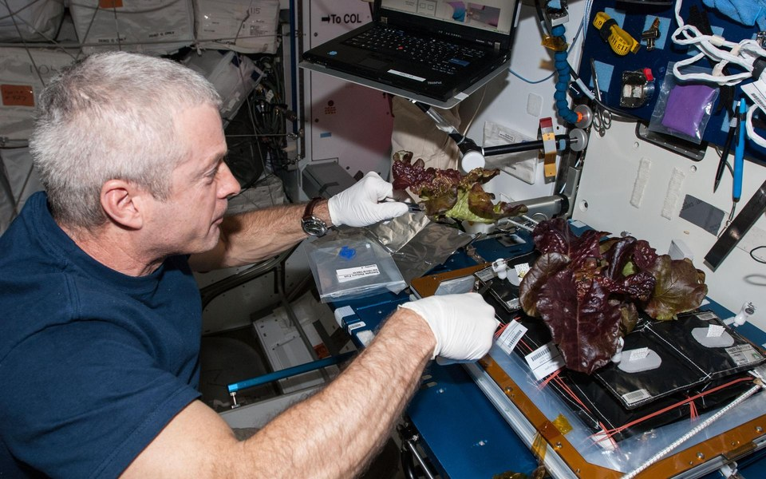  Plants  Lettuce and chile peppers grow on the space station (NASA): crop research, not yet a complete food system.  UNDERSTAND NEEDS  Design for nutrition, reliable supply and the crew's experience.

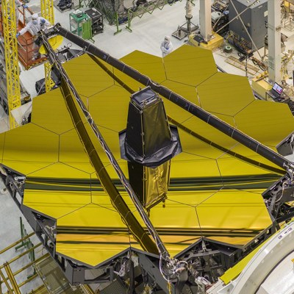 | And gold? Still useful: it coats the mirrors of the Webb space telescope. But in 2041 it no longer measures wealth.
With three worlds and their details on the table, the question becomes which one is coming.
STORY SPINE UNTIL FINALLY

9. Which Branch Are We On?
A possibility tree places all three worlds on one structure and avoids linear thinking. Level one gives the three worlds planning weights that sum to 100%. Level two splits each world on one key driver into three mutually exclusive outcomes with conditional odds that sum to 100% within that world. Multiplying the two gives joint odds, and all nine joint odds total 100%. These are illustrative judgements to support discussion, not calibrated forecasts.
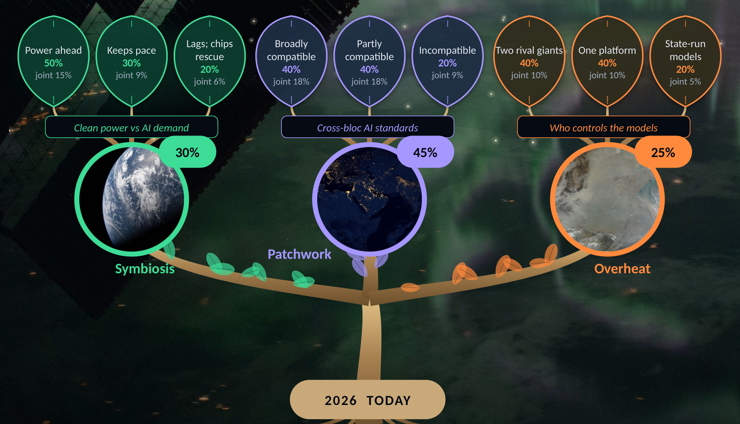
Figure 3. The possibility tree: weights, one driver per world, conditional odds and joint odds
Worked example: Patchwork (45%) with partly compatible standards (40%) gives a joint 18%. Patchwork leads because AI rules are already splitting by region; Symbiosis receives 30% because the clean-power race is not yet won, and Overheat 25%. The next section turns the tree into lights a client can watch.
A light only matters if it changes a decision.
STORY SPINE UNTIL FINALLY: WATCH

10. A Light Only Matters If It Changes a Decision
Possibility trees need contingency planning. Each signpost below has a record, a review trigger and a response. The triggers are proposed review rules measured against a pilot baseline, not external benchmarks.
Signpost | What we record | Review trigger | Response | Points to
Clean power for AI | Clean energy built per new data centre; energy used per completed task | Two monthly reviews worse than baseline | Switch to a smaller model or a manual route | Overheat
Evidence quality | Share of outputs with a traceable source; material errors | Any unmitigated material error | Pause automation; require human approval | Symbiosis or Overheat
Portability | Time and failures when moving one test case between providers | A second provider fails the same test | Add an adapter; avoid single-provider lock-in | Patchwork
Orbital access | Debris-removal missions flown; launch delays | Removal still experimental by 2030 | Plan ground fallbacks for satellite services | Overheat
Human agency | Can users understand, challenge and reverse a result? | A high-impact decision has no appeal route | Redesign the handover before scaling | All worlds

 | Cadence. The pilot lead records weekly, the client owner reviews monthly, and the team revisits the scenario assumptions every quarter.

When a light changes, what does E,O&T sell?
STORY SPINE AND EVER SINCE THEN: RESPOND

11. Sell Better Decisions, Not More Reports
If AI makes reports cheap, E,O&T sells better decisions. Three proposed offers, one per world, share one reusable asset: a Decision Passport that records why a client should act, who owns the decision and what happens if it fails.
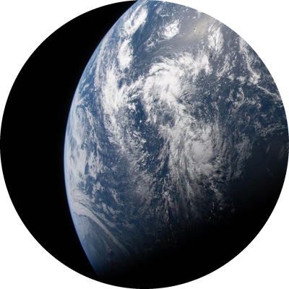 Future Design Lab  CLIENT Strategy and innovation leaders  Rehearse a new service in a digital twin before committing.  VALUE TEST Time to a testable decision |  | 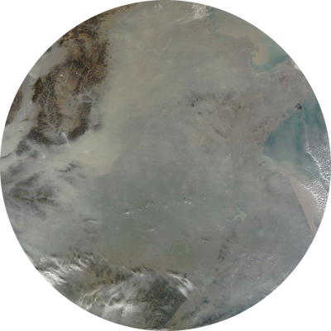 Verified Decisions and Continuity  CLIENT Operations and risk leaders  Check evidence, rehearse an outage and prove a fallback.  VALUE TEST Material errors; fallbacks completed |  | 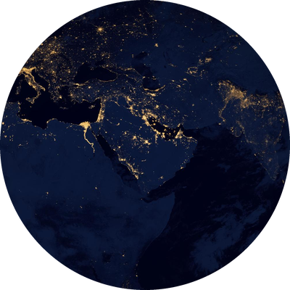 Interoperability Studio  CLIENT Product and technology leaders  Separate the core service from provider-specific adapters.  VALUE TEST Successful transfers; switching effort

Decision Passport: worked example of Omar's dispatch in Overheat (illustrative rehearsal)
Decision | May the AI dispatch this van, or must Omar use the verified manual route?
Assumption | Route and charging data are current enough for this dispatch.
Evidence | Time-stamped sources, a human route check and pilot results, still to be collected.
Owner | Omar authorises; dispatchers can flag an alert.
Review signal | Conflicting or untraceable alerts, or no charging available.
Fallback | Verify by phone, use the manual route and tell the customer.
Proposed service concepts and an illustrative rehearsal, not existing products or results.
One world, one person: the full Story Spine in eight steps.
STORY SPINE STORY IN ONE WORLD

12. One Causal Story Inside One World
The three worlds are alternatives, so the overall story uses an adapted, branching Story Spine. Inside a single world, though, a story must follow cause and effect. Here are all eight steps for Omar in Overheat, a fictional rehearsal, with the 5 Cs carry-out at the end.
 01 ONCE UPON A TIME  Omar ran a depot whose customers depended on daily deliveries. |  | 02 EVERY DAY  His team dispatched the vans on the AI's recommendation.
 03 BUT ONE DAY  Two alerts conflicted, and the planned van could not charge. |  | 04 BECAUSE OF THAT  Omar paused the recommendation before sending a driver.
 05 BECAUSE OF THAT  He checked the records and called the depot to verify the route. |  |  06 BECAUSE OF THAT  He used the manual fallback and logged why the decision changed.
 07 UNTIL FINALLY  A verified alternative kept the delivery moving. |  |  08 AND EVER SINCE THEN  The team reviews every exception with a Decision Passport.

Takeaway (5 Cs carry-out). The cure is not perfect AI. It is a process that keeps evidence, ownership and a fallback visible.

From one story to one plan: work backwards from 2041.
STORY SPINE AND EVER SINCE THEN

13. From 2041 Back to Monday Morning
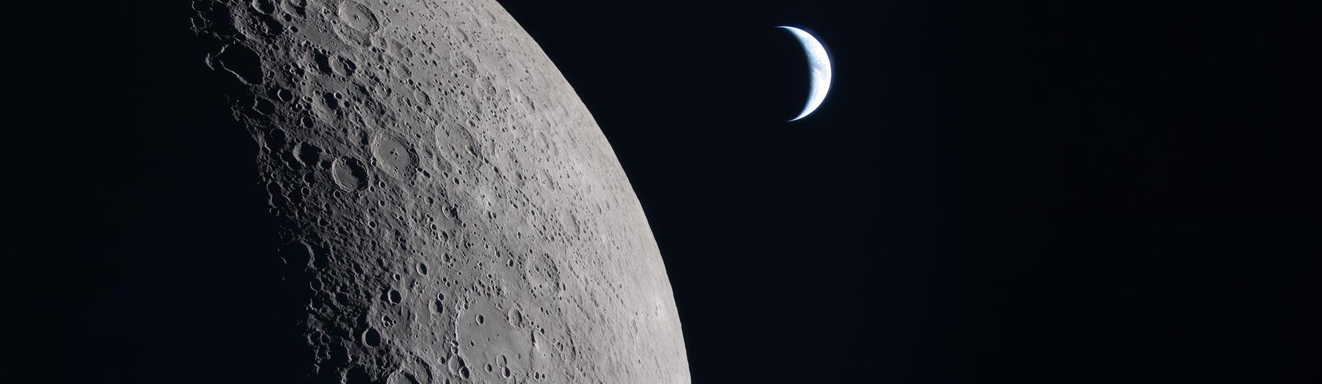
The Moon and a distant crescent Earth, seen from Orion during Artemis II. Image: NASA
Working backwards turns the worlds into action. Following Bent Flyvbjerg's idea of planning right to left and Amazon's habit of writing the press release before building the product, the plan starts at the end, in 2041, and moves step by step back to today, so every move made now is useful in any world.
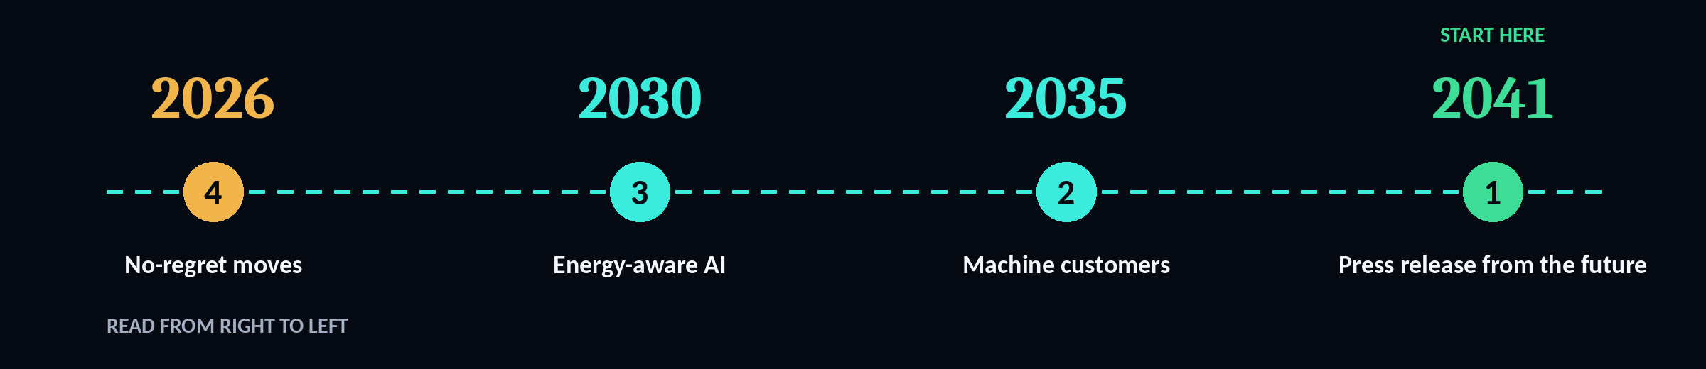
Figure 4. Working backwards, read from right to left
2026  No-regret moves  A digital-twin pilot with one client, a signpost dashboard and a quarterly "day in 2041" hard-empathy workshop. | 2030  Energy-aware AI  Every client plans AI around its power footprint; reskilling covers the 39% of skills that change. | 2035  Machine customers  Each client runs a strategy for AI agents as buyers and a verified AI supply chain. | 2041   Press release  "E,O&T clients thrive in whichever world arrived." Trusted AI, clean power, a usable orbit.

Creative fuel for the team. A shared commonplace book captures every signal and slow hunch, and a planned stimuli queue (AI 2041, Imaginable, one science fiction film a month) feeds the next round of scenarios.

The first 90 days: prove it is useful before scaling it.
STORY SPINE AND EVER SINCE THEN: FIRST TEST

14. The First 90 Days: Prove It Before Scaling It
Working backwards ends with a concrete first step: one client, one workflow and one limited rehearsal. All activities and gates below are proposed; no client commitment or benefit is claimed.
DAYS 1 TO 30  Define and observe  OWNERS Client owner and consultant  Map one workflow, record a manual baseline and interview five users.  GATE: agree success, error severity, data permissions and limits. |  | DAYS 31 TO 60   Prototype and rehearse  OWNERS Technical lead and client users  Build a simulation and a Decision Passport; rehearse all three worlds.  GATE: five users can name the evidence, owner and fallback. |  | DAYS 61 TO 90  Stress-test and decide  OWNERS Sponsor and independent reviewer  Run ten scripted cases: low power, false input, provider outage and normal operation.  GATE: every critical fallback works; no unresolved material error.

Continue, change or stop. Scale only when the pilot shows client-valued benefit and acceptable resource use. Pilot limit: five users and ten cases support learning, not proof of general reliability.

Keep the team creative long after this briefing.
STORY SPINE AND EVER SINCE THEN: KEEP CREATING

15. Rehearse, Reflect, Feed the Next Idea
A proposed 45-minute monthly workshop links the creative conditions, motivating feedback and future-thinking tools from this assignment.
01 GENERATE | 10 MIN  A safe room for alternatives  PSYCHOLOGICAL SAFETY  Write ideas silently, then share. The leader invites disagreement; challenge the assumption, not the person. |  | 02 REHEARSE | 20 MIN  Learn through the scenario  OCTALYSIS, USED ETHICALLY  Pick a world and a role. A shared progress bar tracks evidence, owner and fallback; retries are allowed after feedback. |  | 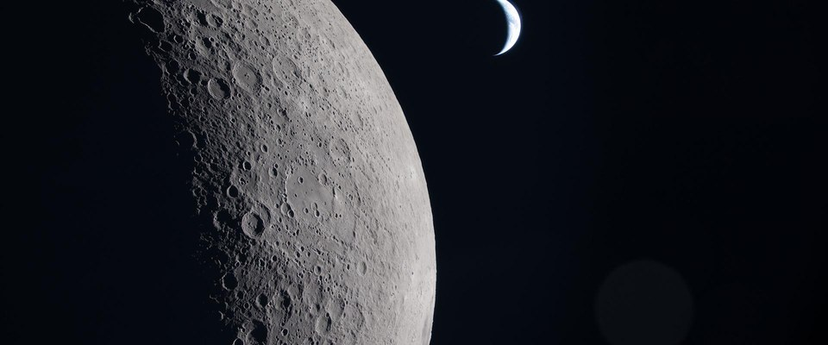  03 REFLECT | 15 MIN  Keep the useful surprise  AI AND SCIENCE FICTION  Try one strange AI or sci-fi variation as an idea, not a fact. Check its assumptions and keep a testable version in the commonplace book.

Ethical design and a monthly stimuli queue. Reward learning and feedback, not speed or a public rank, with no penalties for failed ideas. Each month: one cross-industry source, one science fiction story and one observation walk; revisit slow hunches.

All that remains is the one idea to carry out of the room.
STORY SPINE THE CARRY-OUT MESSAGE

16. Conclusion: The Moon Is Closer Than Ever. So Is 2041.
The story ends where it began, with the Moon. Three worlds are possible, and each calls for a different response from E,O&T's clients: build Symbiosis, shape Patchwork, and insure against Overheat. The signals of 2026 make all three plausible, the possibility tree tells us which branch to watch, and working backwards gives clients moves that pay off whichever world arrives.
One discipline for every world: make the assumptions visible, test the response, and keep a human decision owner in the loop.
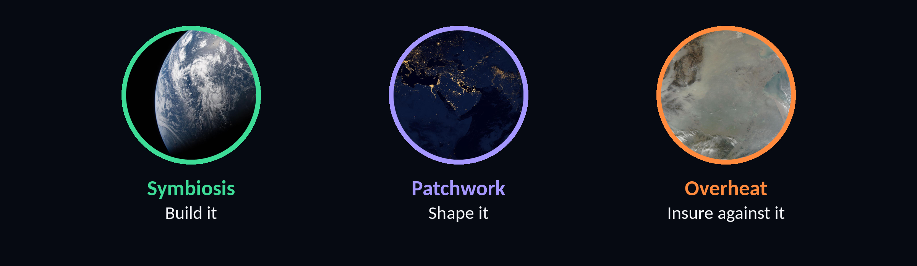
 | We do not predict the future. We prepare for all three, and we work every day for the first one.  Mohammad, Senior Futures Consultant, Em, Oli & Timmonds

PART 2
Personal Reflection: What I Am Taking With Me

Three ideas from this course changed how I think about planning: possibility trees, working backwards, and counterfactual thinking. Together they gave me a structured language for something my work has always demanded: decisions about a future nobody can see.
In twenty years of network engineering and digital transformation, I have learned that a platform chosen today may still shape a business in ten years. Building the three worlds of 2041 for this assignment showed me a different way to approach that kind of decision. Drawing the possibility tree forced me to give each branch a probability, and the less likely branches raised questions a single forecast would never have asked. Working backwards from a 2041 press release, the way Amazon writes the press release before the product exists, made the first steps for 2026 obvious. Counterfactual thinking kept the exercise honest: writing Overheat next to Symbiosis stopped me from falling in love with the optimistic future.
What resonated most is that creativity here is not a talent but a structured skill, wild ideas plus strategy.
My plan is concrete. From November, every new technical proposal I write will open with a one-page working backwards brief describing the result for the customer in three years, the assumptions behind it and the first test. Once a quarter, starting in January 2027, I will build a possibility tree for one roadmap decision, with three branches, nine sub-branches and probabilities, and review it three months later to see which branch reality followed. Before each major design review I will run one upward and one downward counterfactual with the team and record the risks it surfaces.
Personally, I live between Riyadh and Stockholm, and I will turn those flights into fuzzy focus time: no screens, just my stimuli queue and a commonplace book, so slow hunches have somewhere to land.
I will measure success simply: by June 2027, I will have built two possibility trees, completed the first three-month review, and recorded whether the findings changed a roadmap decision.
334 words

References
European Space Agency. (2025). ESA space environment report 2025. https://www.esa.int/Space_Safety/Space_Debris/ESA_Space_Environment_Report_2025
International Energy Agency. (2025). Energy and AI. https://www.iea.org/reports/energy-and-ai
NASA. (2026). Artemis II mission. https://www.nasa.gov/mission/artemis-ii/
World Economic Forum. (2025). The future of jobs report 2025. https://www.weforum.org/publications/the-future-of-jobs-report-2025/
UNEP. (2022). Sand and sustainability: 10 strategic recommendations to avert a crisis. United Nations Environment Programme.
Li, P., Yang, J., Islam, M. A., & Ren, S. (2023). Making AI less "thirsty". arXiv:2304.03271.
NASA. (2023). NASA achieves water recovery milestone on International Space Station.
NASA. (2021). Astronauts harvest first chile peppers grown on the space station (Plant Habitat-04).
ESA. (2020). ESA opens oxygen plant: making air out of moondust.
Food On Demand. (2026, January 21). Zipline flies past 2 million deliveries.
Business Standard. (2025, March 19). What astronauts eat on the ISS (NASA food stock of 3.8 lb per astronaut per day).
Adams, K. (2007). How to improvise a full-length play. Allworth Press.
Chou, Y. (2015). Actionable gamification: Beyond points, badges, and leaderboards. Octalysis Media.
Flyvbjerg, B., & Gardner, D. (2023). How big things get done. Currency.
Gibson, R. (2015). The four lenses of innovation. Wiley.
Henry, T. (2011). The accidental creative. Portfolio.
Johnson, S. (2010). Where good ideas come from. Riverhead.
Lee, K.-F., & Chen, Q. (2021). AI 2041: Ten visions for our future. Currency.
McGonigal, J. (2022). Imaginable. Spiegel & Grau.

Image credits
Cover: "A Breathtaking Earthset from Orion", Artemis II crew, 6 April 2026. NASA (art002e021278).
Section 2: Night Earth observation from the ISS, Expedition 40. NASA (iss040e085126).
Section 4 and figures: "Earth in View", Artemis II. NASA (art002e023506).
Section 5 and figures: "Haze over eastern China". NASA Goddard (GSFC_20171208_Archive_e001269).
Section 6 and figures: "Black Marble: Africa, Europe, and the Middle East". NASA Goddard (GSFC_20171208_Archive_e001591).
Section 10: "Home in the Distance", Artemis II. NASA (art002e020922).
World cards: NASA VR training (jsc2026e000427), Advanced Air Mobility concepts (AAM-Concept-2021 and automation concept), CADRE rovers (PIA26296), Mission Control (jsc2026e019925), Pleiades supercomputer (ARC-2008-ACD08-0272-005), ISS Expedition 35 (iss035e017673).
Section 7: NASA drone flight test (AFRC2026-0152-22); Cygnus in Canadarm2 (iss071e418235); Expedition 66 crew with chile peppers (iss066e023179).
Section 8: ISS water recovery filters (iss072e143163); Sand dunes and center-pivot irrigation in Saudi Arabia (PIA11069); Earth limb and Moon (iss051e039977); Veg-01 harvest (iss040e009126); JWST golden mirror (GSFC_20171208_Archive_e000368).
All NASA images via the NASA Image and Video Library, https://images.nasa.gov (public domain). Portrait: own photograph. Figures: own design. Icons: Font Awesome Free (CC BY 4.0), Material Design Icons (Apache 2.0), Game-icons.net (CC BY 3.0).

AI Declaration
I acknowledge the use of Claude (https://claude.ai), Canva AI (https://www.canva.com), Superdesign (https://superdesign.dev) and Miro (https://miro.com) to research and verify sources, structure and draft sections, generate the mood board and app visuals, and arrange and format the document. The output was used to support my own work .

