**DAILY ONLINE ACTIVITIES SUMMARY**

|  |  |  |  |  |  |  |  |  |
| --- | --- | --- | --- | --- | --- | --- | --- | --- |
| **Date:** | **21/05/2020** | | | | | **Name:** | **Spoorthi** | |
| **Sem & Sec** | **6th /B** | | | | | **USN:** | **4AL17CS097** | |
| **Online Test Summary** | | | | | | | | |
| **Subject** | | **OS IA Test** | | | | | | |
| **Max. Marks** | | **30** | | **Score** | | | **30** | |
| **Certification Course Summary** | | | | | | | | |
| **Course** | **Web Development with Python and JavaScript** | | | | | | | |
| **Certificate Provider** | | | **Harvard University** | | **Duration** | | | **12weeks** |
| **Coding Challenges** | | | | | | | | |
| **Problem Statement:**  **1.** Write a menu program in Python to find Area-Circle, Circumference-Circle, Area- Square, Circumference-Square using functions with menu choice Create separate functions for each choice of menu  **2.** Python program to print right angled triangle | | | | | | | | |
| **Status: Completed** | | | | | | | | |
| **Uploaded the report in GitHub** | | | | | **Yes** | | | |
| **If yes Repository name** | | | | | <https://github.com/msspoorthi/onlinecoding> | | | |
| **Uploaded the report in slack** | | | | | **Yes** | | | |

**Online Test Details**

OS TEST Details:

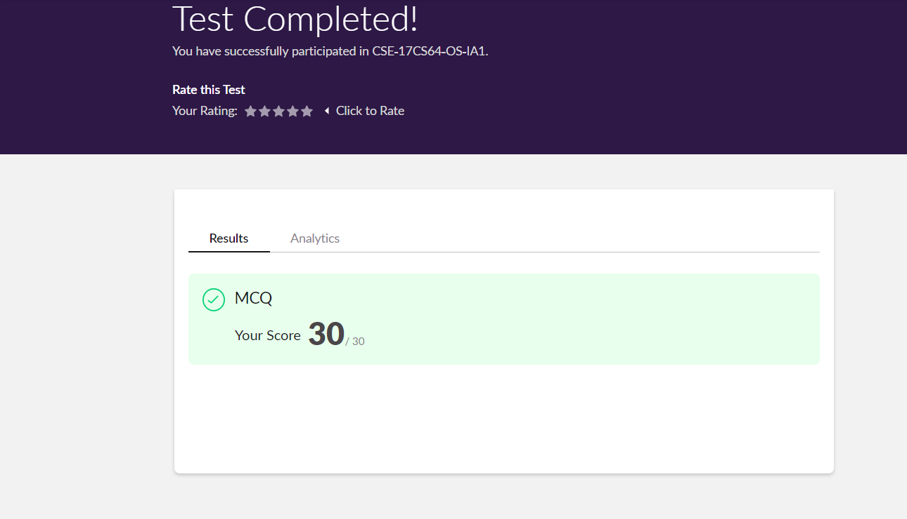

**Online Certification Details**

**Lesson**

* **SQL**

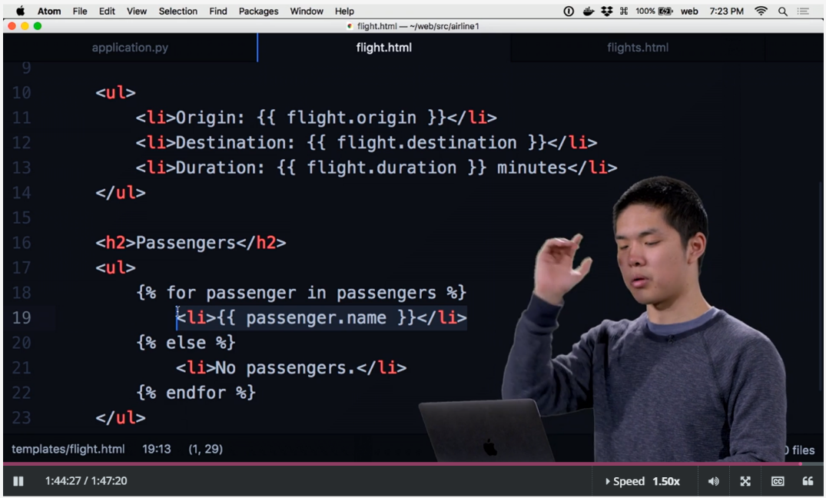

**Coding Challenge Details**

1. Write a menu program in Python to find Area-Circle, Circumference-Circle, Area- Square, Circumference-Square using functions with menu choice  
   Create separate functions for each choice of menu

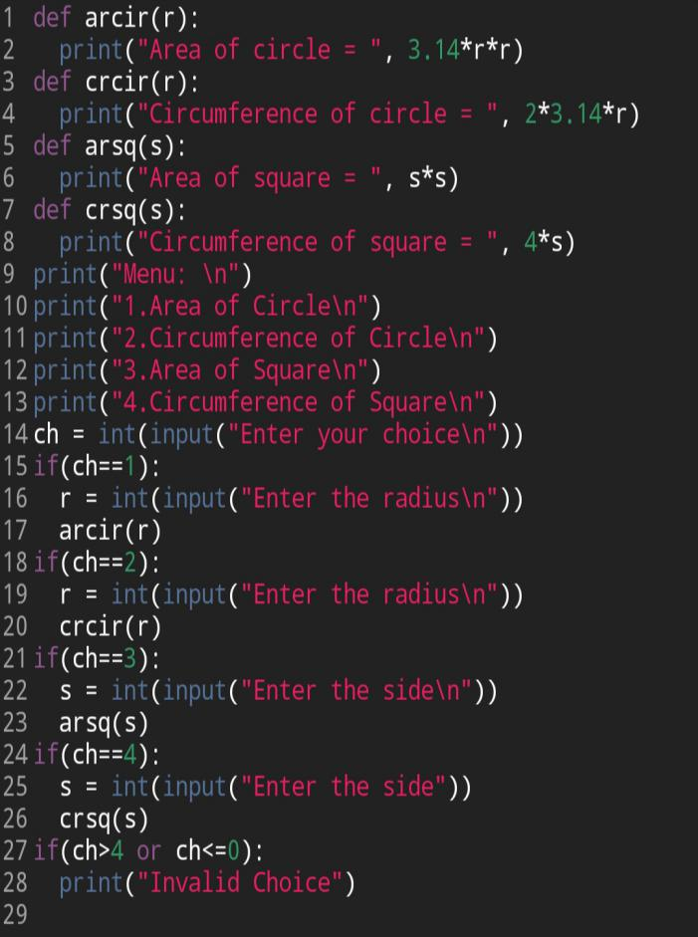

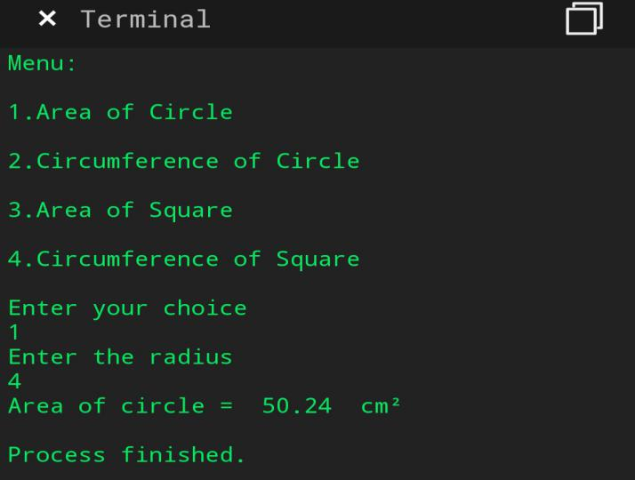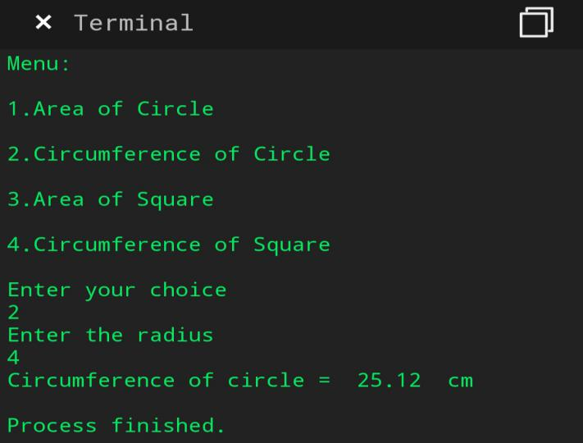

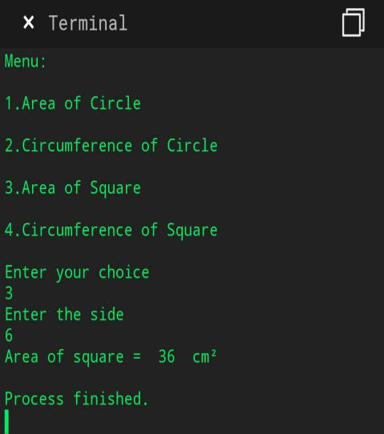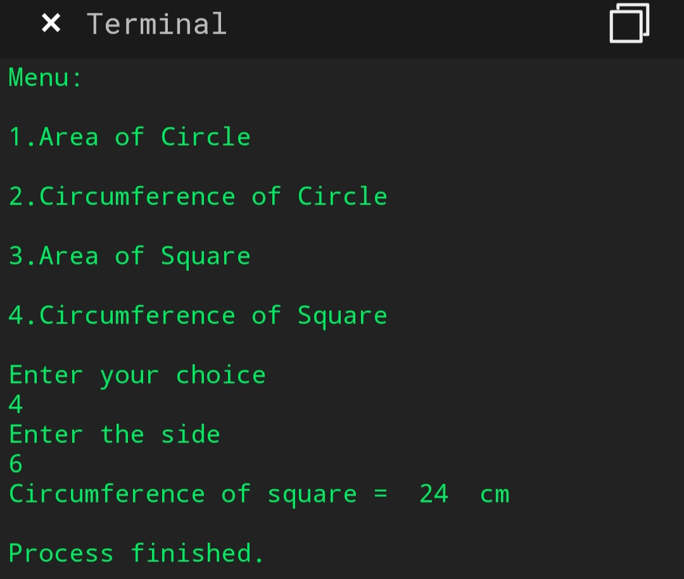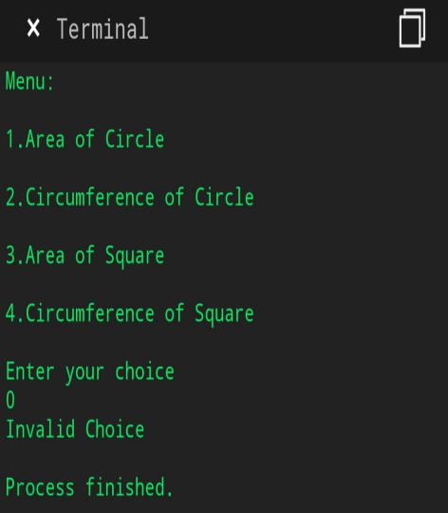

1. Python program to print right angled triangle.

