**DAILY ONLINE ACTIVITIES SUMMARY**

|  |  |  |  |  |  |  |  |  |
| --- | --- | --- | --- | --- | --- | --- | --- | --- |
| **Date:** | **26/05/2020** | | | | | **Name:** | **Spoorthi MS** | |
| **Sem & Sec** | **6th /B** | | | | | **USN:** | **4AL17CS097** | |
| **Online Test Summary** | | | | | | | | |
| **Subject** | | **CGV IA Test - 2** | | | | | | |
| **Max. Marks** | | **30** | | **Score** | | | **Error in the link** | |
| **Certification Course Summary** | | | | | | | | |
| **Course** | **Web Development with Python and JavaScript** | | | | | | | |
| **Certificate Provider** | | | **Harvard University** | | **Duration** | | | **12weeks** |
| **Coding Challenges** | | | | | | | | |
| **Problem Statement:**   1. Python Program to read a number n and print the number of digits in it. 2. This is a Python Program to read a number n and print and compute the series “1+2+…+n=”.   Problem Description  The program takes a number n and prints and computes the series “1+2+…+n=”. | | | | | | | | |
| **Status: Completed** | | | | | | | | |
| **Uploaded the report in GitHub** | | | | | **Yes** | | | |
| **If yes Repository name** | | | | | <https://github.com/msspoorthi/onlinecoding> | | | |
| **Uploaded the report in slack** | | | | | **Yes** | | | |

**Online Test Details**

CGV TEST-2 Details:

Error in the link

**Online Certification Details**

**Lessons**

* Front Ends

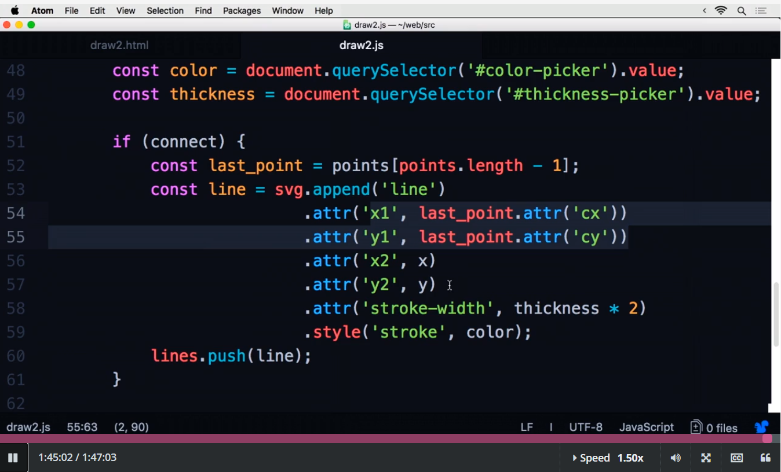

**Coding Challenge Details**

1. Python Program to read a number n and print the number of digits in it.

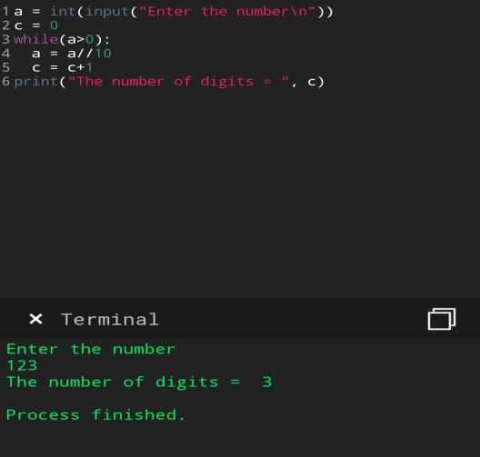

1. This is a Python Program to read a number n and print and compute the series “1+2+…+n=”.

Problem Description

The program takes a number n and prints and computes the series “1+2+…+n=”.

