**DAILY ONLINE ACTIVITIES SUMMARY**

|  |  |  |  |  |  |  |  |  |  |
| --- | --- | --- | --- | --- | --- | --- | --- | --- | --- |
| **Date:** |  | **19-05-2020** | | |  | **Name:** |  | **Spoorthi MS** | |
|  |  |  |  |  |  |  |  |  |  |
| **Sem & Sec** |  | **VI B** | | |  | **USN:** |  | **4AL17CS097** | |
|  |  |  |  |  |  |  |  |  |  |
|  |  |  |  | **Online Test Summary** | | | |  |  |
|  | |  |  |  |  |  |  |  |  |
| **Subject** | |  | **CGV IA Test** | |  |  |  |  |  |
|  | |  |  |  |  | | |  |  |
| **Max. Marks** | |  | **60** |  | **Score** | |  | **56** |  |
|  |  |  |  |  |  | |  | |  |
|  |  |  |  | **Certification Course Summary** | | | | | |
|  | |  | |  |  | | |  |  |
| **Course** |  | **Web Development with Python and Javascript** | | | | | |  |  |
|  |  | | |  |  | | |  |  |
| **Certificate Provider** | | | | **Harvard University** | **Duration** | | |  | **12 weeks** |
|  |  |  |  |  |  | | |  |  |
|  |  |  |  | **Coding Challenges** | | | |  |  |

**Problem Statement:**

**1.** We have a Letter or a word then we need add some letters to it and need to find out shortestpalindrome

**2.** Write a simple code to identify given linked list is palindrome or not by using stack.First take a Stack. Traverse through each node of the linked list and push each node value to Stack.

.

**Status:Completed**

|  |  |  |  |  |  |  |
| --- | --- | --- | --- | --- | --- | --- |
| **Uploaded the report in Github** |  | **Yes** | | | | |
|  |  |  | | | | |
| **If yes Repository name** |  | [**https://github.com/msspoorthi/linked-list-in-palindrom**](https://github.com/msspoorthi/linked-list-in-palindrom)  **https://github.com/msspoorthi/shortest-palendrom** | | | | |
|  |  | | |  |
|  |  |  | | | | |
| **Uploaded the report in slack** |  | **Yes** | | | | |
|  |  |  |  | | |  |

**Online Certification Details**

Lesson-2

* HTML
* CSS

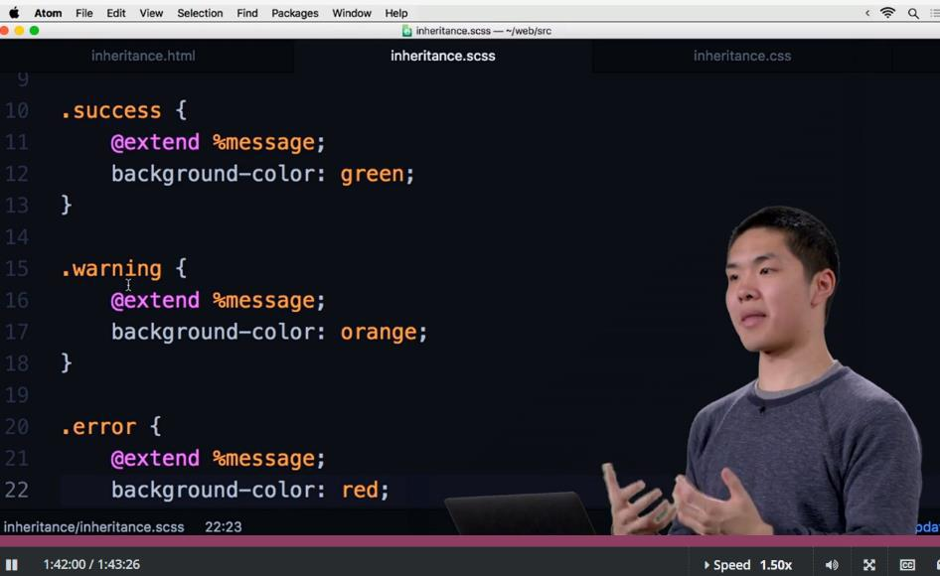

**Coding Challenge Details**

1.We have a Letter or a word then we need add some letters to it and need to find out shortest palindrome

For example we take "S": S will be the shortest palindrome string.

If we take "xyz": zyxyz will be the shortest palindrome string

So we need to add some characters to the given string or character and find out what will be the shortest palindrome string by using simple java program.

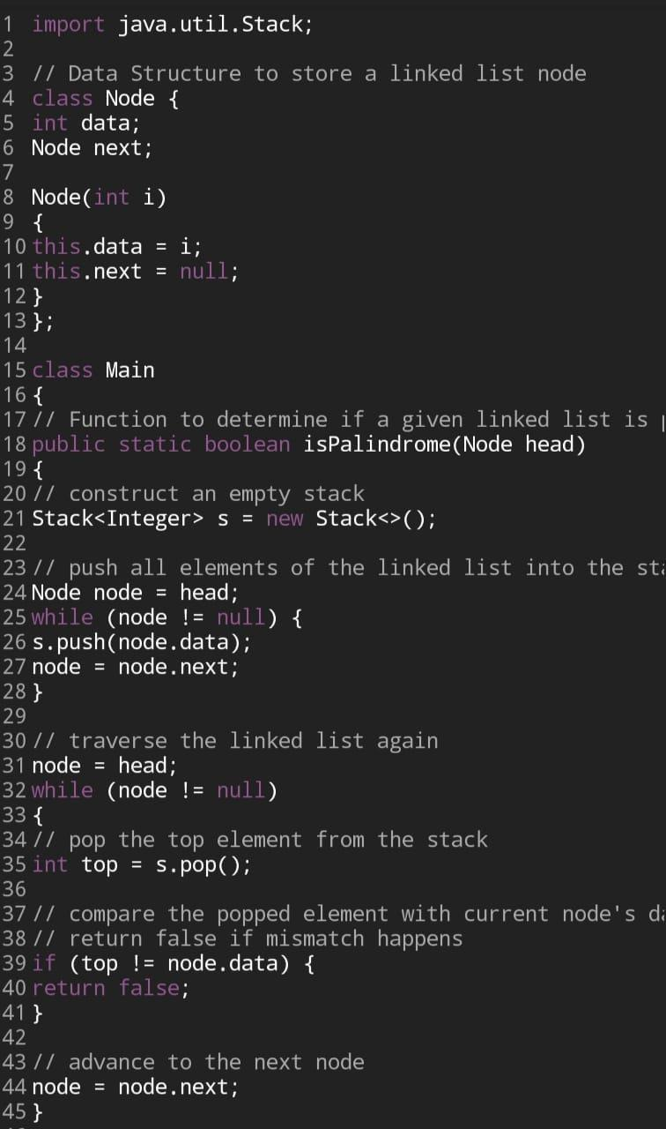

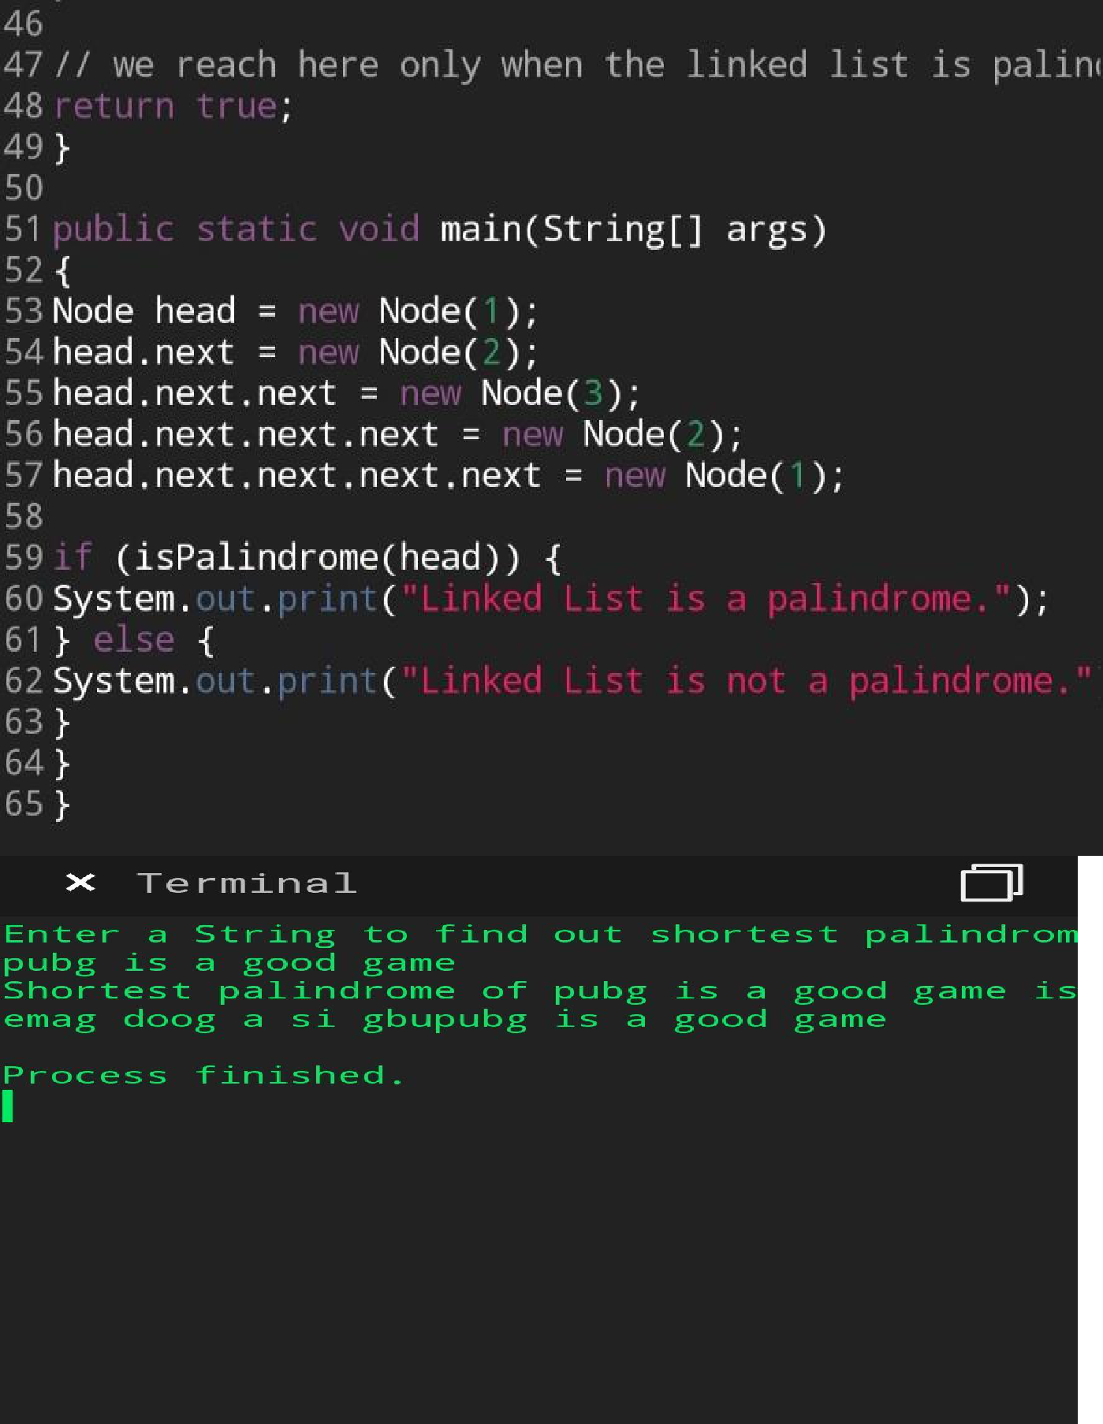

1. Write a simple code to identify given linked list is palindrome or not by using stack.

First take a Stack. Traverse through each node of the linked list and push each node value to Stack.

Once the traversal & copying is done, iterate through linked list from head node again.

In each iteration, pop one stack element and compare with node value in respective iteration. It is expected to match stack popped value with node value.

In case of all matches, its a palindrome. Any one element mismatch makes it not a palindrome.

