**DAILY ONLINE ACTIVITIES SUMMARY**

|  |  |  |  |  |  |  |  |  |  |
| --- | --- | --- | --- | --- | --- | --- | --- | --- | --- |
| **Date:** |  | **20-05-2020** | | |  | **Name:** |  | **Spoorthi M S** | |
|  |  |  |  |  |  |  |  |  |  |
| **Sem & Sec** |  | **VI B** | | |  | **USN:** |  | **4AL17CS097** | |
|  |  |  |  |  |  |  |  |  |  |
|  |  |  |  | **Online Test Summary** | | | |  |  |
|  | |  |  |  |  |  |  |  |  |
| **Subject** | |  | **SSCD IA Test** | |  |  |  |  |  |
|  | |  |  |  |  | | |  |  |
| **Max. Marks** | |  | **30** |  | **Score** | |  | **21** |  |
|  |  |  |  |  |  | |  | |  |
|  |  |  |  | **Certification Course Summary** | | | | | |
|  | |  | |  |  | | |  |  |
| **Course** |  | **Web Development with Python and Javascript** | | | | | |  |  |
|  |  | | |  |  | | |  |  |
| **Certificate Provider** | | | | **Harvard University** | **Duration** | | |  | **12weeks** |
|  |  |  |  |  |  | | |  |  |
|  |  |  |  | **Coding Challenges** | | | |  |  |

**Problem Statement:**

1.Python Program to Execute the Values of Two Number using ^ (exclusive or operator).

2.Write Python Program to Reverse a Given Number. This is a Python Program to reverse a given number.

**Status:Completed**

|  |  |  |  |  |
| --- | --- | --- | --- | --- |
| **Uploaded the report in Github** |  | **Yes** | | |
|  |  |  | | |
| **If yes Repository name** |  | [**https://github.com/msspoorthi/Online-**](https://github.com/msspoorthi/Online-) | | |
|  |  | [**coding-**](https://github.com/vgkavana/Online-coding-) |  |  |
|  |  |  | | |
| **Uploaded the report in slack** |  | **Yes** | | |
|  |  |  |  |  |

**Online Certification Details**

**Lesson-3**

* Flask

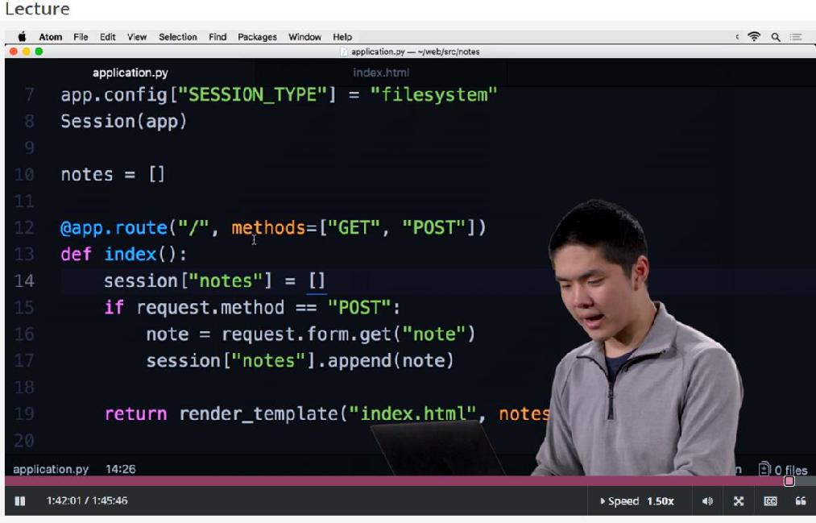

**Coding Challenge Details**

1.Python Program to Execute the Values of Two Number using ^ (exclusive or operator)

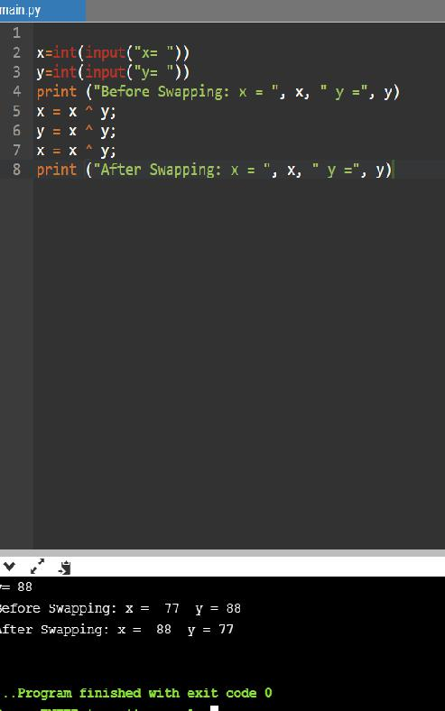

1. Write Python Program to Reverse a Given Number. This is a Python Program to reverse a given number.

