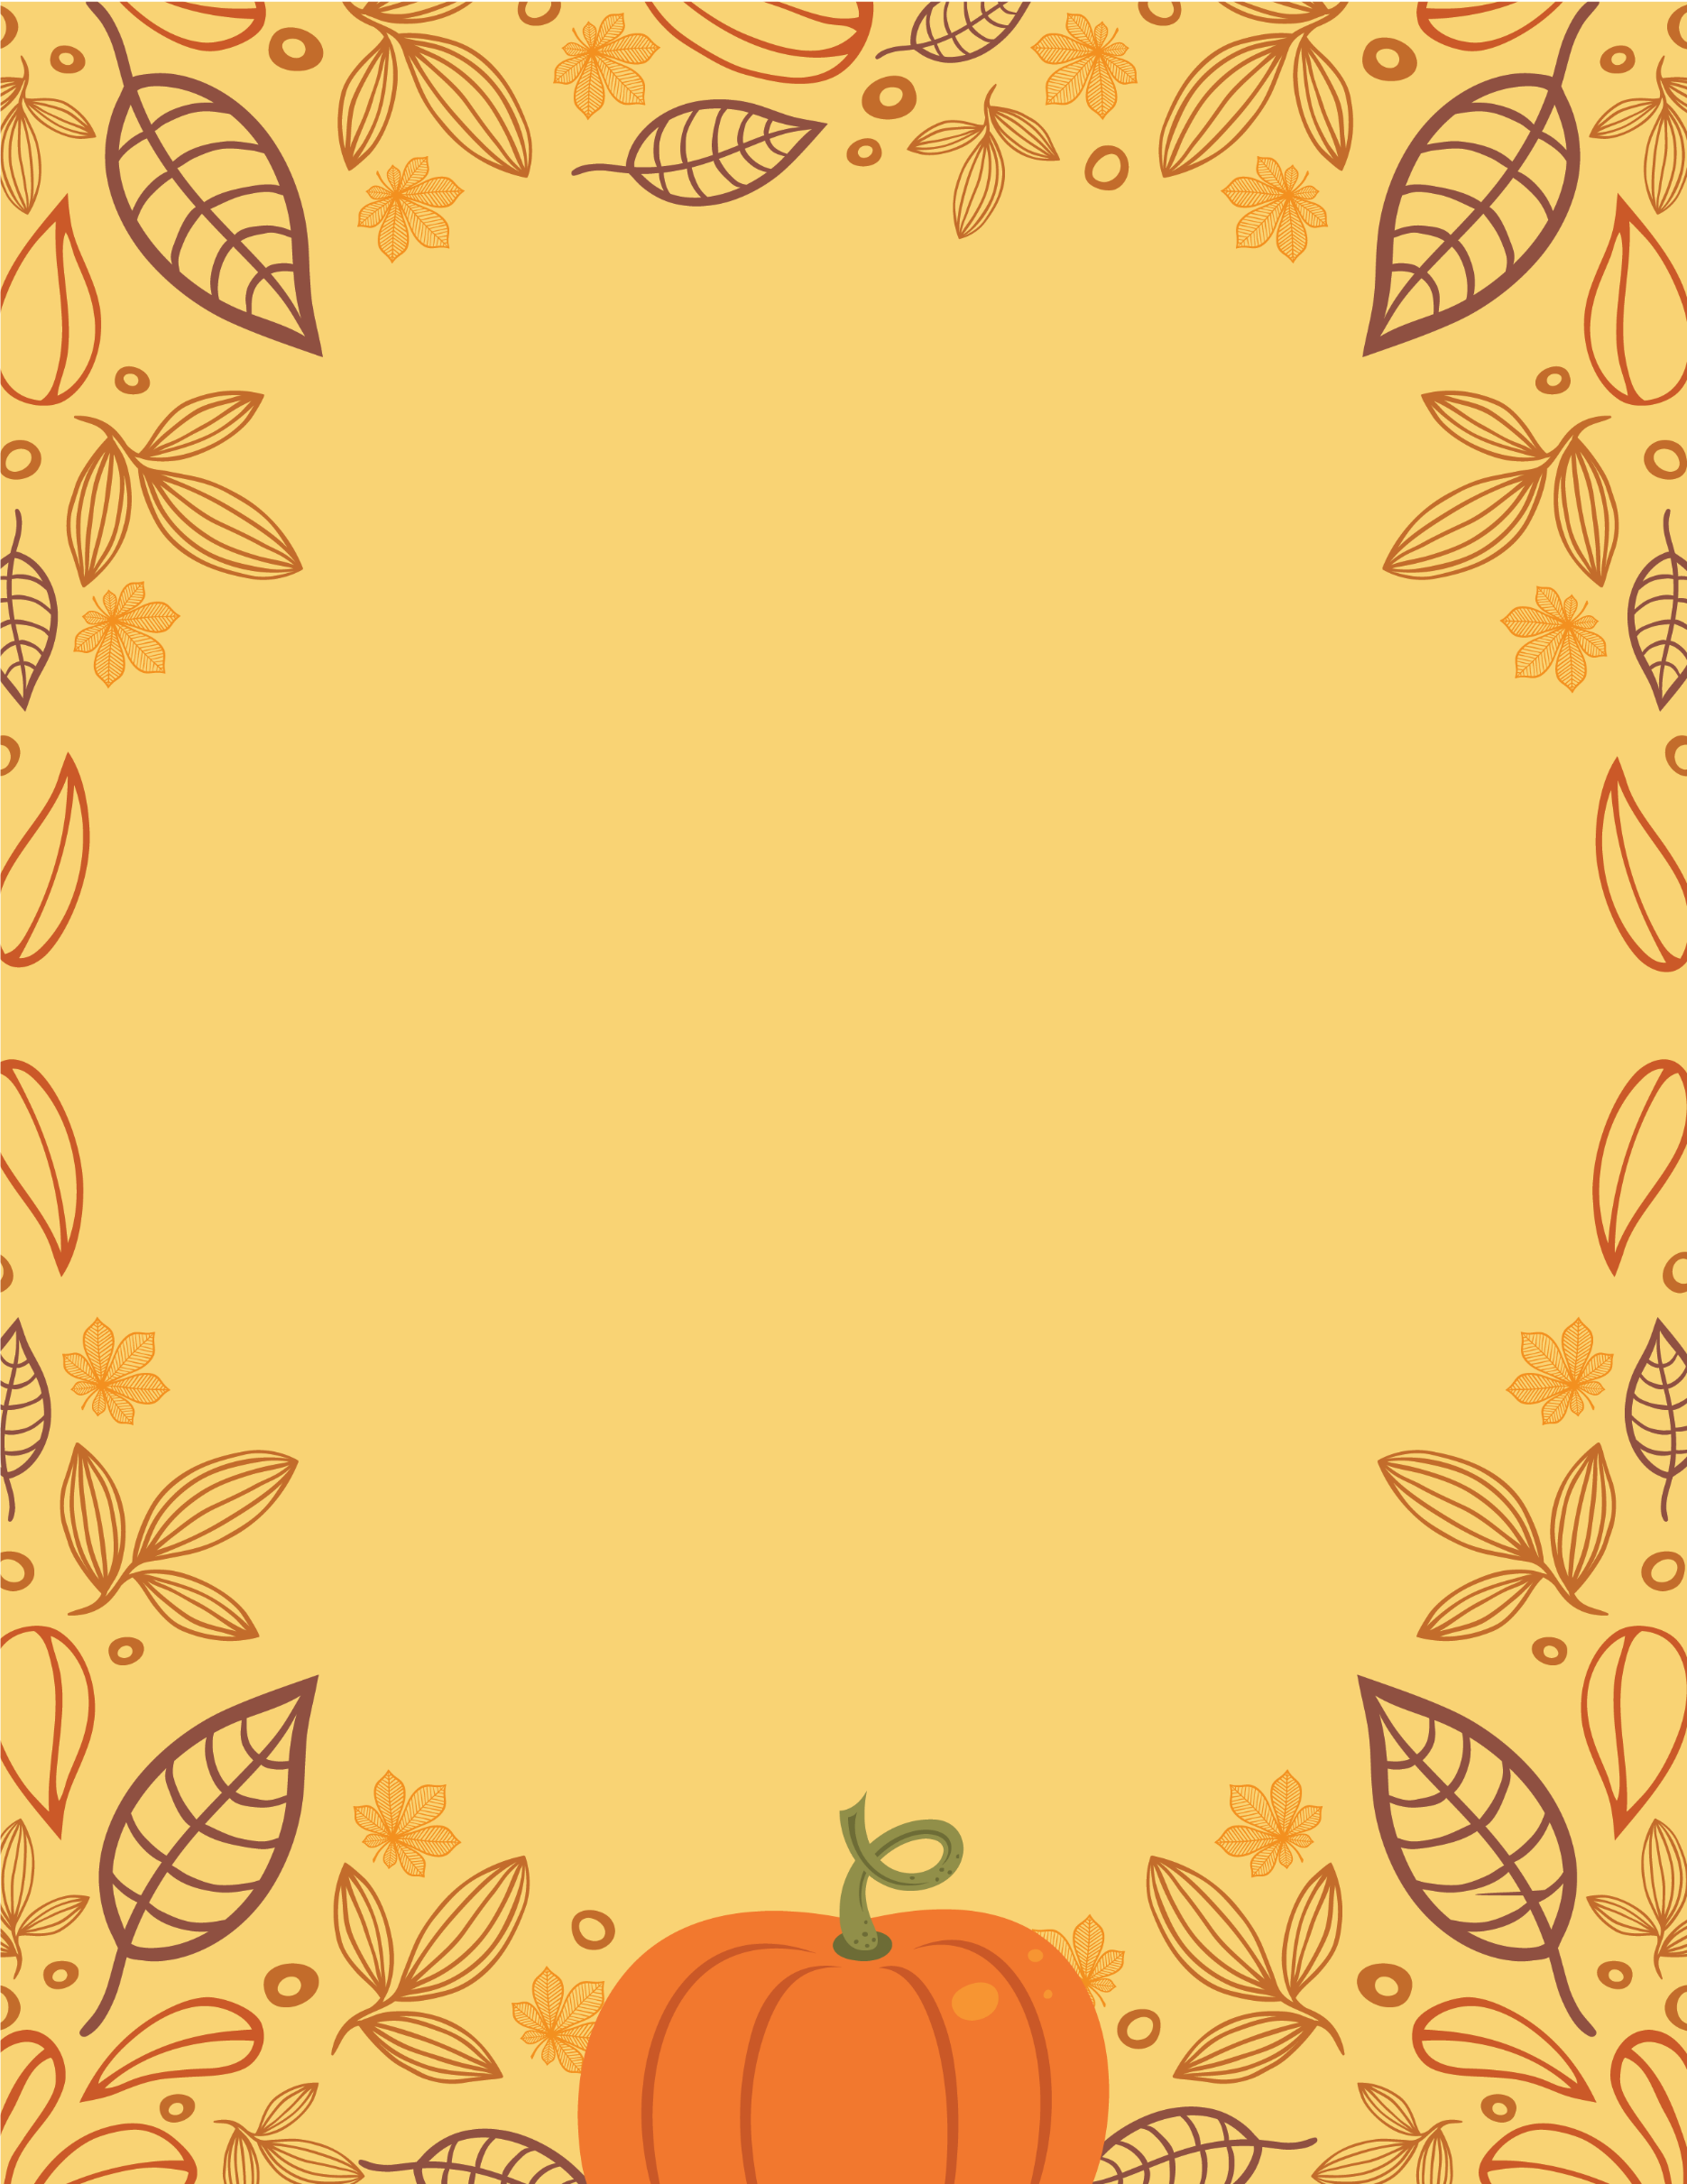

Get ready for the

CDCN

Super 7

Summit

November 1st, 2021

Bring your data needs.

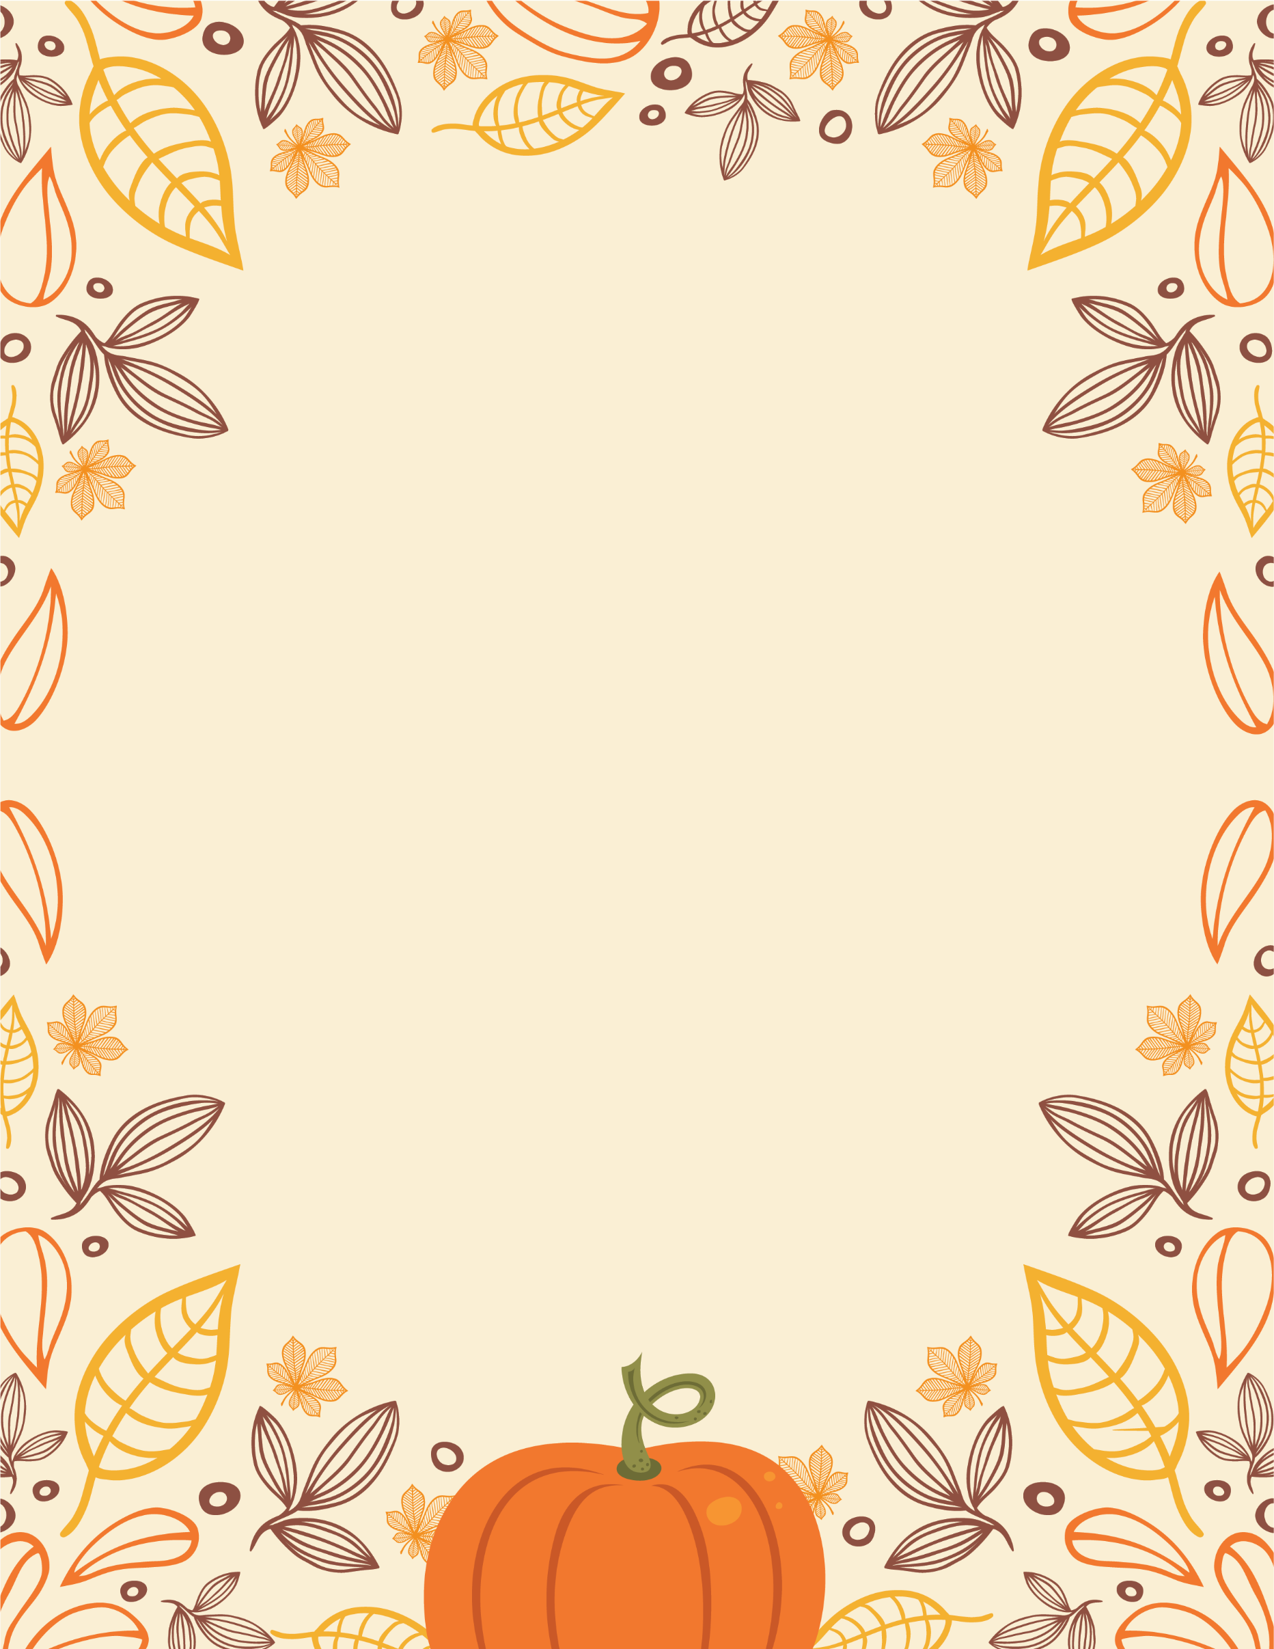

Get ready for a

FALL HARVEST

CELEBRATION

November 26, 20xx at 7 PM

Join us in celebrating   
the fall harvest with friends,   
food, and more!

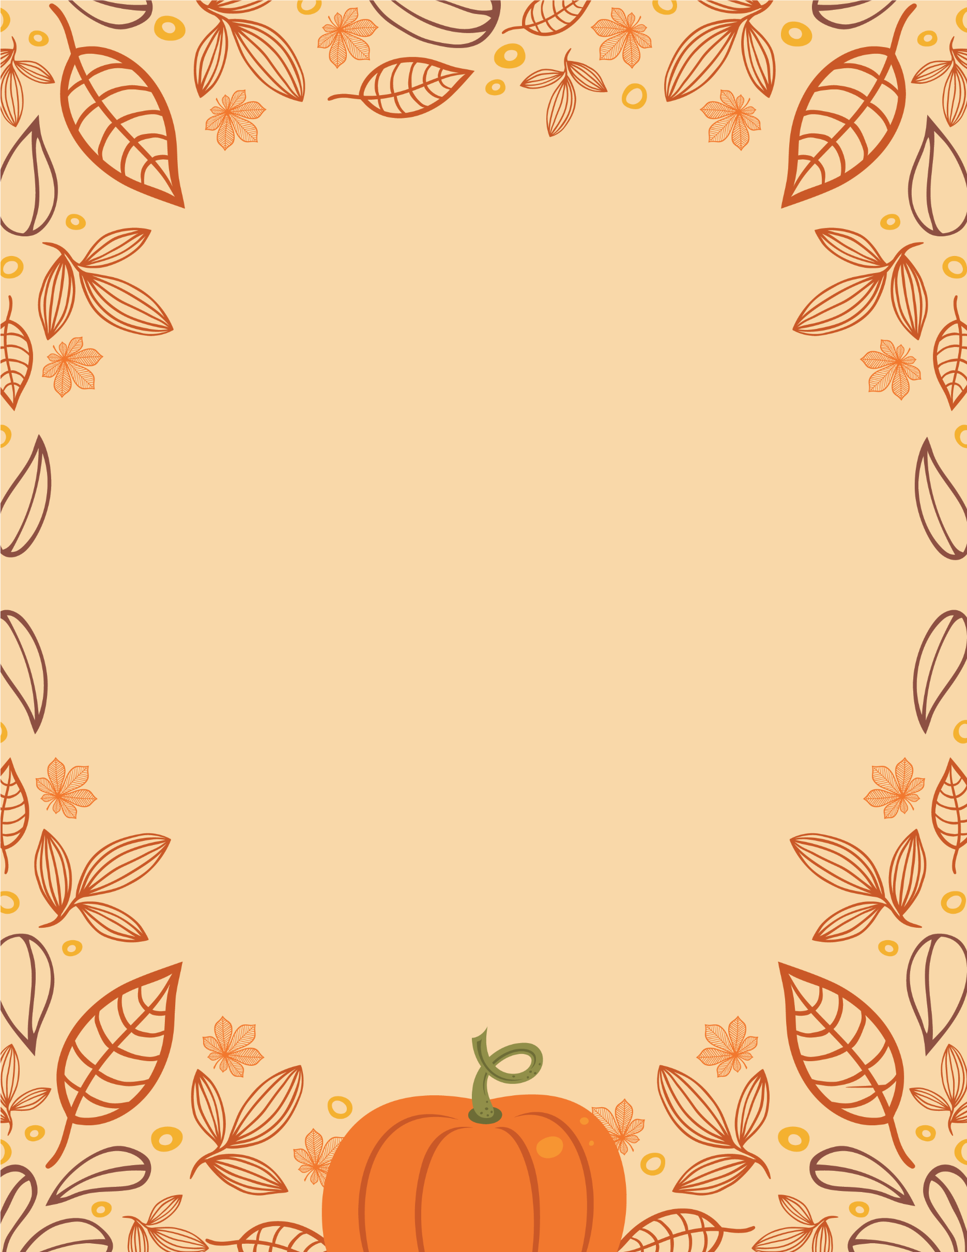

Get ready for a

FALL HARVEST

CELEBRATION

November 26, 20xx at 7 PM

Join us in celebrating   
the fall harvest with friends,   
food, and more!