## Model Part 4 EPOS: What it is and how it works

EPOS, namely Energy Plan Overlay Self-stabilization system, is a decentralized agent-based optimization engine to coordinate participants’ energy plans with respect to a certain energy utilization objective. In EPOS, an agent are defined as a software agent, which can automatically control the activities of a group of energy exchange devices, and alter its energy utilization based on the communication with other agents.

The main mechanism and structure of EPOS are:

1. Organize agent connection based on tree topology

EPOS builds up the agent-network in a tree topology. It automatically assign each agent to a certain level, on each level several agents belongs to an upper parent. In contrast to the conventional centralized optimization, EPOS does optimization in a decentralized bottom-up approach. In other words, each parent can locally coordinate the plan selection with its children and generate their best local aggregate plan to the upper level, till the global optimization complete.

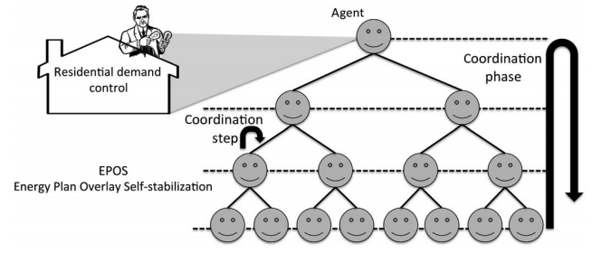

Figure Tree Topology of EPOS

(Source: POURNARAS *et al.*: DECENTRALIZED PLANNING OF ENERGY DEMAND FOR THE MANAGEMENT OF ROBUSTNESS AND DISCOMFORT)

1. Optimize based on exploited alternative plans:

EPOS assume that every individual software agent can exploit various energy utilization plans in a certain time period, such as the power consumption profile in next 24h. Each agent owns at least one plan and EPOS can only do the optimization by selecting available plans. As each household can define the plan generating strategy of its agent, the preference of each household can be fully respected and guaranteed.

1. Stabilize global energy utilization based on local adaption

To better reach a common goal of global energy utilization, such as the robustness and stability of a grid.

And based on its mechanism, EPOS possesses following advantages:

1. Compatible with power or Internet infrastructures

Compared to a centralized structure, the tree topology of EPOS is much more similar to the structure of Internet or grids in reality. Therefore, based on this structure , it is more promising to transform this visual engine into real-life application in the future.

1. Fast in a large scale optimization

Because the optimization workload can be distributed and localized in a smaller scale, EPOS can reach a much faster optimization speed compare to a centralized engine. It is a very crucial aspect of performance when considering the future size of a micro grid, which may contain thousands of households.

1. Privacy with distributed communication and decision making

As every parent can only “see” the aggregate plans of its closest children, the details of lower level decision process are naturally hidden. Therefore, the data privacy of individual plans can be guaranteed by this restricted data accessibility.

What EPOS do in our micro-grid model:

EPOS serve as a global optimization engine in our EV micro grid model. Based on our assumption and restriction of the charging patterns of electric vehicle, various daily alternative plans (charging kW in each minute) are generated. In order to functionalize EPOS in our model, the following works are needed.

1. Exploit alternative energy plans of each agent
2. Converse plan dataset into EPOS “.plan” input file
3. Design experiment, specifying variables and parameters
4. Run EPOS, obtain and interpret the results

[11] E. Pournaras, M. Warnier, and F. M. T. Brazier, “Local agent-based self-stabilisation in global resource utilisation,” *Int. J. Auton. Comput.*, vol. 1, no. 4, pp. 350–373, Dec. 2010.

[15] E. Pournaras, “Multi-level reconfigurable self-organization in overlay services,” Ph.D. dissertation, Dept. Multi-actor Syst., Delft Univ. Technol., Delft, The Netherlands, Mar. 2013.