**DATA OF THE WORLD BANK RELATED TO CLIMATE CHANGE**

**Name: Sai Sudheer Meka**

**Absrtract:**

In this report, I have explored public data of the World Bank specially country-by-country indicators related to climate change. So, I have manipulated the data using the Pandas Dataframe. I have explored some of the statistical properties of few indicators of the columns in the dataset. I have used Bar plot for the URBAN POPULATION GROWTH OVER DECADES and the results are displaced in the Result section. The improvements are given in the Conclusion section.

**GITHUB- Repository:**

**Implementation:**

* First, I have imported necessary libraries(NumPy, Pandas, Matplotlib, Seaborn) for the assignment.
* Then I have defined the function named read file which is used to get the data from the given link.
* In that function, Using the read_csv function in Pandas Library, I have extracted the file and from that I have extracted the Countries data which is relevant to the question.
* Now, I have defined another function named mean_growth, to find the mean and standard deviation of the given column.
* In the mean_gowth function itself, I have used different methods like:- transpose().
* Now I have defined the function bar_graph which gives the relation between the Countries anfd the Percentage of Population growth.
* The bargraph is for 5 years [1971,1981,1991,2001,2011] with x-axis as Country Names .\
* After the I have defined the Correlation_graph which tells about the correlations between the indicators.
* In that I have used the heatmap for the correlation between the few indicators for the country CANADA.
* The results of the both the graphs were discussed in the results section.

**Results:**

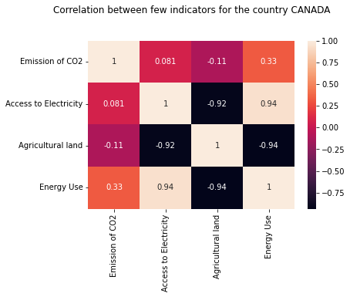

**Heat map of few indicators for the country CANADA**

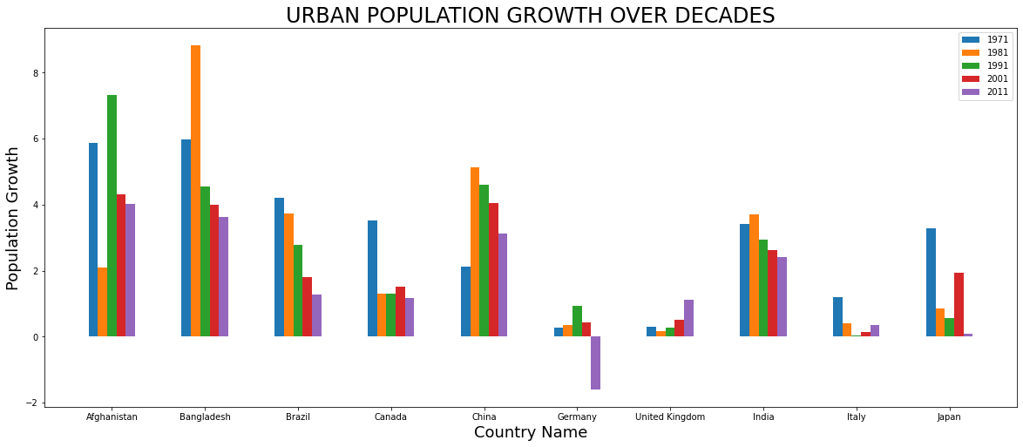

**Bar Graph Representing the Urban Growth OVER Decades**

**Conclusion:**

Overall, it was very great experience to do this assignment, for the assignment we can learn the how to used Heeat map for which process. In Graph data we can seen that Bangladesh has higgest Bangladinesh