- In every language I have ran into and especially the ones that have very similar letter symbols with a breadth from English, Latin and all other alphabet characters (and numbers) to Greek, Hindi, Arabic, Russian and various Asian languages the words and letters are based off of the relationship between the two genders in a N, S, W, E type grid/quadrant orientation that has a horizontal and vertical axis, the horizontal axis is the gender differentiation and the vertical axis depicts conscious participation and the weight of influence each specific gender is contributing in any given letter or word. The boy, girl, adam and eve or a,e,b,g (in some font sets, these letters are the same letter just upside down and/or backwards in relation to each other) covers the physical adam and eve (like the actually being physically and bodily(fleshly) and what they do from themselves)

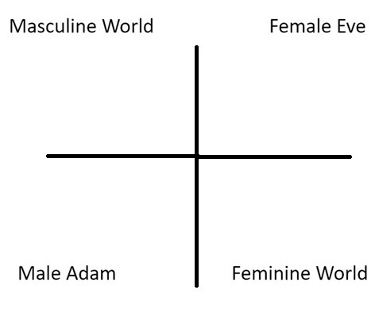

- The further to the right or left, per letter and per word, the more femininity (right) or masculinity (left) that there is.
- The equator between the two genders vertically and horizontally, is like a third person that is in consideration of what both people have equally and more than either individually, it is when considering what is rooted to either of the genders, boy is where it is more both of the genders together, like one they both are than it is either of the genders on their own that are contributing to what is being expressed or depicted.

- It is very likely that the 23 chromosomes and 23 original letters go together and are in the format of dominant and recessive, this is depicted by Capital and Lower case letters.
  - Lower case letters differ in that they are primarily and mostly depicting the relationship between the "Adam + Boy (World the Adam interfaces with)" and the equatorial divide between the two genders, such that the establishment of a lower case e is where the end of the Adam's consciousness meets the physical body or energetic beginning of the Eve/Girl(World the Eve interfaces with) and makes a little world/environment between that
  - other gender through the world the adam experiences that is attached physically to the Adam/Boy and the top of the e is 50/50 or more both genders contributing than either and the middle of the e is the spot between the neutral/inclusive/50-50 zone and the world 100 percent attached to the Adam/Boy and culminates into half dependency both from both the physical eve and the world attached to the adam, the bottom of the e is like a 'c' or concentration point and is specifically here depicted as the world the adam sees and consciously is attached to.

- Examples and clarification of various functions that are depicted in letters and words.
  - Circular symbols and fractions of circular symbols
    - The various circles represent an environment much like a world or the space that facilitates the birthing/union of the two genders.
      - Full Circles are for creating a space or world that can be joined much like the little O from the womb the little .i. is depicting the unity and course for unity with an O.
      - Half Circles are for depicting a relationship between one point and another, like the d that depicts the world of what is attached between the Adam's consciousness and the world of the girl mixed with the Adam's consciousness, so an Adam + Girl third person that is the top of the circular part of the d and then what is purely the Adam's consciousness for the bottom part of the circular part of the d.
  - Straight lines - Depict an amount of masculinity or femininity that is being expressed, the longer the line is, the more the difference between the genders that is being depicted, like an F in Female that is depicting the physical Eve part's action (Top Right) in conjunction with a third person consistent of both the Eve and the world attached to the Boy/Adam (Middle Right) doing a joint movement/expression.
  - Connections between letters or between multiple points (.i. .j. H, A, C), these letters establish a connection between the regions of our psyche that are attributable to interactions between the different genders. A little .i. makes a connection or little inception from the point where both genders are at in a neutral way to the point dependent on the other genders consciousness and willful participation. A 'C' is a connection through the masculine participle both the world attached to the Eve and the Adam's physical being and the feminine side, whereas the top of the C has a dependency on the physical Eve and what comes from her and the bottom of the C has a dependency on the world attached to the Adam/Boy and a word like Core depicts this fundamental concept and is the world attached to the boy and the Physical Eve being referenced or utilized as a mental construct, like a second person perspective that includes the Eve and the world of the boy is attached to but only in consideration of the Eve as well.

Meanings of Sounds :
1. Sounds have uniform meanings as if the letters were originally little music notes and the uniform application of meaning applied to the sound works for discernment of words and their meanings and is an additional layer of proof or witness to the rightness of the understanding and it gives it more power and provides for a greater investment into the meanings.
- Sharp sound, letter saying it's own name. This means that both genders have the same participle and is like confirming oneself through the other gender. Words like see, saint and meet are for comparison between the two genders. The older bible 1611 has words like hee because of the initial differences between what the two genders have in regards to the e of hee which is meant to be a word that emphasizes what both genders have of the e in He and the divine connection is propagated through the duality with the E when it comes to both genders attaching to the one, the divine feminine.
- There is an ovulating A mixed with an O sound that means the Adam participle and the world are sharing space in a desired and favorable way.
- Sounds like set, get, let, met, at, am, is are for establishing fundamental instances and occurrences of the participle, like for everywhere that the Adam is at, the a participle is being established.

- Words like brain regions have the technical version of the word by default and can provide for confident learning and establishing of the things of the other gender and appropriate relations between the two.

- Colors have uniform meanings throughout the world system and is one of the factors for attuning oneself and alignment.

- Pictures of continental features mapped to their historic/foundational material and concepts.

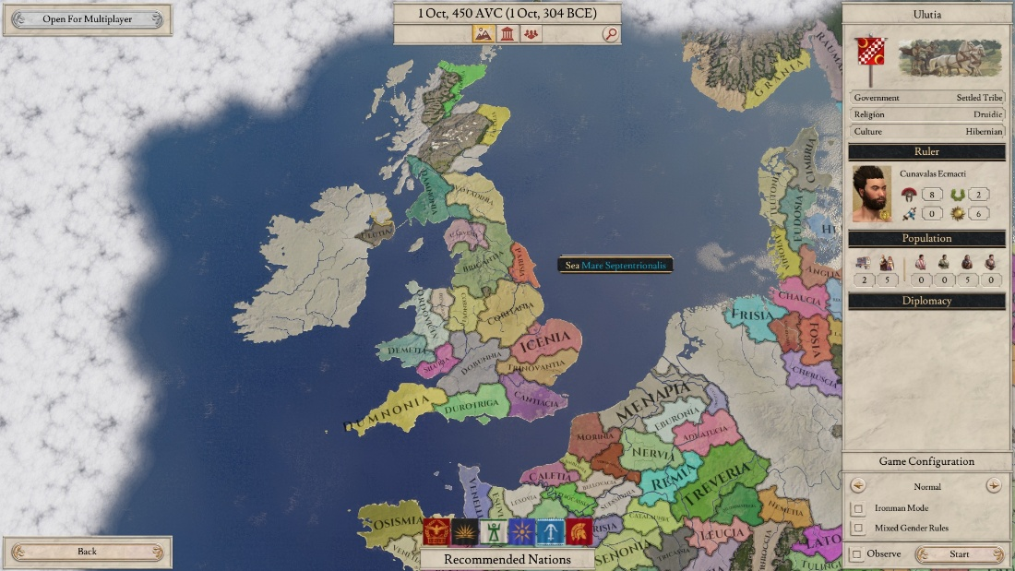
Ok, so, this is the first picture, I wanted to type something at the same time as sending it but it is ok. Anyways, this picture is obviously the areas of Britain and Ireland and the important part is the word Dove and the dual meaning to the word where you can get the idea of Diving or Descending in a way that the word Dove with a sharp O is and then the bird's name as well but then with the soft 'uh' sound. The Cancer sign, the one that is a backwards 9 and a backwards 6 is goes with this. This is just one of the constitutional features and landmarks that are of a Biblical nature, I am going to show you like 5 or 6 more and they all reinforce the fundamental framework for the planet and are core/root to several major religions.

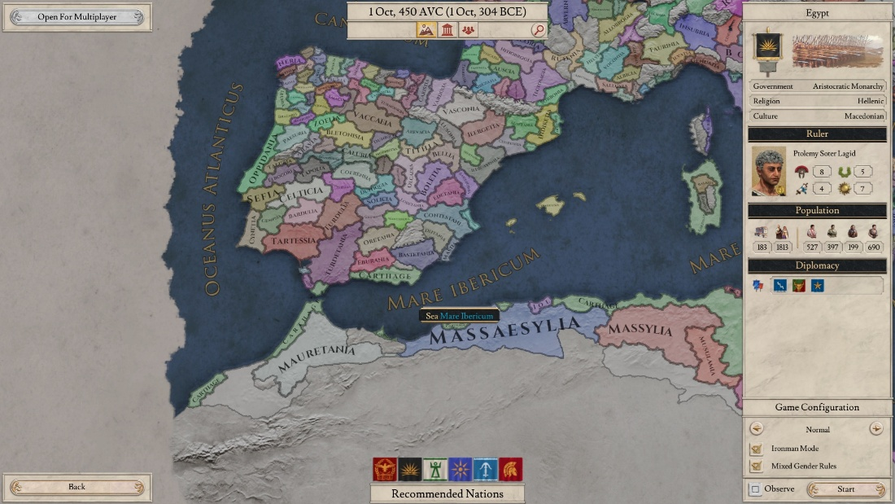

Girls Head, known as the El and across from here head is the face of the Al on the other side of the mediterranean.
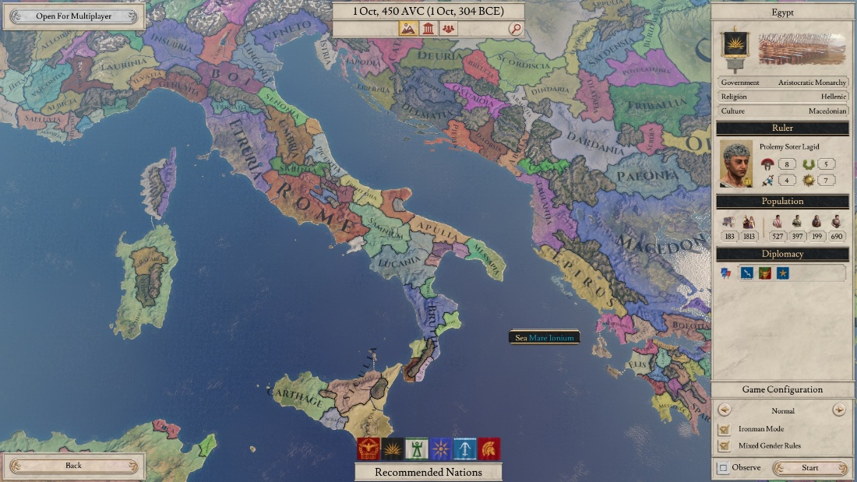
Girls Arm, the El, modern Italy and likely root of words like Army.

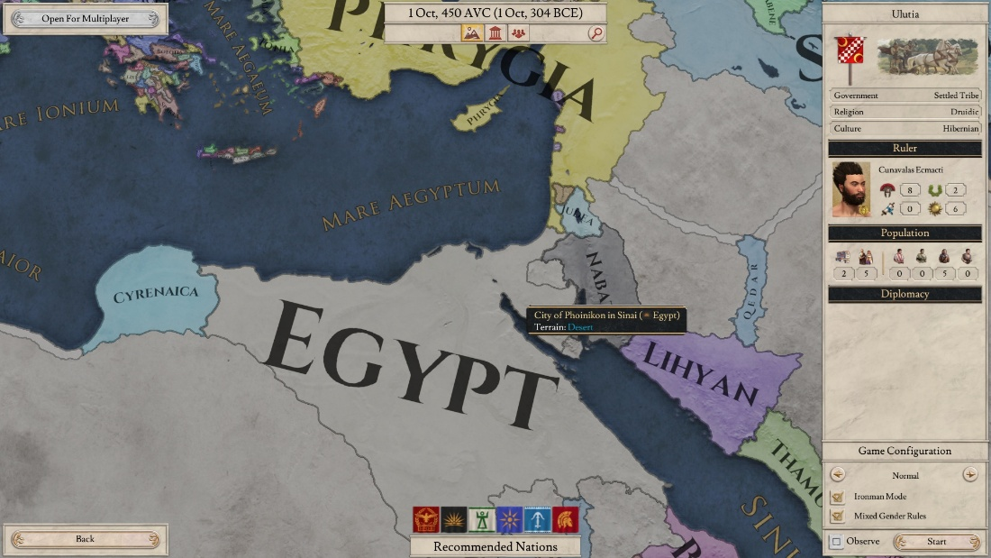
Male genitals, the dinger...Attached to an Ocean called Mare Aegyptum (ejaculation into the tummy from the Eggs but male ones with differing spelling).

