## Maze API

.NET

2024

## Solution

Maze.API is the main project. The project provides services to download data from the Maze API to the database and display downloaded data from the database.

• /Show/Download downloads the show information from the Maze API for given id

• /Show/Display displays the show information for given id

The API implements Open API. When the project is started the page is shown which allows methods to be tried.

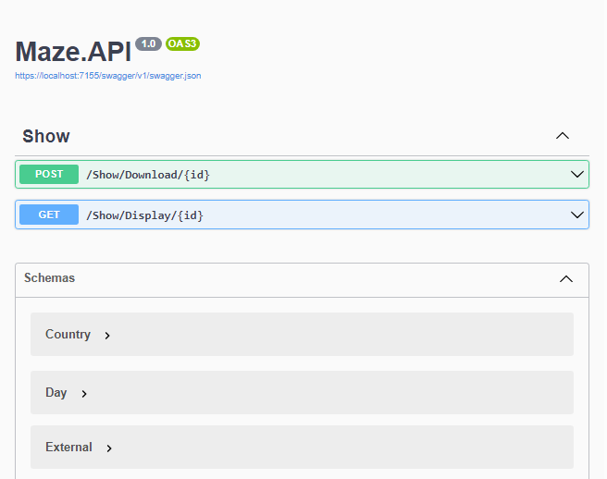

## Architecture

The solution uses **Service Oriented Architecture**, functionalities are implemented as services. **Unit of work** design pattern is used, every service does only one thing. **Data centric** architecture is used, the data has a central role and the services are centered around data.

## Technologies

• .NET 8.0

• C#

• API

• LINQ

• Entity Framework Core

• SQL Server

## User Secrets

Open **User Secrets** and add authorization to secure API and the connection string to the database in projects Maze.API and Maze.Test.

• **Authorization**, used in the Authorization header for the Download method. Authorization scheme is **Basic**.

• **ConnectionString** to connect to the database. Specify connection to SQL Server.

## Database

The project includes the model to build the database. Open **Package Manager Console** and enter the following command.

Update-Database

This will build the database specified in the connection string.

## Projects

Maze.API

The main project provides API services and authorization.

Maze.Database

The database project provides services to store data in the database.

Maze.Integration

The integration project provides services to get data from Maze API.

Maze.Models

The project provides integration data models and models to store data in the database.

Maze.Orchestration

The project provides services to orchestrate integration and database services.

Maze.Test

The project provides tests to test download and display.

Swagger

The project provides Open API support.