# Cashier Application (POS System) for CRISTY’S LOVE BURGER HUB

Shadip Kumar Joshi

B.Sc. (Hons.) Computing, Softwarica College of IT and E-commerce, Coventry University

ST4008CEM: Computing Activity Led Learning Project 1

Giriraj Rawat

July 26, 2022

# TABLE OF CONTENTS

Cashier Application (POS System) for CRISTY’S LOVE BURGER HUB 4

Login 4

Registration 6

Edit Data 7

Conclusion 10

# TABLE OF FIGURES

Figure 1 5

Figure 2 5

Figure 3 6

Figure 4 6

Figure 5 6

Figure 6 7

Figure 7 7

Figure 8 8

Figure 9 9

# Cashier Application (POS System) for CRISTY’S LOVE BURGER HUB

Aim of frontend is to build a GUI that is simple, user-friendly, interactive, and efficient in order-taking using python’s Tkinter library. GUI adheres to prototypes created in design phase of modern-waterfall SDLC.

# Login

This page facilitates login of employees to their respective accounts. The application starts with “MANAGER LOGIN” (as in Figure 1), where only managers can login by inputting their respective login-credentials. A successful sign-in directs to “STAFF LOGIN” (as in Figure 2), whereas invalid entry of data prompts error pop-up message. Staffs can also access their accounts in “STAFF LOGIN” with correct login-information. New employees can be registered via “REGISTER” under superior’s authorization in their respective page.

“INFO” retrieves data of registered staffs while “EDIT” permits modification of their respective details in database after authentication. Superiors can access database if staffs under them forget their pin to reset it. They also have power to delete record due to resignation of a staff. In “MANAGER LOGIN” page “PRODUCT” informs about available restaurant menus while “QUIT” exits the whole program. Likewise, clicking “LOGOUT” sign-outs active manager, thereby returning to the default starting login page.

Figure 3 presents codes of “MANAGER LOGIN”.

### Figure 1

*Manager login*

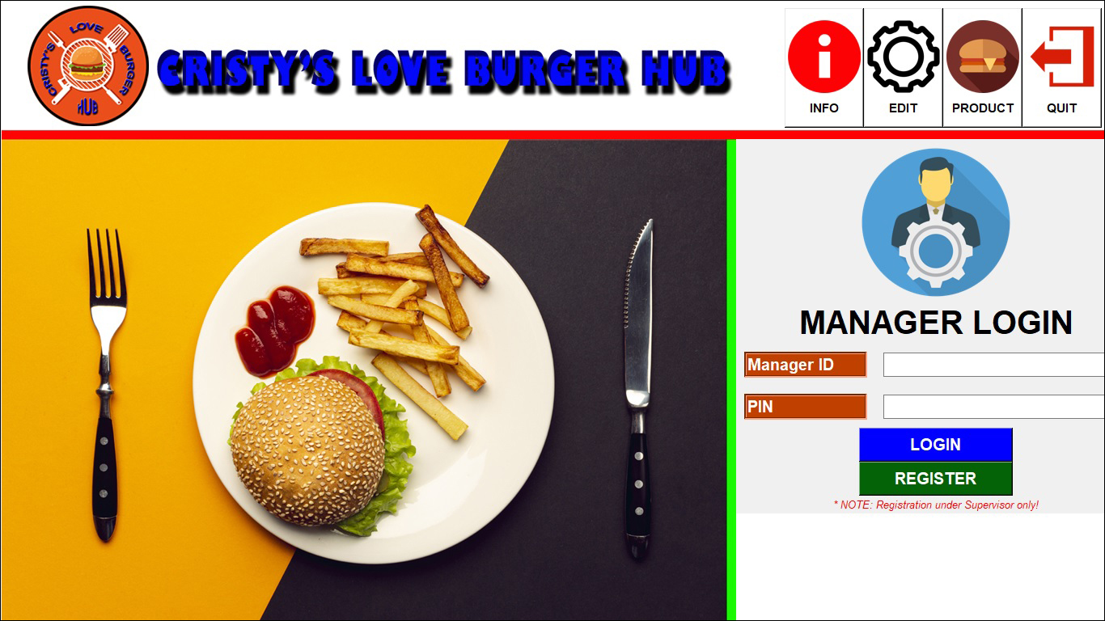

### Figure 2

*Staff login*

### Figure 3

Codes of *manager login*

# Registration

This page provides interface to add new employees to database. If two pins match, “REGISTER” prompts “Success” message”. This page also has “BACK” button to return backward if no registration is needed. Figures 4, 5 and 6 represent registration of manager and staff, and their coding respectively.

### Figure 4

*Manager Registration*

### Figure 5

*Staff Registration*

### Figure 6

Code of *Manager Registration*

# Edit Data

Employees can update their individual information and save it in system by clicking “UPDATE”. Furthermore, superior can also edit or delete staff’s data using “DELETE” if necessary. This page provides “BACK” button to return to the previous page. Figures 7, 8 and 9 represent edit page of manager and staff, and their source-code respectively.

### Figure 7

*Edit manager data*

### Figure 8

*Edit staff data*

### Figure 9

Code of ‘*Edit Manager Data’*

# Conclusion

Concepts and logics taught in classroom are fully utilized by applying Tkinter tools in Python to build a working GUI according to SRS document and prototype. It focuses mainly on UI of two-stage secure login and order-menu to solve problems of traditional ordering-system in restaurants. I chose GUI because of my interest in graphics.

Due to my inexperience as newcomers in IT, many individual UI(s) for secure login expended lots of my time and effort. Though this was tiring, I recognized my shortcomings. I consulted internet, my instructor and concerned books when help was needed. In future projects, research focusing on integrating all functionalities in single interface will be kept in mind. I will amass experience by coding more GUI in my daily life. This endeavour to learn by continuous practice without being discouraged is my strength. This project has taught me that visual interface is easier than texts. I will use more visual reading methods in real life.

Creation of this software has enriched my experience, knowledge, teamwork, and problem-solving skills. It has validated practicality of theoretical knowledge in IT field. It enlightened me that problem solving means finding alternative solutions when one method doesn’t work by thinking smarter.