# Cashier Application (POS System) for CRISTY’S LOVE BURGER HUB

Shadip Kumar Joshi

B.Sc. (Hons.) Computing, Softwarica College of IT and E-commerce, Coventry University

ST4008CEM Computing Activity Led Learning Project 1

Giriraj Rawat

July 28, 2022

# Table of Contents

Cashier Application (POS System) for CRISTY’S LOVE BURGER HUB 4

Introduction 4

Login page 4

Registration page 8

Edit Data page 11

Version Control 13

Conclusion 14

# Table of Figures

Figure 1 5

Figure 2 5

Figure 3 6

Figure 4 8

Figure 5 9

Figure 6 10

Figure 7 11

Figure 8 12

Figure 9 12

Figure 10 13

# Cashier Application (POS System) for CRISTY’S LOVE BURGER HUB

# Introduction

Objective of this frontend is to build a simple, user-friendly, and interactive ‘*Login-Registration-Modification’* GUI for employees in *Point of Sale (POS)* system using python’s Tkinter tools. GUI adheres to prototypes from design phase of modern-waterfall SDLC.

# Login page

It facilitates login of employees to their respective accounts. ‘MANAGER LOGIN’ in figure 1 is for managers and ‘STAFF LOGIN’ in figure 2 is for staffs. New employees can be registered via “REGISTER” under superior’s authorization in their respective page.

“INFO” button retrieves data of registered staffs through .treeview() in tabular format while “EDIT” permits modification of their respective details in database after authentication. Superiors can access database if staffs forget their pin and reset it. They also have power to delete record due to resignation of a staff. In “MANAGER LOGIN” page “PRODUCT” informs about available restaurant products while “QUIT” exits the whole program. Likewise, clicking “LOGOUT” sign-outs active manager, thereby returning to the default starting login page.

Figure 3 presents codes of “MANAGER LOGIN” page.

### Figure 1

Manager Login

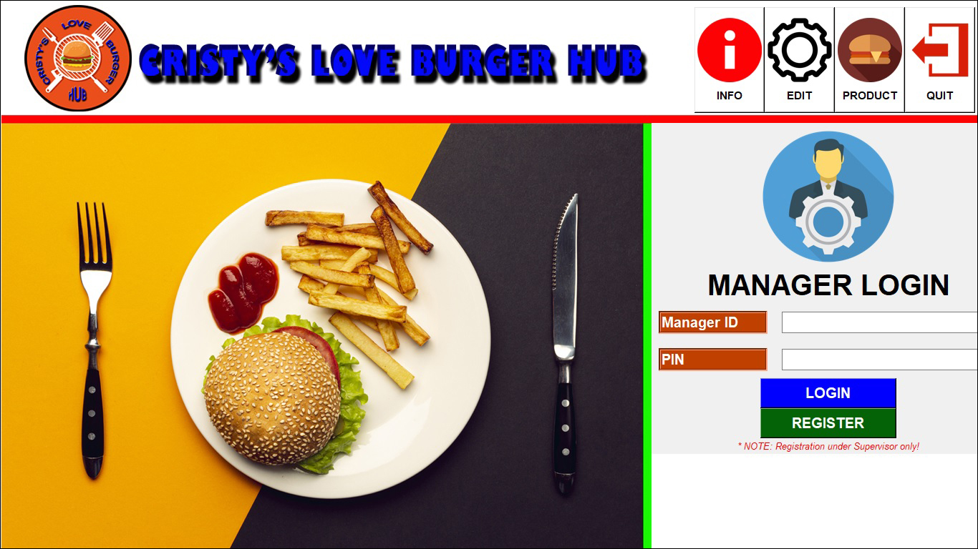

### Figure 2

Staff login

### Figure 3

Login code

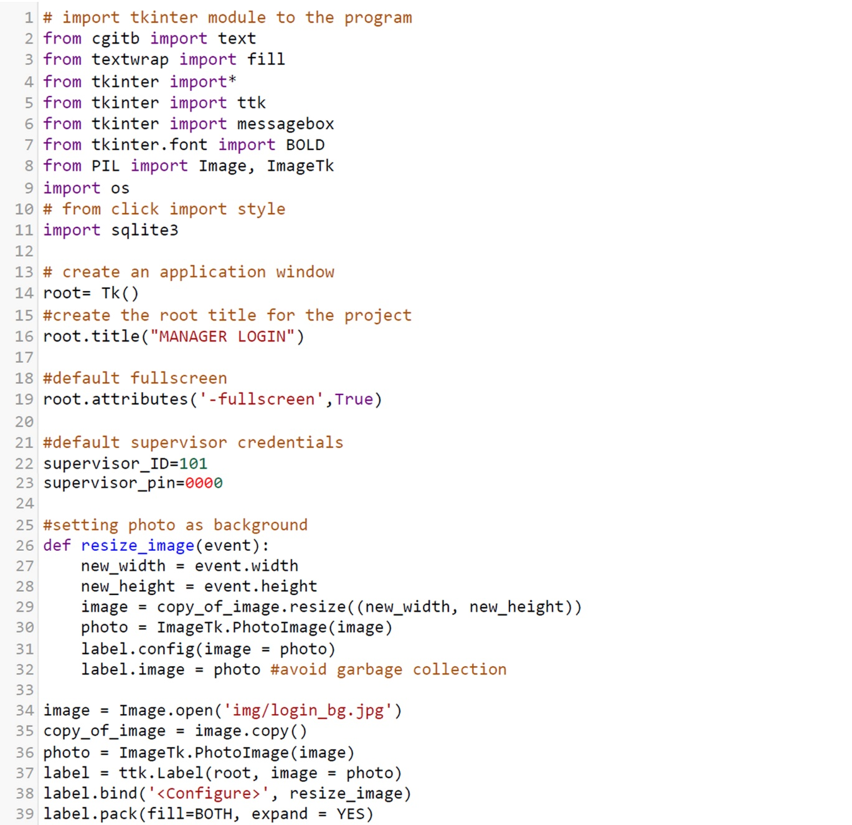

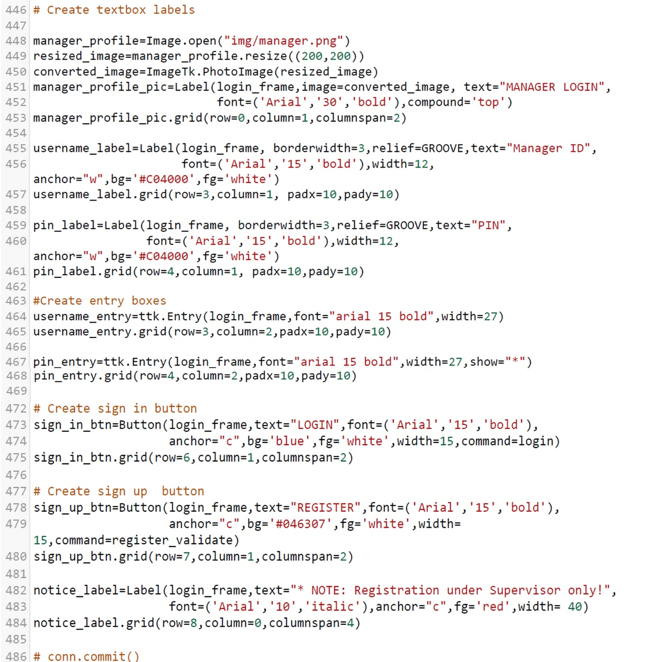

# Registration page

It provides interface to add new employees to database. If all fields are filled with valid data, “REGISTER” prompts “Success” message. It also has “BACK” button to return backward if no registration is needed. Figures 4, 5 and 6 represent registration of manager and staff, and their coding respectively.

### Figure 4

Manager Registration

### Figure 5

Staff Registration

### Figure 6

Registration code

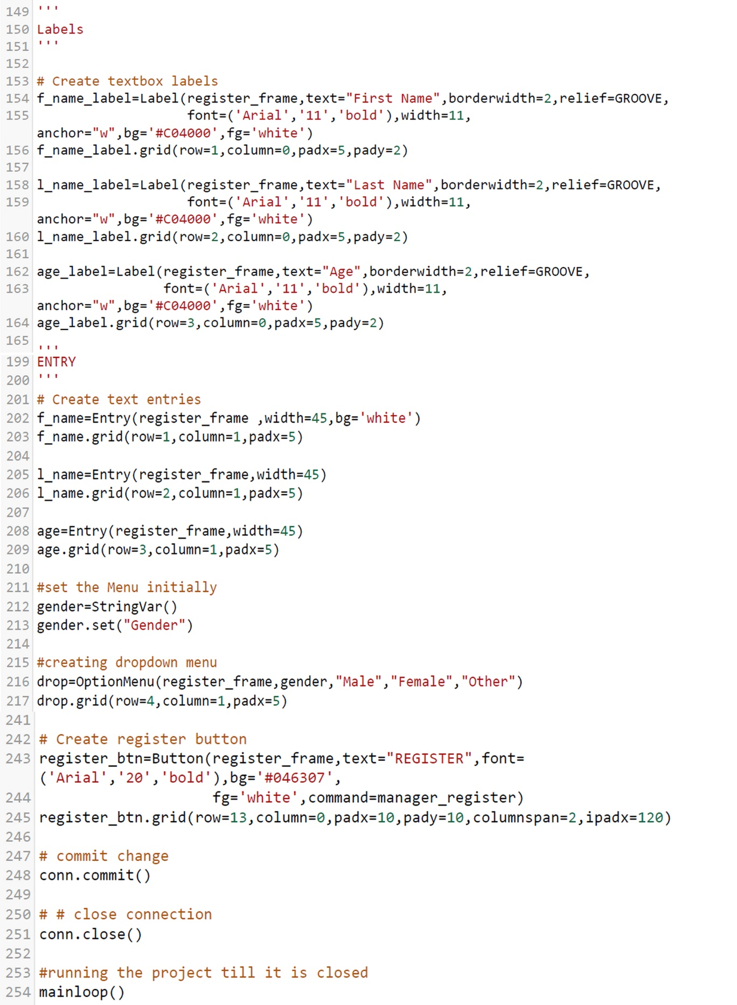

# Edit Data page

It provides UI for employees to update their individual information and save it in system by clicking “UPDATE” button. Furthermore, superior can also edit or delete staff-data using “DELETE” if necessary. It provides “BACK” button to return to the previous page. Figures 7, 8 and 9 represent edit page of manager and staff, and their source-code respectively.

### Figure 7

Edit manager Data

### Figure 8

Edit Staff Data

### Figure 9

Edit Employee Data code

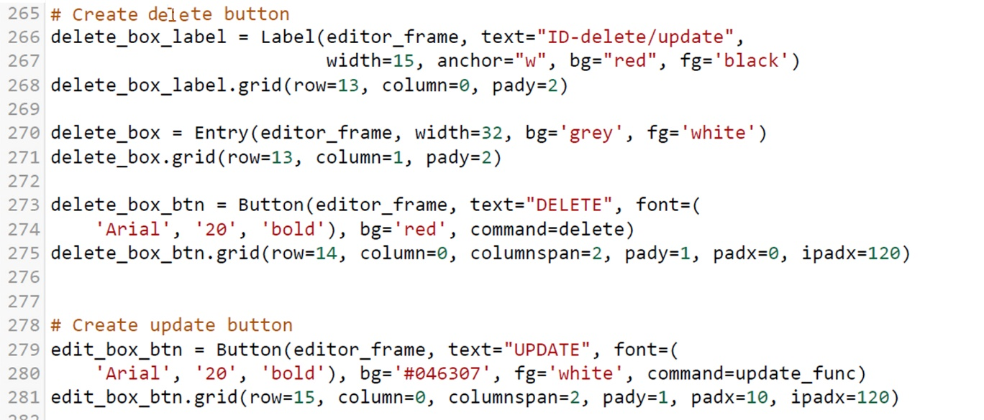

# Version Control

**Github:**<https://github.com/softwarica-github/st4008cem-cw-32a-cristy-s-love-burger-hub-3.git> as in figure 10.

### Figure 10

Github commits

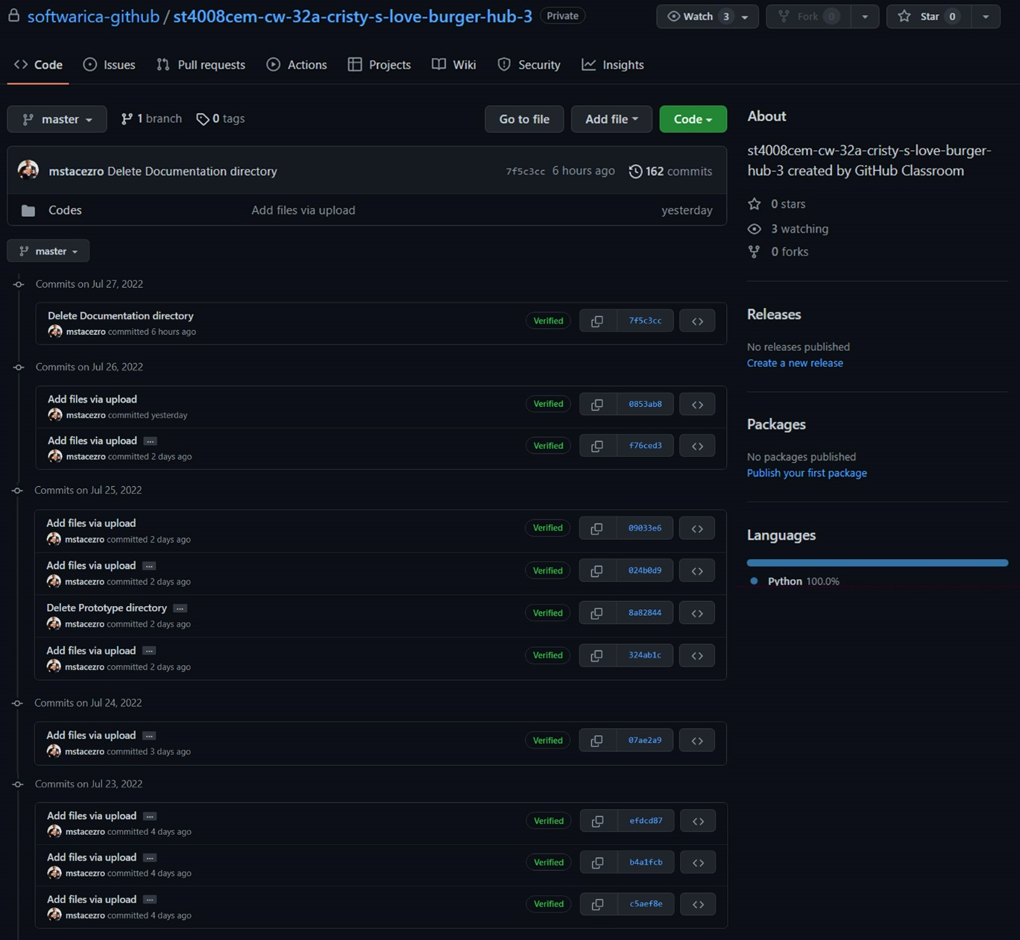

# Conclusion

Concepts of Tkinter tools taught in classroom were fully utilized to design an attractive GUI for data-entry according to SRS document and prototype. Science has proved that colours influence mood. I want my users to be in good mood while using this POS, so I focused on combining simplicity with aesthetics, and popping bright-warm colours to counter outdated classic POS-designs in market. The GUI is simple enough for connection to backends. I chose GUI because of my expertise in graphics.

Due to inexperience as first-timer in coding, many individual UI(s) for secure login expended lots of my time plus effort. Though tiring, I recognized my shortcomings; consulted internet, instructors and concerned books for help. In future projects, research on functionalities integration in single interface will be prioritized. I will amass experience by coding more GUI in my daily life. This endeavour to learn by continuous practice without being discouraged is my strength. This project taught me: *A* *working software is a good software, however a working software focusing user is a better software.*

Creation of this software enriched my experience, knowledge, teamwork, and critical thinking. It has validated practicality of theoretical knowledge in IT field, enlightening me that problem solving means thinking smarter to find alternative solutions when one method doesn’t work.