Evansville Day School Relay Web-App
Django Powered Web Application

Version 1.0

Revision History
11/02/15 | 1.0 | Initial Documentation & Basic design details for Web Application | Matthew Stagg, Carson Doades, Dan Bean, Zach Peak, Justin Hopkins

Table of Contents
1 Introduction 5
1.1 Purpose 5
1.2 Scope 5
1.3 Definitions, Acronyms, and Abbreviations 5
1.4 References 5
1.5 Overview 5
2 System Overview 6
3 Design Considerations 7
3.1 Assumptions and Dependencies 7
3.2 Constraints 7
4 System Architecture 8
5 Design Details 9
5.1 Web Application 9
5.1.1 Static Structure 9
5.1.2 Behavior 10
5.1.3 User Interface 12
5.1.4 Data Structure 12
5.1.5 Dependencies 12
5.1.6 Components 12

Software Architecture Document

Introduction
This is the System Design Document for the Software Development CS 478 Web Application project.

Purpose
The Software Design Document captures the design constraints and assumptions as well as the detailed design of the subsystems and components of the application.

Scope
This Design Document pertains to the Evansville Day School Relay project, with a specific focus on the features and capabilities being implemented in version 1.0.

Definitions, Acronyms, and Abbreviations
See Glossary Document.

References
Software Requirements Specification.

Overview
This Design Document is divided into five major sections. Section 1 is an Introduction that provides information about the document itself. Section 2 is an overview of the application and its primary functionality. Section 3 identifies the assumptions and constraints followed during the design of the software. Section 4 documents the overall system architecture. Finally, section 5 provides the detailed design information for each subsystem and component in the current delivery.

System Overview
LAMP is an open source technology stack consisting of the Linux OS, Apache web server, MySQL database software, and PHP. In this case, however, PHP is being replaced with Python 2.x. Python is an interpreted scripting language that powers the Django web framework. The project uses Git for version control and production deployment.
Django is a python web framework that loosely adheres to the Model-View-Controller (MVC) design paradigm. It handles most backend functions that will be implemented server-side, including user sessions, encryption, REST API integration, database interaction, and dynamic HTML page generation.
The aim of the project is to create a web application that allows school administrators to quickly communicate with students. Users register their phone number in a database, which will then be added to certain mailing lists. Special users (defined here as teachers) can send out mass text messages to each number in a mailing list that is assigned to them, this creates a quick and simple way for a school to communicate with parents (defined here as users). Special administration accounts (defined here as admins) will have the power to adjust certain aspects of the system, such as the logo and grant users privileges. The web app can be accessed from any computer with internet access and a browser.

Design Considerations
This section contains all of the assumptions, dependencies, and constraints that were considered during the design of each subsystem and component.

Assumptions and Dependencies
The Web Application is dependent on the SQL backend because the web application cannot work without the data from the SQL backend and vice versa.

Constraints
User of the app should have internet access and a browser of some sort
The app is hosted on a home server with a dynamic IP, meaning max user load will be low
Due to the educational nature of this project and the fact that all data is fake or unimportant, there is no encryption or security measures (except for protection against SQL injection)

System Architecture

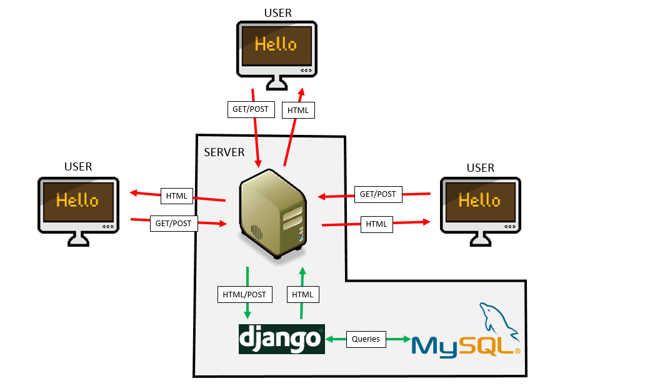

Design Details

Web Application

Static Structure

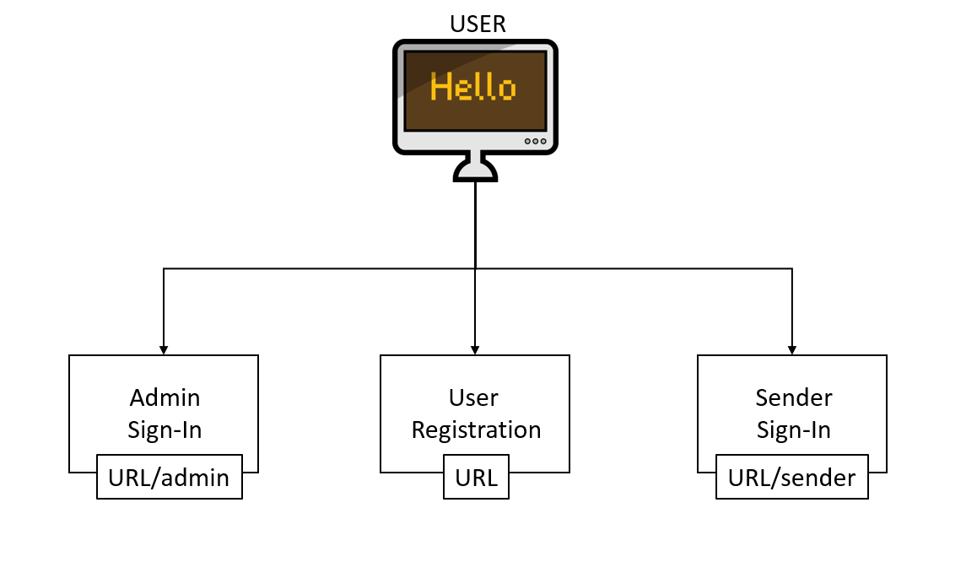

Behavior
- Admin Access

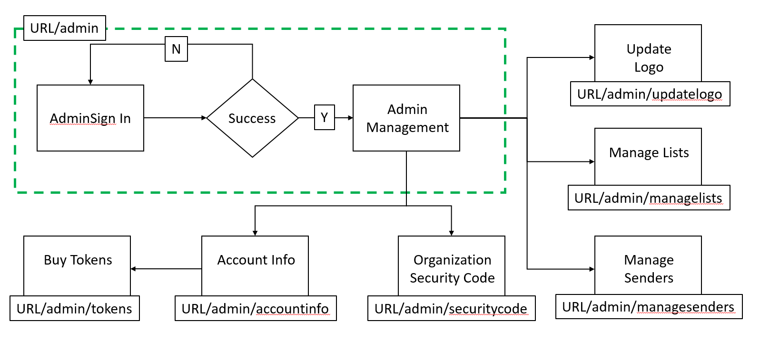

- Teacher Access

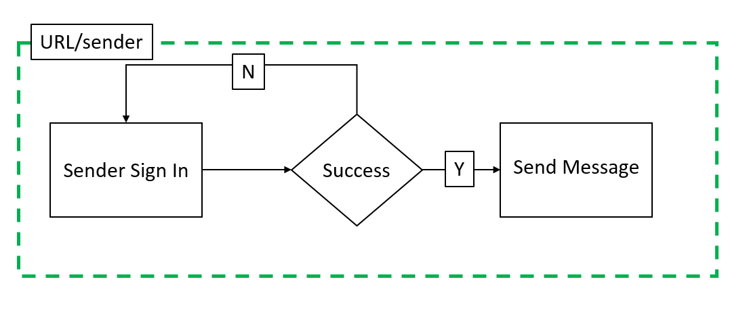

- User Access

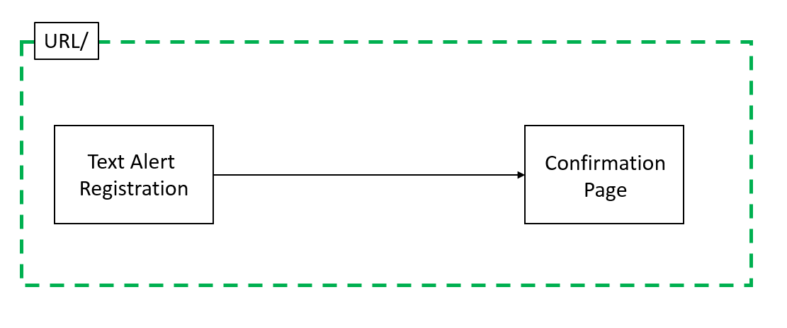

User Interface

SEE MOCKUPS FOLDER

Data Structure
All provided by Django web framework. Accessed through model interface. No hand rolled data structures or algorithms needed.

Dependencies
None.

Components (DJANGO APPs)

Admin
This app manages admin login and all admin functions

VIEWs
- adminLogin – Manages admin logins and access to admin functions
- updateLogo – Updates the site logo
- manageLists – Create, delete, and edit existing sender lists
- manageSenders – Create, delete, and edit existing senders
- securityCode – Manges optional security code needed by users to sign up for service
- accountInfo – Shows message history and allow admin to purchase more tokens
- tokens – Used to purchase more tokens

Sender
- sender – Manages sender login and access to sender functions

User
- user – Allows users to sign up for mailing list

