**Introduction**

As ISIS has been pushed back from the territories they earned, other groups (some associated with ISIS) have moved on to different different countries and different continents. One of the continents that has had an influx in terrorist activity over the years is Africa. New branches of ISIS, Al-Qaida and new islamic terrorist groups have been formed and have been increasing in attacks and numbers. They have learned from the examples set by the Islamic terrorist groups based in the Middle East, and are improving their techniques. Determining the effectiveness of certain groups and their areas can be used to aid in determining how much of a threat they will pose into the future, without more intervention.

**Questions**

The questions that will be answered at the end of this report include:

* Which countries have the highest average in terrorist incidents from 2010 - 2018 (most recent available data)?
* Are terrorist groups in Africa becoming more aggressive compared to their Middle Eastern counterparts?
* What is the likelihood that African terrorist groups will increase in terrorist incidents and deaths without more intervention?

**Data**

The data used in this came from the GTD (Global Terrorism Database) from the University of Maryland: Study of Terrorism and Responses to Terrorism (START)

Due to the large amount of Islamic terrorist groups within the areas, the data has been condensed to include only the more reputable and violent terrorist groups in these regions, which include: Taliban, ISGS, ISIS, AQIM,Al-Qaida.

The below dataframe is to show the data that will be used in this report. In order to compare the countries in highest perecentage of increases in incidents, data from each country leveraged against the incidents over the years available to determine the percentage increase.

Determining the effectiveness of certain groups and their areas can be used to determine how much of a threat they will pose into the future.

Taking the countries listed below and combining them with the specific groups with the deaths to incidents to come up with the result of the groups and their counterparts' 'aggressivness'. For example, taking ISGS (Islamic state in the Greater Sahara) compared with the incidents with ISI/ISIL (Islamic state in iraq and Islamic state of Iraq and the Levant). ISI and ISIL are the same group, but their ISI became ISIL as they gained more territory, ISIS is also the same group for reference.

Comparing all of the incidents and deaths by region, and groups that occupy their regions, to determine which regions (Sub-Saharan Africa, South Asia, Middle East, North Africa) are becoming more violent.

**Results**

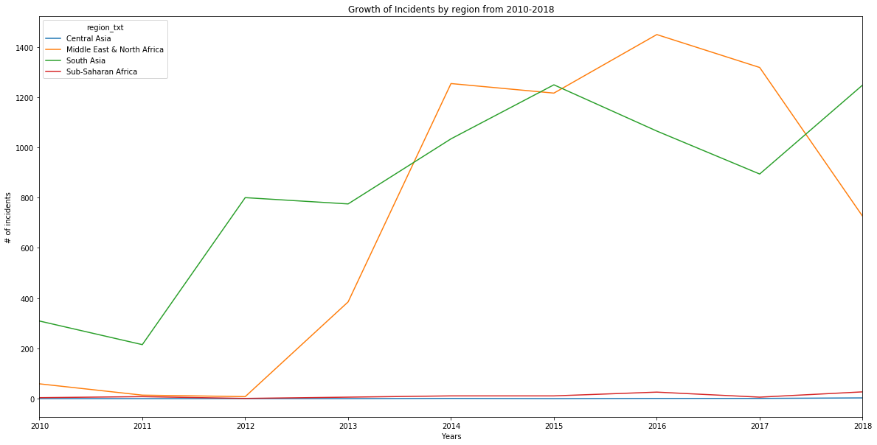

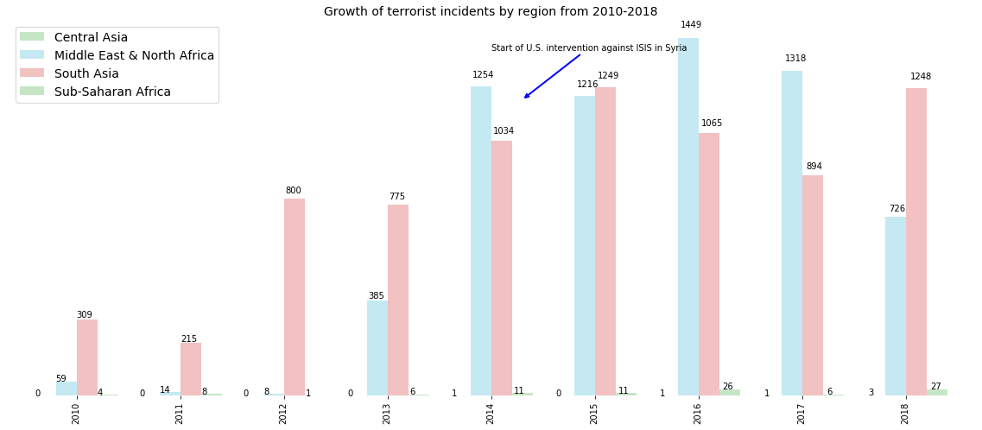

As you can see in the above results, according the bar graph, the North African and Middle Eastern terrorist groups as soon as the U.S. started pushing against the ISIS rule in Syria and Iraq, groups in North Africa and the Middle East skyrocketed from 2013-2014.

Following the increase in incidents in North Africa and the Middle East you can see that it was increasing but has started to decrease in 2018. There is high negative percentage in growth of deadly incidents. More data will be needed to determine the deadliness of these groups, since they have only been reputable over the past few years

**Conclusion**

Terrorist groups in North Africa and the Middle east are just as nearly as deadly in South Asia, but they are not regarded as to as high as the ones in South Asia. It took only a couple of years for the groups in North Africa and the Middle east to get to the same level as incidents in South Asia. These groups show not be avoided, some pushback seems to be happening, but following the charts with the South Asian groups, is that they tend to fall a little and then come back with more ferocity. More data needs to be calculated to be able to determine the recklessness of these groups in the future.