     We have a functional pattern needed to have some modification by certain rule as follows:

 1. When seeing a train of  'L' or ‘H’ appearing after at least one  'H' or ‘L’, let the first 'L' or 'H' become 'X'.

          for example: “LHH” ==> “LXH” ; “L.....LH.....H” ==> “L....LX....H”

                             ”HLL” ==> “HXL” ; “H.....HL.....L” ==> “H....HX....L”

1. If 'L' or 'H' is switching , such as “...HLHLHL...” but not  ”HLL...” or “LHH...”, the replacement by 'X' is not allowed.
2. The rule is also shown by the picture at the end of this page.

**A.Please write a tool to finish this work to update the pattern and save as a new one.**

**B.Please prepare the following three files:**( [source_pattern_name] is the file name of the pattern I attached to you.)

1.**The source codes**: (For example, rulecheck.cpp)

     2.**The updated pattern:** Dump the result as a new pattern including the changed and unchanged part to a new file called a new name "[source_pattern_name]_rc".

     3.**The log out file:** Summarize the replacing times from 'HLL'  to 'HXL' and from ‘LHH’ to ‘LXH’ separately for each pin and list them out to a file called "[source_pattern_name]_rc_logout".  The log might like below:

PIN0 ‘HLL’ to ‘HXL’ : 100 times. ‘LHH’ to ‘LXH’: 80 times.

PIN1 ‘HLL’ to ‘HXL’ : 88 times. ‘LHH’ to ‘LXH’: 98 times.

PIN2 ‘HLL’ to ‘HXL’ : 75 times. ‘LHH’ to ‘LXH’: 95 times.

1. **Also note that:**
2. You can use one of your skilled computer language to finish your task.
3. Note that every vertical column  shows the time sequence from the first cycle to the last for each pin in the pattern (You can see it below). The attached file “pat_n”  is the one I gave you.

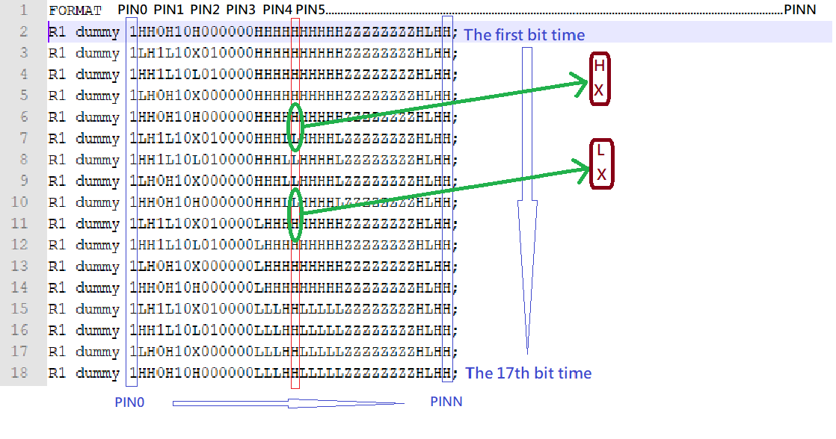

      Could you forward your **source codes** (C/C++/Python/Perl/VBA...) and **executing result** (including the new pattern and the log out file) before Friday as soon as you can get a chance to finish it? Thanks a lot.