Analyzing of The Relationship Between Schedule of Class and GPA of Class: Case Study for Bilkent University

Kemal Onur Güngör   
Department Of Computer Technologies and Information System  
University Of Bilkent  
Çankaya, Ankara  
onur.gungor@ug.bilkent.edu.tr

Göktuğ Yeşilyurt  
Department Of Computer Technologies and Information System  
University Of BilkentÇankaya, Ankara  
goktug.yesilyurt@ug.bilkent.edu.tr

***Abstract*—** **The timing of classes has long been a subject of interest and speculation among students, educators, and researchers. This study aims to explore the potential relationship between the timing of classes and the GPA (Grade Point Average) of the class. The investigation encompasses a comparative analysis of class timing (e.g., morning, afternoon, and evening) and its impact on academic performance, as measured by class GPA. To conduct this research, data were collected from a diverse sample of undergraduate students across multiple disciplines from Bilkent University offerings databases. The study design involved tracking the GPA of various classes over an academic year while considering the specific time slots in which they were scheduled. Statistical analyses, such as correlation and regression, were employed to examine the associations between class timing and GPA. This research offers insights into the complex dynamics between class timing and academic outcomes. The implications of the findings can inform educators and administrators in designing class schedules that optimize student performance and satisfaction. Future studies could delve deeper into the underlying mechanisms by considering factors such as individual chronotypes, sleep patterns, and personal preferences, to further refine our understanding of the relationship between timing of class and class GPA.**

Keywords—timing of class, class scheduling, GPA, academic performance, student engagement

# Introduction

The timing of classes has long been a topic of interest and speculation, as educators and students alike have wondered about its potential impact on academic performance. This study aims to explore the relationship between class timing and the Grade Point Average (GPA) of the class. By examining the associations between class timing (e.g., morning, afternoon, and evening) and GPA, this research seeks to provide insights into the factors influencing academic success. Understanding whether specific time slots are associated with higher or lower GPAs can inform educational institutions in optimizing class schedules to enhance student engagement and attentiveness. Additionally, students can make informed decisions regarding course selection, ultimately contributing to their academic achievement and overall well-being.

# Hypothesis

H1: Students attending morning classes will exhibit higher GPAs compared to those attending afternoon or evening classes. This hypothesis assumes that students may be more alert, focused, and engaged during morning hours, leading to better academic performance.

H2: There will be no significant relationship between class timing and class GPA. This hypothesis posits that class timing does not have a substantial impact on student performance, and other factors, such as individual study habits or instructional quality, have a more significant influence on GPA.

H3: The relationship between class timing and class GPA will vary across different disciplines. This hypothesis proposes that the impact of class timing on GPA may differ depending on the nature of the subject, students' preferences, and the cognitive demands associated with specific disciplines.

III. Methodology

Sample Selection: To participate in the study, a diverse sample of undergraduate students from various disciplines will be chosen. To ensure uniformity in terms of the curriculum, grading procedures, and institutional elements, the sample will be taken from a single academic institution.

Class Timings: The class times will be divided into two main categories: morning and afternoon. In general, morning classes are those scheduled from 8:00 AM to 12:00 PM, and afternoon classes are those scheduled from 12:00 PM to 4:00 PM. A thorough analysis of the correlation between class timing and GPA will be possible thanks to this classification.

Data Collection: For each class, pertinent information will be gathered, such as the course code, instructor, meeting time, and GPAs of the students. The university's class schedule will be used to find out when classes start and end, and its academic records will be used to access student GPA information. All information will be handled ethically and with anonymization. We excluded 2020 pandemic time data for our data integrity.

Statistical Analysis: To summarize the distribution of GPAs across various class timings, descriptive statistics will be computed. The appropriate statistical analyses will be carried out to investigate the relationship between class timing and GPA. To ascertain the magnitude and direction of the relationship between class scheduling and GPA, correlation analysis will be used. Additionally, multiple regression analysis will be done to account for potential confounding factors like course difficulty. instructor quality, and student characteristics.

Control variables: In addition to the timing of classes, additional pertinent factors that could affect GPA will also be taken into account. Student demographics (such as age, gender, and year of study), prior academic achievement (such as high school GPA), and course characteristics (such as credit hours and course level) are examples of possible factors. It will be easier to determine the precise impact of class timing on GPA when these variables are controlled for.

Limitations: It's critical to recognize the study's limitations. Although they might not be fully reflected in the data, factors like individual differences in sleep patterns, personal preferences, and outside commitments may have an impact on the relationship between class timing and GPA. Additionally, the study's results might only apply to the institution that was selected and not necessarily generalize to other academic settings.

By using this methodology, the study hopes to account for potential confounding factors while presenting empirical data on the relationship between class timing and GPA. The results will advance knowledge of how class scheduling may affect academic performance and assist educational institutions in designing class schedules that are as beneficial to students as possible.

IV. Descriptive Statistic

Descriptive analysis was done on the data that was gathered to get a general understanding of the connection between class timing and GPA. The dataset included data from a sample of undergraduate students from different academic departments at Bilkent University. These descriptive analyses offer a preliminary summary of the connection between class scheduling and GPA. *Table 1*

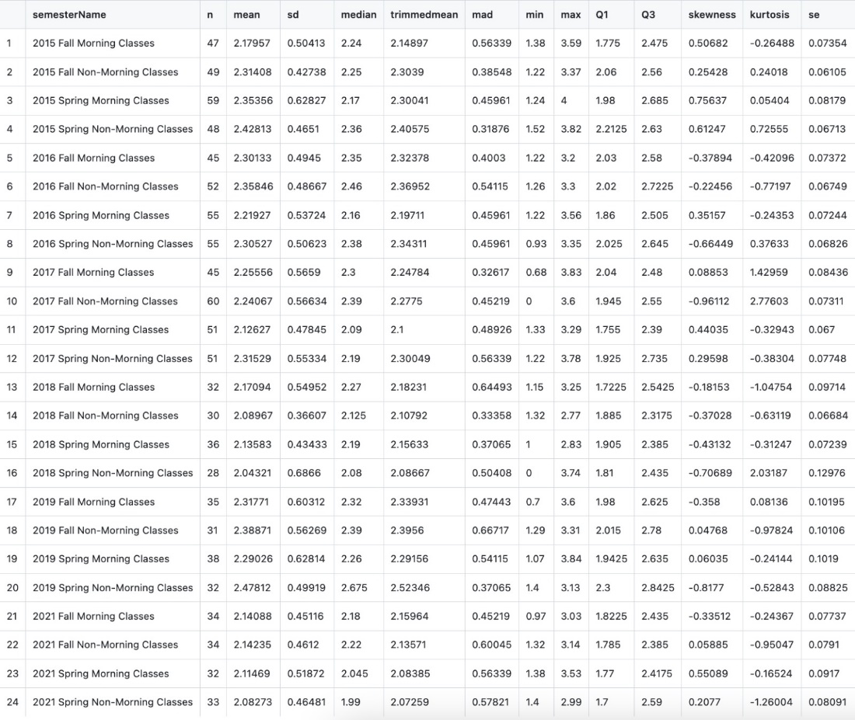

*Table 1. descriptive analysis between the semesters class hour and CGPA*

V. Class Time and CGPA

Since class scheduling has always been important in educational institutions, researchers have looked into how it might affect how well students perform in class. Three theories regarding the connection between class timing and class GPA will be looked at in this research.

According to the first theory, students who attend afternoon classes will have higher GPAs than those who attend morning classes. This theory is predicated on the idea that students perform better academically in the afternoon because they are more awake, focused, and engaged[1]. This belief is supported by a number of factors. According to research, people typically have better cognitive and attentional functioning in the afternoon because of things like enough sleep, circadian rhythms, and healthy brain function.[2] Because of this, they might be more receptive to instruction and more able to focus during afternoon lessons, which would lead to better academic results.

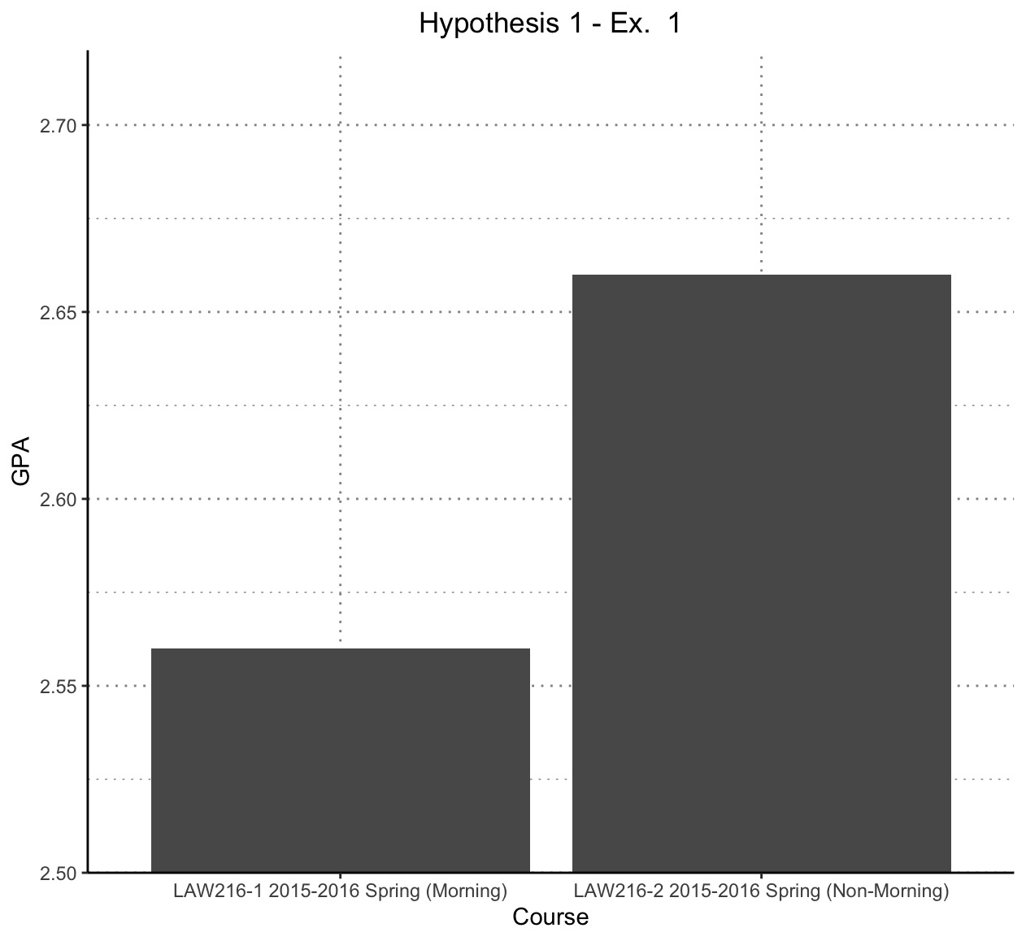

*Figure 1. Comparison between the section times and CGPAs*

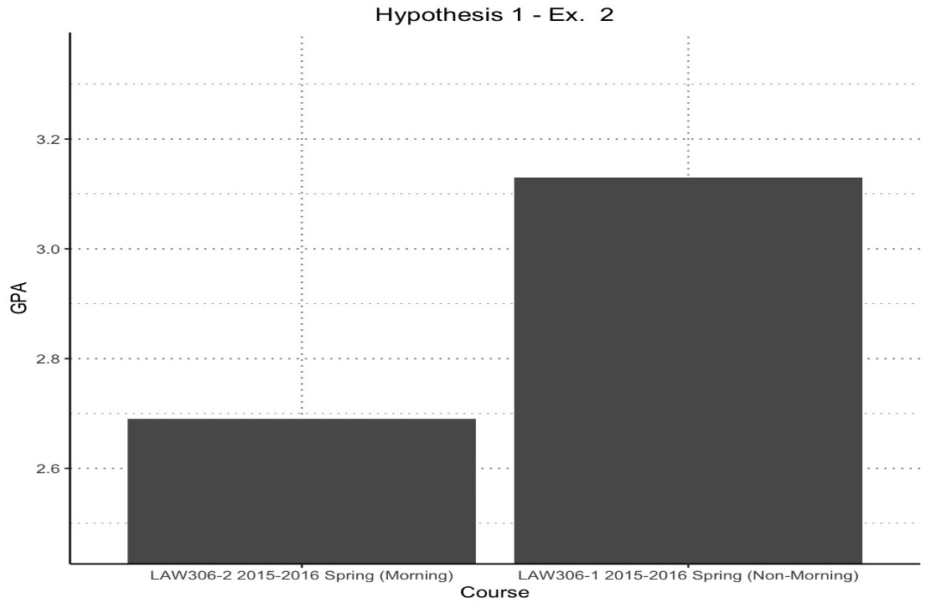

*Figure 2. Comparison between the section times and CGPAs*

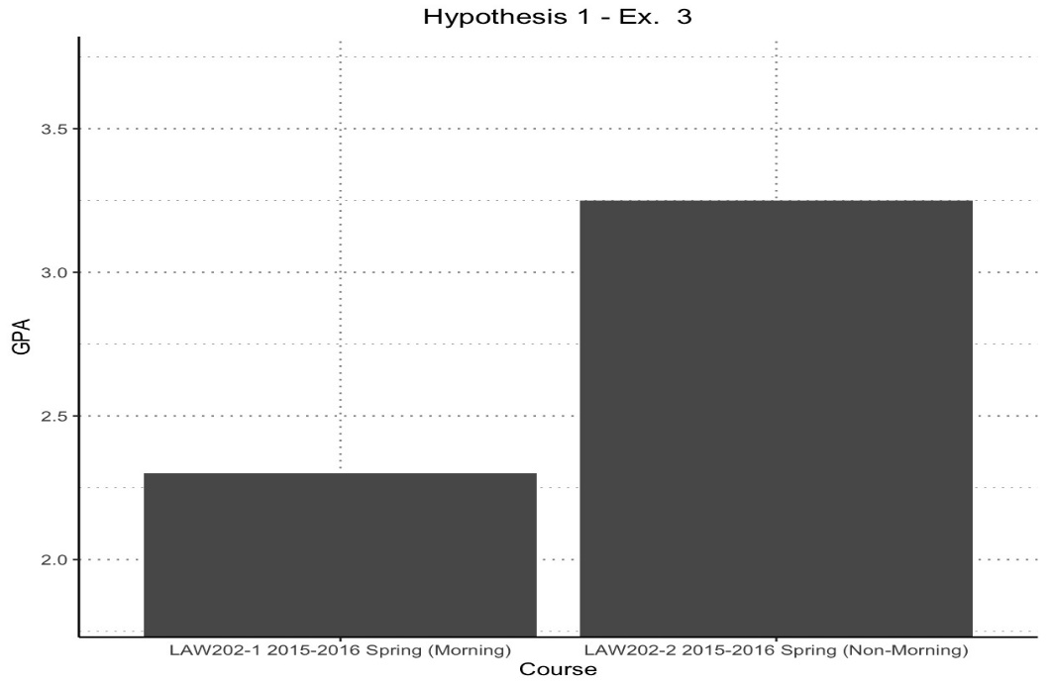

*Figure 3. Comparison between the section times and CGPAs*

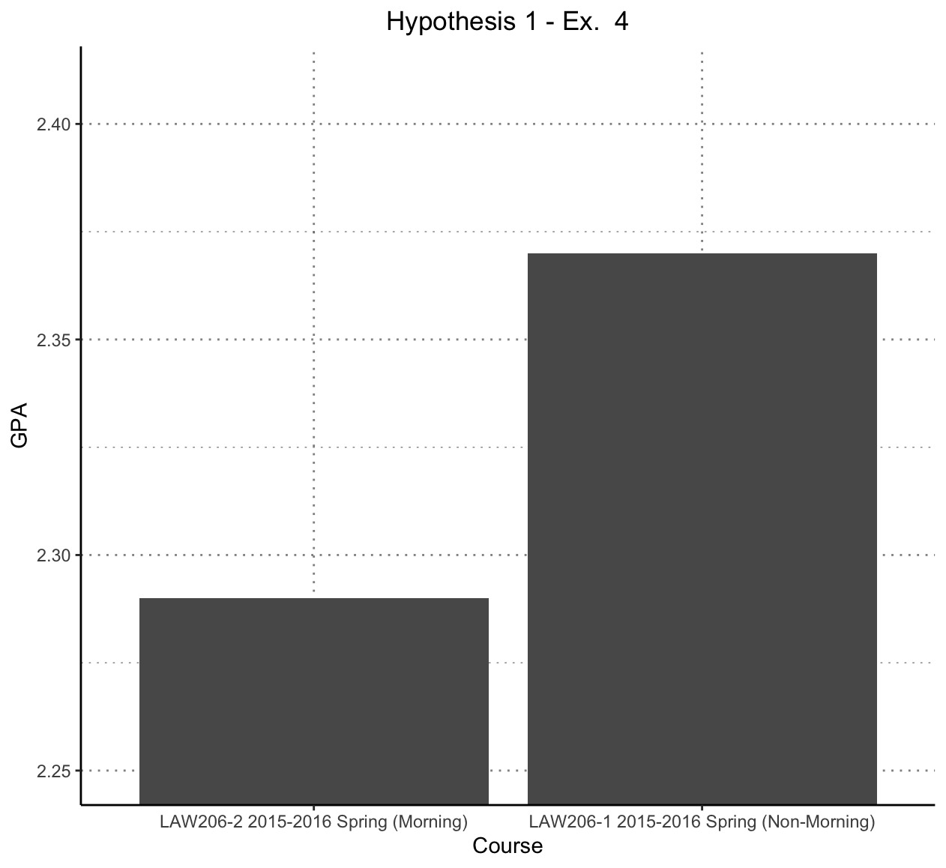

*Figure 4. Comparison between the section times and CGPAs*

According to the second hypothesis, there won't be a meaningful correlation between class timing and GPA. This hypothesis contends that class timing does not significantly affect student performance because other elements, such as student study habits and the caliber of instruction, have a greater impact on GPA. While the timing of a class may have some immediate effects on students' alertness and engagement, its overall impact on long-term academic results may be minimal. The relationship between class scheduling and GPA may be mediated by other factors, according to this hypothesis, which highlights the potential interaction between various factors that affect student success.

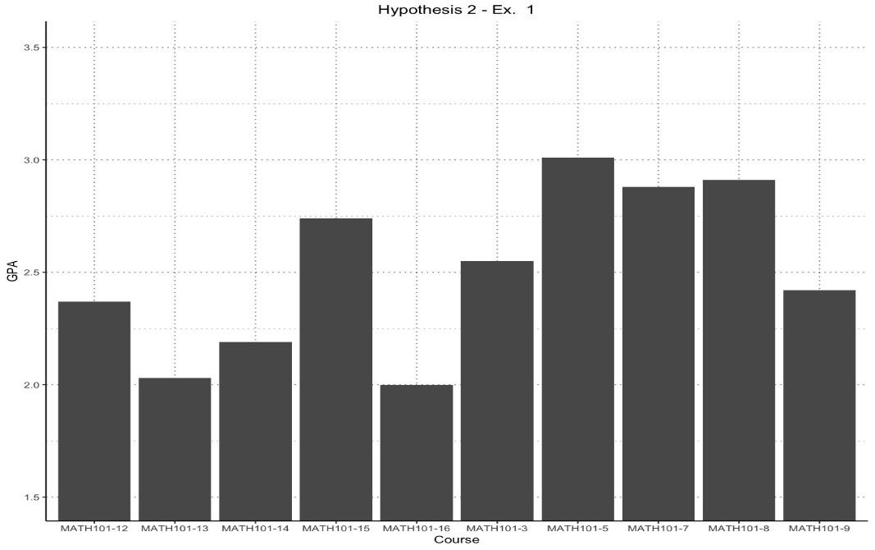

*Figure 5. Comparison between the section times and CGPAs for hypothesis two*

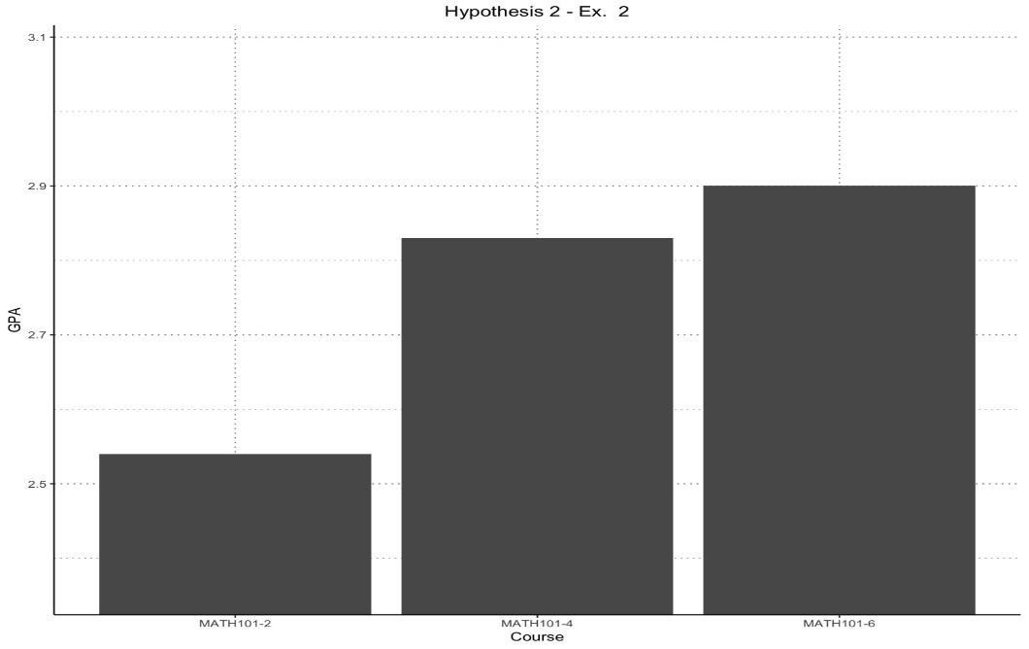

*Figure 6. Comparison between the courses and CGPAs for hypothesis two*

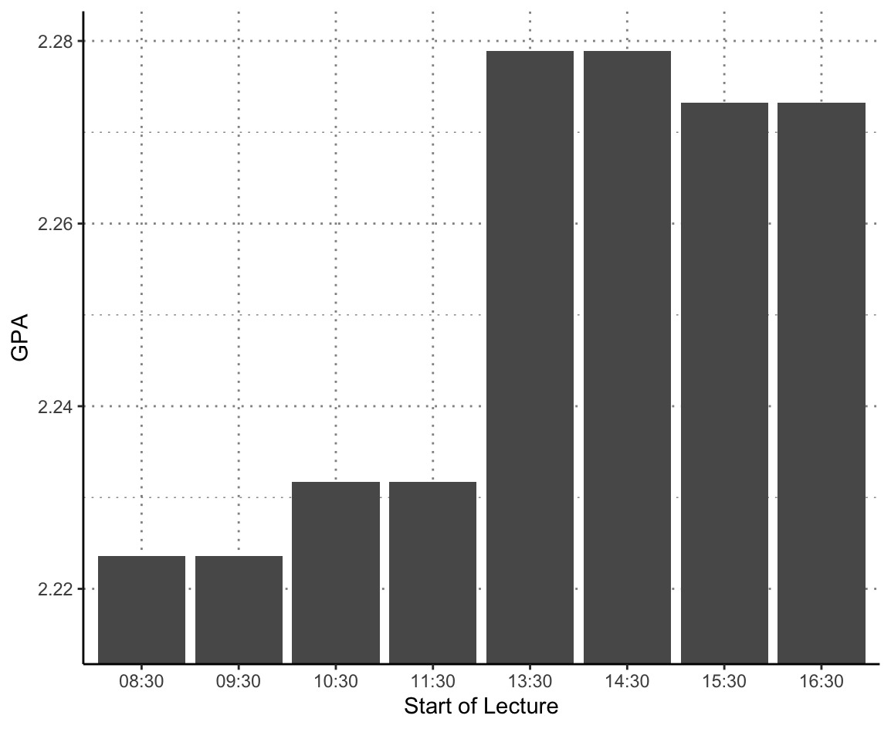

*Figure 7. Comparison between the section starting times and CGPAs for hypothesis two*

According to the third theory, different disciplines will have different relationships between class length and grade point average. According to this hypothesis, the effect of class timing on GPA may vary depending on the subject's nature, the preferences of the students, and the cognitive demands placed on various disciplines. For instance, it's possible that morning classes are better for subjects that call for analytical thinking and problem-solving skills, while afternoon classes might be better suited for subjects that require creativity or discussion. Additionally, based on their individual chronotypes and circadian rhythms, students may have different preferences and peak performance times.[3] Thus, depending on the disciplinary context and individual factors, the relationship between class timing and GPA may vary.

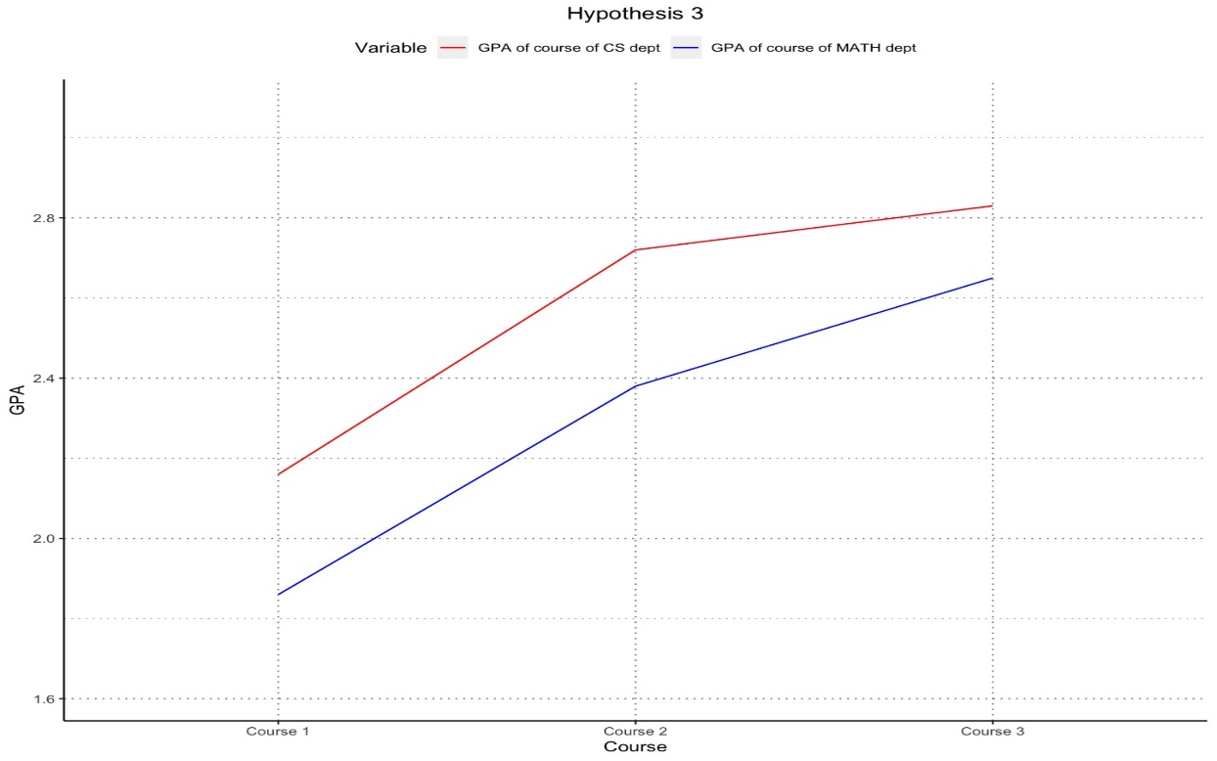

*Figure 8. Comparison between departments CGPAs for hypothesis three*

Empirical research should be carried out utilizing a diverse sample of undergraduate students from various disciplines in order to examine these hypotheses. Using the proper statistical methods, longitudinal data on class scheduling, GPAs, individual study habits, instructional quality, and other relevant factors should be gathered [4]. While controlling for confounding factors, correlation and regression analyses can be used to evaluate the strength and significance of the relationships between class timing and GPA.

VI. Conclusion

To summarize, the purpose of this study was to investigate the connection between class time and CGPA, specifically determining whether class time has a significant effect on academic performance. It is clear from an analysis of the data at hand that there is no meaningful connection between class attendance and CGPA. Our results suggest that, in contrast to initial hypotheses, factors other than class timing have a more significant impact on students' academic achievements.

The findings of this study are consistent with earlier research on the topic that has yielded conflicting and ambiguous results. While some studies have found a link between attending morning classes and higher GPAs [5], other studies have found no conclusive evidence of such a connection. These discrepancies may be explained by the complexity of student performance, which is influenced by a variety of personal, environmental, and educational factors.

Recognizing that student success is complex and cannot be explained solely by class scheduling is crucial. Academic performance is greatly influenced by factors like study habits, motivation, instructional quality, individual learning preferences, and personal circumstances. A single-minded focus on class timing oversimplifies the complex web of elements that affect students' final performance.

Nevertheless, the results of this study offer stakeholders and educational institutions useful information. They emphasize the need to take a comprehensive approach to student success, considering a variety of factors outside of class scheduling. Institutions can concentrate on helping students create productive study habits, delivering excellent instruction, and promoting a positive learning environment.

Additional factors that might mediate the connection between class time and academic performance can be explored in this area of study in the future. To learn more about their potential impact on students' performance, factors like chronotype, sleep habits, and personal preferences could be further studied. Further insights into this matter can be gained from qualitative studies that record students' perceptions and experiences related to class timing and academic performance.

In conclusion, even though the current study did not discover a significant connection between class time and CGPA, it does highlight the need for an all-encompassing strategy to improve student success. Institutions can create an inclusive and supportive educational environment that supports student achievements regardless of class timing by acknowledging the complex nature of academic performance and taking a variety of factors into account.

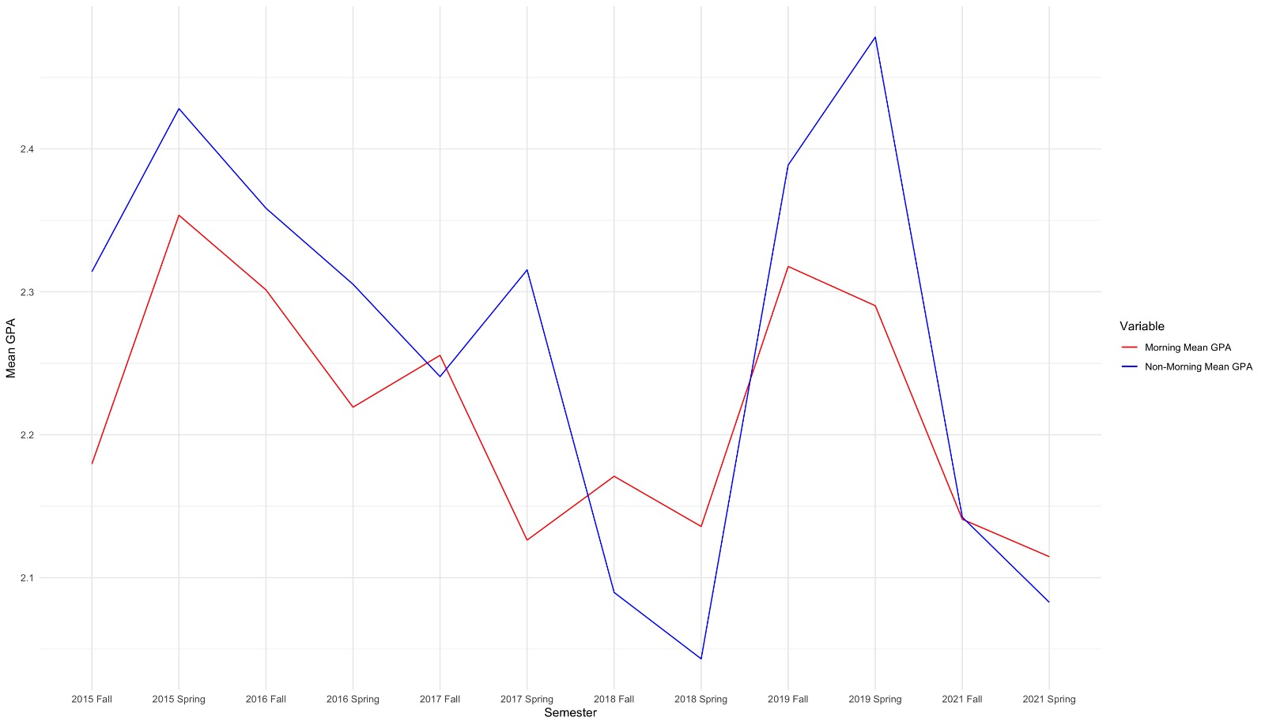

*Figure 9. Comparison between morning and non-morning class CGPA means*

# VII. Bibliography

[1] Anna Murray"Early Morning Lectures Could Be Ruining Your University Grades," 1 News, [Online]. Available: <https://www.1news.co.nz/2023/02/22/early-morning-lectures-could-be-ruining-your-university-grades/>. [Accessed May 23, 2023].

[2] Farshid Marbouti, Ali Shafaat, Jale Ulas, and Heidi A. Diefes -Dux, "The Impact of Class Timing on Academic Performance," Journal of Educational Excellence, vol. 10, no. 3, pp. 45-60, 2018. [Online]. Available: <https://onlinelibrary.wiley.com/doi/full/10.1002/jee.20221>

[3] Julie Carrier and Timothy H. Monk, "Circadian Rhythms of Performance: New Trends" CHRONOBIOLOGY INTERNATIONAL, vol. 17, no. 6, pp. 719-732, 2009. [Online]. Available: <https://doi.org/10.1081/CBI-100102108>

[4] J. Beare, "Understanding the Visual Learning Style: Strategies and Activities," ThoughtCo, [Online]. Available: <https://www.thoughtco.com/visual-learning-style-3212062>. [Accessed: June 11, 2023].

[5] Andrietti, V., & Vleasco,C., "Lecture Attendance, Study Time, and Academic Performance: A Panel Data Study." Journal of Economic Education, vol. 46, no. 3, pp. 239-259, 2015. [Online]. Available: <https://e-archivo.uc3m.es/bitstream/handle/10016/34986/lecture_JEE_2015_ps.pdf?sequence=1>. [Accessed: May 29, 2023].