Individual teams work in individual environments to accomplish their work. That is the key problem here.

The first solution for this problem came as virtualization. In virtualization, we create a virtual machine with its own CPU, memory, and storage. The virtual machine functions as a virtual computer. Note, to run the virtualization, we need a hypervisor. A hypervisor is an application which enables us to segregate the hardware resources and provision them to a virtual machine. The hypervisor has its own tiny Linux-based operating system. It gets installed on a physical hardware. Then it allows us to create virtual machines using the hypervisor. The virtual machines are fully isolated and work as an individual system. We can create multiple virtual machines on a single server. Components of virtualization, the host, the guest, and the virtualization layer.

The other solution we have is container. Let us quickly understand what a container is. A container is a standard unit of software that packages up the code and all its dependencies so that the application runs quickly and reliably from one computing environment to another.
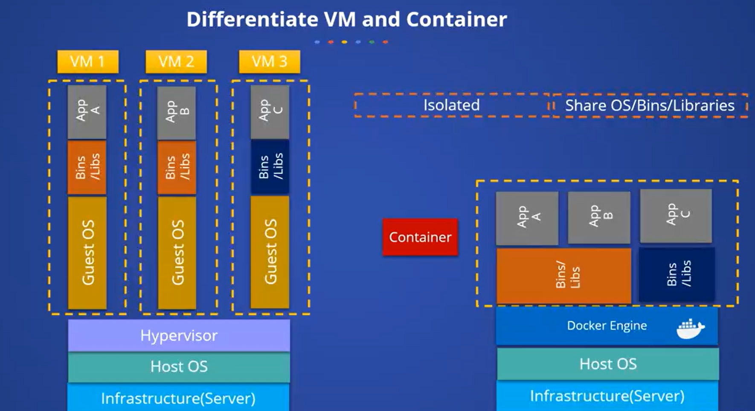
A daemon is a background process that runs continuously and performs specific operations or waits for certain events to occur. It typically starts when the system boots and runs without direct user interaction.

In the context of Docker, a daemon is a program that manages Docker containers on a host system. The Docker daemon, known as dockerd, listens for Docker API requests and manages Docker objects such as images, containers, networks, and volumes. It communicates with other daemons to manage Docker services.

Docker networking is a way for all of the isolated containers to connect with one another. There are 5 differents network drivers:

- Bridge: Container’s default network driver
- Host: Eliminates the network barrier between Docker containers and Docker hosts
- Overlay: Used when you want your containers to run on multiple Docker hosts
- Nonedriver: Switches off all networking options
- Macvlan: Gives containers a mac address to make seem like physical devices

One can store data in a container’s writeable layer. There are 4 storage options for persistent data:

- Data volumes: Stored on the host file system, using a copy-on-write process
- Volume Container: Involves hosting a volume in a dedicated container
- Directory Mounts: Another alternative is to mount the local directory of a host into a containers
- Storage Plugins: Allow you to link to external storage systems
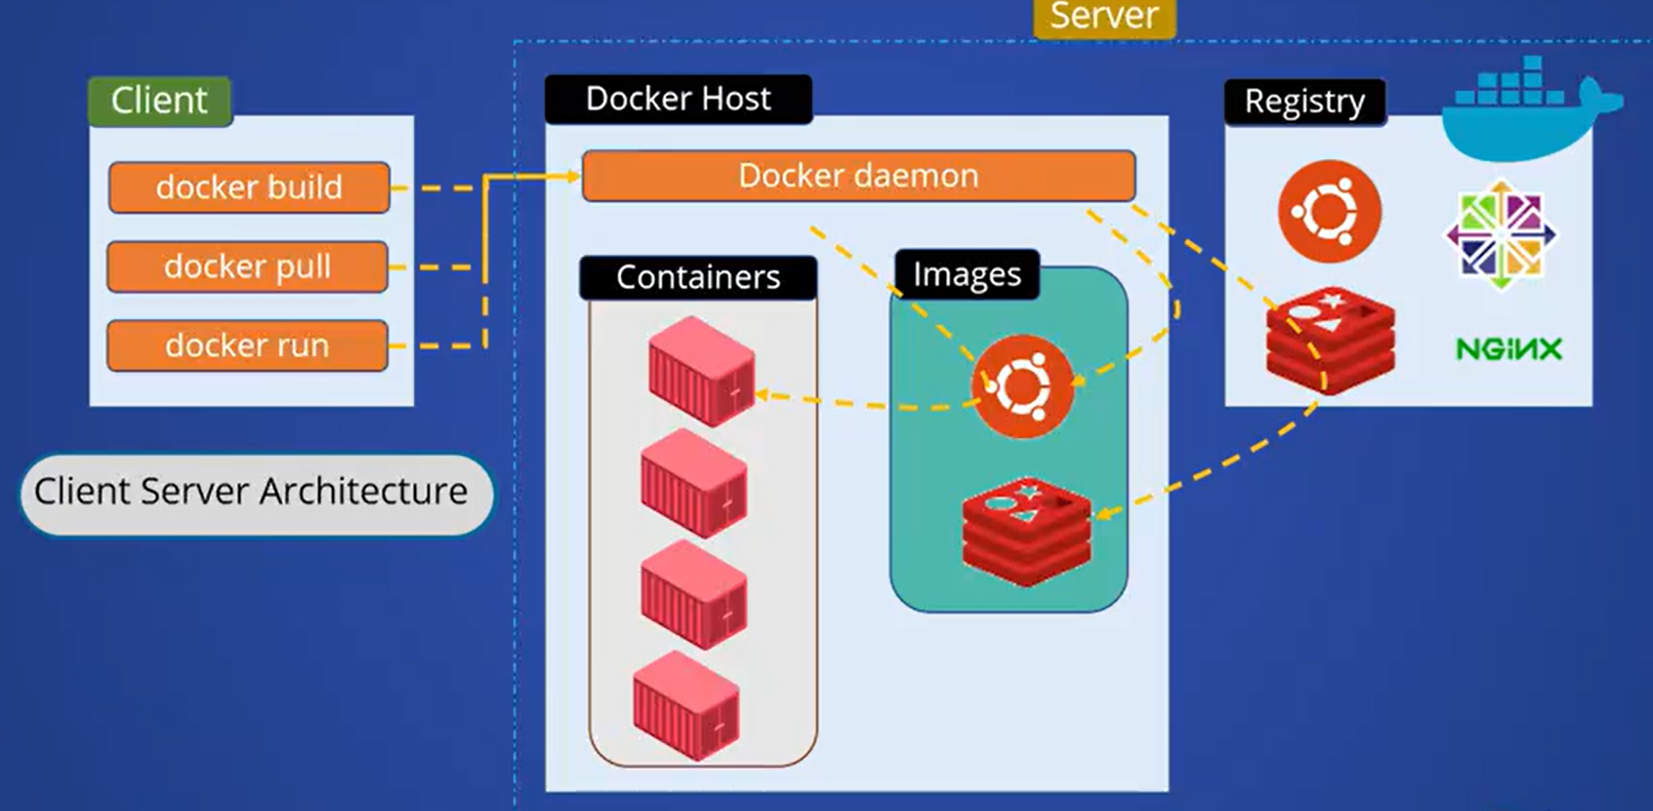
Docker engine which actually works as a server takes the input from the command line and executes and gives you the output. Above you can see the different components that the docker engine is consisted of. They are docker daemon, Rest API, and the CLI. The Docker CLI is the client, and
the Docker daemon is the server, and the Rest API using which the Docker client and Docker daemon interacts. So the Docker engine changes the settings and conditions automatically to ensure whenever we apply the configuration options via the configuration management tool or configuration management file.

The Docker swarm is nothing but a clustering mechanism provided by Docker. So now the question is, what is cluster? In simple words, if you want to define what is cluster is nothing but a group or collection of servers which serve similar kind of service. So we can define the swarm as the cluster management system or the orchestration feature embedded in the Docker engine.

Similarly, the data storage that we want to use inside a Docker engine or a Docker server, we are calling them as data volume. So these data volumes are shareable across multiple containers. Additional benefit of using the data volumes are like we can easily take the backup or migrate from one Docker engine to another Docker engine. We can manage the volumes using the Docker CLI command as well. And the very fantastic feature is the volume that we can use it either in a Linux machine or we can use it in a Windows machine. The same volume can be used in both different operating systems, which enables the Docker engine as portable in different operating systems.

