Docker Registry is nothing but a content distribution system that stores and distributes different images created by the community or different users.

- docker pull centos
  - Instructs Docker to fetch the centos image from the official Docker Hub. This is just a quick way to get to the longer docker.io/library/centos command.

- docker pull myregistrydomain:port/dca/img1
  - Specifies that Docker must contact the registry at myregistrydomain:port to locate the dca/img1 image.

----------------------------------------------------------------------------------------------------------------------------

Run a registry on my local machine

- docker run -d -p 5000:5000 –restart=always –name registry registry:2
- docker tag centos:7 localhost:5000/mycentos
  - push the tagged image to the running registry at localhost:5000
- docker push localhost:5000/mycentos
  - push the image to the local docker registry

Basic Authentication to access the docker images in the docker registry

- Password creation file which includes user “dcauser” and password “dcapassword”
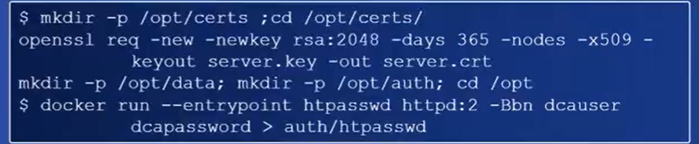
- Main step where we mention the registry auth along with the file which we created to store the information of username and password

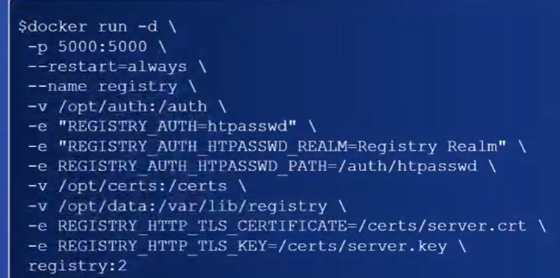

- Login to the registry
  - docker login localhost:5000

----------------------------------------------------------------------------------------------------------------------------

Dockerfile Directives

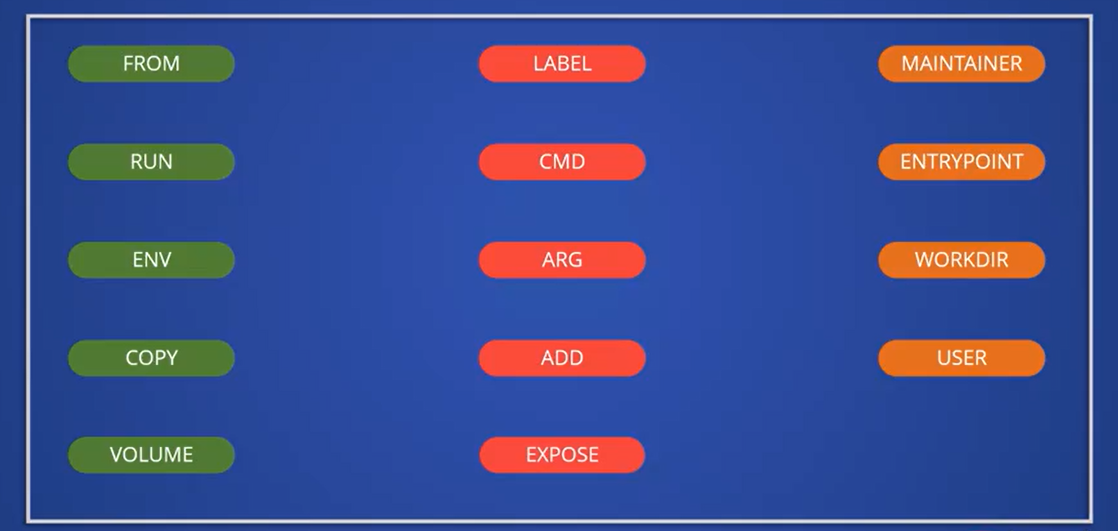
- FROM Directive
  - Determines the base of the image you will create
  - One can start with a parent image or a base image
  - Base images is always Non-writeable
  - Commands will add layer on top of the writeable layer
  - When you use a parent image, you’re tend to base a new image on an existing one

- LABEL Directive
  - A LABEL is a key-value pair that can be used to tag a Docker image with metadata
  - Labels can be used to better organize Dockerfiles
  - Additional information (maintainer name, version, environment, customer information etc)

- MAINTAINER Directive
  - Identifies the author/developer of the Dockerfile

- RUN Directive
  - Will make a new layer on top of the current one, run the command and save the results to the newly generated layer
  - Installing appropriate packages, updating packages, creating users and groups and so on can all be done with the RUN Directive
  - Give multiple shell commands in a single RUN directive (using the && symbol)

- CMD Directive
  - Aim is to give an executing container defaults
  - A Dockerfile can only contain one CMD instruction
  - To provide a default command
  - Default instruction will be executed when container is created from the image

- RUN vs CMD
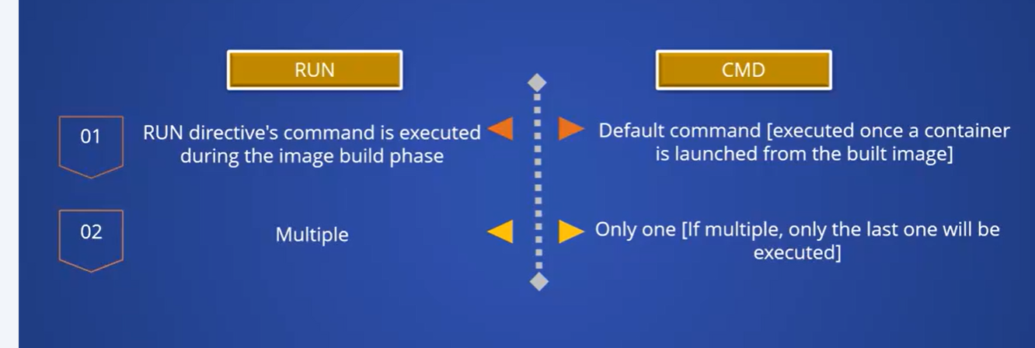

- ENTRYPOINT Directive
  - Run when a container is generated from a Docker image
  - The ENTRYPOINT directive differs from the CMD directive:
    - Unlike the CMD directive, the ENTRYPOINT order cannot be overridden using the command-line parameters sent with the docker container run command
  - To provide additional arguments to the executable, we may use the CMD directive in combination with the ENTRYPOINT Directives
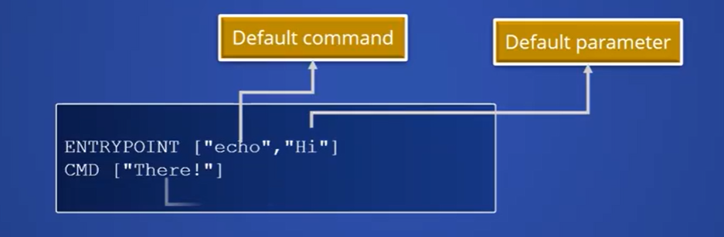

- ENV Directive
  - To store the value of the home path the $HOME environment variable is used

- ARG Directive
  - To describe variables that can be passed to the build process by the user
  - The ARG Directive is the only one that can come before the FROM directive in the Dockerfile

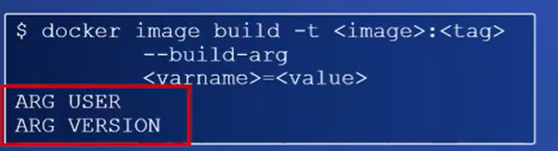
- WORKDIR Directive
  - To define the docker container’s current working directory
  - This directory will be used to execute any subsequent ADD, CMD, COPY, ENTRYPOINT and RUN directives
  - If the required directory does not exist, docker will build it and render it the current working directory, so this directive implicitly executes the mkdir and cd commands

- COPY Directive
  - To copy files from local file system to the docker image file system during the docker image build phase

- ADD Directive
  - Enables one to use a URL as the parameter in addition to the features provided by the COPY Directive

- ADD vs COPY
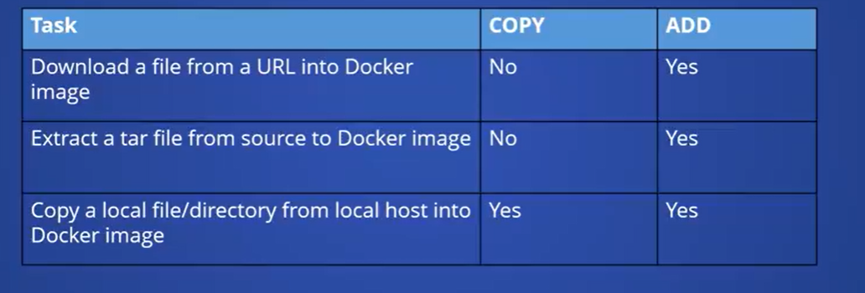

- USER Directive
  - To make a non-root user the default user of a Docker container
  - Docker can use the root user as the container’s default user
  - The USER directive can be used to override this default behavior
  - All subsequent RUN, CMD and ENTRYPOINT directives in the Dockerfile will be run with the username defined in the USER directive
  - VOLUME directive
    - To build docker volumes
    - A mapping directory will be generated in the underlying host machine once a VOLUME is created in the Docker container
    - Helps us to take backup of the specific path
    - Data stored on volumes can be shared between containers

- EXPOSE Directory
  - Tells Docker that a runtime, the container is listening on the listed port
  - Only for inter-container communication
    - The ports exposed by the EXPOSE directive will only be accessible from inside the Docker Containers
  - Use the -p flag with the docker container run command to expose these ports outside of the Docker container

By default, the Docker pull uses the checksum mechanism to verify the downloaded image or every layer that is attached to the image you are downloading. The Docker pull also have the ability to detect any corrupted downloads. Usually, the publishers who publish the images sign their images and image consumers can ensure that the images they pull are signed. So you can enable this content trust by setting the Docker content trust value to 1, and then you try to pull any image from a given registry. It will be checked for the signature that has been signed by the publisher. So in this example you can see the value has been set to 1 of Docker content trust and exported as an environment variable. Now when I try to pull the CentOS image, you will see the signature that has been signed by the publisher.

After you complete the usage or one image that is completely unused now and you want to remove it or clean it up completely from scratch. So here we will use the docker image prune command to ensure they are deleted. To delete, all the images not being used, we can add the option -a to the docker image prune to delete all the container images at a time.

docker run –rm
- To delete container automatically on exit. Running containers with the –rm flag is useful for containers that are only used for a short period of time.

docker container ls
- To see a list of running containers.
- List of all containers despite of status (-a)

/var/lib/docker/containers/[container-id]/[container-id]-json.log
- default docker log location

Run Time Configurations
- Allows you to control how much memory or CPU a container can use
- When insufficient memory is detected, host throws an Out Of Memory Exception
- Hard Memory: Limits the amount of user or system memory
- Soft Memory: Allows to use memory as much it requires until a certain requirements
- Each container has unrestricted access to the host machine’s CPU cycles. Restrictions are applied to restrict a container’s access to the host machine’s CPU cycles
The -p or -P command line options used to bind ports on the host. To connect all exposed ports in a container’s image to the host.

docker run -p “<hostPost>:<containerPort>” webapp
docker run -P webapp

