Docker Container Storage & Volumes
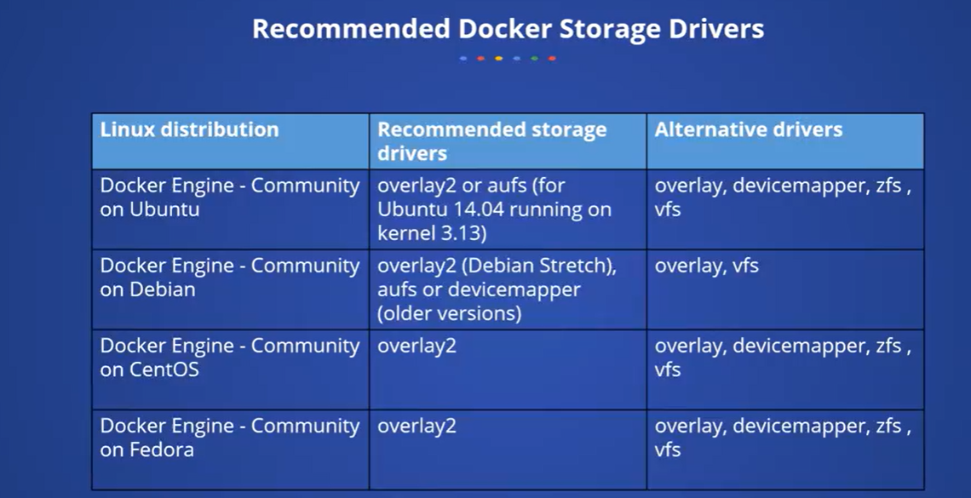
The loop-LVM more makes use of loop back mechanism that allows the files on the local discs to be read from and written to as if they were an actual physical disk or a block device. However, the addition of the loopback mechanism and interaction with the OS file system layer means that the IO operations can be slowed down, and it can be resource intensive. The use of loopback devices in the device mapper configuration can result to a race condition.

The other mechanism to store the data is Bind mounts. However, the bind mounts have limited functionality compared to volumes. When you use a bind mount, a file or a directory on the host machine is mounted into the container and the file or the directory that is mounted is referenced by its absolute path on the host machine. That means the data you write on a bind mount will be actually stored in the hosts file system.
Another option while the container runs on a Linux host is tmpfs. When you create a container with tmpfs mount, the container can create files outside the containers writable layer, and when compared to volumes and bind mounts, the tmpfs mount is a temporary mount point and only persisted in the host memory. That means when the container stops, the tmpfs mount is removed and the files written there won't be persisted anymore.

Docker Volume vs. Bind Mounts
Docker provides two mechanisms for persisting data between containers and the host machine: volumes and bind mounts. While both serve similar purposes, they have different implementation methods and use cases. Let's delve into each in detail:

Docker Volumes:
1. Purpose:
Docker volumes are directories that are outside the lifecycle of a container and exist independently of the container's lifecycle. They are designed to persist data generated by containers and allow for data sharing between containers and the host machine.
2. Implementation:
- Docker volumes are managed by Docker and are stored within the Docker data directory, typically located in /var/lib/docker/volumes on the host machine.
- Docker volumes can be created explicitly using the docker volume create command or implicitly when a container is created with a volume specified.
3. Features:
- Data Persistence: Docker volumes persist data even if the container is removed or recreated, making them suitable for long-term storage.
- Sharing Data Between Containers: Multiple containers can share the same volume, enabling data sharing and collaboration between containers.
- Volume Plugins: Docker volumes support plugins that enable integration with external storage systems, such as cloud storage providers or network-attached storage (NAS) devices.
4. Use Cases:
- Database Storage: Docker volumes are commonly used for storing database data, such as MySQL or PostgreSQL data directories, ensuring data persistence across container restarts.
- Shared Configuration: Docker volumes can be used to share configuration files or application data between containers in a microservices architecture.

Bind Mounts:
5. Purpose:
Bind mounts are file or directory paths on the host machine that are mounted into a container at runtime. They allow containers to access files or directories from the host machine's filesystem.
6. Implementation:
- Bind mounts are specified at container runtime using the -v or --mount flag with the host path and container path.
- Bind mounts do not have a separate management mechanism like volumes; they are managed directly by Docker and are accessible on the host machine.
7. Features:
- Host Machine Dependencies: Bind mounts allow containers to access files or directories directly from the host machine's filesystem, making them suitable for development and testing environments.
- Dynamic Updating: Changes made to files or directories on the host machine are immediately reflected within the container, enabling rapid development and debugging workflows.
- Limited Persistence: Bind mounts do not persist data beyond the lifecycle of the host machine or container, making them less suitable for long-term storage.
8. Use Cases:
- Development Environments: Bind mounts are commonly used in development environments to mount source code directories into containers, allowing developers to test their code changes in real-time.
- Configuration Overrides: Bind mounts can be used to override configuration files or directories within a container with custom configurations from the host machine.

Comparison:
- Lifecycle: Docker volumes persist data independently of the container's lifecycle, while bind mounts are tied to the host machine's filesystem and container's lifecycle.
- Persistence: Docker volumes provide long-term data persistence, while bind mounts offer dynamic updating but limited persistence.
- Management: Docker volumes are managed by Docker and have separate management mechanisms, while bind mounts are managed directly by Docker and are accessible on the host machine's filesystem.
In summary, Docker volumes and bind mounts serve similar purposes but have different implementation methods and use cases. Docker volumes are ideal for long-term data persistence and sharing between containers, while bind mounts are suitable for dynamic updating and accessing files or directories directly from the host machine's filesystem. The choice between Docker volumes and bind mounts depends on the specific requirements of the application and the desired data management strategy.

