Computer Graphics 371
Project Report

Fall 2016

Michael Sterle-Contala (25469260)
Kendy Jeune (27014465)

Introduction
For our project, we chose the “Walk Through a Procedural World” option. We thought this would allow more creativity as well as give us experience with procedural generation. We chose a natural setting for our world, as it would be more challenging to create organic assets.
The project was divided into 3 parts: rendering & asset management, asset generation and user interface.

Asset Handling

Models
Due to the nature of procedural model generation, there would be a great many copies of simple primitive meshes, and so efficient instancing would be key. To this end, 3 hierarchical classes were defined, Model, Mesh and MeshInstance. MeshInstance objects hold a transformation marix and material properties. Mesh objects hold vertex data as well as a collection of MeshInstance objects. Model objects hold a tranformation matrix for model-scoped transformations as well as a collection of Mesh objects. In this way, a call to Model::draw() calls each individual Mesh::draw() in its collection of Mesh objects. The Mesh::draw() passes vertex and instance data directly to OpenGL.
To optimize the draw call, the Mesh’s collection of instance data had to be both contiguous in memory and randomly accessible. This was a challenge, because although the std::vector template class provides the same contiguity as a basic array, its individual elements do not have a fixed memory address and move around in memory after certain vector operations such as resizing. Because of this, basic pointers were not possible, and so the MeshInstancePtr class was used. This class behaves as a basic pointer, but functions instead by tracking the base container address and offset. In this way, a MeshInstancePtr object always points to the vector element it was set to, satisfying our requirement for random access.

Textures
We needed both cubemap and 2D textures, and possibly 1D as well, so we created a general abstract Texture class to handle the common functionality of creation and modification. Textures were going to be primarily generated (as opposed to loaded from file) so simple texture data access was made through the Texture base class and fully implemented at the subclass level. Texture objects are linked to OpenGL textures through their unique OpenGL reference.

Framebuffer Objects
Because all of our textures were going to be generated, we knew that we would require post-generation effects. To this end, we created Filter and Blender classes to allow convolution filtering and texture blending respectively. These are accomplished through the use of framebuffer objects, which, similar to Texture objects, are linked to OpenGL assets through native reference ID.

Shaders
We would optimize our rendering process by having many specialized shaders, and so the Shader class was defined to make shader management simpler. Again, like the Texture class, the Shader class links objects to OpenGL shader assets through native ID.

Rendering Implementation

Shadows
Several approaches were looked at for shadow rendering, and althugh light mapping would have allowed faster rendering, we wanted to create a framework that could accommodate dynamic objects and animation in the future. To this end, we decided to implement shadow mapping for all shadows. We originally created our shadows by running the shadow map through a PCF subroutine in the fragment shader, but after implementing and testing VSM, we saw smoother shadows and increased framerate, as seen in Illustration 3 below.
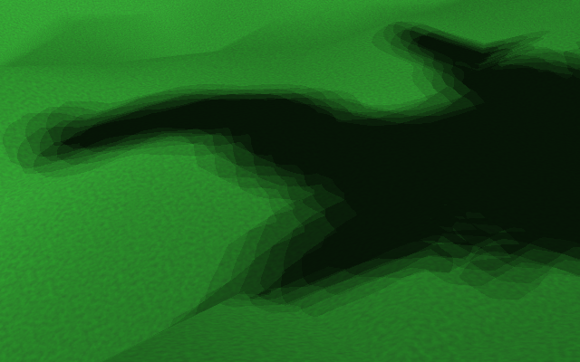  Illustration 1: PCF Shadow Mapping (3x3 Kernel)  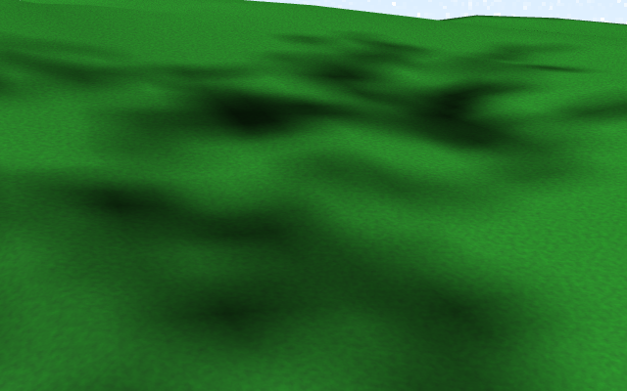  Illustration 2: VSM Shadow Mapping (3x3 Kernel) | Illustration 3: Experimental Framerate Results for Shadow Mapping Methods

Transparency
Although translucency was beyond the scope of our project, basic cutout transparency would be required for tree leaves. To achieve this, we simply set a threshold in the final shader program.

Procedural Asset Generation
Our goal was to recreate a natural setting, and to achieve this, we needed to create algorithms to generate organic-looking objects. Through research, we found that the methods at the heart of procedural asset generation are fractals and noise functions.

Models
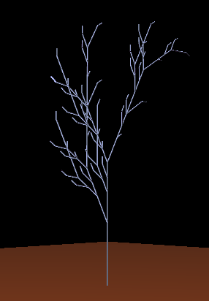
We settled on trees and shrubs for our model assets, as they would allow us to use the greatest range of our rendering features. We chose to generate these model through fractal generation. Fractals are self-repeating patterns of a recursive nature, and are ideally suited to simulating organic objects because they replicate the cellular growth method found in nature. To this end, Lindenmayer systems (L-systems) were chosen for their simple elegance, deep capability of natural process simulation and ability to express a large variety of outputs.
Illustration 4: Basic L-System (96,768 polygons)
We first built a basic L-system compiler that operated on strings. This L-system class created objects based on an input axiom and set of production rules, and could be run iteratively to produce new values at every generation. To “draw” these values we built a 3D turtle graphics interpreter. We adapted standard Turtle graphic commands to our model-based architecture – for example, “forward” causes the turtle to move forward and place a cylinder between its previous and current position.
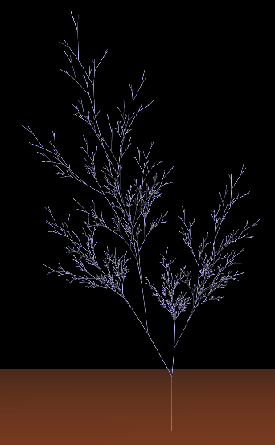
To allow a greater variety of output expressions we next built a paremetric L-system compiler. This one allows each symbol to have associated parameters, pass those parameters on and production rules to be conditional upon those parameters. It also allows us to use these parameters for associated Turtle commands. For example, while the non-parametric L-system would require X “forward” commands to produce a branch of length X, the same output could be achieved with a parametric command “forward(X)”. This resulted in far less polygons, vastly speeding up rendering.
Illustration 5: Parametric L-System (32,760 polygons)
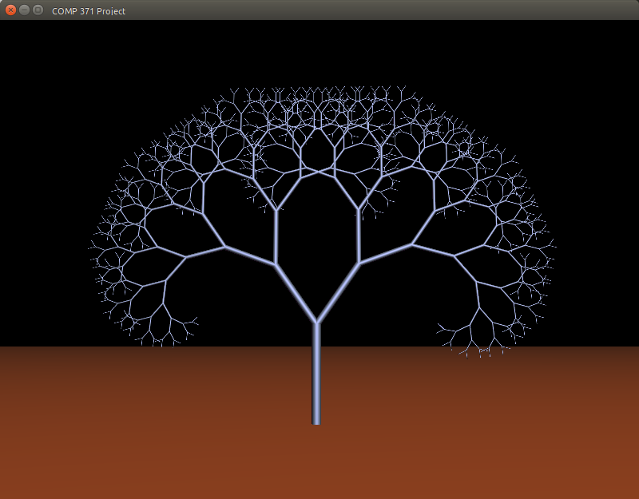 | 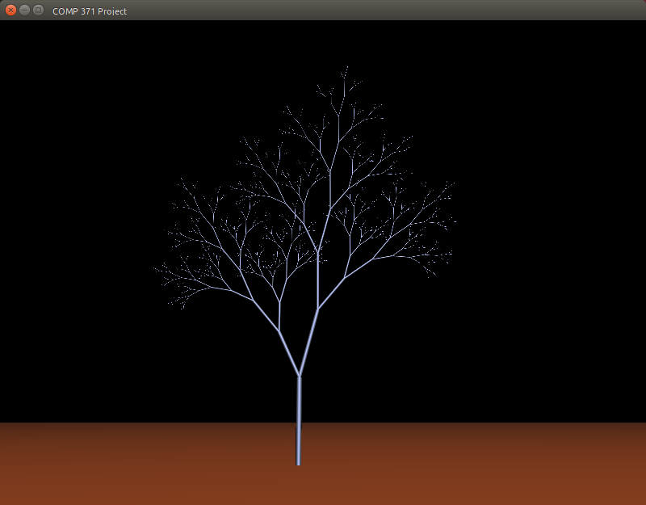 | 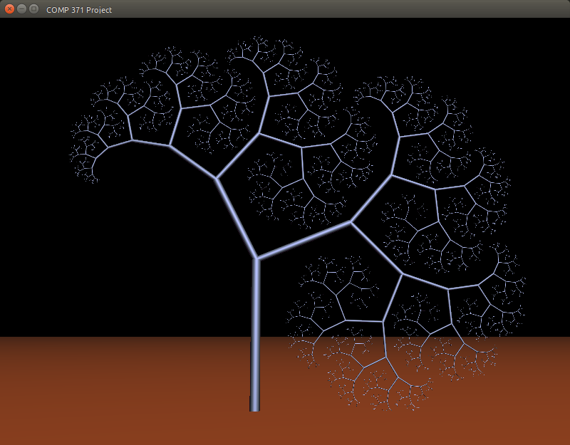 | 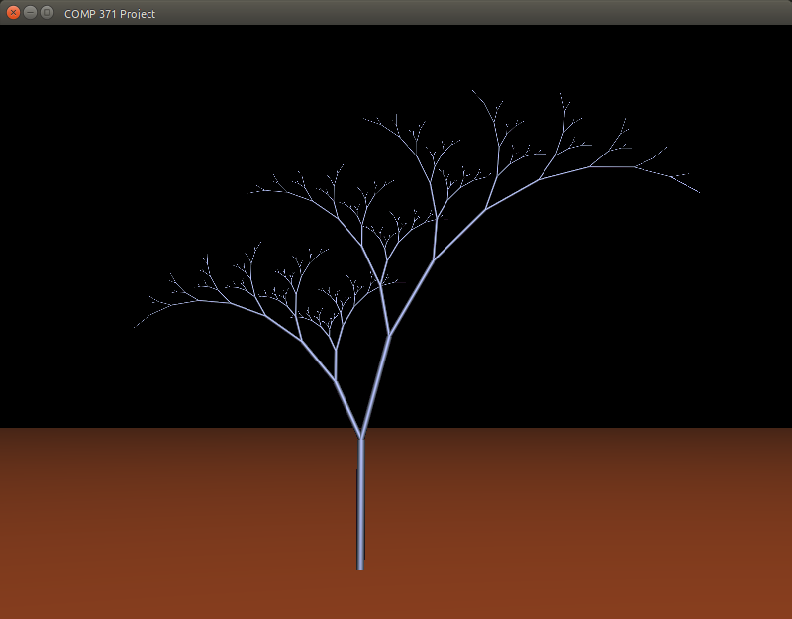
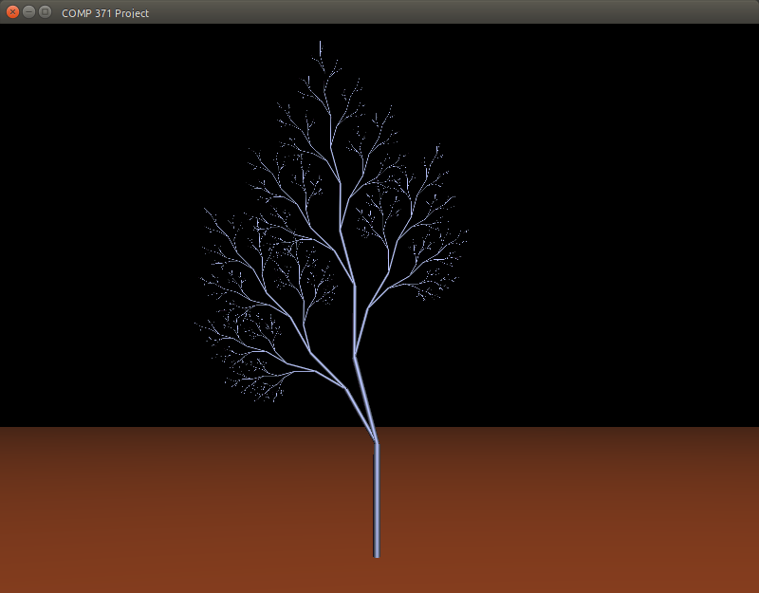 | 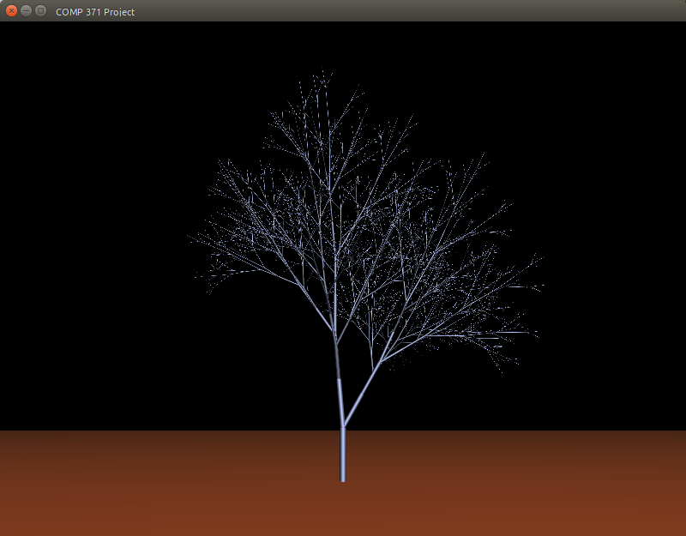 | 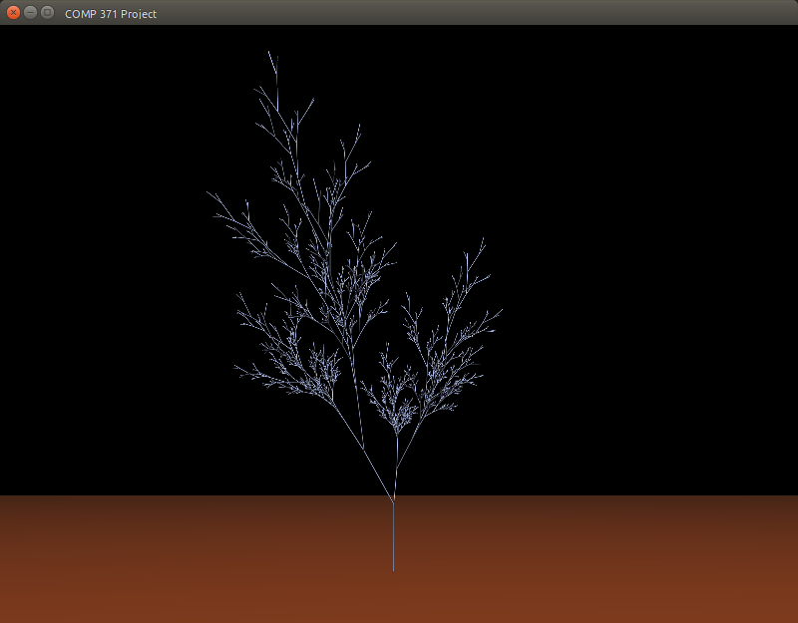 | 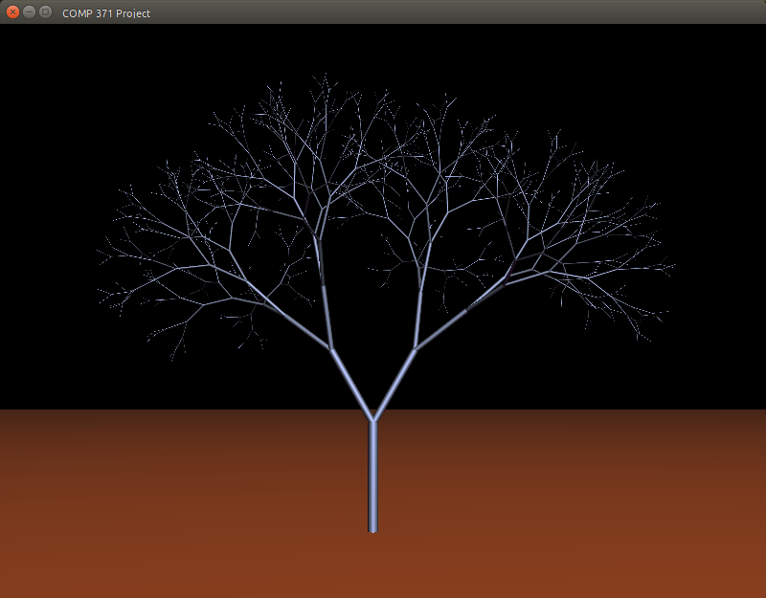

Textures
We decided to use noise functions as the base of our textures. There are many types of noise functions, but the one we went with is Perlin noise because it is easily tileable and can be made fractal.
We implemented a basic 3D Perlin generator and used it as a generator function for our various textures. We also developed Filter and Blender classes for linear convolution filters and texture blending respectively.

Terrain Textures
For the terrain we produce 3 textures, one each for grass, snow and rock. These are tileable, and the once that is used is decided in the fragment shader based on slope and altitude of the fragment.

Skybox Texture
The skybox is textured using 3D perlin noise. The 2D texture coordinates for each face of the cubemap are converted to 3D rays from the camera through the given point on the cube. These are extended to a skyplane parallel with the ground. These final coordinates are the ones sent to the perlin noise function. In addition, we add an exponential fade to white around the horizon to simulate Raleigh scattering.

User Interface

Key Interaction Input
The main objective for the keys interactions input was to let the user have access to different sets of keys for the navigation modes implemented in our project. We desired the controls to be fairly simple and straight forward. We sought the navigation to be similar to first person controls with the mouse moving the camera look-at direction and the keys moving the position of the camera. Implementing the key interactions is a very interesting part of design since it allows you to look around and have a first sensation of control. Every resources needed for the achievement of the keys callback function was provided by the GLFW library therefore we did not need to add any specific implementation.
The keys are as follow:
Walk Mode |  | Explore Mode
W, A, S, D | Move forward, backward, left, right | W, A, S, D
Unavailable | Rotate terrain around the X-Y-Z axis | X, Y, Z
Unavailable | GLPolygonMode.  GL_FILL, GL_LINE, GL_Point,  GL_TRIANGLE  (respectively) | T, V, P, U
H | Toggle Between Walk Mode, Explore Mode | H
Unavailable | Fly upward /Move camera to +y axis | Spacebar
Shift(Hold) | Run/Increase camera speed | Unavailable

Camera Movement
Initially we had in mind to implement diverse way of moving the camera. After discussion we finally agreed upon implementing two different ways of moving the camera resulting in different traversal modes. This project consists of two different navigation approach. Explore mode allow the user to traverse the terrain without any height or ground collision restriction letting us observe the field in infinitely different views. Additionally, this mode was intended to provide complete control over the terrain in order for us to fix bugs. To accomplish this mean of navigation we made sure that the mouse movement moved the camera as well. This first step was greatly needed in order for us to know in which direction we are going (toward the terrain or outside the terrain). Walk mode allow the user to move along the terrain height to represent an object/player on the terrain. For this mode, the objective was to lock the camera at a certain height hence making the user not able to move along the y-axis or penetrate the terrain. We wanted this approach to be both slow and fast, thus we added a running feature allowing us to increase the camera movement speed by a factor of 0.7. To use that feature the user simply has to hold the left shift key while moving.

Collision Detection:
By far, one of the biggest challenge in this project. With little experience in collision detection implementation, this topic was very hard to grasp mostly because of a general topic it is. Each objects interact differently when colliding with another object. For this design we, again, tried to keep it highly simple. The technique applied in this project can be described in the following algorithm:
- Finding the position of the particular object,
- Creating a bounding volume around it’s main by calculating the top, center and base position
- Using glm build in function to calculate the distance between the camera and the bounding volume.
- When a certain distance has been reached we restrict the camera from moving forward or in a direction that will place it over the maximum distance.
- Reset the camera position away from the bounding volume each time it collides with the object to give the impression of a ‘’bump’’ collision.
Fortunately, a huge variety of resources were available online and we learned that there exist more than a dozen techniques to implement Collision Detection such as Raytracing, spatial partitioning or AABB (shown in class). For the sake of the software we wanted to make sure that we reduce the amount of calculation needed and it would make sense since object in our terrain are generated procedurally.

References

Rendering
- Learn OpenGL (http://learnopengl.com)
- Tom Dalling OpenGL Series (https://github.com/tomdalling/opengl-series)
- thebennybox 3D Game Engine (https://github.com/BennyQBD/3DGameEngine)
- NVIDIA Developer (https://developer.nvidia.com/)
- Learn OpenGL - Shadow Mapping (http://learnopengl.com/#!Advanced-Lighting/Shadows/Shadow-Mapping)
- http://fabiensanglard.net/shadowmappingVSM/

Model Generation
- http://outerra.blogspot.ca/2012/05/procedural-grass-rendering.html
- The Algorithmic Beauty of Plants (http://algorithmicbotany.org/papers/#abop)

Terrain Generation
- Making maps with noise functions (http://www.redblobgames.com/maps/terrain-from-noise/)
- Generating Random Fractal Terrain (http://www.gameprogrammer.com/fractal.html)

Texture Generation
- Synthesizing Bark (http://www-evasion.imag.fr/Publications/2002/LN02/bark.pdf)
- Improved Noise reference implementation (http://mrl.nyu.edu/~perlin/noise/)
- Understanding Perlin Noise (http://flafla2.github.io/2014/08/09/perlinnoise.html)
- OpenGL.org (https://www.opengl.org)

User Interface
- http://learnopengl.com/#!Getting-started/Camera
- http://www.glfw.org/docs/latest/group__input.html
- https://www.toptal.com/game/video-game-physics-part-ii-collision-detection-for-solid-objects
- http://www.wildbunny.co.uk/blog/2011/04/20/collision-detection-for-dummies/
- http://stackoverflow.com/questions/6083286/having-a-little-issue-calculating-the-bounding-sphere-radius
- http://www.gamedev.net/page/resources/_/technical/math-and-physics/simple-bounding-sphere-collision-detection-r1234
- https://xoppa.github.io/blog/using-the-libgdx-3d-physics-bullet-wrapper-part1/
- Course lab sample code
- Course Notes.

