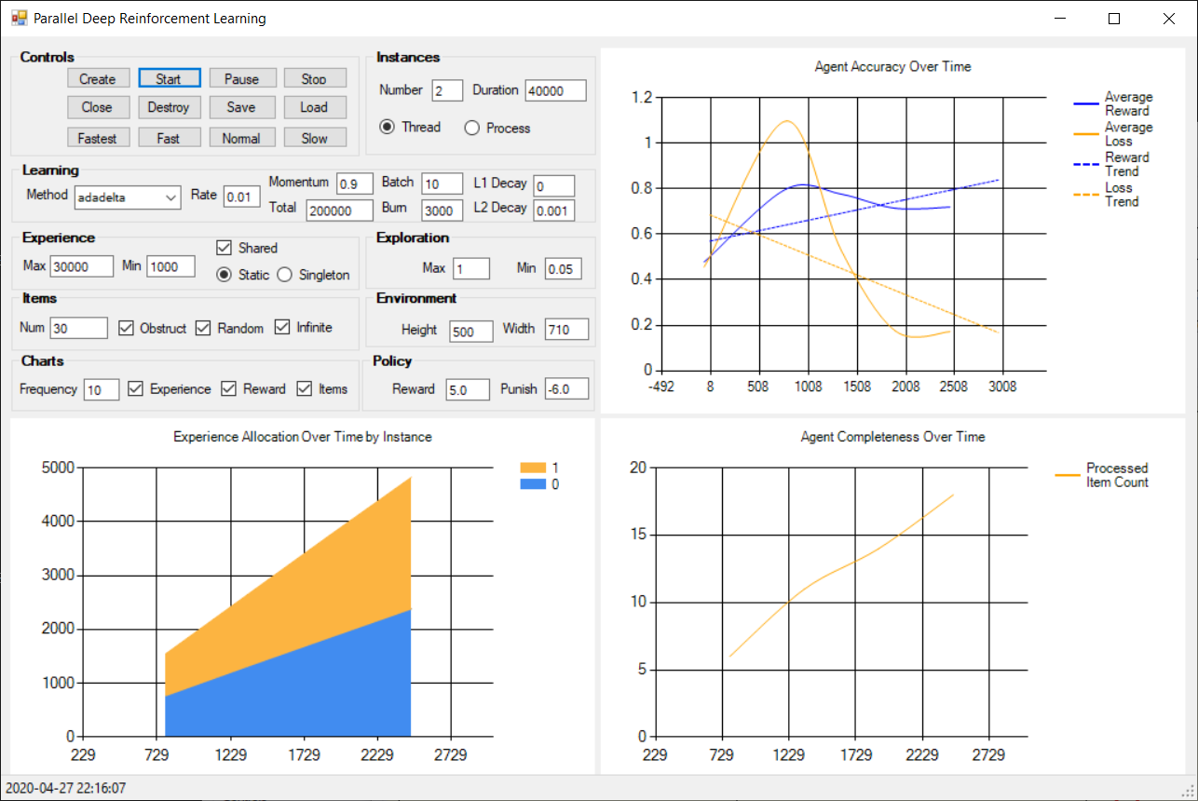

Run DeepQLearning.exe on Windows machine.

Driver (w / thread agents)

1. Click Create to create the agents.
2. Click Start to start agents running
3. The agents will run for the selected default parameter, which include 2 threads for 40k cycles.
4. Click Save to serialize data in the deepQnet#.dat files.
5. Click Destroy to kill agents.
6. Click Close to close driver.

Driver (w/ process agents)

1. Select Process radio button.
2. Click Create to create agents and start running.
3. The agents will run for the selected default parameter, which include 2 threads for 40k cycles.
4. Click Save on each agent to serialize data in the deepQnet#.dat files.
5. Close the agent windows.
6. Click Close to close driver.