Web Forum for Montreal underground music

For this project, I will design a web forum for the purpose of discussing underground music related topics, musical instrument trading/selling, and upcoming or past events. Users will be able to register a profile, keeping information such as usernames/passwords/email/location and desired avatar linked to their profile, which will appear when posting. Users will be able to create and edit their own posts, and create new threads. There will also be an administrator account, with its own set of tools, the ability to create new boards in the forum. Posts will appear in thread oldest to newest. There will be a forum search, to facilitate locating topics being discussed, and the ability to bookmark, or “watch” certain threads for quick access. There will be a post counter attached to each user, visible on their profile page and when posting to threads. Users and admins will also be able to contact each other via private message, inbox/outbox will be visible. Users will be able to register/login with their Facebook account if desired.

Technologies:

-Facebook login

-Admin panel

-Password encryption

-Flash messages (?)

**URLs:**

/forum (or index)

/board/:boardid

/search?keyword=…

/bookmarks – adding could be done nicely via Ajax (later, advanced feature)

/profile /login /register /passrst

/inbox /outbox

**DB tables**

USERS, BOARDS, THREADS, POSTS

Users – UserId, Username, Email, Pass1, Pass2, Avatar, NofPost

Boards – BoardId, ThreadId, Title

Threads – ThreadId, UserId, Title, Date, Replies

Posts – PostId, ThreadId, UserId, Date, Title, Body

Forum index:

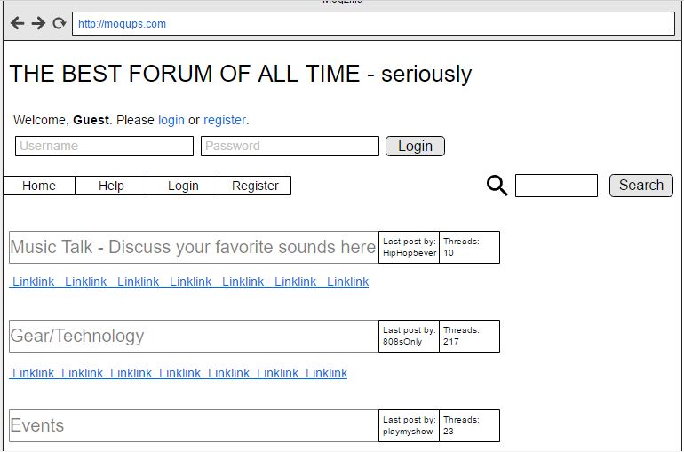

Register:

