Table of Contents
1. Project Title 3
2. Problem Statement 3
3. Objectives 3
4. Contribution 4
4.1 Unified Simulation Engine 4
4.2 Comparative Analysis Mode 4
4.3 CPU Idle Time as a First-Class Metric 4
4.4 Learning Material Inside the Tool 4
4.5 Zero-Setup, Client-Side Execution 5
5. Implementation 6
5.1 Technology Stack 6
5.2 Project Structure 6
5.3 Scheduling Logic 7
5.4 Flowchart 8
5.5 User Interface 10
6. Result 15
6.1 Sample Workload 15
6.2 Interpretation of the Results 15
6.3 Non-Functional Outcome 16
7. Conclusion 17
7.1 Limitations 17
7.2 Future Work 17
References 17

1. Project Title
CPU Scheduling Visualizer — a web-based application that takes a set of processes as input, executes them under five classical CPU scheduling algorithms, draws the resulting Gantt chart, and reports the standard scheduling performance metrics for each algorithm.

2. Problem Statement
CPU scheduling is one of the first topics in Operating Systems where intuition stops being enough. A student can memorise that First Come First Served executes processes in arrival order, or that Round Robin slices CPU time into fixed quanta, but that knowledge remains shallow until the student can actually see how an execution timeline is constructed and understand why one algorithm ends up with a lower average waiting time than another for the same workload.
In practice, this topic is normally learned on paper. Students draw Gantt charts by hand and then compute completion time, turnaround time and waiting time for every process with a calculator. This traditional approach creates several practical difficulties:
- Errors are silent. A single wrong arrival time in a hand-drawn chart quietly corrupts every metric that follows, and the student has no way to tell whether the mistake is conceptual or merely arithmetic.
- Preemptive algorithms are difficult to trace. Shortest Remaining Time First and Round Robin switch between processes repeatedly, and keeping track of the remaining burst time of every process manually becomes tedious and highly error-prone.
- Comparison is impractical. To claim honestly that Shortest Job First performs better than First Come First Served for a given workload, the same problem must be solved five separate times. Almost nobody does this, so the comparison remains a statement copied from a textbook rather than an observation the student has actually made.
- There is no feedback loop. Questions such as "what happens if the time quantum is 2 instead of 4?" cannot be answered quickly, so experimentation rarely happens at all.
The gap addressed by this project is therefore not a shortage of information about scheduling algorithms, but the absence of a fast, reliable and visual environment in which those algorithms can be executed, inspected and compared against one another.

3. Objectives
The project was developed around the following objectives:
- To implement five standard CPU scheduling algorithms — FCFS, SJF, SRTF, Priority Scheduling and Round Robin — correctly and within a single, consistent codebase.
- To allow the user to define an arbitrary workload by entering the number of processes together with the arrival time, burst time and priority of each process, plus a time quantum where the selected algorithm requires one.
- To generate a Gantt chart automatically from the execution sequence produced by the selected algorithm, including the periods during which the CPU remains idle.
- To compute and display per-process metrics — completion time, turnaround time and waiting time — along with average waiting time, average turnaround time, total CPU idle time and total execution time.
- To provide a comparative analysis mode in which two or more algorithms are executed against the same workload and their results are presented side by side, with the best-performing algorithm identified automatically.
- To integrate an algorithm guide that explains the nature of each algorithm, its scheduling rule, its time complexity, and its advantages and limitations.
- To deliver the entire system through a clean and responsive user interface that remains usable on both desktop and smaller screens.

4. Contribution
Several CPU scheduling tools already exist, but most of them stop at a single algorithm and a static table of numbers. The contribution of this project lies in combining simulation, visualization, comparison and explanation into one continuous workflow.

4.1 Unified Simulation Engine
All five algorithms are driven by a common scheduling module that operates on the same process model and produces output in the same structure — an execution timeline together with a per-process result set. Because every algorithm returns its result in an identical shape, the Gantt chart, the metrics table and the comparison view are written once and reused for every algorithm. This also makes the codebase easy to extend.

4.2 Comparative Analysis Mode
This is the feature that distinguishes the project most clearly. Instead of solving the same problem five times by hand, the user enters the workload once, selects the algorithms of interest, and receives every Gantt chart and every metric set together. The textbook statement that "SJF produces the minimum average waiting time" becomes something the user can verify directly, and equally something the user can watch break down when arrival times are staggered.

4.3 CPU Idle Time as a First-Class Metric
Many similar tools report only waiting time and turnaround time. This project additionally tracks total CPU idle time, which exposes the gaps in the timeline where no process has yet arrived — a detail that students frequently overlook when drawing Gantt charts manually.

4.4 Learning Material Inside the Tool
The algorithm guide is placed beside the simulator rather than in separate documentation, so a user who does not understand why SRTF preempted a running process can read the rule and immediately re-run the simulation without leaving the application.

4.5 Zero-Setup, Client-Side Execution
The application is built as a static bundle and runs entirely inside the browser. There is no server component and no database, which means the entire simulation executes on the client side and results appear without any perceptible delay.

5. Implementation

5.1 Technology Stack
The technologies used in the project and the reason behind each choice are summarised below.
Layer | Technology | Reason for selection
User interface | React.js | Component-based structure; a change in state automatically re-renders the chart and the tables
Build tool | Vite | Fast development server and an optimised production bundle
Application logic | JavaScript (ES6+) | Scheduling algorithms implemented as pure functions
Styling | Tailwind CSS, PostCSS | Utility-first styling with consistent spacing and a responsive dark theme
Markup and layout | HTML5, CSS3 | Application shell and custom Gantt chart rendering
Version control | Git and GitHub | Source management and project hosting
Table 1: Technology stack of the CPU Scheduling Visualizer.

5.2 Project Structure
The source tree is organised so that the scheduling logic and the user interface remain fully separated.
CPU-Scheduling/
├── public/
├── src/
│ ├── components/
│ │ ├── AlgorithmResult.jsx → result block for one algorithm
│ │ ├── GanttChart.jsx → execution timeline rendering
│ │ ├── ResultTable.jsx → per-process CT / TAT / WT table
│ │ └── StatCards.jsx → average performance metric cards
│ ├── data/
│ │ └── algorithms.js → algorithm metadata and guide content
│ ├── utils/
│ │ └── scheduler.js → scheduling engine
│ ├── App.jsx → state, input forms, mode switching
│ ├── index.css
│ └── main.jsx
├── index.html
├── package.json
├── tailwind.config.js
└── vite.config.js
This separation is deliberate. The file scheduler.js contains no interface code, and the components contain no scheduling logic. As a result the algorithms can be tested independently, and a sixth algorithm can be added later without modifying the user interface at all.

5.3 Scheduling Logic
Each process is represented as an object holding a process identifier, an arrival time, a burst time and a priority value. The scheduler maintains a simulation clock and, at every decision point, chooses the next process to execute according to the rule of the selected algorithm.
Algorithm | Type | Selection rule | Extra input
FCFS | Non-preemptive | The process with the earliest arrival time among the available processes | —
SJF | Non-preemptive | The process with the smallest burst time among the arrived processes | —
SRTF | Preemptive | The process with the smallest remaining burst time, re-evaluated at every new arrival | —
Priority | Non-preemptive | The process with the smallest priority number among the arrived processes | Priority value
Round Robin | Preemptive | Processes taken in circular order from the ready queue, one time quantum at a time | Time quantum
Table 2: Scheduling rules implemented in the engine. A smaller priority number denotes a higher priority.
If no process has arrived at the current value of the clock, the CPU is marked as idle and the clock is advanced to the next arrival time. That idle block is recorded in the timeline and accumulated into the total CPU idle time. Once the timeline is complete, the performance metrics are derived using the standard formulas:
Turnaround Time (TAT) = Completion Time − Arrival Time
Waiting Time (WT) = Turnaround Time − Burst Time

Average WT = Σ Waiting Time ÷ Number of processes
Average TAT = Σ Turnaround Time ÷ Number of processes
In comparative mode the same process array is passed to each selected algorithm in turn. Because the engine functions are pure and never mutate their input, the algorithms cannot interfere with one another and the results obtained are directly comparable.
5.4 Flowchart
The overall flow of the application, from process input to the display of results, is shown in Figure 1. The scheduling engine referenced in that figure is expanded separately in Figure 2.
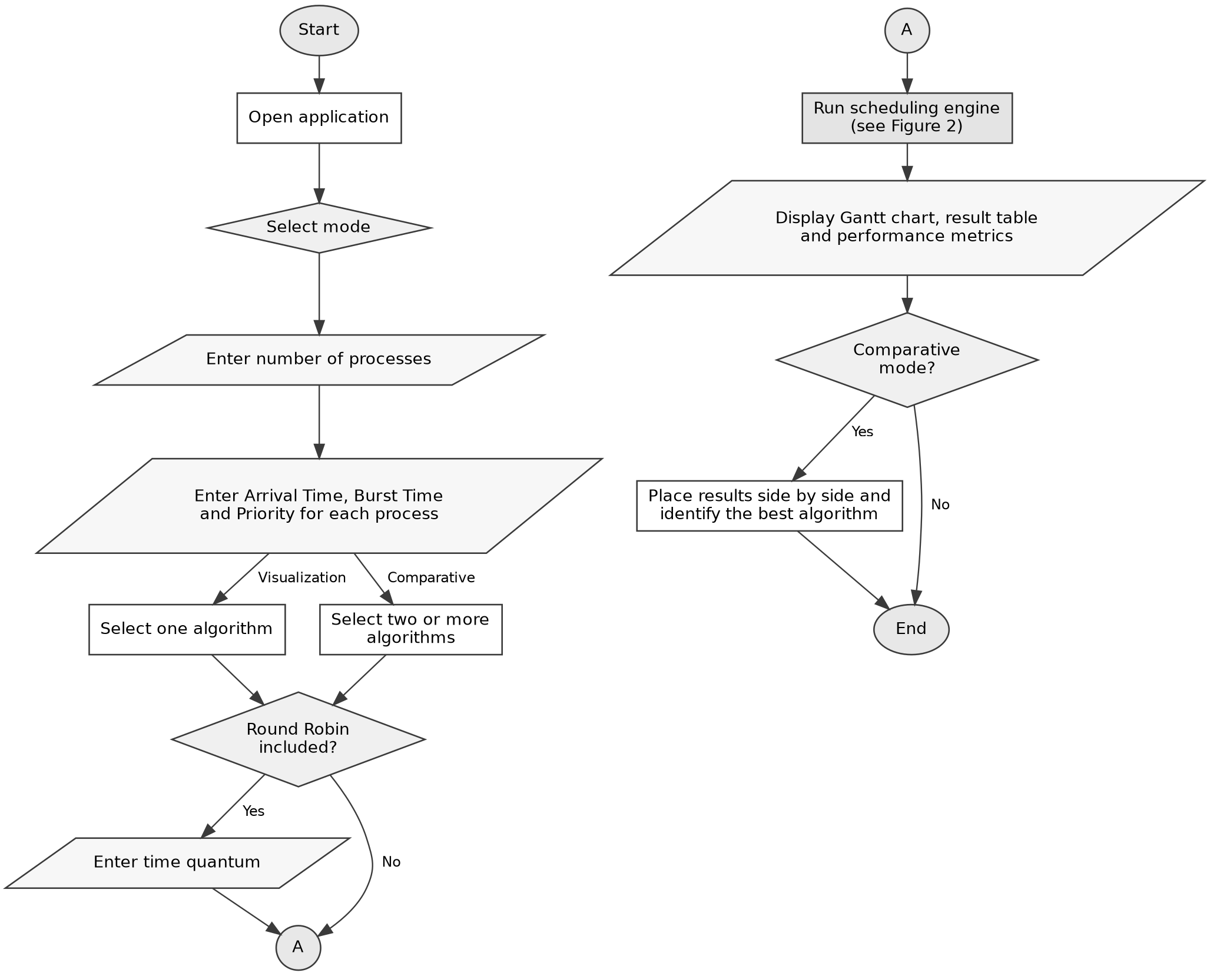
Figure 1: Overall flow of the CPU Scheduling Visualizer.

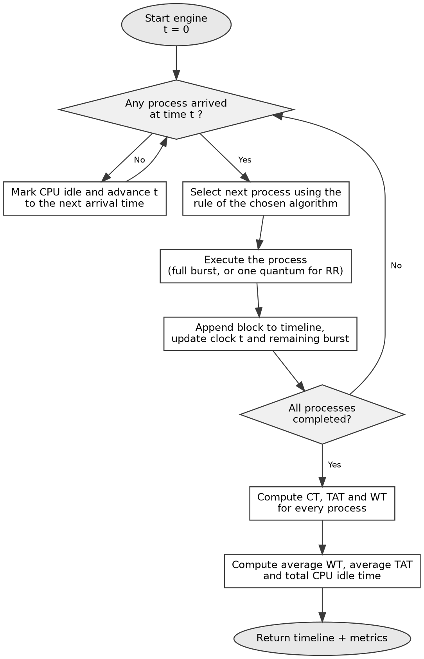
Figure 2: Internal flow of the scheduling engine.
5.5 User Interface
The interface uses a dark theme with clearly separated panels, so that input, execution timeline and performance metrics are never visually confused with one another. The layout is responsive: the panels are arranged side by side on a desktop screen and stack vertically on smaller displays.

5.5.1 Screen Layout
The main screen is organised into the following regions:
Region | Purpose
Navigation bar | Switches between Visualization, Comparative Analysis and the Algorithm Guide
Process input panel | Number of processes, followed by one row per process for arrival time, burst time and priority
Algorithm selector | FCFS, SJF, SRTF, Priority and Round Robin; the time-quantum field appears only when Round Robin is selected
Gantt chart | Horizontal execution timeline in which each block is labelled with its process ID and bounded by its start and end times; idle periods are shown as gaps
Result table | One row per process showing PID, AT, BT, Priority, CT, TAT and WT
Statistic cards | Average waiting time, average turnaround time, total CPU idle time and total execution time
Comparison view | Available in comparative mode: one result block per selected algorithm, followed by a summary that names the best performer
Table 3: Regions of the main application screen.

5.5.2 Interaction Flow
- The user selects a mode — single-algorithm visualization or comparative analysis.
- The number of processes is entered, and the input table expands to that many rows.
- Arrival time, burst time and priority are entered for each process.
- One algorithm, or several in comparative mode, is selected, and a time quantum is supplied if Round Robin is included.
- Running the simulation executes the engine and brings the results into view.
- The inputs can be edited and the simulation re-run immediately, which is what makes experimentation — such as varying the time quantum — practical.

5.5.3 Screenshots of the Application
The following screenshots illustrate the working interface of the application.
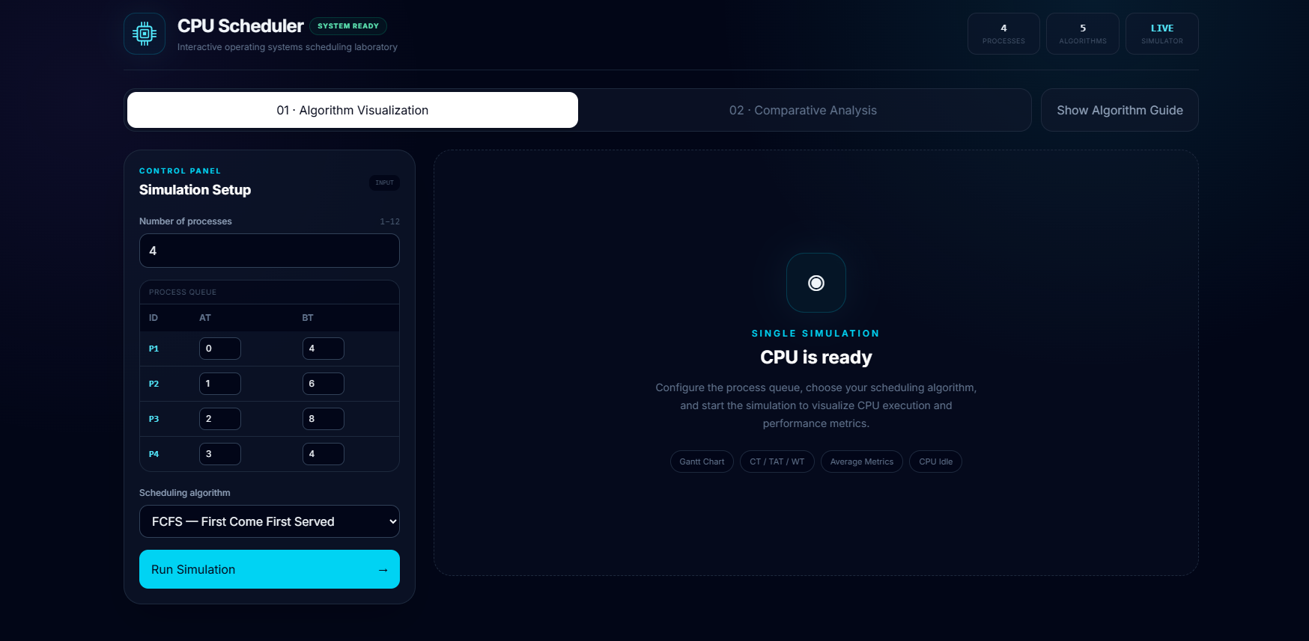
Figure 3: Home screen with the process input panel.
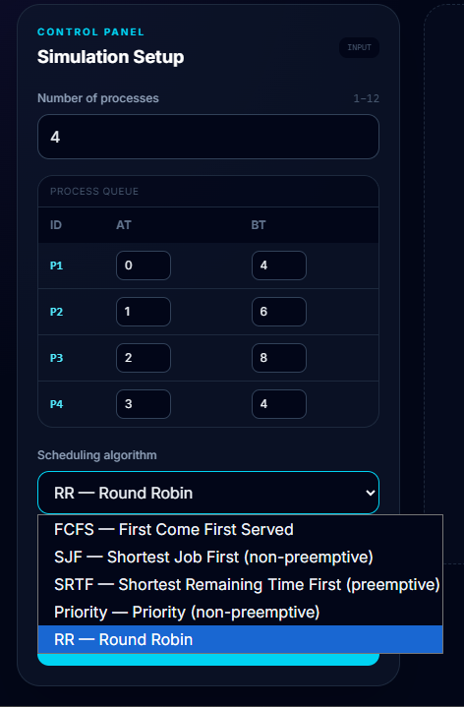
Figure 4: Algorithm selection panel.
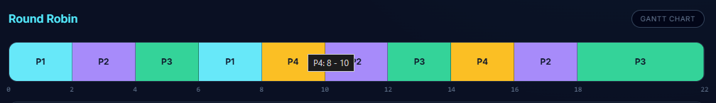
Figure 5: Gantt chart generated for the sample workload.
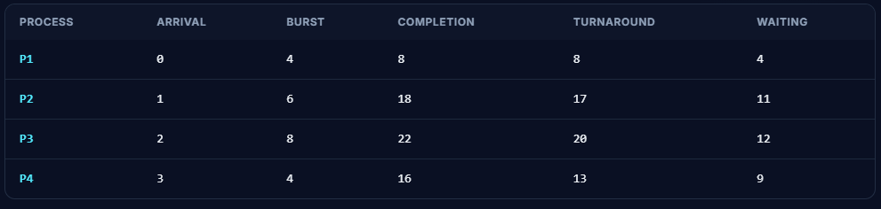
Figure 6: Per-process result table.

Figure 7: Average performance metrics.
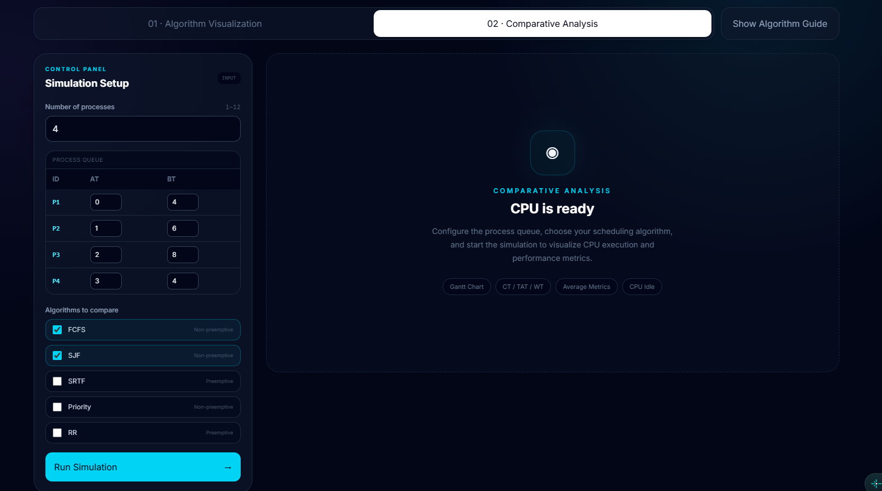
Figure 8: Comparative analysis of multiple algorithms.

Figure 9: Integrated algorithm guide.

6. Result
The application was completed and tested against a range of workloads, including cases with staggered arrival times that force the CPU to idle, and cases in which a shorter process arrives during execution and preempts the running process under SRTF. In every case the generated timeline and the computed metrics matched the results obtained by solving the same problem manually.

6.1 Sample Workload
For the four processes listed below, the application produces the comparative results shown in Table 5.

Process | Arrival Time | Burst Time | Priority
P1 | 0 | 5 | 2
P2 | 1 | 3 | 1
P3 | 2 | 8 | 4
P4 | 3 | 2 | 3
Table 4: Sample input workload.
Algorithm | Average Waiting Time | Average Turnaround Time | Observation
FCFS | 5.50 | 10.00 | P4 waits behind the long P3 despite needing only 2 time units
SJF | 4.25 | 8.75 | Short jobs finish early; P3 is pushed towards the end
SRTF | 3.75 | 8.25 | Lowest averages, at the cost of additional context switches
Priority | 4.75 | 9.25 | P2 runs early because of its priority, not its burst length
Round Robin (q = 2) | 6.25 | 10.75 | Fairest response time, but the highest averages for this workload
Table 5: Comparative results produced for the sample workload.
Note: the values in Table 5 correspond to the sample workload above. If a different workload is used during the demonstration, the table should be replaced with the values reported by the application for that workload.

6.2 Interpretation of the Results
- SRTF consistently produces the lowest average waiting time for workloads of this kind, which matches the theoretical expectation. However, the Gantt chart makes the cost of that advantage visible in the form of a larger number of execution blocks.
- FCFS suffers noticeably when a long process arrives early. The convoy effect, which is usually described only in words, becomes directly observable in the timeline.
- Round Robin trades average performance for fairness. Reducing the time quantum improves responsiveness while increasing the frequency of context switching.
- Priority scheduling can leave a high-burst, low-priority process waiting until the very end of the timeline, which illustrates the starvation problem clearly.
- When arrival times are staggered, the total CPU idle time becomes non-zero, showing that the processor is not necessarily busy for the entire duration of the schedule.

6.3 Non-Functional Outcome
Because the entire simulation runs inside the browser, results are produced without any perceptible delay for workloads of the size typically used in coursework. The production build is a static bundle, and the interface remains usable at mobile screen widths, where wide tables scroll horizontally instead of breaking the layout.

7. Conclusion
The project set out to turn CPU scheduling from something that students calculate on paper into something they can run, observe and compare. That objective has been achieved. The CPU Scheduling Visualizer accepts an arbitrary workload, executes it under five classical scheduling algorithms, draws the resulting execution timeline, reports all of the standard performance metrics, and — through its comparative mode — allows the same workload to be evaluated under several algorithms at once.
Developing the application also reinforced a number of points that are easy to read past in a textbook. Handling CPU idle time correctly required more care than expected, and implementing SRTF made it clear how much bookkeeping preemption genuinely involves. Keeping the scheduling engine separate from the interface proved worthwhile: once the engine returned a consistent output structure, building the comparison view became largely a matter of rendering.
The tool is not a complete operating system simulator, and it was never intended to be. It covers preemptive and non-preemptive CPU scheduling at the level taught in an undergraduate Operating Systems course, and it performs that task reliably.

7.1 Limitations
- Only single-processor scheduling is modelled; multiprocessor and multilevel queue scheduling are not covered.
- Context-switch overhead is treated as zero, as is conventional in classroom problems, so Round Robin appears slightly more favourable than it would be in a real system.
- The Gantt chart is rendered in its final state rather than being animated step by step.

7.2 Future Work
- Step-by-step and animated construction of the Gantt chart, so that the timeline is built in front of the user rather than appearing all at once.
- Additional metrics such as context-switch count, CPU utilization and response time.
- Support for more algorithms, including preemptive Priority Scheduling, Multilevel Queue and Multilevel Feedback Queue scheduling.
- Interactive performance charts in the comparison view, in place of tables alone.
- Export of results as PDF and of comparison data as CSV, so that generated output can be attached to assignments directly.

References
[1] A. Silberschatz, P. B. Galvin and G. Gagne, Operating System Concepts, 10th ed., Wiley.
[2] A. S. Tanenbaum and H. Bos, Modern Operating Systems, 4th ed., Pearson.
[3] React Documentation — https://react.dev
[4] Vite Documentation — https://vitejs.dev
[5] Tailwind CSS Documentation — https://tailwindcss.com/docs

