Maze

Introduction
We will build a maze solving program in Python using TDD techniques. Due to the fact that JES does not support unittest or doctest, we will need to make our own testing ‘framework’ (so-to-speak) for testing our program in the JES environment. All the files you need will be available on Blackboard.
The initial setup is shown here 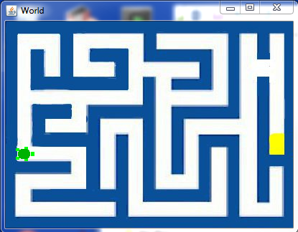 The turtle starts at the left side and will succeed if it finds the cheese which is on the right side of the image.

The Maze Class
We will represent our maze as a Python class. If you are uncertain about how to define a Python class, you should review that at this point. The class will contain the maze image as a JES Picture object. The image of the maze is called maze.jpg. As you follow through this assignment, do each numbered problem.

The First Test
Tests for our program will be in the same file as the program itself. We will have a comment line separating the two halves.
Create a file called maze.py and put the following lines into your program.
# Maze program written by <your name here>

# Tests follow this line
doTests = true
if doTests:
m=Maze()
if m.__class__ == Maze:
printNow(“Test 1 passed, Maze exists.”)
else:
printNow(“Test 1 failed, Maze does not exist.”)

The program will be written between the first two comment lines. I added the variable doTests for the future when we want to load this file in without running all our tests.
When you load this file into JES you should see the first test fail with a message like
======= Loading Progam =======
The error was:Maze
Name not found globally.
A local or global name could not be found. You need to define the function or variable before you try to use it in any way.

- Create a class called Maze to make the test pass. Include a doc string under the class definition explaining the class. Load the file to insure that the first test passes.
Now we want to associate our maze image with the maze class.
- Write a failing test to verify we have an image in our maze object. If m is a Maze object, the image will be pointed to by the Maze instance variable, image.
- Write the code to make this test pass.
So far we have a Maze class and that class loads our maze.jpg image when you create an instance of it. We do not yet have the turtle world or a turtle.
- Write a test to assert there is a ‘world’ for our turtle in the maze. It will be represented by an instance variable called w. Use try: and except: to keep an assertion from spoiling our nice display of test results.
- Write the code to add the ‘world’ for the turtle in the initialization method of Maze. Make the world size equal to the image size. When this test runs, we should see the empty world appear on the screen when it’s created.
- We want to see our maze rather than a blank world. Write a test to check that the world has the maze as its picture. To get the name of the world image, you use m.w.getPicture().fileName. You will need to select the end of the string returned by filename so you don’t compare ‘maze.jpg’ with the entire path.
- Now we need our turtle. Write a test to check for the existence of a turtle in our world.
- Write the code to make the turtle exist in the initialization method of Maze. Create an instance variable called ‘t’ and set it to the result of makeTurtle.
- Now you should see a turtle in the maze sitting on a wall in the center of the image. We need to test that the turtle is in the proper starting location. The coordinates of that location are indicated here.
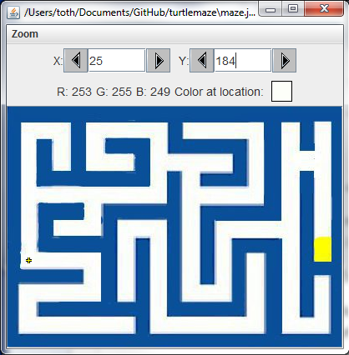
- Write the code to test for the turtle in that location.
- Write the code to make the turtle start in the correct position and pass the previous test.

Moving the Turtle
To solve the maze we need to move the turtle. To move a turtle there is a method called ‘forward’. In solving the maze we want to be able to know when the turtle can and can not move. The turtle should not move through walls. We will detect a wall by looking in the image at a spot just before the turtle. For this we will create a method in Maze called colorInFront. We use getPixelAt and getColor to determine if we are hitting a wall. When we call getPixelAt, we want to give it coordinates in front of the turtle. There are two methods for the Turtle object which give us the coordinates of the turtle; getXPos and getYPos.
- Write a test for the existence of colorInFront.
- Write the code to make it pass. Don’t implement colorInFront yet. Just make it exist. As with all methods you add to the Maze class, make sure it has an informative doc string.
Obviously colorInFront will return white when called at the starting position.
- Write a failing test to see if it returns white.
Now the question arises about how far in front of the turtle should we look for the color. We may want the turtle to be equidistant from the wall in front of it as it is to each side wall. That seems to be a reasonable first choice. From our earlier observations we saw that the turtle is approximately 9 pixels on either side from the walls. That implies we should look 9 pixels in front of the turtle as well.
- Write the code to return the color 9 pixels in front of the turtle when calling colorInFront. You will need to use the heading of the turtle to determine the direction to look from the turtle’s location. You should return pure white even though the actual pixel color is only close to white. For this you should use the distance function and check if the distance is less than 150. If it is, then choose that color and return that pure color from the function. Right now we only have to worry about white but later we will add other colors.
The next test we want may be to have the turtle in front of a wall and check that we get ‘blue’ from colorInFront.
- Write a test that verifies colorInFront returns blue when facing a wall. You can just turn the turtle to the left from the starting position for this.
- Write the code to make this pass. You should only need to add a couple of lines of code to colorInFront to make it pass. You may need to adjust the distance from 9 to 11 since the colors don’t change abruptly everywhere.

Solve Algorithm
Now that we can see in front of the turtle, it is a good time to discuss the algorithm for solving the maze. It is a recursive algorithm which calls itself whenever it gets to a branch in the maze.

