Maze

Introduction
We will be constructing a Python program to solve a maze. The maze is shown below:
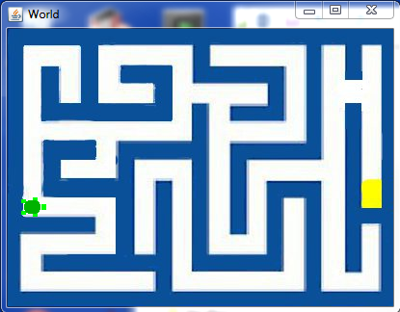
The turtle will look for the cheese (the yellow spot on the right).
The maze will be represented by a class called Maze. The class will contain the maze image as a JES picture. The image of the maze is called maze.jpg. As you follow this tutorial, do each numbered assignment. We will be using TDD to create our program. Since JES does not support the Python testing frameworks like unittest and doctest, we will be making a set of our own tests at the bottom of our program file. Separate the program from the tests with a comment line
# tests
The first task is to create our Maze class. Write a test for the existence of a Maze class as follows:
m = Maze()
Loading in the file now should produce the following error
======= Loading Progam =======
The error was:Maze
Name not found globally.
A local or global name could not be found. You need to define the function or variable before you try to use it in any way.
This is our failing test
- Create a class called Maze to make the test pass. Include a doc string under the class definition. Load the file to insure that the test you made now passes.
Now we want to associate our maze image, maze.jpg, with the maze class. Write a failing test to look at the maze image which we will just call ‘image’ inside the maze object.
# test for image
show(m.image)
You should see the failure of this test when you load the file. The failure should look like this:
The error was:'Maze' object has no attribute 'image'
Attribute not found.
You are trying to access a part of the object that doesn't exist.
- Load the image, maze.jpg, into self.image in the __init__ method. Load the file to insure your test now passes. You should see the maze image displayed on the screen (without the turtle)
So far we have a Maze class and that class loads our maze.jpg image when you create an instance of it. We do not yet have the turtle world or a turtle. First write a test to access the world inside of the maze. To do this just try to access m.w as follows.
world = m.w
You should see the following error when you try to read in the file.
The error was:'Maze' object has no attribute 'w'
Attribute not found.
You are trying to access a part of the object that doesn't exist.
- Create a world called w in the __init__ method. Use the width and height of the image to set the dimensions of the world. Load your file to insure the test for the world existence passes.
You should see a blank image appear. That is the image of our world. It will immediately be covered up by our test for the image so move the image of the maze aside to see the blank world.
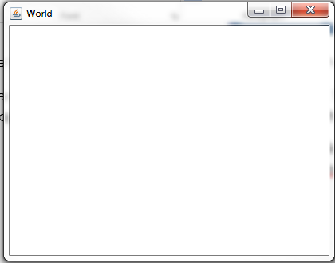
We want to see our maze appear in the world however. Write a test to check that the world has the maze as its picture
p=m.w.getPicture()
assert p.getFileName() != ‘None’, ‘No file name for world picture.’
When you load the file, you should see the following error
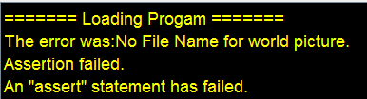
- Not documented in the text book, it is possible to set the world background to an image. To do that, we use a method called setPicture. (type “dir(m.w)” to see the possible methods you can use.) Now set the background to be our image using the setPicture method of our World object. Reload the file to make sure the test now passes

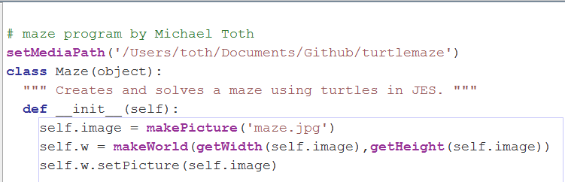

- We need a turtle so that is the next step. Write a test to access the currently non-existent turtle to make a failing test. Then create a turtle in the __init__ method called t. Don’t forget to precede instance variables with the word self. The turtle will be self.t and the world will be self.w. Now when you create a maze you will see the turtle but it’s on a wall in the center of the world view.
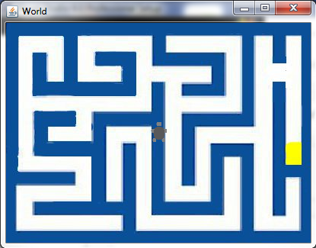

We need to move the turtle to the proper location and orientation. We want the turtle to be where the circle is and pointed to the right. Use explore(m.image) to see what the coordinates are of that spot. Write a failing test to check for the coordinates of the turtle.
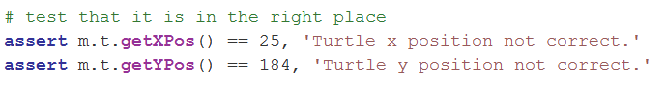
The error should appear
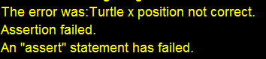

- Once you find the coordinates, move the mouse there and point it to the right (heading = 90). You can use the setHeading method of the Turtle object to change orientation. Make sure you use penUp and penDown to keep from drawing when you move the turtle. Now when you create an instance of Maze, you should see the turtle in the correct starting position and your test should pass.
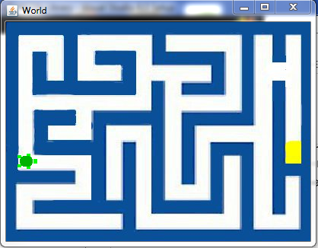

Moving the Turtle
To solve the maze we need to move the turtle. To move a turtle there is a method called forward. In solving the maze we want to be able to know when the turtle can and can not move. The turtle should not move through walls! We will detect a wall by looking in the image at a spot just before the turtle. For this we will create a method in Maze called colorInFront. We use getPixelAt and getColor to determine if we are hitting a wall. When we call getPixelAt we want to give it coordinates in front of the turtle. There are two methods for the Turtle object which give us the coordinates of the turtle; getXPos and getYPos.
- Write a test for the existence of colorInFront.

As before you should see the attribute error
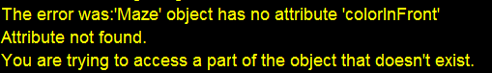
- Create the method called colorInFront to fix this error.
Now we have an empty method and we want to write tests for this method called colorInFront. The first test is to see that colorInFront returns white when we are starting (because the area in front of the turtle is white).
- Write a test to see if we get white from colorInFront so you get the following error.
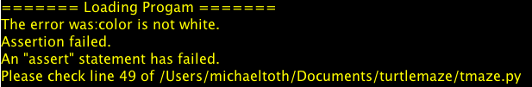

- Add code to colorInFront so it returns the color of the spot 10 pixels in front of the turtle. Load the file to insure it returns white for the starting point of the turtle. The actual color in front of the turtle is not pure white. We will use the distance function to determine how close we are to white and if the distance is less than 150, assume it’s white.
- We also want to see blue when we are up against a wall. Write a test so it fails when we are close to a wall. You will need to move the turtle to another location for this test.
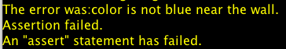
- Now write the code to make it pass

You may have noticed that so far we have not concerned ourselves with the direction the turtle is pointing when we check the value in front of it. We just add to the x position and look at that point. This won’t work when the turtle is facing south, west, or north.
- Add a test for the north direction (heading = 0).
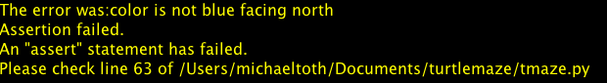
- Now add code to make this test pass.
Keep in mind that the heading of the turtle can be either 90 or -270 for the eastward direction. For the northern direction, it is always 0. (I think)
- Do the same kind of tests for the west and south direction.
Now we have no failures and we can detect walls in front of the turtle. It’s time to discuss the algorithm for solving the maze.
The algorithm will be recursive. Here’s a pseudo code implementation.
- If the cheese is in front of the turtle, return true and play a happy sound.
- Look in all 4 directions around the turtle.
- If you see an empty (white) area, try to solve the maze in that direction. (Call the solve method again.)
- If there are no more places to move, return false
- go to the next empty area around the turtle and try that direction
- If calling solve passes, return true
These six steps form the basis of the solve method we will create. The part that says “solve the maze in that direction” will involve moving to the next location where a turn is possible or necessary. For instance if we hit a wall and we can turn, at that point we call solve again (recursively) with the new location.
Understanding this algorithm will give us clues to our next test. We need to tell the turtle to move to the next spot where it either has to change direction like when it comes to a bend in the path, or can change direction like when there is a path to the right or left as well as straight ahead.
A method called travel2BranchOrWall will be useful. This will move the turtle forward until either it hits a wall or it sees a path to the right or the left.
- Write a test for the existence of travel2BranchOrWall. Orient the turtle so it is facing east at the starting location. Here’s the failure.
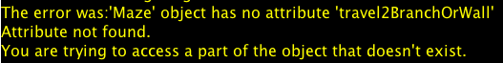

To make this test pass with the turtle in the starting position, we know we will hit the wall before any other choices can be made.
- Now write the first test for travel2branchorwall. If we called travel2branchorwall from the starting position, we would expect to stop at the right-hand turn. Write a test to check if the turtle is there after calling travel2branchorwall.
- Write the code to move the turtle forward until it is against a wall. You should see the turtle there at the end of the test.
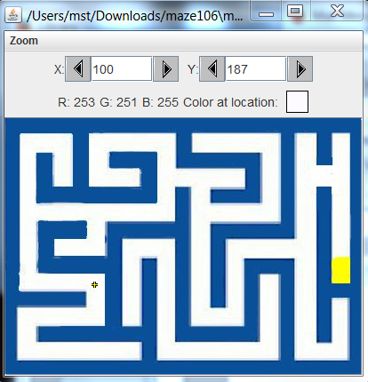
From the explore function we can see we want the turtle to be at 100,187.
- Write the test for calling travel2branchorwall from the starting position.
- Look at where the turtle stopped
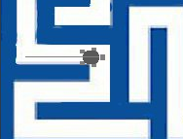
a little too far from the wall. Checking values says 8 more pixels are needed. If we adjust the routine to add 8 more pixels after it discovers the wall, that would fix the problem.
Write the code to do this and then re-run the test.

We are not yet dealing with openings to the left and right. You can see if the turtle heads north from the starting location we want it to stop at the branch to the right. Use explore to find that coordinate. (I get 25,105)
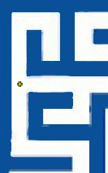
- Write a test to check that the turtle stops at the branch when heading north from the starting location. It should fail.
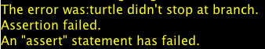
Writing the code to make this pass is a little trickier. With the turtle facing north at the starting location, we have a path to the right already but we don’t want to stop for that path because that path is going to be the first one we try. We don’t want to go into places we already visited. So we need to move forward enough so we don’t see that passage to the right before we start checking for another one. If we move forward first until we don’t have that branch in our sights, then we can start checking for paths to the right and left. It might be convenient to have a function that gives us a description of all four directions at once and we can use that to make decisions.
- Write a test for a function called surroundings that will return a list of 4 items. Each item can have the following possible values; ‘empty’,’wall’,’visited’,’end’. Just write the test for the existence of the method.
- Add the method to the class. Don't implement it yet. Just add it to the class
We are introducing a new term, 'visited' now. There are four different states that a position in the maze can have; empty, visited, end, and wall. End is when you reach the cheese. There is only one place where you will find that. Wall is of course a wall, empty is an unexplored region, and visited is when i've been there before. So we need to mark the places we go so we know that we have been there before. By its nature, the turtle leaves a trail with its pen. What if we used that as a marker to indicate we have visited this spot before?
Here's the problem. The line you see made by the turtle is not on the image but on another graphics layer above the image. In fact, there is no way I know of to get that pixel value. So we will need to draw on the image to mark where we have gone. We need to mimic the way the turtle is drawing by drawing on the image ourselves as we move. This means we can't call forward and expect our line to be drawn on our image. We need to make our own version of forward which also draws on our image.
- We need a method to return the color of our current spot. Write the test for that
- Write the code to make it pass.
We need to draw a green spot every time we move in our travelForward method to mark the space we were in as ‘visited’. If we travel forward from our starting position, the space behind us should be marked as ‘visited’
- Make a test that surroundings returns ['empty','wall','visited','wall'] after moving the turtle forward 30 pixels.
- Make a method called travelForward which will place a 10 pixel wide filled circle at the current turtle location and move forward 1 pixel. An argument called 'dist' will be how many times to move. If dist is equal to 10, then there will be 10 circles drawn and the turtle will have moved 10 pixels.
You may notice at this point your test for surroundings is still failing. Even though we are marking the spot we have been, Why is that? Looking back at the code, you may notice so far we have only had to deal with blue and white. Now we add green to the list and we need to modify colorInFront.
- Add green to our choices of color in colorInFront and currentColor
At this point you should be in the GREEN condition where you have no errors.
Now all this work to get surroundings to behave was in order to deal with the problem of stopping at a branch in the maze. It is a convenient way to quickly see what's around us as we travel2branchorwall.
- Add a test that we stop at the branch when we are going north. Use explore to pick the spot you want the turtle to stop and then write the test. Keep in mind your x value should not change from the starting position otherwise it won't work.
- If you look at the maze now you will see the turtle up against the wall instead of at the branch.
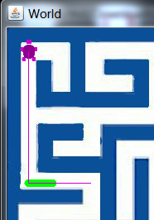
What happened to our green line when we go north? We need to modify travel2branchorwall so it calls our travelForward method instead of forward. Do this and load the file again.
- To make our test pass we need to monitor the surroundings as we go to see if there is more than one ‘empty’ state in each of the four directions. When we get to that condition, we want to stop at the location shown below. We have written our test, now change travel2BranchOrWall to monitor the right and left directions for an opening while we travel.
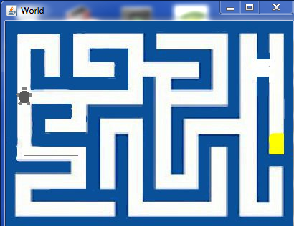
- Now you may notice your first test for moving to the wall is now failing. This is because the space to the left of the turtle is empty and that is noticed by the travel2BranchOrWall method. We need to add some code to move the turtle a bit before we monitor for right or left turns. Add code to fix this problem.
- At this point all tests should pass and your turtle should stop at branches to the right and left. It’s time to start implementing the solve method. Write a test for the existence of the solve method.
- Write the solve method but don’t implement it yet.
- Since solve is recursive it’s harder to test. First we will put the turtle so it’s pointing directly at the cheese and check to see if it solves that simple problem. Write a test to verify that solve returns true when starting in that location. 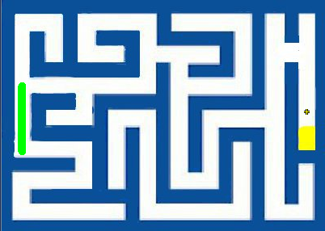
- Of course it will fail since we do not have it implemented yet. Since the solve routine is recursive, we need stopping conditions. We will put those in first. The first stopping condition is that if the cheese is in front of the turtle, we have solved the maze and should return true. Put that in the solve method.
- Now let’s put the turtle above the cheese so it has to travel to get to it. Write that test.
- The reason we didn’t solve it was because the turtle is not yet moving. Add code to make the turtle move forward to the next branch or wall. You will need to first move the turtle a bit so the space behind it does not show up as ‘empty’. Otherwise travel2BranchOrWall will stop thinking it is at a branch. You will also need to modify travel2BranchOrWall to stop at the cheese.
There is a need to change the color of our trail if we are backtracking over visited areas. If we don’t change the color, we will solve the maze but the solution will be unclear because all the trails we took are green. If we change them to red when we fail in a certain direction, we will see the final solution in green.
- Write a test to verify that if we move forward, turn around and move back, the color in our trail is now red.

- The way the algorithm works, we want to call solve for each of the four directions that the turtle can move at any given point. First call solve for the forward direction, then to the right, behind, and then finally to the left. We check the result from each of those four directions. If we orient the turtle to face north, it will first check that direction, then look to the east. It should see a wall to the east so it will then check to the south, and finally to the west. Write a test so the mouse starts facing north at the same location as the last test. In this case we want the space behind the turtle to be empty so we won’t move it forward first.
- The next test will use the section of the maze with no outlet.
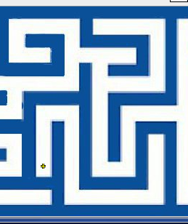
Write a test to call solve from this location.
- You may see it fail depending on how you implemented solve so far. If it did not return false, you need to fix your code to make this test pass.
- Are we done? Let's see. Put a test to see if it solves the puzzle.
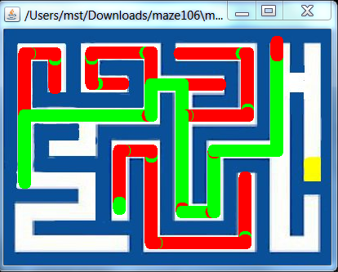

Looks like we have another problem. Something funny going on at the wall in the upper right hand corner. It stopped there and this is the error
getPixel(picture,x,y): y (= -1) is less than 0 or bigger than the height (= 287)
ValueError:
Please check line 36 of C:\Users\mst\Downloads\maze106\tmaze.py
And looking at the code shows
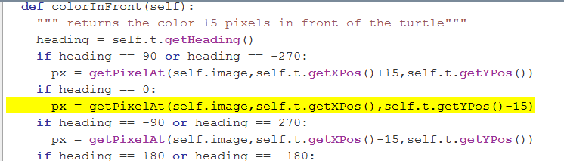
So we are getting too close to the edge of the picture. Our turtle is going all the way to the pixel with the y value = 14. Something is wrong with our algorithm to stop at the wall.
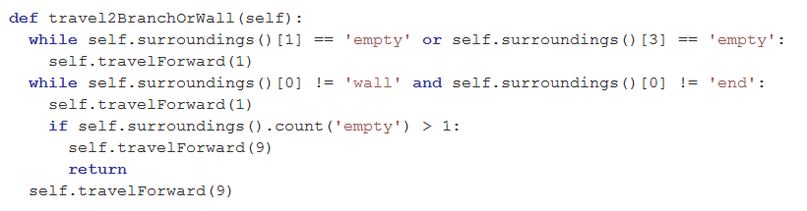
We skip forward too many times because of the geometry of the walls. We skip forward 9 when we get to the branch and then skip forward again. Write a test to travel2branchorwall twice from the point before the branch and see if we are correct.

Assignment Solutions
- 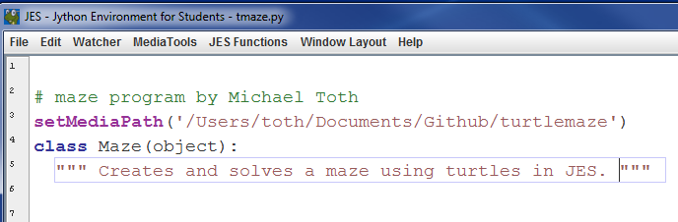
- 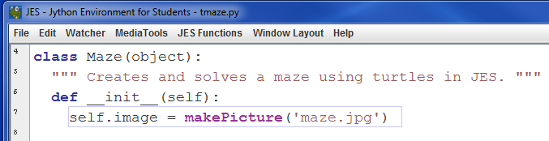
- 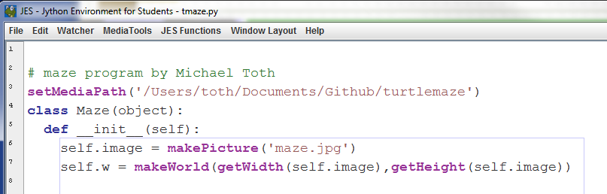

- penUp(self.t)
moveTo(self.t,25,184)
self.t.setHeading(90)
penDown(self.t)

- penUp(self.t)
moveTo(self.t,25,184)
self.t.setHeading(90)
penDown(self.t)

- 
 