Maze

Introduction
We will build a maze solving program in Python using TDD techniques. Due to the fact that JES does not support unittest or doctest, we will need to make our own testing ‘framework’ (so-to-speak) for testing our program in the JES environment. All the files you need will be available on Blackboard.
The initial setup is shown here 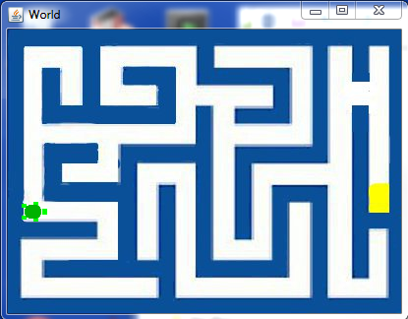 The turtle starts at the left side and will succeed if it finds the cheese which is on the right side of the image.

The Maze Class
We will represent our maze as a Python class. If you are uncertain about how to define a Python class, you should review that at this point. The class will contain the maze image as a JES Picture object. The image of the maze is called maze.jpg. As you follow through this assignment, do each numbered problem.

The First Test
Tests for our program will be in the same file as the program itself. We will have a comment line separating the two halves.
Create a file called maze.py and put the following lines into your program.
# Maze program written by <your name here>

# Tests follow this line
doTests = true
if doTests:
m=Maze()
if m.__class__ == Maze:
printNow(“Test 1 passed, Maze exists.”)
else:
printNow(“Test 1 failed, Maze does not exist.”)

The program will be written between the first two comment lines. I added the variable doTests for the future when we want to load this file in without running all our tests.
When you load this file into JES you should see the first test fail with a message like
======= Loading Progam =======
The error was:Maze
Name not found globally.
A local or global name could not be found. You need to define the function or variable before you try to use it in any way.

- Create a class called Maze to make the test pass. Include a doc string under the class definition explaining the class. Load the file to insure that the first test passes.
Now we want to associate our maze image with the maze class.
- Write a failing test to verify we have an image in our maze object. If m is a Maze object, the image will be pointed to by the Maze instance variable, image.
- Write the code to make this test pass.
So far we have a Maze class and that class loads our maze.jpg image when you create an instance of it. We do not yet have the turtle world or a turtle.
- Write a test to assert there is a ‘world’ for our turtle in the maze. It will be represented by an instance variable called w. Use try: and except: to keep an assertion from spoiling our nice display of test results.
- Write the code to add the ‘world’ for the turtle in the initialization method of Maze. Make the world size equal to the image size. When this test runs, we should see the empty world appear on the screen when it’s created.
- We want to see our maze rather than a blank world. Write a test to check that the world has the maze as its picture. To get the name of the world image, you use m.w.getPicture().fileName. You will need to select the end of the string returned by filename so you don’t compare ‘maze.jpg’ with the entire path.
- Now we need our turtle. Write a test to check for the existence of a turtle in our world.
- Write the code to make the turtle exist in the initialization method of Maze. Create an instance variable called ‘t’ and set it to the result of makeTurtle.
- Now you should see a turtle in the maze sitting on a wall in the center of the image. We need to test that the turtle is in the proper starting location. The coordinates of that location are indicated here.
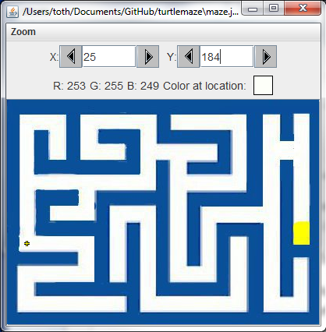
- Write the code to test for the turtle in that location.
- Write the code to make the turtle start in the correct position and pass the previous test.

Moving the Turtle
To solve the maze we need to move the turtle. To move a turtle there is a method called ‘forward’. In solving the maze we want to be able to know when the turtle can and can not move. The turtle should not move through walls. We will detect a wall by looking in the image at a spot just before the turtle. For this we will create a method in Maze called colorInFront. We use getPixelAt and getColor to determine if we are hitting a wall. When we call getPixelAt, we want to give it coordinates in front of the turtle. There are two methods for the Turtle object which give us the coordinates of the turtle; getXPos and getYPos.
- Write a test for the existence of colorInFront.
- Write the code to make it pass. Don’t implement colorInFront yet. Just make it exist. As with all methods you add to the Maze class, make sure it has an informative doc string.
Obviously colorInFront will return white when called at the starting position.
- Write a failing test to see if it returns white.
Now the question arises about how far in front of the turtle should we look for the color. We may want the turtle to be equidistant from the wall in front of it as it is to each side wall. That seems to be a reasonable first choice. From our earlier observations we saw that the turtle is approximately 9 pixels on either side from the walls. That implies we should look 9 pixels in front of the turtle as well.
- Write the code to return the color 9 pixels in front of the turtle when calling colorInFront. You will need to use the heading of the turtle to determine the direction to look from the turtle’s location. You should return pure white even though the actual pixel color is only close to white. For this you should use the distance function and check if the distance is less than 150. If it is, then choose that color and return that pure color from the function. Right now we only have to worry about white but later we will add other colors.
The next test we want may be to have the turtle in front of a wall and check that we get ‘blue’ from colorInFront.
- Write a test that verifies colorInFront returns blue when facing a wall. You can just turn the turtle toward a wall from the starting position for this.
- Write the code to make this pass. You should only need to add a couple of lines of code to colorInFront to make it pass. You may need to adjust the distance from 9 to 11 since the colors don’t change abruptly everywhere.

Solve Algorithm
Now that we can see in front of the turtle, it is a good time to discuss the algorithm for solving the maze. It is a recursive algorithm which calls itself whenever it gets to a branch in the maze.
  - If the cheese is in front of the turtle, return true and play the ‘end.wav’ sound.
  - If there is no place to move, return false
  - For any unexplored areas around the turtle, call solve for that direction and return the result

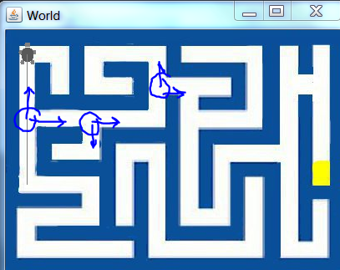
Understanding this algorithm will give us clues to our next test. We need to tell the turtle to move to the next spot where it either has to change direction like when it comes to a bend in the path, or can change direction like when there is a path to the right or left as well as straight ahead. At each of the circles drawn we call solve again. That is, solve will call itself. Every time we call solve, it is for only a straight segment. Whenever there is a turn or a choice, solve is invoked again so the depth of the calling is however many choices are made on the way to the cheese.
A method called travel2BranchOrWall will be useful. This will move the turtle forward until either it hits a wall or it sees a path to the right or the left.
- Write a test for the existence of travel2BranchOrWall.
- Create the method and put your doc string in. Don’t implement it yet. Verify it makes your test pass.
At this point in time we have the turtle facing a wall and we most likely will want to remove any side effects of previous tests. A useful method may be to have a reset for the maze which clears the conditions to the starting conditions, moving the turtle to its starting location and orienting it properly.
- Write a failing test for the existence of reset.
- Create the method with the doc string but don’t implement it
- Write the code to test that the maze is in its initial condition
  - The turtle at 25,184 facing east.
  - The image reloaded from disk to clear any paths we have drawn with the turtle.
- Write the code to make the previous test pass. You can use the clearPath method of the turtle to erase previous paths drawn.
The reset method will be useful when we have tests that displace the turtle.
Now we should be about ready to implement travel2BranchOrWall. As always, first the test. After travel2BranchOrWall, we expect the turtle to be at this location after a call to reset.
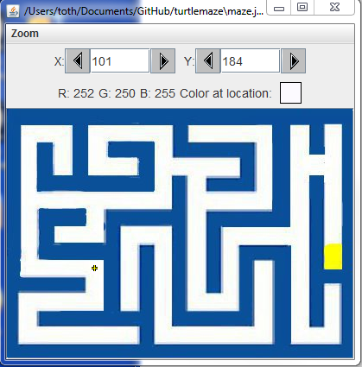 Since we are at 25,184 to start, the y value should stay at 184 and the x value should be 11 pixels before the wall.
- Write the test to check if we are at the proper location after travel2BranchOrWall.
- Write the code to implement travel2BranchOrWall. We only care about making the first test pass, not getting the entire method finished in one step. Just worry about getting the turtle to the wall for now.
If you implemented travel2BranchOrWall, you will land in the right spot for the eastward direction. If you now try it in the north direction (heading = 0) then you will see it doesn’t stop at the branch. When we go north, we want to stop at this location.
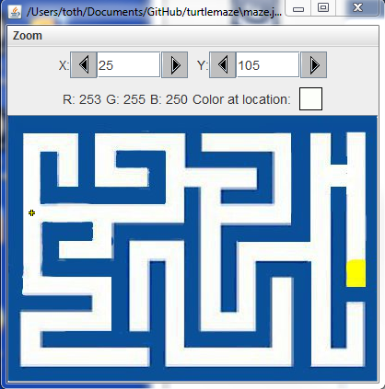
- Write a test for the northern path using travel2BranchOrWall.
Of course we know why it doesn’t stop there. We haven’t implemented the code for that yet. There are some things to consider when we write the code to make this test pass.
- What are the conditions that tell us we are at a branch?
- After those conditions are met do we need to make any adjustments to the turtle position?
The conditions for a branch are that we have more than one choice to make in our direction. If we have more than one empty space around the turtle, we have a choice to make.
It would be convenient to have a method which will return an array of 4 values that tell us what is ahead, to the right and left, and behind us. If we had that, we could check it each time we move to see if we are at a branch.
There are four possible states for any position on the maze; 'empty', 'wall', 'end', and 'visited'. We only have three colors right now; white, blue, and yellow. We need to remember where we have been so places that we have been are considered 'visited'. We will pick green for visited. This means that whenever we move, we need to leave a green trail. It is tempting to try to use the trail left naturally by the turtle however that color information is not available to us. As a result, we need to draw a green path on the image as we travel.

- Write a test that we are leaving a green trail. (One way is move forward, turn around, and check if the return value of colorInFront is green)
Now we can create our own forward method in the maze which will call the system forward function but also leave a green filled circle where it has been.

- Write the code to draw a green filled circle when you move forward. (call it 'forward(self,dist)' and inside the method, call forward(1) 'dist' times, each time drawing the circle first.) (You will need to understand how the coordinates passed in to the drawFilledOval routine work with where the circle is placed)
Now we want to have that function that gives us our surroundings. The test should be
- Write a test for the return value of surroundings to be [white,blue,blue,white] when we have reset.
- Write the code to make it pass.
- Now utilize surroundings and use it while we travel2BranchOrWall to stop at the condition there is more than one white entry in the list. You will run into the problem of starting out with more than one white direction. If so, just go forward until that condition is passed and proceed until you see more than one white value in the array.
What you should find is that now test 13 is failing. This is because we now stop when we get to the right turn. We want to go a little farther. To make the test pass, we want to go 8 more pixels. Add that to the travel2branchorwall function. Make sure you use self.forward when you go the extra 8 pixels otherwise it won't leave the green trail.
This should be a green condition time.
Now we are about ready to implement solve. First test that we get success when starting just at the cheese.

- Write a test that checks for solve() passing back true when the turtle is at the cheese.
- Implement that code to make it pass. (Implement the condition for success)
The next test will be to fail if we start in an impossible place like the isolated region.

