Update Measurement %%% 3
clc, clear
close all
%%%%%% DETERMINE S/C POSITION AND VELOCITY BASED ON ORBITAL ELEMENTS %%%%%%
% Generate values for spacecraft's state (position, velocity, acceleration)
height = 1000*1000; % height above Earth (m) (assume circular orbit at 1000 km)
Rearth = 1000*6378; % radius of Earth (m)
alt = Rearth+height; % altitude of orbit (m)
e = 0; % eccentricity (rad) (circular orbit = 0)
i = 45*(pi/180); % inclination in rad (polar orbit = 90 deg)
w = 0; % right ascension of ascending node (rad)
Omega = 0; % argument of periapsis (rad)
nu = 0; % true anomaly (rad)
t = [0:12*60*60]'; % 12 hours of data - time vector for ode45 (sec)
% Propagate elements for length of time specified in t vector using ode45
[R,V] = elementstoRV(alt,e,i,w,Omega,nu);
x = [R; V]; % [m, m/s]
options = odeset('abstol',1e-8,'reltol',1e-8);
[t1,z_true] = ode45(@earthgravity_m,t,x,options);
Pos_ECI = z_true(:,1:3); % ECI [m]
Vel_ECI = 1000*z_true(:,4:6); % ECI [mm/s]
%%%%%%%%%%%%%%%%%%%%%%%%%%%%%%%%%%%%%%%%%%%%%%%%%%%%%%%%%%%%%%%%%%%%%%%%%%%
angvel = 7.292e-5; % angular velocity of Earth (rad/s)
% ECEF Coordinates
n = 60;
for m = 1:length(t1)
if m+1 > length(t1)
break
end
if m == 1
theta(m) = angvel*(t(m+1)-t(m)); % rad
else
theta(m) = theta(m-1) + angvel*(t(m+1)-t(m));
end
rot = [cos(theta(m)) -sin(theta(m)) 0;
sin(theta(m)) cos(theta(m)) 0;
0 0 1];
Pos_ECEF(m,:) = rot*Pos_ECI(m,:)';
Vel_ECEF(m,:) = rot*Vel_ECI(m,:)';
lat_calc(m) = (180/pi)*(asin(Pos_ECEF(m,3)/norm(Pos_ECEF(m,:)))); % deg
long_calc(m) = (180/pi)*(atan2(Pos_ECEF(m,2),Pos_ECEF(m,1))); % deg
end
load coord.mat;
% % Plot orbit to check
% figure, plot3(Pos_ECEF(:,1),Pos_ECEF(:,2),Pos_ECEF(:,3))
% xlabel('x')
% ylabel('y')
% zlabel('z')
% grid on
% axis equal
% %
% figure
% plot(long,lat,'k')
% hold on
% plot(long_calc(1:n:end),lat_calc(1:n:end),'*')
% Initialize variables
rsc = Pos_ECI(:,1:3); % ECI [m]
Vel = Vel_ECI(:,1:3); % ECI [m/s]
xtrue = [rsc'; Vel']; % ECI [m, mm/s]
% Define constants
sigma_pos = 500; % 100 m
sigma_vel = .05; % 1 mm/s
sigma_theta = 0.01*(pi/180); % 0.01 deg (converted to rad)
T_IC = eye(3,3); % rotation matrix from camera to inertial frame, assuming camera is nadir
options = odeset('abstol',1e-8,'reltol',1e-8); % set tolerances for ode45
for mc = 1 % for monte carlo analysis
mc
% Create perturbed initial state
rsc = xtrue(1:3,1) + 0*sigma_pos*randn(3,1); % use initial position with added noise
rscdot = xtrue(4:6,1) + 0*sigma_vel*randn(3,1); % use initial velocity with added noise
% Build state vector and covariance [m, mm/s]
x = [rsc; rscdot]; % create initial state matrix
P = [sigma_pos^2*eye(3), zeros(3); zeros(3), (1000*sigma_vel)^2*eye(3)]; % create initial P matrix
z = [x; reshape(P,36,1)]; % compile state and covariance into column vector
n = 60;
xtrue_short = xtrue(:,1:n:end);
xhatminus(:,1) = x;
xhatplus(:,1) = x;
PlotP(1,:) = reshape(P,36,1);
% % Inputing initial camera quaternion
% thetacam = 90*pi/180;
% e_thetacam = [0,1,0]/norm([0,1,0]);
% qcam = [sin(thetacam/2)*e_thetacam cos(thetacam/2)];
z_true = z(1:6)';
err = [];
for k_old = 1:n:length(t)
if k_old+1 > length(t)
break
end
if k_old == 1
k = 2;
else
k = ((k_old-1)/n)+2;
end
[t2,Posout] = ode45(@earthgravity,0:60,z_true(end,:)',options);
if k_old == 1
T2 = t2;
true2 = Posout;
else
T2 = [T2; t2+T2(end)]; % ECI
true2 = [true2; Posout]; % ECI
end
[t1, z1] = ode45(@integrate,0:60,z,options); % integrate z to find xdot and Pdot
zminus = z1(end,:);
z_plot(k,:) = zminus;
if k_old == 1
T = t1;
z_prop = z1;
err = z_prop(:,1:6)-true2(:,1:6);
% err_vel = z1(:,4:6)-rscdot';
else
T = [T; t1+T(end)];
z_prop = [z_prop; z1];
err = z_prop(:,1:6)-true2(:,1:6);
% err_vel = [err_vel; z1(:,4:6)-rscdot'];
end
% size(err)
% Obtain Estimated State Values
xhatminus(:,k) = [zminus(1:6)]';
Pminus = reshape(zminus(:,7:42),6,6); % reshape into 6x6 matrix
Pminus = 0.5*(Pminus + Pminus');

Update Measurement %%%
Find FOV footprint limits in terms of lat/long coordinates Specify Desired FOV and calculate footprint size (GIFOV)
FOV = 30*(pi/180); % rad
GIFOV = 2*(alt-Rearth)*tan(FOV/2); % km
% Landmark Observation
[lat_obs,long_obs,height_obs] = ECEF2latlong(Pos_ECEF(k,1),Pos_ECEF(k,2),Pos_ECEF(k,3));
delta_lat = GIFOV/110.54e3; % convert to m [1deg = 110.54 km]
delta_long = GIFOV/(111.32e3*cos(lat_obs*(pi/180))); % convert to m [1deg = 111.32*cos(lat)]
top = [lat_obs+delta_lat, long_obs+delta_long]; % convert to m [1deg = 111.32*cos(lat)]
left = [lat_obs+delta_lat, long_obs-delta_long];
bottom = [lat_obs-delta_lat, long_obs-delta_long];
right = [lat_obs-delta_lat, long_obs+delta_long];
box = [top; left; bottom; right];
% figure, plot(box(1,1),box(1,2),'*',box(2,1),box(2,2),'*',box(3,1),box(3,2),'*',box(4,1),box(4,2),'*')
% dist = acos(sin(lat(k)*(pi/180))*sin(lat(k+1)*(pi/180))+cos(lat(k)*(pi/180))*cos(lat(k+1)*(pi/180))*cos((long(k)-long(k+1))*(pi/180)));
% Check for coastline points within footprint limits
coordfind = find(lat < max(box(:,1)) & lat > min(box(:,1)) & long < max(box(:,2)) & long > min(box(:,2)));
if isempty(coordfind) == 0
if length(coordfind) > 1
latlong_est = [lat(coordfind(1:2)) long(coordfind(1:2))];
number = 2;
else
latlong_est = [lat(coordfind(1)) long(coordfind(1))];
number = 1;
end
for num = 1:number
[ox, oy, oz] = geo2ECI(latlong_est(num,1)+10*randn(1),latlong_est(num,2)+10*randn(1),height_obs); % vector of landmark
o = [ox; oy; oz];
% Compute measurement
s_true = o-xtrue_short(1:3,k);
eI_true = s_true/norm(s_true);
y_true = T_IC*eI_true;
dv = sigma_theta*randn(3,1); % generate random noise for position vector
dT = v_to_T(dv); % rotation matrix based on random noise in position vector of camera
y = dT*y_true;
s = o-xhatminus(1:3,k); % find LOS vector
s_norm = norm(s); % normalize LOS vector
eI = s/s_norm; % find unit vector in direction of inertial frame
h = T_IC*eI;
H = T_IC*(1/norm(s_true))*[eI*eI'-eye(3) zeros(3)]; % measurement sensitivity matrix
R = sigma_theta^2*(eye(3)-eI*eI'); % measurement covariance matrix
K = (Pminus*H')/(H*Pminus*H'+R+(0.5*trace(R))*(eI*eI')); % find optimal Kalman gain
xhatplus(:,k) = xhatminus(:,k) + K*(y-h); % state update
Pplus = (eye(6)-K*H)*Pminus*(eye(6)-K*H)' + K*R*K'; % covariance update
end
else
fprintf('No Coastline at k = %f. \n',k)
Pplus = Pminus;
xhatplus = xhatminus;
end
PlotP(k,:) = reshape(Pplus,36,1); % reshape P into vector
errX(:,k) = [xhatplus(1:3,k)-xtrue_short(1:3,k); (xhatplus(4:6,k)-xtrue_short(4:6,k))]; % Plot error
x = xhatplus(:,k); % update state measurement
P = Pplus; % update covariance measurement
z = [x; reshape(P,36,1)]; % compile state and covariance into column vector
end
mc =
1
No Coastline at k = 444.000000.
No Coastline at k = 445.000000.
No Coastline at k = 446.000000.
No Coastline at k = 447.000000.
No Coastline at k = 448.000000.
No Coastline at k = 449.000000.
No Coastline at k = 450.000000.
No Coastline at k = 451.000000.
No Coastline at k = 452.000000.
No Coastline at k = 453.000000.
No Coastline at k = 454.000000.
No Coastline at k = 455.000000.
No Coastline at k = 456.000000.
No Coastline at k = 457.000000.
No Coastline at k = 458.000000.
No Coastline at k = 459.000000.
No Coastline at k = 460.000000.
No Coastline at k = 461.000000.
No Coastline at k = 462.000000.
No Coastline at k = 463.000000.
No Coastline at k = 464.000000.
No Coastline at k = 465.000000.
No Coastline at k = 466.000000.
No Coastline at k = 467.000000.
No Coastline at k = 468.000000.
No Coastline at k = 469.000000.
No Coastline at k = 470.000000.
No Coastline at k = 471.000000.
No Coastline at k = 472.000000.
No Coastline at k = 473.000000.
No Coastline at k = 474.000000.
No Coastline at k = 475.000000.
No Coastline at k = 476.000000.
No Coastline at k = 477.000000.
No Coastline at k = 478.000000.
No Coastline at k = 479.000000.
No Coastline at k = 480.000000.
No Coastline at k = 481.000000.
No Coastline at k = 482.000000.
No Coastline at k = 483.000000.
No Coastline at k = 484.000000.
No Coastline at k = 485.000000.
No Coastline at k = 486.000000.
No Coastline at k = 487.000000.
No Coastline at k = 488.000000.
No Coastline at k = 489.000000.
No Coastline at k = 490.000000.
No Coastline at k = 491.000000.
No Coastline at k = 492.000000.
No Coastline at k = 493.000000.
No Coastline at k = 494.000000.
No Coastline at k = 495.000000.
No Coastline at k = 496.000000.
No Coastline at k = 497.000000.
No Coastline at k = 498.000000.
No Coastline at k = 499.000000.
No Coastline at k = 500.000000.
No Coastline at k = 501.000000.
No Coastline at k = 502.000000.
No Coastline at k = 503.000000.
No Coastline at k = 504.000000.
No Coastline at k = 505.000000.
No Coastline at k = 506.000000.
No Coastline at k = 507.000000.
No Coastline at k = 508.000000.
No Coastline at k = 509.000000.
No Coastline at k = 510.000000.
No Coastline at k = 511.000000.
No Coastline at k = 512.000000.
No Coastline at k = 513.000000.
No Coastline at k = 514.000000.
No Coastline at k = 515.000000.
No Coastline at k = 516.000000.
No Coastline at k = 517.000000.
No Coastline at k = 518.000000.
No Coastline at k = 519.000000.
No Coastline at k = 520.000000.
No Coastline at k = 521.000000.
No Coastline at k = 522.000000.
No Coastline at k = 523.000000.
No Coastline at k = 524.000000.
No Coastline at k = 525.000000.
No Coastline at k = 526.000000.
No Coastline at k = 527.000000.
No Coastline at k = 528.000000.
No Coastline at k = 529.000000.
No Coastline at k = 530.000000.
No Coastline at k = 531.000000.
No Coastline at k = 532.000000.
No Coastline at k = 533.000000.
No Coastline at k = 534.000000.
No Coastline at k = 535.000000.
No Coastline at k = 536.000000.
No Coastline at k = 537.000000.
No Coastline at k = 538.000000.
No Coastline at k = 539.000000.
No Coastline at k = 540.000000.
No Coastline at k = 541.000000.
No Coastline at k = 542.000000.
No Coastline at k = 543.000000.
No Coastline at k = 544.000000.
No Coastline at k = 545.000000.
No Coastline at k = 546.000000.
No Coastline at k = 547.000000.
No Coastline at k = 548.000000.
No Coastline at k = 549.000000.
No Coastline at k = 550.000000.
No Coastline at k = 551.000000.
No Coastline at k = 552.000000.
No Coastline at k = 553.000000.
No Coastline at k = 554.000000.
No Coastline at k = 555.000000.
No Coastline at k = 556.000000.
No Coastline at k = 557.000000.
No Coastline at k = 558.000000.
No Coastline at k = 559.000000.
No Coastline at k = 560.000000.
No Coastline at k = 561.000000.
No Coastline at k = 562.000000.
No Coastline at k = 563.000000.
No Coastline at k = 564.000000.
No Coastline at k = 565.000000.
No Coastline at k = 566.000000.
No Coastline at k = 567.000000.
No Coastline at k = 568.000000.
No Coastline at k = 569.000000.
No Coastline at k = 570.000000.
No Coastline at k = 571.000000.
No Coastline at k = 572.000000.
No Coastline at k = 573.000000.
No Coastline at k = 574.000000.
No Coastline at k = 575.000000.
No Coastline at k = 576.000000.
No Coastline at k = 577.000000.
No Coastline at k = 578.000000.
No Coastline at k = 579.000000.
No Coastline at k = 580.000000.
No Coastline at k = 581.000000.
No Coastline at k = 582.000000.
No Coastline at k = 583.000000.
No Coastline at k = 584.000000.
No Coastline at k = 585.000000.
No Coastline at k = 586.000000.
No Coastline at k = 587.000000.
No Coastline at k = 588.000000.
No Coastline at k = 589.000000.
No Coastline at k = 590.000000.
No Coastline at k = 591.000000.
No Coastline at k = 592.000000.
No Coastline at k = 593.000000.
No Coastline at k = 594.000000.
No Coastline at k = 595.000000.
No Coastline at k = 596.000000.
No Coastline at k = 597.000000.
No Coastline at k = 598.000000.
No Coastline at k = 599.000000.
No Coastline at k = 600.000000.
for count = 1:length(z_prop)
maxstd_pos = max(max(sqrt(z_prop(count,[7,14,21]))));
maxstd_vel = max(max(sqrt(z_prop(count,[28,35,42]))));
state = z_prop(count,:);
P2 = reshape(state(:,7:42),6,6);
P_pos = P2(1:3,1:3);
P_vel = P2(4:6,4:6);
% Determining rotation matrix from inertial frame to spacecraft frame
ex = -state(1:3)/norm(state(1:3));
ez = cross(ex,state(4:6)/norm(state(4:6)));
ez = ez/norm(ez);
ey = cross(ez,ex);
ey = ey/norm(ey);
T_BI = [ex',ey',ez'];
% Rotating covariances from inertial to spacecraft frame
P_pos_rot = T_BI'*P_pos*T_BI;
P_vel_rot = T_BI'*P_vel*T_BI;
% Rotate state
err_pos_rot(:,count) = T_BI'*err(count,1:3)';
err_vel_rot(:,count) = T_BI'*err(count,4:6)';
P_pos_rot_diag(:,count) = sqrt(diag(P_pos_rot));
P_vel_rot_diag(:,count) = sqrt(diag(P_vel_rot));
end
maxstd_pos2 = max(max(P_pos_rot_diag));
maxstd_vel2 = max(max(P_vel_rot_diag));
sigPos_x = sqrt(z_prop(:,7));
figure(1)
subplot(3,1,1)
hold on
plot(T,sigPos_x)
plot(T,-sigPos_x)
plot(T,err_pos_rot(1,:),'r')
% axis([0 length(xtrue) -maxstd_vel2 maxstd_vel2])
title('Error in X Position (m)')
xlabel('Time (min)')
ylabel('Magnitude (m)')
sigPos_y = sqrt(z_prop(:,14));
subplot(3,1,2)
hold on
plot(T,sigPos_y)
plot(T,-sigPos_y)
plot(T,err_pos_rot(2,:),'r')
% axis([0 length(xtrue) -maxstd_vel2 maxstd_vel2])
title('Error in Y Position (m)')
xlabel('Time (min)')
ylabel('Magnitude (m)')
sigPos_z = sqrt(z_prop(:,21));
subplot(3,1,3)
hold on
plot(T,sigPos_z)
plot(T,-sigPos_z)
plot(T,err_pos_rot(3,:),'r')
% axis([0 length(xtrue) -maxstd_vel2 maxstd_vel2])
title('Error in Y Position (m)')
xlabel('Time (min)')
ylabel('Magnitude (m)')
sigVel_x = sqrt(z_prop(:,28));
figure(2)
subplot(3,1,1)
hold on
plot(T,sigVel_x)
plot(T,-sigVel_x)
plot(T,err_vel_rot(1,:),'r')
% axis([0 length(xtrue) -maxstd_vel2 maxstd_vel2])
title('Error in X Position (m)')
xlabel('Time (min)')
ylabel('Magnitude (m)')
sigVel_y = sqrt(z_prop(:,35));
subplot(3,1,2)
hold on
plot(T,sigVel_y)
plot(T,-sigVel_y)
plot(T,err_vel_rot(2,:),'r')
% axis([0 length(xtrue) -maxstd_vel2 maxstd_vel2])
title('Error in Y Position (m)')
xlabel('Time (min)')
ylabel('Magnitude (m)')
sigVel_z = sqrt(z_prop(:,42));
subplot(3,1,3)
hold on
plot(T,sigVel_z)
plot(T,-sigVel_z)
plot(T,err_vel_rot(3,:),'r')
% axis([0 length(xtrue) -maxstd_vel2 maxstd_vel2])
title('Error in Y Position (m)')
xlabel('Time (min)')
ylabel('Magnitude (m)')
figure(3)
plot(sqrt(sum(P_pos_rot_diag.^2)))
hold on
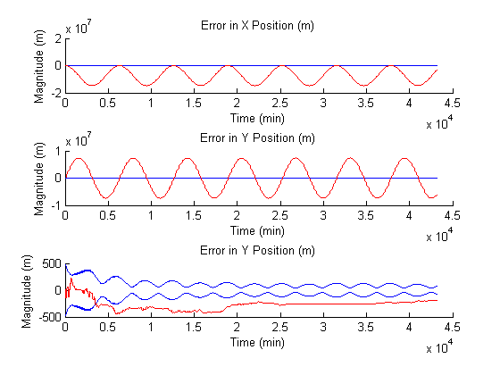
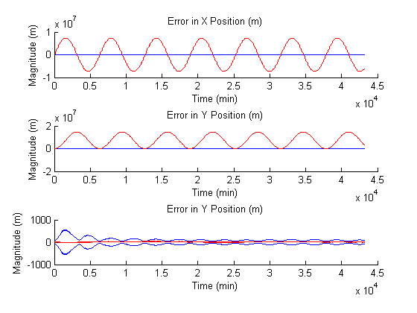
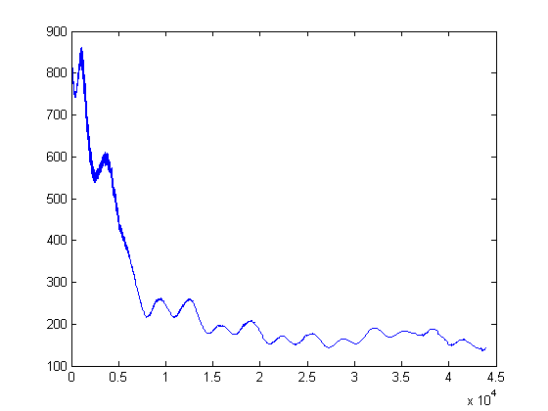
end
Published with MATLAB® R2013a

