Simulating avian body mass measurements using the R package birdsize

Renata M. Diaz

# Introduction

Different currencies of measurement - e.g. total number of individuals, total biomass, or total metabolic flux or energy use - provide linked, but qualitatively very different, perspectives on the structure and function of ecological systems (White et al. (2007)). The study of the interrelated dynamics of size structure, species composition, individual abundance, and biomass and energy use is well-established for systems for which data on both individuals’ body sizes and individual organismal abundance are widely available, including aquatic systems, terrestrial forest systems, and, to a lesser extent, small mammal systems (Kerr and Dickie (2001), White et al. (2007)). Work in these systems has yielded important insight into - for example - how ecological degradation can manifest in the relationship between total abundance and total biomass (Warwick and Clarke (1994)), or how shifts in community-wide mean body size can buffer total energy use against apparent changes in total individual abundance (White et al. (2004)). Efforts to generalize these efforts to terrestrial vertebrate systems have been constrained due to the lack of body size measurements for these communities (White et al. (2007), Thibault et al. (2011)). Sampling methodologies for avian communities often rely on visual or auditory point-counts, which provide information about species abundance and diversity but do not directly capture information about body size or energy use.

The birdsize R package offers a way around this limitation by estimating individual-level (and, from there, population or community-wide) body size measurements for birds given either species identity or a species’ mean and/or standard deviation of body size. Birds exhibit determinate growth, and birdsize assumes that intraspecific body size distributions for birds are, to a first approximation, well-described by normal distributions parameterized with a species-specific mean and standard deviation (see also Thibault et al. (2011)). Moreover, there is a strong scaling relationship between a species’ mean body size and its standard deviation of body size, meaning that, for species for which the standard deviation is not known, the standard deviation can be estimated from the mean (see also Thibault et al. (2011)). Estimates obtained in this way are, of course, considerably less precise than those that could be obtained through exhaustive field sampling, and may not be appropriate for all use cases. However, given the logistical constraints on field operations of this scale (and the even harsher constraint of time, which prevents us from retroactively taking these measurements for ecological timeseries), birdsize makes it possible to conduct macroecological-scale analyses of avian communities that would not otherwise be possible. This approach was first used at scale by Thibault et al. (2011) and subsequently by Diaz and Ernest (2022) (in review). birdsize formalizes this method and makes it accessible via a straightforward user interface, in order to facilitate use by other research groups with diverse use cases.

# The estimation procedure in birdsize

The core functionality of birdsize is to generate estimates of individual body size for populations of birds by drawing from a normal distribution parameterized with a species-level mean and standard deviation of body size. It includes built-in values for these parameters for 443 species found in the North American Breeding Bird Survey (Pardieck et al. (2019)), and can accept user-supplied parameter values for additional species.

For the 443 species included with birdsize, mean and standard deviation values were manually obtained from the CRC Handbook of Avian Body Masses (Dunning (2008)). These species are listed in the data frame birdsize::known_species. Many species in Dunning (2008) have multiple records from different time periods, locations, and subspecies. In these instances, parameter values are averaged across records to obtain a single species-wide value. For records in Dunning (2008) with mean, but no standard deviation, reported, the standard deviation is estimated via a scaling relationship between the mean and standard deviation of body mass (see also Thibault et al. (2011)). Specifically, a linear model of the form log(variance(body_size)) ~ log(mean(body_size)) has a model R^2 of 0.89, and produces the scaling relationship of variance(body_size) = 0.0047(body_size) ^ 2.01. This scaling relationship is used to generate estimated standard deviations for records without standard deviation recorded, affecting 353 of 928 raw records.

A user may also manually supply parameter values, in order to generate estimates for species not included in birdsize::knownspecies, or to use different parameter values than those included with birdsize. This may be of particular interest for users wishing to explore questions related to (for example) intraspecific variation in body size across different populations of the same species, or extending to species not common to North America. In this case, if both mean and standard deviation are supplied, they will be used, and if only the mean is provided, the standard deviation is estimated via the scaling relationship explained above.

# Population and community-wide summaries

While birdsize generates estimated body size measurements at the level of individual birds, in many instances the quantity of interest is actually the population or community-wide total biomass or metabolic rate. Indeed, given the several layers of estimation involved in obtaining measurements via birdsize, it is likely to generally be more appropriate to focus on these aggregate properties than on estimates for “individuals”. Accordingly, birdsize includes functions to compute these summaries, grouping by species, year, or other variables supplied by the user. These are demonstrated in the package vignettes and use cases, below.

# Integration with the Breeding Bird Survey

The methodology in birdsize was first developed and applied to the North American Breeding Bird Survey, and birdsize is built to naturally accommodate Breeding Bird Survey data obtained from ScienceBase (Pardieck et al. (2019)) or tools such as the Data Retriever (Senyondo et al. (2017)). There is no actual data from the Breeding Bird Survey included in the birdsize package, and users are encouraged to access the most up-to-date data from the creators directly. To facilitate this, the bbs-data and demonstration vignettes illustrate how to access these data and use them with birdsize, and the example data tables in birdsize (i.e. demo_route_raw and demo_route_clean) contain synthetic data matching the format of the Breeding Bird Survey.

However, birdsize is not constrained to work *only* with Breeding Bird Survey data. It accepts any dataset, real or synthetic, that includes population sizes and species identity and/or body size parameters (see above); see Use case #3, below.

# Use case 1: Simulation over the Breeding Bird Survey timeseries

A common anticipated use case for birdsize is to generate estimates of species- and community- level biomass and metabolic rate for a Breeding Bird Survey route over time. Here, we generate these estimates using the demo_route_raw dataset, which has the same shape and structure as data from the Breeding Bird Survey, but contains simulated values for the actual data.

First, it is recommended to clean the raw data to remove species poorly sampled via Breeding Bird Survey methods and remove records not identified to species. This is accomplished using the filter_bbs_survey function:

clean_data = filter_bbs_survey(demo_route_raw)  
head(clean_data)

## record_id routedataid countrynum statenum route rpid year aou count10  
## 1 900000 9009911011994 900 99 1 101 1994 4730 8  
## 2 900001 9009911011995 900 99 1 101 1995 4730 13  
## 3 900002 9009911011996 900 99 1 101 1996 4730 8  
## 4 900003 9009911011997 900 99 1 101 1997 4730 9  
## 5 900004 9009911011998 900 99 1 101 1998 4730 10  
## 6 900005 9009911011999 900 99 1 101 1999 4730 12  
## count20 count30 count40 count50 stoptotal speciestotal  
## 1 12 15 12 15 5 62  
## 2 9 11 10 10 5 53  
## 3 11 9 13 15 5 56  
## 4 13 16 9 12 5 59  
## 5 6 12 8 7 5 43  
## 6 13 5 9 5 5 44

For the purposes of simulating body size and metabolic rate, the relevant columns in these data are year, aou, and speciestotal, which refer to the year of the survey, the species identity, and the total number of individuals of that species recorded on that route in that year, respectively.

Given a dataframe like this, birdsize::community_generate iterates over rows and draw speciestotal individuals of the appropriate species (identified by the aou, or species code). The resulting data frame has one row per simulated individual. It retains all columns from the original data frame, and adds columns for sim_species_id, genus, species, individual_mass, individual_bmr, mean_size, sd_size, abundance, and sd_method. Most of these are bookkeeping columns explained in the package documentation (see ?birdsize::community_generate). Of particular relevance are the individual_mass and individual_bmr columns, which include the estimated body mass (in grams) and estimated basal metabolic rate for each simulated “individual”. The sd_method column notes which method (see above) was used to obtain parameters for the species’ mean and standard deviation body size. In this instance, it is AOU lookup, meaning parameters were obtained based on the aou column.

simulated_community <- community_generate(clean_data)  
  
head(simulated_community)

## record_id routedataid countrynum statenum route rpid year count10 count20  
## 1 900000 9009911011994 900 99 1 101 1994 8 12  
## 2 900000 9009911011994 900 99 1 101 1994 8 12  
## 3 900000 9009911011994 900 99 1 101 1994 8 12  
## 4 900000 9009911011994 900 99 1 101 1994 8 12  
## 5 900000 9009911011994 900 99 1 101 1994 8 12  
## 6 900000 9009911011994 900 99 1 101 1994 8 12  
## count30 count40 count50 stoptotal speciestotal aou sim_species_id genus  
## 1 15 12 15 5 62 4730 4730 Alauda  
## 2 15 12 15 5 62 4730 4730 Alauda  
## 3 15 12 15 5 62 4730 4730 Alauda  
## 4 15 12 15 5 62 4730 4730 Alauda  
## 5 15 12 15 5 62 4730 4730 Alauda  
## 6 15 12 15 5 62 4730 4730 Alauda  
## species individual_mass individual_bmr mean_size sd_size abundance  
## 1 arvensis 37.41438 138.9203 37.475 3.300613 62  
## 2 arvensis 45.24433 159.0767 37.475 3.300613 62  
## 3 arvensis 33.94949 129.6204 37.475 3.300613 62  
## 4 arvensis 42.24105 151.4740 37.475 3.300613 62  
## 5 arvensis 34.38454 130.8026 37.475 3.300613 62  
## 6 arvensis 38.40766 141.5400 37.475 3.300613 62  
## sd_method  
## 1 AOU lookup  
## 2 AOU lookup  
## 3 AOU lookup  
## 4 AOU lookup  
## 5 AOU lookup  
## 6 AOU lookup

These individual-level estimates can be condensed into year and species totals using birdsize::community_summarize. Summarizing by "species_and_year" will produce species-level totals for each year surveyed:

annual_species_summaries <- community_summarize(simulated_community, level = "species_and_year")  
  
head(annual_species_summaries)

## # A tibble: 6 × 21  
## routed…¹ count…² state…³ route rpid year aou sim_s…⁴ genus species mean_…⁵  
## <chr> <dbl> <dbl> <dbl> <dbl> <int> <int> <int> <chr> <chr> <dbl>  
## 1 9009911… 900 99 1 101 1994 3000 3000 Bona… umbell… 532   
## 2 9009911… 900 99 1 101 1994 3151 3151 Stre… chinen… 159   
## 3 9009911… 900 99 1 101 1994 3152 3152 Stre… roseog… 155   
## 4 9009911… 900 99 1 101 1994 3280 3280 Elan… leucur… 346   
## 5 9009911… 900 99 1 101 1994 3460 3460 Buteo plagia… 528.  
## 6 9009911… 900 99 1 101 1994 3550 3550 Falco mexica… 734   
## # … with 10 more variables: sd_size <dbl>, species_designator <chr>,  
## # total_abundance <int>, total_biomass <dbl>, total_metabolic_rate <dbl>,  
## # total_richness <int>, mean_individual_mass <dbl>, sd_individual_mass <dbl>,  
## # mean_metabolic_rate <dbl>, sd_metabolic_rate <dbl>, and abbreviated  
## # variable names ¹​routedataid, ²​countrynum, ³​statenum, ⁴​sim_species_id,  
## # ⁵​mean_size

Summarizing by only "year" will produce community-wide totals (over all species) for each year::

annual_summaries <- community_summarize(simulated_community, level = "year")  
  
head(annual_summaries)

## # A tibble: 6 × 15  
## routedataid count…¹ state…² route rpid year speci…³ total…⁴ total…⁵ total…⁶  
## <chr> <dbl> <dbl> <dbl> <dbl> <int> <chr> <int> <dbl> <dbl>  
## 1 90099110119… 900 99 1 101 1994 aou 1361 157505. 353113.  
## 2 90099110119… 900 99 1 101 1995 aou 1443 162410. 366382.  
## 3 90099110119… 900 99 1 101 1996 aou 1413 167076. 370201.  
## 4 90099110119… 900 99 1 101 1997 aou 1381 158538. 357272.  
## 5 90099110119… 900 99 1 101 1998 aou 1415 156028. 355564.  
## 6 90099110119… 900 99 1 101 1999 aou 1412 163775. 367453.  
## # … with 5 more variables: total_richness <int>, mean_individual_mass <dbl>,  
## # sd_individual_mass <dbl>, mean_metabolic_rate <dbl>,  
## # sd_metabolic_rate <dbl>, and abbreviated variable names ¹​countrynum,  
## # ²​statenum, ³​species_designator, ⁴​total_abundance, ⁵​total_biomass,  
## # ⁶​total_metabolic_rate

Similarly, summarizing by only "species" will produce species-level totals over all years:

species_summaries <- community_summarize(simulated_community, level = "species")  
  
head(species_summaries)

## # A tibble: 6 × 19  
## countrynum statenum route rpid aou sim_spec…¹ genus species mean_…² sd_size  
## <dbl> <dbl> <dbl> <dbl> <int> <int> <chr> <chr> <dbl> <dbl>  
## 1 900 99 1 101 3000 3000 Bona… umbell… 532 38.7  
## 2 900 99 1 101 3151 3151 Stre… chinen… 159 11   
## 3 900 99 1 101 3152 3152 Stre… roseog… 155 11.0  
## 4 900 99 1 101 3280 3280 Elan… leucur… 346 23.3  
## 5 900 99 1 101 3460 3460 Buteo plagia… 528. 37.8  
## 6 900 99 1 101 3550 3550 Falco mexica… 734 51.0  
## # … with 9 more variables: species_designator <chr>, total_abundance <int>,  
## # total_biomass <dbl>, total_metabolic_rate <dbl>, total_richness <int>,  
## # mean_individual_mass <dbl>, sd_individual_mass <dbl>,  
## # mean_metabolic_rate <dbl>, sd_metabolic_rate <dbl>, and abbreviated  
## # variable names ¹​sim_species_id, ²​mean_size

Finally, community_summarize can group by other variables as specified by setting level = "custom" and supplying column names via the id_vars argument. Here, we group by genus and year:

genus_year_summaries <- community_summarize(simulated_community, level = "custom", id_vars = c("year", "genus"))  
  
head(genus_year_summaries)

## # A tibble: 6 × 11  
## year genus speci…¹ total…² total…³ total…⁴ total…⁵ mean_…⁶ sd_in…⁷ mean_…⁸  
## <int> <chr> <chr> <int> <dbl> <dbl> <int> <dbl> <dbl> <dbl>  
## 1 1994 Acridot… aou 13 1513. 4055. 1 116. 7.91 312.   
## 2 1994 Alauda aou 62 2311. 8583. 1 37.3 3.39 138.   
## 3 1994 Amphisp… aou 52 941. 4305. 1 18.1 0.274 82.8  
## 4 1994 Bonasa aou 45 24256. 41864. 1 539. 36.4 930.   
## 5 1994 Buteo aou 69 36575. 63428. 1 530. 37.1 919.   
## 6 1994 Carduel… aou 50 803. 3800. 1 16.1 1.12 76.0  
## # … with 1 more variable: sd_metabolic_rate <dbl>, and abbreviated variable  
## # names ¹​species_designator, ²​total_abundance, ³​total_biomass,  
## # ⁴​total_metabolic_rate, ⁵​total_richness, ⁶​mean_individual_mass,  
## # ⁷​sd_individual_mass, ⁸​mean_metabolic_rate

These functions can be used to generate plots of species or community level biomass over time. For example, here we plot community-wide biomass in each year surveyed:

ggplot(annual_summaries, aes(year, total_biomass)) +  
 geom_line()

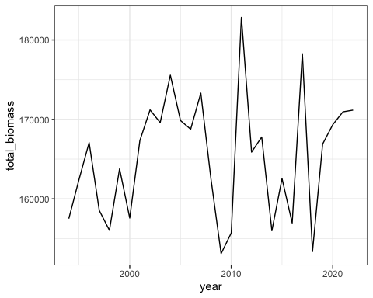

# Use case 2: Using user-provided parameters to simulate changes in body size over time

The data tables provided in birdsize contain geographically- and time-averaged estimates of mean and standard deviation of body size for each species. In order to investigate - for example - how changes in these parameters over space or time affect the body size distributions and ecosystem function for these systems, a user can provide customized parameter values.

To do this based on the species data provided in birdsize, we can modify the mean body size associated with each species in our toy dataset such that mean body size decreases over time.

First, we obtain the mean masses for each species in our dataset as provided in birdsize::sd_table:

species_to_simulate <- clean_data %>%   
 select(year, aou) %>%  
 left_join(sd_table)

## Joining, by = "aou"

head(species_to_simulate)

## year aou genus species mean_mass mean_sd contains_estimates  
## 1 1994 4730 Alauda arvensis 37.475 3.300613 TRUE  
## 2 1995 4730 Alauda arvensis 37.475 3.300613 TRUE  
## 3 1996 4730 Alauda arvensis 37.475 3.300613 TRUE  
## 4 1997 4730 Alauda arvensis 37.475 3.300613 TRUE  
## 5 1998 4730 Alauda arvensis 37.475 3.300613 TRUE  
## 6 1999 4730 Alauda arvensis 37.475 3.300613 TRUE

For this example, we can introduce a simple adjustment where mean_mass decreases by 1% of its starting value each year, beginning in 1994:

species_to_simulate <- species_to_simulate %>%  
 mutate(modified_mass = mean_mass - (.01 * (year - 1994) * mean_mass)) %>%  
 mutate(mean_size = modified_mass)

We can provide these modified mean_size values to community_generate by adding the mean_size column to our original dataset (clean_data). Note that, if aou or species and genus are provided, community_generate will use these parameters to look up mean_size and ignore the user-provided values. To avoid this, we must remove or rename these columns before passing the data:

parameters_to_add <- species_to_simulate %>%  
 select(aou, mean_size, year)   
  
clean_data_with_size_change <- clean_data %>%  
 left_join(parameters_to_add) %>%  
 rename(speciescode = aou)

## Joining, by = c("year", "aou")

simulated_size_change <- community_generate(clean_data_with_size_change)

Here, we can examine how the mean body size of each species behaves over time in the simulated data, and see a (fuzzy) decline consistent with the decline we introduced via modification to the parameters:

simulated_mean_change <- simulated_size_change %>%  
 group_by(speciescode, year) %>%  
 summarize(mean_mass = mean(individual_mass)) %>%  
 ungroup()

## `summarise()` has grouped output by 'speciescode'. You can override using the  
## `.groups` argument.

ggplot(simulated_mean_change, aes(year, mean_mass)) +  
 geom_point() +  
 facet_wrap(vars(speciescode), scales = "free")

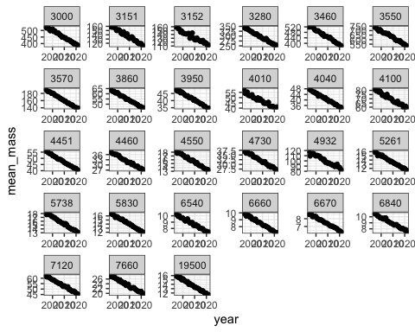

# Use case 3: Simulating imaginary birds

Finally, the core community_generate functionality of birdsize can apply to any dataframe that contains species abundances and mean size values. Here, we manually construct such a table for a set of purely simulated bird species:

fictional_abundance_data <-  
 data.frame(  
 sim_species_id = 1:10,  
 mean_size = sample.int(500, size = 10),  
 speciestotal = round(rlnorm(10, 4, 1))  
 )  
  
fictional_community_data <- community_generate(fictional_abundance_data)

fictional_community_summary <- community_summarize(fictional_community_data, level = "species") %>%  
 mutate(sim_species_id = as.factor(sim_species_id))  
  
  
ggplot(fictional_community_summary, aes(sim_species_id, total_abundance)) +  
 geom_col() +  
 ggtitle("Total abundance for each fictional species")

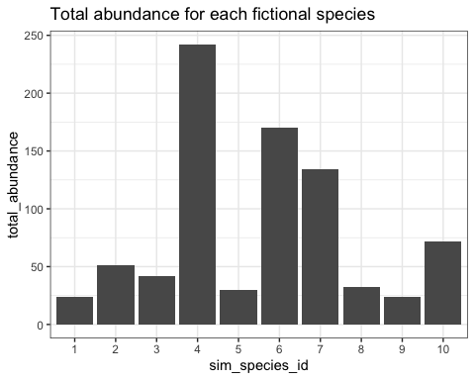

ggplot(fictional_community_summary, aes(sim_species_id, total_biomass)) +  
 geom_col() +  
 ggtitle("Total simulated biomass for each fictional species")

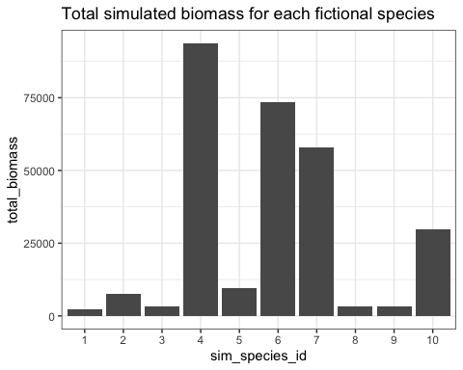

# References

Diaz, R. M., and S. K. M. Ernest. 2022, November. [Temporal changes in the individual size distribution decouple long-term trends in abundance, biomass, and energy use of North American breeding bird communities](https://doi.org/10.1101/2022.11.08.515659). bioRxiv.

Dunning, J. B. 2008. CRC handbook of avian body masses. CRC handbook of avian body masses. 2nd ed. CRC Press, Boca Raton.

Kerr, S. R., and L. M. Dickie. 2001. The Biomass Spectrum: A Predator-Prey Theory of Aquatic Production. Pages 352 Pages. Columbia University Press.

Pardieck, K. L., D. J. Ziolkowski, M. Lutmerding, V. Aponte, and M.-A. Hudson. 2019. [North American Breeding Bird Survey Dataset 1966 - 2018, version 2018.0](https://doi.org/10.5066/P9HE8XYJ). U.S. Geological Survey.

Senyondo, H., B. D. Morris, A. Goel, A. Zhang, A. Narasimha, S. Negi, D. J. Harris, D. G. Digges, K. Kumar, A. Jain, K. Pal, K. Amipara, and E. P. White. 2017. [Retriever: Data Retrieval Tool](https://doi.org/10.21105/joss.00451). Journal of Open Source Software 2:451.

Thibault, K. M., E. P. White, A. H. Hurlbert, and S. K. M. Ernest. 2011. [Multimodality in the individual size distributions of bird communities](https://doi.org/10.1111/j.1466-8238.2010.00576.x). Global Ecology and Biogeography 20:145–153.

Warwick, R. M., and K. R. Clarke. 1994. [Relearning the ABC: Taxonomic changes and abundance/biomass relationships in disturbed benthic communities](https://doi.org/10.1007/BF00347523). Marine Biology 118:739–744.

White, E. P., S. K. M. Ernest, A. J. Kerkhoff, and B. J. Enquist. 2007. [Relationships between body size and abundance in ecology](https://doi.org/10.1016/j.tree.2007.03.007). Trends in Ecology & Evolution 22:323–330.

White, E. P., S. K. M. Ernest, and K. M. Thibault. 2004. [Trade-offs in Community Properties through Time in a Desert Rodent Community.](https://doi.org/10.1086/424766) The American Naturalist 164:670–676.