Bonus D - Lists and Loops
One coin is a variable. Twenty coins is a list.
Bonus D
Look at your game from Chapter 6 or 7. Each coin is a variable, a new Blob(...) line, a move(), a drawSprite(), and an if. Adding one more coin takes five pieces in four places. Twenty coins is about a hundred lines, and every one of them is a chance to type coin13 where you meant coin14.
This chapter fixes that with a list: one variable that holds as many coins as you give it, and loops that do the same thing to every one of them.
It's for the student who wants lots of coins. Take it during Chapter 7, or any time after Chapter 6. It takes one meeting. If you're working on your Chapter 7 game, save a copy first, and do this chapter on the copy.
This chapter does it in three moves.
Part | The idea
One | A bag. An ArrayList, one variable for many things.
Two | Two loops that both say for. One counts, to make things. One visits, to move and draw them.
Three | Taking things out. Removing a coin you collected, safely.

Part One - A bag

D.1 ArrayList
Think of a list as a bag. You keep putting things in, and it holds as many as you give it. There are three things you do with a list:
ArrayList<Blob> coins; // 1. declare it (what kind of bag)
coins = new ArrayList<Blob>(); // 2. create it (get an empty bag)
coins.add(new Blob(...)); // 3. add to it (put something in)
Aside: ArrayList<Blob>
An ArrayList is a list that grows as you add to it. The <Blob> says what kind of bag it is: a bag of Blobs. coins.add(...) puts one more thing in the bag.

Step 1 - An empty bag
Build it. Open your Chapter 6 sketch. At the top, replace Blob coin; with:
ArrayList<Blob> coins; // a list that holds Blobs
In setup(), replace the line that makes your coin with:
coins = new ArrayList<Blob>(); // an empty list
Watch out. Forget that line, and there's no bag. The sketch stops with NullPointerException the first time you try to put something in it.

Part Two - Two loops that both say for
Java uses the same word, for, for two loops that feel completely different. One counts, and you use it to make things. The other visits, and you use it to do something to everything already in the list. Keeping them straight is the real skill in this chapter.

Step 2 - Fill it: the counting loop
Build it. In setup(), right after the empty list, fill it:
// Counting loop - runs 12 times to create 12 coins
for (int i = 0; i < 12; i++) {
coins.add(new Blob(
this,
random(width), // random x position
random(height), // random y position
random(8, 18), // random radius
random(-2, 2), // random horizontal speed
random(-2, 2), // random vertical speed
color(255, 220, 50) // gold
));
}
Aside: the counting loop
for (int i = 0; i < 12; i++) says do this 12 times. int i = 0 starts a counter at zero. i < 12 keeps going while the counter is under 12. i++ adds one to the counter each time around. So the braces run with i at 0, 1, 2, and on up to 11: twelve times.

Run it.
Check. Nothing new on the screen.

The bag has twelve coins in it now. Nothing draws them.

Step 3 - Draw them: the for-each loop
Build it. Where you used to move and draw your coin, visit every coin in the bag. Delete your old coin's collision if for now.
for (Blob c : coins) {
c.move();
c.drawSprite();
}
Aside: the for-each loop
for (Blob c : coins) reads for each Blob c in coins. It hands you the coins one at a time, calling each one c while it's your turn with it, and runs the braces once for every coin in the list.

Run it.
Check. The world is full of coins.

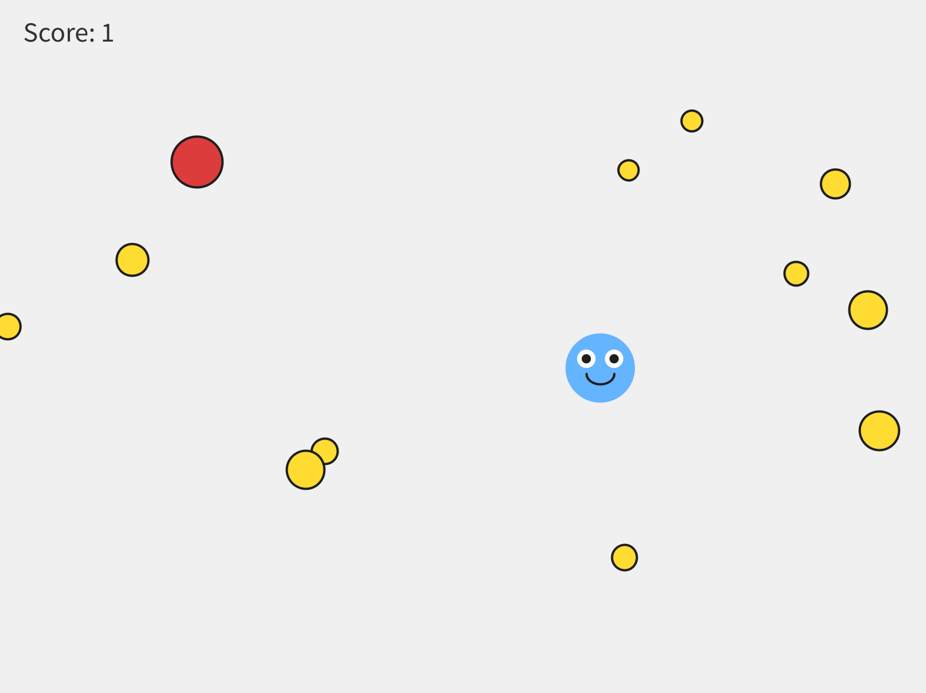
Twelve coins, from one loop.
Watch out. The bag is a bag. It can't draw itself. coins.drawSprite(); stops the sketch with:
The function drawSprite() does not exist.
Reach into the bag and ask each coin, with the for-each loop.

Watch out. Mix the two loops up, and the messages get strange. for (int i = 0; i < coins; i++) gets The operator < is undefined for the argument type(s) int, ArrayList<Blob>, because you can't count up to a bag. for (Blob c : 12) gets Can only iterate over an array or an instance of java.lang.Iterable, because you can't visit a number. One counts. One visits.

Step 4 - How many?
Build it. Change the 12 in the counting loop to 40, and run. Then try 3. How many feels right?
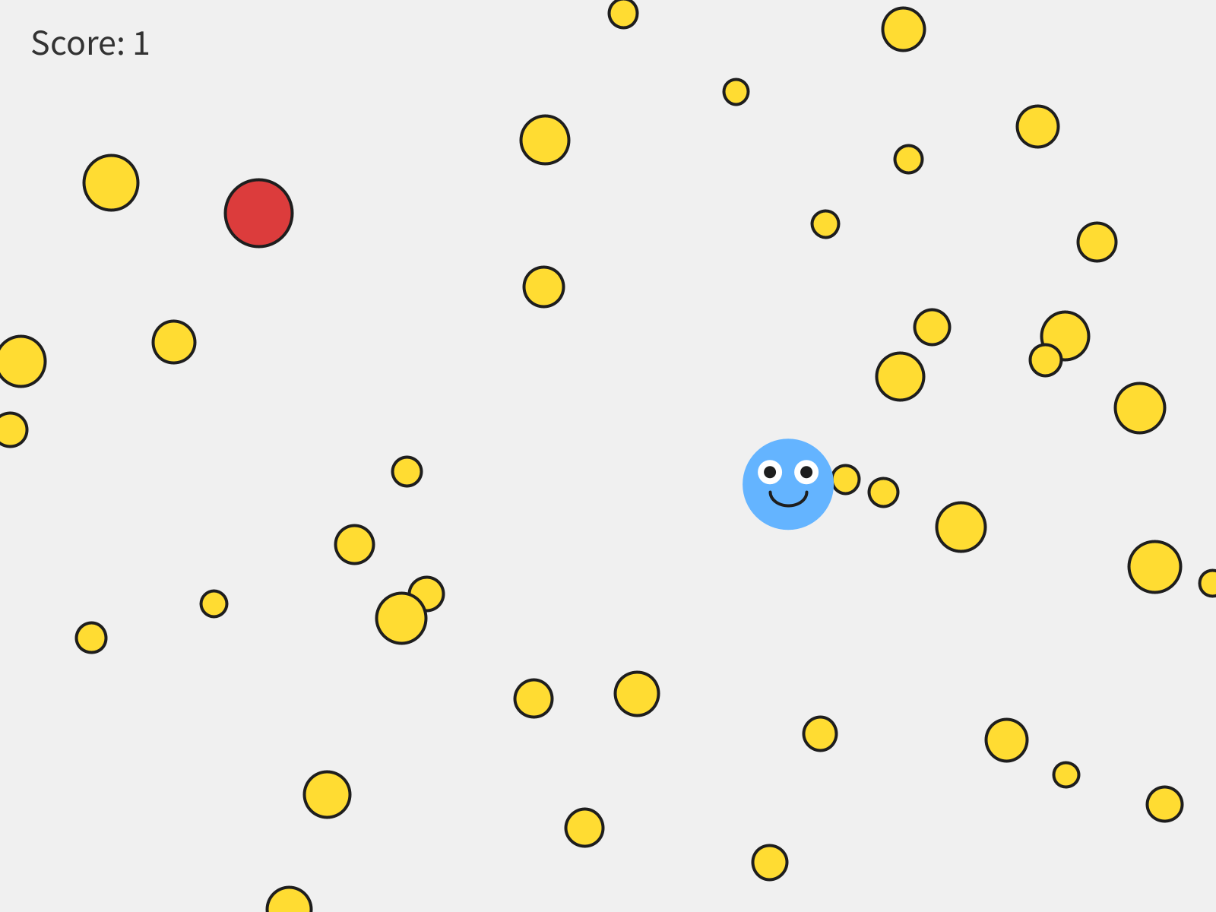
Forty. Same five lines of code.
Watch out. Put the counting loop in draw() by mistake, and it adds twelve coins every frame. After one second there are about 700, and the sketch grinds to a halt. Making things goes in setup().

Part Three - Taking things out

D.5 The problem with removing
With a list, collecting a coin means taking it out of the list. Removing something from a list while you're walking through it causes a real problem.
Picture five coins in a row. You're standing on coin 2, and you take it out. Every coin after it shifts back one place to fill the gap. Then the loop steps you forward to place 3, and the coin that was at 3 is at 2 now, behind you. You just skipped it.
It's not just a picture. Put three coins right on top of your player and walk the list forward, removing each one you touch: you collect two of them, and one gets skipped.
The fix is to walk backwards, from the end of the list toward the front. Taking a coin out then only shifts coins you've already passed, so every coin gets its turn. You don't have to work out why. Recognize it as the safe way to remove things while looping, and copy it when you need it.

Step 5 - Walk backwards
Build it. Replace your for-each loop with the backwards loop, with no collision check yet:
// Backwards loop - the safe way to remove things while looping
for (int i = coins.size() - 1; i >= 0; i--) {
Blob c = coins.get(i); // grab the coin at position i
c.move();
c.drawSprite();
}
Run it.
Check. Nothing looks different. The two loops do the same thing until you take something out.

Aside: size(), get(), and counting from 0
coins.size() is how many things are in the list right now. Every item has a number for its place, called its index, and a list starts counting at 0. So twelve coins are numbered 0 to 11, and the last one is coins.size() - 1. coins.get(i) hands you the coin at place i. And i-- counts down, one at a time.

Step 6 - Collect
Build it. Inside the backwards loop, after the coin is drawn, add the collision:
if (player.collidesWith(c)) {
coins.remove(i); // take it out of the list
score = score + 1;
}
Run it, and collect a few.
Check. Touch a coin, it's gone, and the score goes up.

Watch out. Take a coin out inside a for-each loop, and the sketch stops with ConcurrentModificationException. That's a big word for you changed the list while you were walking through it. The backwards loop is the fix.

Watch out. Start the backwards loop at coins.size(), without the - 1, or count up with i++ where i-- belongs, and the sketch stops with:
IndexOutOfBoundsException: Index 12 out of bounds for length 12
Twelve coins are numbered 0 to 11, so there's no coin 12 to get.

Step 7 - A new wave
coins.size() shrinks every time you collect one. When it hits zero, the board is clear, and you get to decide what that means.
Build it. After the backwards loop, send a fresh wave:
// An empty list means the board is clear: send a new wave
if (coins.size() == 0) {
for (int i = 0; i < 12; i++) {
coins.add(new Blob(this, random(width), random(height),
random(8, 18), random(-2, 2), random(-2, 2),
color(255, 220, 50)));
}
}
Clear the board, and watch it fill up again. Or set playerWon = true; in there, and the game ends. Your call.

Step 8 - A coin on a click
Build it. Add a coin wherever you click:
void mousePressed() {
coins.add(new Blob(this, mouseX, mouseY,
random(8, 18), random(-2, 2), random(-2, 2),
color(255, 220, 50)));
}

Step 9 - A second list
Your turn. Make your hazards a list too: ArrayList<Blob> hazards;, filled with a counting loop, and visited with a for-each loop. You never take a hazard out, so the for-each loop is all you need.

D.7 Make it yours
Your turn. Change how many coins are in a wave, how big they are, and how fast.
Your turn. Optional: any of these.
- Make each wave bigger than the last, with a variable that counts waves, used in the counting loop.
- Add one more hazard to the hazards list every time a wave clears.
- Put a list into your Chapter 7 game. Convert your coins, and keep the hazards as they are. In restartGame(), coins = new ArrayList<Blob>(); and then the counting loop give you a fresh, full board every restart: the same rebuild-from-scratch idea as the rest of restartGame().
- Make a collected coin split into two smaller coins, added to the list.

Chapter summary
You built | It's an example of
ArrayList<Blob> coins; | a list: one variable for many things
coins = new ArrayList<Blob>(); | an empty bag
for (int i = 0; i < 12; i++) { coins.add(...); } | the counting loop, to make things
for (Blob c : coins) { ... } | the for-each loop, to visit things
the backwards loop, with coins.remove(i) | the safe way to take things out while looping
if (coins.size() == 0) | an empty list, and a new wave

New syntax in this chapter
Syntax | Where you met it
ArrayList<Blob>, new ArrayList<Blob>() | D.1, Step 1
add() | D.1, Step 2
for (int i = 0; i < 12; i++) { }, i++ | Step 2
for (Blob c : coins) { } | Step 3
size(), get(i), i-- | Step 5
remove(i) | Step 6

Vocabulary
ArrayList -- a list that holds many objects of the same kind, and grows as you add more. (D.1)
counting loop -- a loop that repeats a set number of times. Used to make things. (Step 2)
for-each loop -- a loop that visits every item already in a list, one at a time. Used to visit things. (Step 3)
index -- an item's place in a list. Lists start counting at 0. (Step 5)
size() -- how many items are in the list right now. (Step 5)

Check your understanding
- What's the difference between the counting loop and the for-each loop? When do you use each one?
- Why doesn't coins.drawSprite(); work?
- Twelve coins. What's the index of the last one?
- Why do we loop backwards when we take things out?
- Your sketch stops with ConcurrentModificationException. What did you do?

