Chapter 1 - Hello, Blob!
Run your first program and put something alive on the screen.
Chapter 1
By the end of today there's something on your screen, and you put it there. It's a circle. The library we're using calls it a Blob, and it's the first object you'll make in this course. Every chapter after this one gives you more say over what's on the screen, and by Chapter 7 it's a game.
The program that makes the circle is ten lines of code. You'll type all ten. Then you'll run it, break it on purpose, and change it until the blob is yours.
This chapter does it in three moves.
Part | The idea
One | A Blob is an object. Type the sketch, run it, and read every line.
Two | Once, and over and over. setup() runs one time, and draw() runs about sixty times a second. Moving one line proves it.
Three | Make it yours. Its color, where it sits, how big it is, what's behind it, and maybe a friend.
Part One is mostly reading. Parts Two and Three are five small steps, and the sketch runs at the end of every one.

Part One - A Blob is an object

1.1 Type it, then run it
Open Processing. You get a window with a big space for code, a ▶ Run button, and a ■ Stop button. A program in Processing is called a sketch.
Save before you type anything: File → Save As, and name it HelloBlob. Saving first means you'll know where your sketch lives when you come back to it.
Build it. Type this in. Type it by hand. Your fingers learn the code faster than your eyes do.
// Lesson 1 - Hello, Blob!
import coxprogramming.processing.sprites.*;
Blob myBlob;
void setup() {
size(800, 600);
myBlob = new Blob(this, 400, 300, 40, color(255, 80, 80));
}
void draw() {
background(255); // white background erases the previous frame
myBlob.drawSprite(); // draw the blob at its position
}
Get it exactly right. One missing semicolon is enough to stop the whole thing. Then press ▶ Run.
Check. A new window opens with a red circle in the middle. Look closely and the circle has a thin black outline. Remember the outline, because it comes back in Step 3. Press ■ Stop to close the window.

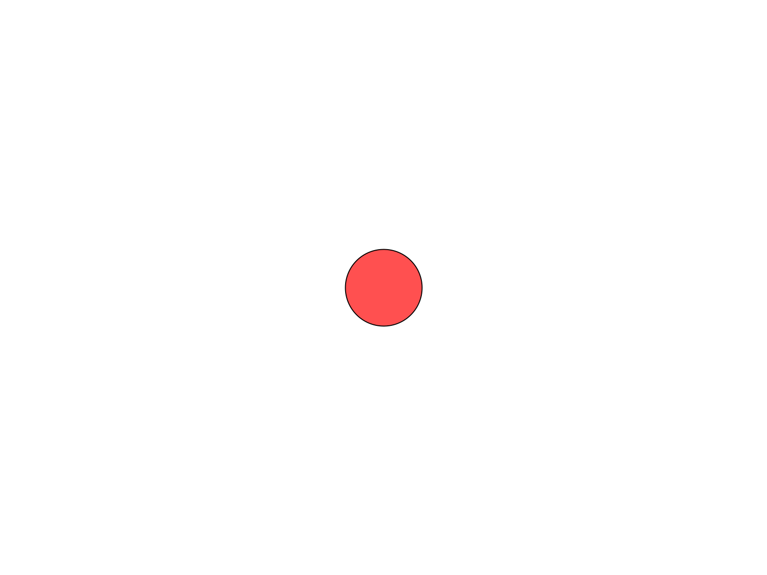
Your first sketch. The red circle is a Blob.
If you get an error instead, look at the line Processing highlights, and check it letter by letter against the code above. Step 2 shows you the three most common mistakes, on purpose.

1.2 Objects have properties and behaviors
The red circle is an object. An object is a thing in your program that has its own information and knows how to do things.
Programmers have a word for each of those. Properties are the things that describe an object: where it is, how big it is, what color it is. Behaviors are the things an object can do. A Blob can draw itself on the screen.
You'll find both in the code. The properties are the numbers you hand a Blob when you make it. The behavior is drawSprite().

1.3 Reading it, line by line
Ten lines of code, and one note at the top. Here's what each one does.
// Lesson 1 - Hello, Blob!
Aside: comments
A line that starts with // is a comment, a note for people. Processing skips it. A comment can also sit at the end of a line, like the two in draw().

import coxprogramming.processing.sprites.*;
This tells Processing you want to use the library's tools. A library is a set of tools somebody else built, so you can use them. Blob is one of them. This line goes first, always.
Blob myBlob;
This makes a variable: a box with a name on it. The box is called myBlob, and the word in front of it, Blob, says what kind of thing the box holds. Right now the box is empty. The next part of the sketch puts a blob in it.
void setup() {
size(800, 600);
myBlob = new Blob(this, 400, 300, 40, color(255, 80, 80));
}
setup() is a function: a set of instructions with a name. Its instructions go between the curly braces, { and }. Processing runs setup() one time, when your sketch starts. Part Two is about exactly that.
Aside: the semicolon
Every instruction ends in a semicolon, ;. That's how Processing knows where one instruction stops and the next one starts, the way a period ends a sentence. Lines that end in a brace, like void setup() {, are the exception.

size(800, 600) makes the window 800 pixels wide and 600 pixels tall. A pixel is one tiny dot of your screen.
Aside: x and y
Every spot in the window has two numbers. x is how far across it is from the left edge. y is how far down it is from the top. The top-left corner is (0, 0), and in this window the bottom-right corner is (800, 600).
Watch the y. In math class, up is bigger. On a screen, down is bigger.

Then the line that makes the blob:
myBlob = new Blob(this, 400, 300, 40, color(255, 80, 80));
new Blob(...) makes a brand-new Blob, and the = puts it in the myBlob box. The five things inside the parentheses are what a Blob needs to know about itself, always in this order:
 | What it is
this | the sketch the blob belongs to. Copy it exactly, every time.
400 | x: how far across the blob's center is
300 | y: how far down the blob's center is
40 | the radius: how far it is from the center to the edge. A radius of 40 makes a circle 80 pixels across.
color(255, 80, 80) | its color. Section 1.4 is about these three numbers.
Those are its properties. (400, 300) is the exact middle of an 800-by-600 window, which is why your blob sits in the middle.
void draw() {
background(255); // white background erases the previous frame
myBlob.drawSprite(); // draw the blob at its position
}
draw() is the other function. background(255) paints the whole window white. Then myBlob.drawSprite() asks your blob to draw itself.
Aside: the dot
myBlob.drawSprite() reads left to right: myBlob, draw yourself. First the object's name, then a dot, then the behavior you want. The parentheses on the end mean do it now.
A behavior written in code is called a method. drawSprite() is your blob's method for drawing itself.

Part Two - Once, and over and over
Every sketch in this course has these two functions.
setup() is like setting up an art table. It happens once, before anything else. You put out your paper and your paints, and you're done setting up.
draw() is like drawing one page of a flipbook. Processing runs it again, and again, and again, about 60 times a second. Flip the pages fast enough and it looks like motion. Each page is called a frame.
- Something that happens one time goes in setup().
- Something that has to keep happening goes in draw().
Your blob sits perfectly still, though. So how would you know draw() is running sixty times a second?

Step 1 - Move one line
Build it. Cut the whole line myBlob.drawSprite(); out of draw(), comment and all. Paste it at the end of setup(), under the line that makes the blob:
void setup() {
size(800, 600);
myBlob = new Blob(this, 400, 300, 40, color(255, 80, 80));
myBlob.drawSprite();
}
void draw() {
background(255); // white background erases the previous frame
}
Run it.
Check. A white window, empty.


The blob's somewhere in this picture.
Where did the blob go? Make a guess before you read on.
The blob got drawn. setup() drew it, once, right at the start. Then draw() ran, and its first instruction is background(255), which paints the whole window white, right over the blob. Then draw() ran again, and again, sixty times a second, painting white each time. The blob's under the paint.
That's why drawSprite() belongs in draw(). Anything you want to see has to be drawn again on every frame, after the background.
Build it. Put the line back at the end of draw(), where it started, and run.
Check. The red blob is back in the middle of a white window.

Step 2 - Break it on purpose
Sooner or later, every sketch you write stops with an error. The quickest way to get good at errors is to make a few on purpose, while you know exactly what you broke.
Aside: reading an error
When Processing can't run your sketch, it highlights a line and shows a message under your code. The message says what went wrong, as well as Processing can tell. The highlighted line is where it noticed. Those can be two different lines.

Make each break, run, read the message, and then fix it before the next one.
Build it. Delete the import line, and run.
Check. The sketch stops, and the message reads:
Cannot find a class or type named “Blob”

Processing can't find Blob, because the line that tells it where to look is gone. This is the most common mistake in the course. The message only names Blob, so when you see it, check the import line first. Put it back.
Build it. Delete the semicolon at the end of size(800, 600);, and run.
Check. The message reads Syntax Error - Missing ';'?, and the highlighted line is the one after size, the myBlob = new Blob(...) line.

Processing noticed the problem when it got to the next instruction. When an error points at a line that looks fine, look at the line above it. Put the semicolon back.
Build it. Change drawSprite to drawsprite, with a small s, and run.
Check. The message reads The function drawsprite() does not exist.

To Processing, drawsprite and drawSprite are two different words. Capital letters count, everywhere. Fix it, run, and make sure your red blob is back.

Part Three - Make it yours

1.4 Color is three numbers
color(255, 80, 80) means a lot of red, a little green, and a little blue. Each number goes from 0, none of that color, up to 255, as much as the screen can make. These are RGB numbers: Red, Green, Blue, always in that order.
You write | You get
color(0, 0, 0) | black
color(255, 255, 255) | white
color(255, 0, 0) | red
color(255, 80, 80) | the starter's pink-red
Now predict one. Red all the way up, green all the way up, and blue at zero: color(255, 255, 0). Mix red paint and green paint and you get a muddy brown. Write down what you think the screen will make.

Step 3 - Your color
Build it. Change color(255, 80, 80) to color(255, 255, 0), and run.
Check. A yellow blob.

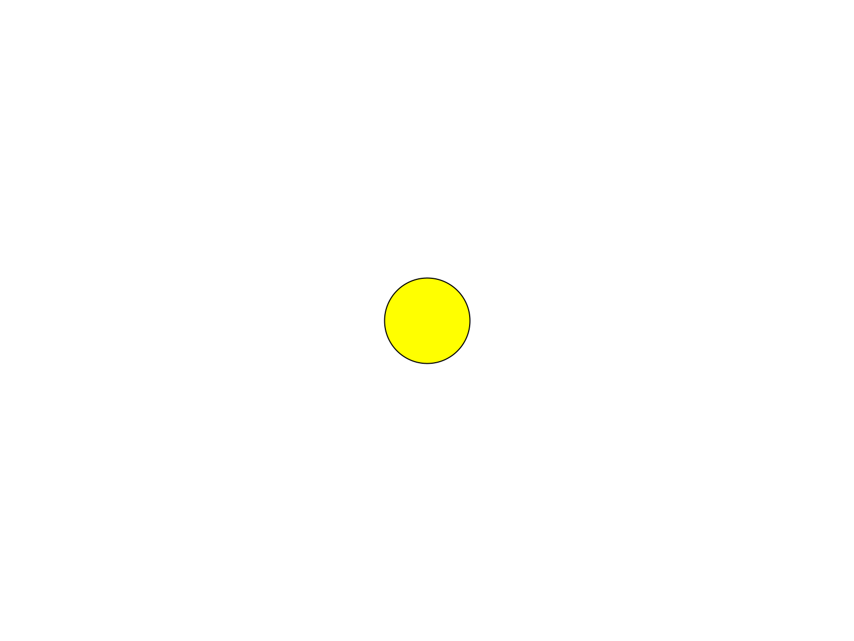
Red light and green light make yellow.
Your screen makes every color out of light, and paint and light mix by different rules.
The Color Selector saves you the guessing. Open Tools → Color Selector, click around until you find a color you like, and read the R, G, and B numbers right off the panel.
Your turn. Find a color you actually like in the Color Selector, and put its three numbers in your blob's color( , , ). "Because I like green" is a perfectly good reason.
One more, for that outline from 1.1. Try color(255, 255, 255), a white blob on a white background.
Check. You can still see it, as a thin black ring.


A white blob on white. The outline gives it away.
Processing draws an outline around every shape until you tell it to stop. In Chapter 2 you will. Put your own color back.

Step 4 - Where, and how big
Build it. In the new Blob line, change 400, 300 to 400, 100, and run. The blob moves up, because a smaller y is closer to the top.
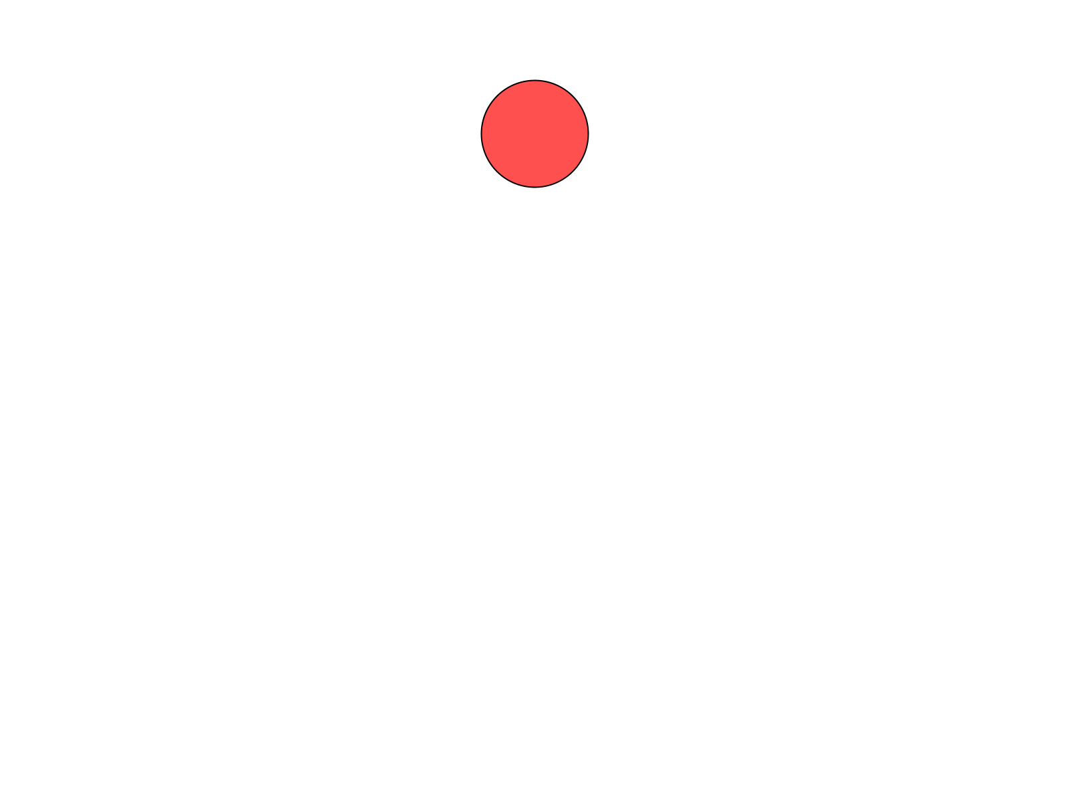
y is 100: near the top.
Now predict where (0, 0) will put it, and try it.
Check. A quarter of a blob, tucked into the top-left corner.


The blob's center is on the corner.
x and y are where the blob's center goes. At (0, 0) the center sits right on the corner, and three quarters of the blob hang off the edges of the window.
Then the size. Change the radius, the 40, to 80 and run. Then try 15.
Your turn. Put your blob where you want it, at the size you want.

Step 5 - What's behind it
background() takes the same kind of numbers as color(). Give it one number for a grey, from 0 for black up to 255 for white, or three for any color at all.
Build it. Change background(255) to background(0), and run.
Check. Your blob on a black window, with its outline gone. The outline is black too.

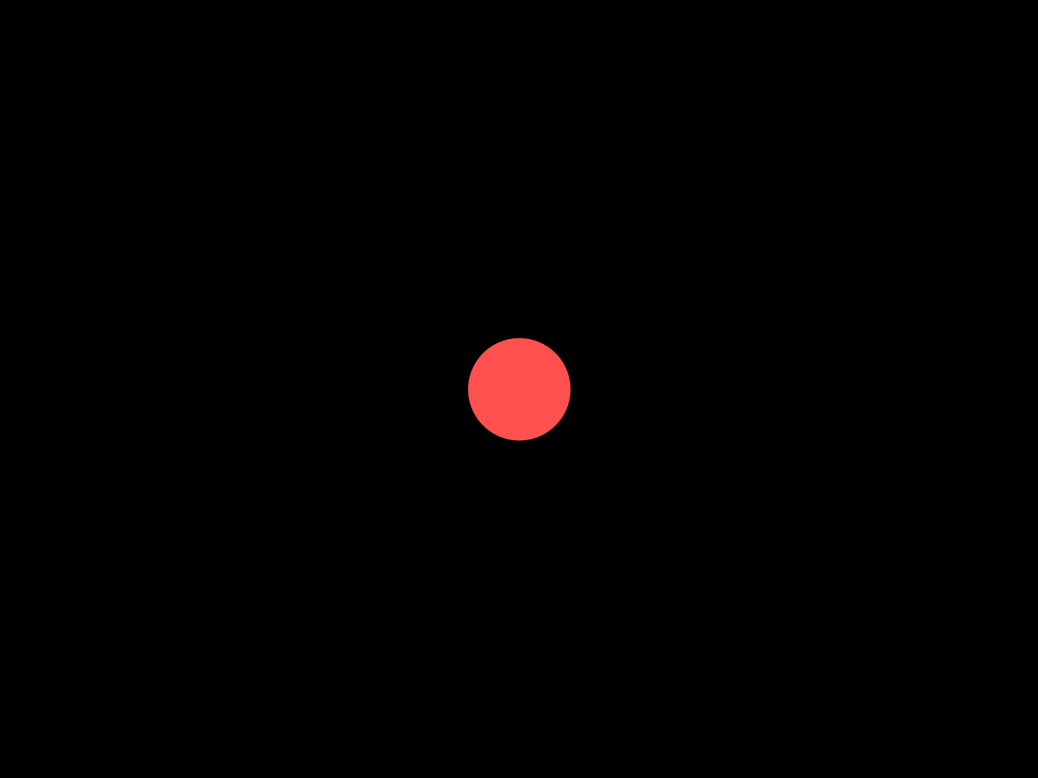
background(0).
Your turn. Give your blob a background you chose. The Color Selector's three numbers work here too: background(30, 40, 90) is a night sky.

1.5 A friend
Your turn. Optional: give your blob a friend, a second Blob with its own color and its own spot. A second blob takes three lines, one in each of the three places your first blob uses:
- At the top, a second box: Blob friend;
- In setup(), a second new Blob(...), to put a blob in that box.
- In draw(), a second drawSprite(), after the background.
You pick its name, and all five of its numbers.
Check. Two blobs. Here's one friend. Yours will be wherever you put it.

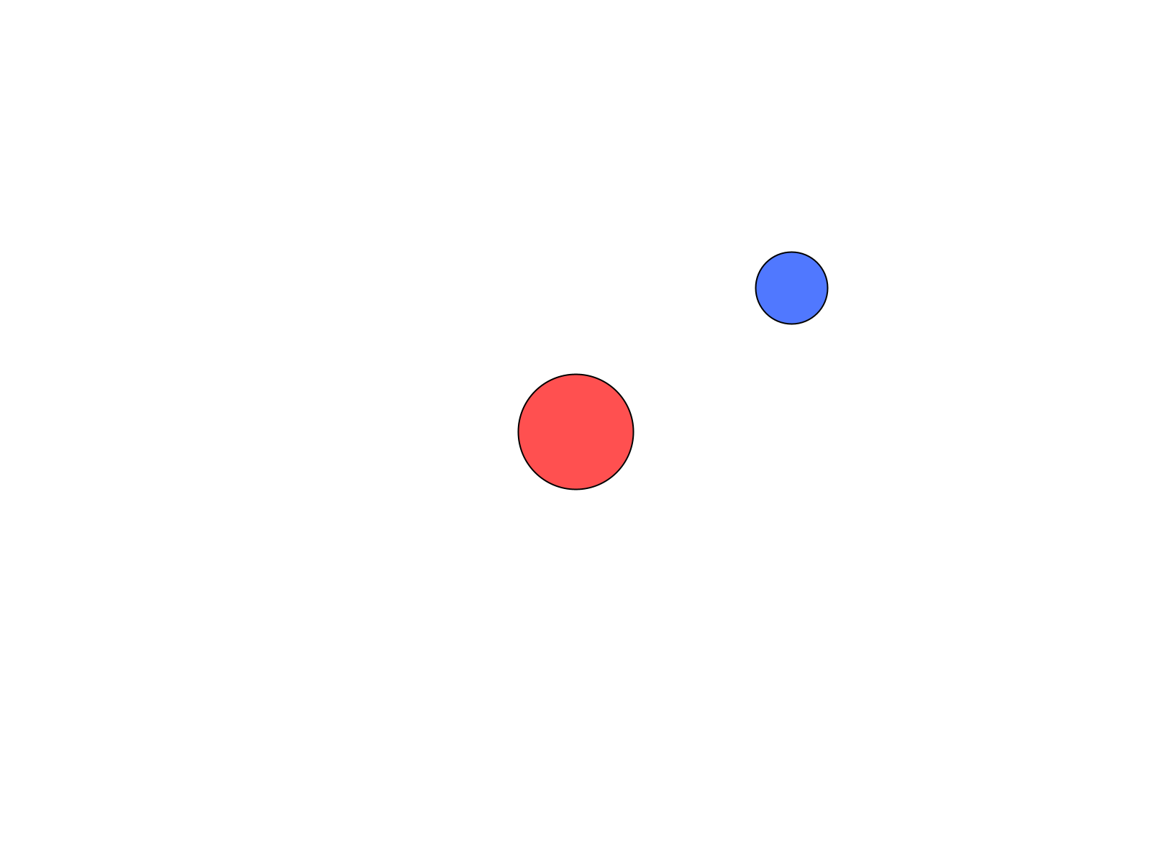
myBlob, and a friend at (550, 200).
Watch out. Skip the second of those three lines, and the sketch starts, then stops with NullPointerException, on your friend's drawSprite() line. The box at the top is still empty when draw() asks it to draw.

If one friend goes well, keep going: four or five blobs make a small scene. A face, a snowman, a planet with moons, whatever you see in them.

Chapter summary
You started with an empty window and ten lines to type. You end with a blob that's yours: your color, in your spot, at your size, on a background you chose.
You built | It's an example of
Blob myBlob; | a variable, a box with a name
new Blob(this, 400, 300, 40, color(255, 80, 80)) | making an object, and handing it its properties
myBlob.drawSprite() | asking an object for a behavior, called a method
drawSprite() moved into setup(), and back | setup() runs once, and draw() runs every frame
three errors, made on purpose | reading an error: what it says, and where it noticed
your own color( , , ) | RGB, three numbers mixed as light
a friend, if you made one | the same three places, a second time

New syntax in this chapter
Syntax | Where you met it
// comments | 1.3
import | 1.3
a variable: Blob myBlob; | 1.3
void setup() { } and void draw() { } | 1.3, Part Two
the semicolon | 1.3
size(800, 600) | 1.3
x and y | 1.3
new Blob(this, x, y, radius, color) | 1.3
the dot: myBlob.drawSprite() | 1.3
background() | 1.3, Step 5
color(r, g, b) | 1.4

Vocabulary
behavior -- a verb: something an object can do. A Blob can draw itself. (1.2)
comment -- a note for people, after //. Processing skips it. (1.3)
frame -- one page of the flipbook. draw() makes one frame each time it runs, about 60 a second. (Part Two)
function -- a set of instructions with a name, like setup() and draw(). (1.3)
library -- a set of tools somebody else built, so you can use them. SpriteGame is the library that has Blob. (1.3)
method -- a behavior, written in code. You ask for one with a dot: myBlob.drawSprite(). (1.3)
object -- a thing in your program that has its own information and knows how to do things. (1.2)
pixel -- one tiny dot of your screen. (1.3)
property -- a noun: something that describes an object. Where it is, how big, what color. (1.2)
radius -- how far it is from the center of a circle to its edge. Half the circle's width. (1.3)
RGB -- the three numbers, Red, Green, and Blue, that make a color. Each goes from 0 to 255. (1.4)
sketch -- a program in Processing. (1.1)
variable -- a box with a name on it. Blob myBlob; makes one. (1.3)

Check your understanding
- Name three properties of your blob, and one behavior.
- Which function runs once, and which runs over and over? About how many times a second?
- In Step 1 the blob disappeared. Where was it?
- Your sketch stops with Cannot find a class or type named “Blob”. What do you check first?
- What does color(0, 0, 255) make? What about color(0, 0, 0)?
- Where in the window is (800, 0)?

What's next
Your blob's a circle, and a circle is all a Blob knows how to look like. In Chapter 2 you make your own kind of object: a character you draw yourself, out of as many shapes as you want, that still knows everything a Blob knows.
And yes, it's going to move. That's Chapter 3.

