Chapter 2 - Draw Your Character
Build the character that will star in everything you make from here on.
Chapter 2
Chapter 1 ended with a blob that was yours: your color, your spot, your size. It's still a circle, though. A circle is the only way a Blob knows how to look.
A plain Blob already knows a lot. It has a position, it can move, it can wrap around the screen, and later it can tell when it's touching something. What it's missing is a face you care about.
So today you build a character on top of Blob. It keeps everything a Blob knows, and you decide what it looks like. This is the character you'll use for the rest of the course, so make it one you actually want to look at.
This chapter does it in three moves.
Part | The idea
One | A Blob with a new face. Make a new tab, put a character in it, and read every line.
Two | Your drawing replaces Blob's. Break it two ways, and see the plain Blob underneath.
Three | Measure from the belly button. Every shape goes where it goes because of pos.x and pos.y. Moving the character proves it, and then you make it yours.

Part One - A Blob with a new face

2.1 Two tabs
Open your sketch from Chapter 1. Or start a new one, and save it as MyCharacter before you type anything.
Your character gets a tab of its own.
Aside: tabs
A tab is a separate file inside your sketch. They sit in a row along the top of your code, and the first one is the main tab. Big sketches are easier to read when each kind of object lives in its own tab.

Build it. Click the small arrow at the far right of the tab bar, and choose New Tab. Name it MyCharacter. Processing adds the .pde on the end for you.
The arrow is small, and it's all the way at the right edge. Look for it twice.
Build it. Paste this into the new MyCharacter tab:
/**
* MyCharacter - this is YOUR character. Change everything!
*/
class MyCharacter extends Blob {
/**
* The constructor: called once when you create the character.
* "super" connects your character to the Blob it's built on.
* The radius (30) is the invisible collision circle - make it match your art.
*/
MyCharacter(PApplet p, float x, float y) {
super(p, x, y, 30, color(100, 180, 255));
}
/**
* drawSprite: called every frame to draw your character on screen.
* Use pos.x and pos.y as the center - all other shapes are measured from there.
*/
void drawSprite() {
// Body
fill(100, 180, 255);
noStroke();
ellipse(pos.x, pos.y, 60, 60);
// Eyes
fill(255);
ellipse(pos.x - 12, pos.y - 8, 16, 16);
ellipse(pos.x + 12, pos.y - 8, 16, 16);
fill(30);
ellipse(pos.x - 12, pos.y - 8, 8, 8);
ellipse(pos.x + 12, pos.y - 8, 8, 8);
// Smile
stroke(30);
strokeWeight(2);
noFill();
arc(pos.x, pos.y + 5, 24, 18, 0, PI);
}
}
Build it. Click back to your first tab. Replace everything in it with this:
// Lesson 2 - Draw Your Character
import coxprogramming.processing.sprites.*;
MyCharacter player;
void setup() {
size(800, 600);
player = new MyCharacter(this, width/2, height/2);
}
void draw() {
background(240);
player.drawSprite();
}
Run it.
Check. A friendly blue face in the middle of a light grey window, with two eyes and a smile.

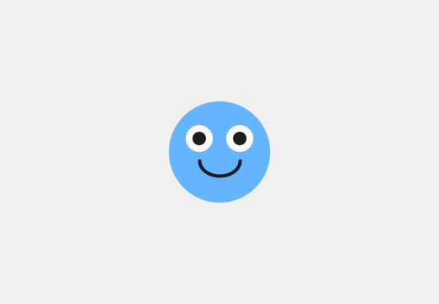
The starter character. It won't look like this for long.

2.2 The main tab
The main tab is Chapter 1's sketch with three changes.
MyCharacter player; makes a box called player, for holding a MyCharacter. In Chapter 1 the box was for a Blob. MyCharacter is a kind of thing you just invented, in the new tab.
new MyCharacter(this, width/2, height/2) makes your character and puts it in the box. It takes three things: the sketch, then x, then y.
Aside: width and height
Processing remembers the size of your window. width is 800 here, and height is 600, because that's what size(800, 600) asked for. The / means divide, so width/2 is 400: halfway across. (width/2, height/2) is the middle of the window, whatever size the window is.

background(240) is a light grey. And player.drawSprite() is the same dot as Chapter 1: player, draw yourself.

2.3 The class, and the handshake
Now the MyCharacter tab. It starts with the line that does the work:
class MyCharacter extends Blob {
A class is a blueprint for making a new kind of object. This one says how to make a MyCharacter, and everything about it goes between this brace and the last one in the tab.
extends Blob means your character is built on top of Blob. It already knows how to move, wrap around the screen, and detect collisions. All you add is what it looks like.
Your character gets all of Blob's properties and behaviors, for free. It has a position, a radius, and a color, and it can do everything a Blob can do. In a minute you'll swap out one behavior, drawSprite(), for your own.
Next is the constructor, the part that runs once, when new MyCharacter(...) makes your character:
MyCharacter(PApplet p, float x, float y) {
super(p, x, y, 30, color(100, 180, 255));
}
The three things in the first line catch the three things the main tab sent. p is the sketch, which was this. x and y are where to start.
Aside: float
float is the kind of number that can have a decimal point, like 2.5. Positions are floats, because a character can sit partway between two pixels. PApplet is the kind of thing a sketch is. Every character class you write has both words, right in this spot.

The line starting with super is the handshake. It connects your character to the library. Copy it exactly.
Look at what's inside it, though: the sketch, x, y, a radius, and a color. That's the five things a Blob needs, from Chapter 1. The handshake hands them to the Blob your character is built on.
- The 30 is your character's radius: an invisible circle the library uses later, for collisions. Keep it about the size of your character's body.
- The color is a backup. You're about to draw over it.
Watch out. Delete the super line, and the sketch stops with this:
Implicit super constructor Blob() is undefined. Must explicitly invoke another constructor
All of that means the handshake is missing. Put it back exactly as it was.

2.4 drawSprite(), yours
The rest of the tab is one method:
void drawSprite() {
You met drawSprite() in Chapter 1. A Blob already has one, and it draws a circle. When you write your own drawSprite() in your class, yours replaces Blob's. Programmers call that overriding a method. Every frame, player.drawSprite() runs your drawing.
Aside: void
void at the start says the method just does its job. It draws, and that's the end of it. Every method you write for a while starts with void.

Inside are three groups of shapes.
The body.
fill(100, 180, 255);
noStroke();
ellipse(pos.x, pos.y, 60, 60);
fill() picks the color for the shapes that come after it. noStroke() turns off the outline you saw on the white blob in Chapter 1. ellipse() draws an oval: where its center goes, then how wide, then how tall. Sixty wide and sixty tall is a circle.
The eyes. White ovals first, then dark pupils on top of them.
fill(255);
ellipse(pos.x - 12, pos.y - 8, 16, 16);
ellipse(pos.x + 12, pos.y - 8, 16, 16);
fill(30);
ellipse(pos.x - 12, pos.y - 8, 8, 8);
ellipse(pos.x + 12, pos.y - 8, 8, 8);
Shapes stack. Whatever you draw later sits on top of what you drew earlier. The pupils come after the whites, so they sit on top.
The smile.
stroke(30);
strokeWeight(2);
noFill();
arc(pos.x, pos.y + 5, 24, 18, 0, PI);
stroke() turns the outline back on, in a dark grey, and strokeWeight(2) makes it two pixels thick. noFill() means the next shape is only an outline.
Aside: arc
arc() draws part of an oval. The first four numbers are the same as an ellipse. The last two say where to start and where to stop, measured so that PI is half a turn. 0 to PI is the bottom half of the oval, which is a smile.

Part Two - Your drawing replaces Blob's

Step 1 - Misspell it
In Chapter 1, drawsprite with a small s stopped your sketch with an error. Try it here, on the method in your class.
Build it. In the MyCharacter tab, change void drawSprite() to void drawsprite(). Predict what happens, then run.
Check. It runs fine. The face is gone, and in its place is a plain blue circle with a thin black outline.

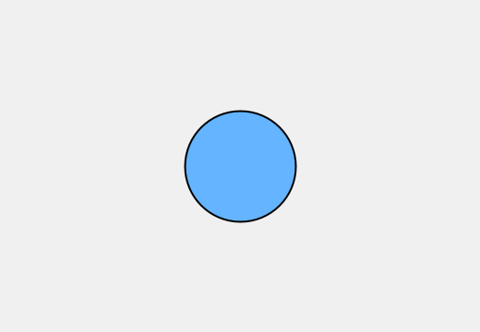
The Blob under your character.
drawsprite is a brand-new method, with a name of its own. The main tab calls drawSprite(), with a capital S, and now the only drawSprite() your character has is Blob's. Blob's draws a plain circle, at the radius and in the backup color from your handshake, with Processing's outline. That circle was under your face the whole time. Your drawSprite() was covering it up.
Build it. Put the capital S back, and run. The face is back.

Step 2 - Draw the body last
Build it. In your drawSprite(), cut the three body lines, from // Body to the body's ellipse. Paste them at the bottom of the method, after the arc. Run.
Check. A plain blue circle again, and this time the outline's gone too.

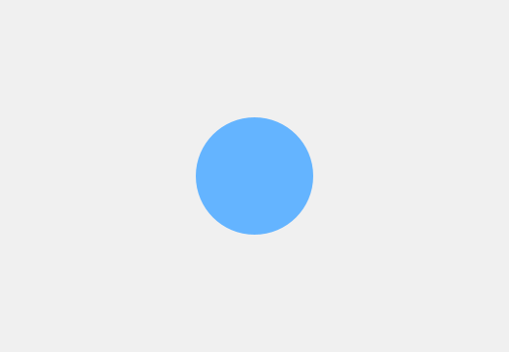
The body, painted over the face.
The face is still there, under the body. Shapes stack, so the body you drew last covered everything you drew before it. The outline is missing because the body's own noStroke() comes right before it.
Build it. Put the body lines back at the top, and run.
Watch out. Leave out noFill() before the arc, and the smile fills in with the pupils' dark grey. You get an open mouth. Maybe you wanted one.

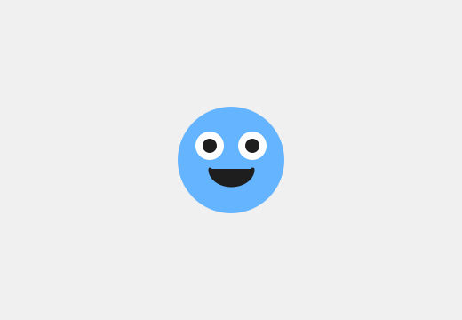
The smile without noFill().

Part Three - Measure from the belly button
Every shape in your character is placed from pos.x and pos.y. pos is your character's position, one of the properties it got from Blob, and it's the center of your character.
Think of pos.x, pos.y as your character's belly button. Every shape you draw is measured from there.
- Minus x moves a shape left. Plus x moves it right.
- Minus y moves a shape up. Plus y moves it down.
Yes, up is minus. Screens are strange that way.
So ellipse(pos.x - 12, pos.y - 8, 16, 16) is an eye 12 pixels left of the belly button and 8 pixels up.

Step 3 - A new body color
Build it. Find fill(100, 180, 255), right above the body's ellipse, and put in a color of your own. The Color Selector works the same as in Chapter 1. Run.
Check. The body changes color. The eyes and the smile have their own fill and stroke, so they look just as they did.

Step 4 - Slide an eye
Build it. The left eye is the two lines with pos.x - 12: its white and its pupil. Change both to pos.x - 20, and run.
Check. The left eye slides out toward the edge of the face.

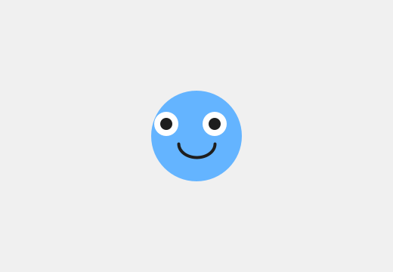
The left eye, 20 pixels left of center.
Put it wherever you like it.

Step 5 - Start somewhere else
Build it. In the main tab, change width/2, height/2 to 200, 150, and run.
Check. The whole face is up near the top-left now, all in one piece.

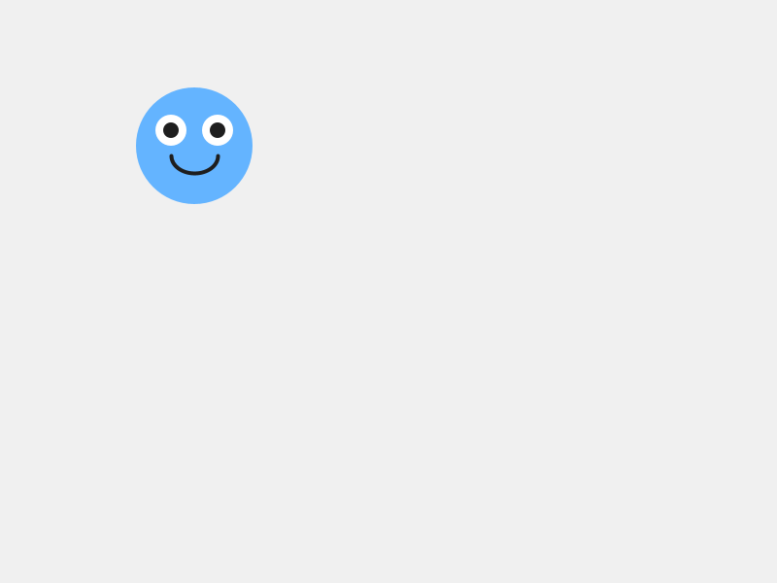
Your character, starting at (200, 150).
Every shape moved, because every shape is measured from the belly button, and the belly button moved.

Step 6 - The eye at fixed numbers
Here's an eye written another way. Before you moved it, the character's belly button was at (400, 300). So the left eye's white was at 400 - 12 and 300 - 8, which is (388, 292).
Build it. First, put the main tab back to width/2, height/2. Then, in the MyCharacter tab, change the left eye's white, the first ellipse under fill(255), to plain numbers:
ellipse(388, 292, 16, 16);
Run it.
Check. Your character looks exactly the same as before.

Now change the main tab to 200, 150 again, and run.
Check. The face moves up to the top-left. One white eye stays behind in the middle of the window.

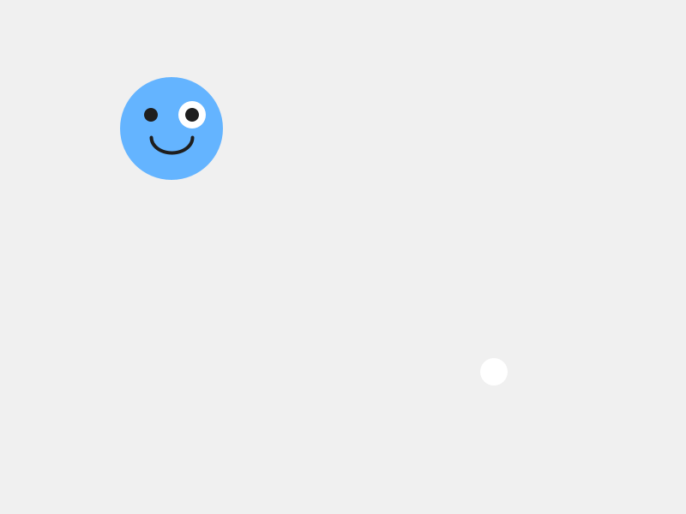
One eye didn't get the message.
Why did that eye stay behind, when every other part of the face moved? Make a guess before you read on.
Plain numbers nail a shape to one spot in the window. It looks fine as long as the character sits still, and today it does. In Chapter 3 your character starts moving, and a shape at plain numbers gets left behind. So measure every shape from pos.x and pos.y.
Build it. Put the eye back to pos.x - 12, pos.y - 8. Put the main tab back to width/2, height/2, or anywhere you like.

2.5 Make it yours
This chapter is the make-it-yours. Spend the rest of your time here.
The shapes you can use, all measured from the belly button:
You write | You get
ellipse(x, y, w, h) | an oval, centered at x, y
rect(x, y, w, h) | a rectangle. Its x, y is the top-left corner, so rect(pos.x - 20, pos.y - 20, 40, 40) is a square centered on the belly button.
triangle(x1, y1, x2, y2, x3, y3) | a triangle, from its three corners
line(x1, y1, x2, y2) | a line, from one end to the other. Its color is the stroke.
arc(x, y, w, h, start, stop) | part of an oval
Your turn. Make your character yours. Some places to start:
- Change the body shape. rect(), triangle(), or several overlapping ellipse() calls all work.
- Add hair, a hat, wings, antennae, a tail, ears, a beak, horns. Anything.
- Change every color, with the Color Selector.
- Add detail. Eyebrows change the whole mood. So do freckles, a nose, or a mouth with teeth.
- Give it an expression. Angry eyebrows are two short line() calls.
Order matters as you go. Draw the body first, then what sits on it.
You can keep adding detail in every chapter from here on. Today's job is to get a character on the screen that's recognizably yours. Goodbye, starter blob~
Your turn. When your character is done, check the 30 in the super(...) line. If your character came out much bigger or smaller than the starter, change the 30 to about half your character's width.
Try a big change first, like 100, and run. The screen looks exactly the same. The radius is invisible. In Chapter 6 it's the circle the library uses to decide whether your character is touching something, so set it to fit your character's body now.
Your turn. Optional: make a second character class in another new tab: a sidekick, a pet, a rival. Same pattern, different art. Give the class its own name, like class Sidekick extends Blob, and use that name everywhere MyCharacter appears in the copy.

Chapter summary
You started with a Blob that could only be a circle. You end with a character of your own, built on top of Blob: it knows everything a Blob knows, and it looks the way you drew it.
You built | It's an example of
the MyCharacter tab | a class, a blueprint for a new kind of object, in a tab of its own
class MyCharacter extends Blob | a new kind of object built on top of another
super(p, x, y, 30, color(...)) | the handshake, handing Blob the five things it needs
your own void drawSprite() | overriding a method: your drawing replaces Blob's
drawsprite, misspelled | the plain Blob that was underneath all along
the body drawn last | shapes stack, and later shapes sit on top
every shape at pos.x and pos.y plus or minus | measuring from the belly button, so the whole face moves together

New syntax in this chapter
Syntax | Where you met it
tabs | 2.1
width, height, and / | 2.2
class MyCharacter extends Blob { } | 2.3
the constructor, PApplet, float | 2.3
super(...) | 2.3
void drawSprite() { } | 2.4
fill(), noFill(), stroke(), noStroke(), strokeWeight() | 2.4
ellipse(), arc(), PI | 2.4
pos.x, pos.y | 2.4, Part Three
rect(), triangle(), line() | 2.5

Vocabulary
class -- a blueprint for making a new kind of object. (2.3)
constructor -- the part of a class that runs once, when new makes an object. (2.3)
extends -- built on top of. class MyCharacter extends Blob means everything a Blob can do, your character can do too. (2.3)
handshake -- the super(...) line. It connects your character to the library. Copy it exactly, and change only the radius. (2.3)
overriding -- writing your own version of a method your object already had. Yours replaces the old one. (2.4)
pos.x, pos.y -- your character's position, its belly button. Measure every shape from there. (Part Three)
tab -- a separate file inside your sketch. (2.1)

Check your understanding
- What does extends Blob give your character? Say it in one sentence.
- What are the five things inside the super(...) handshake, and where have you seen those five before?
- Why did misspelling drawSprite give you a plain circle, and why that color?
- Your eyes vanished after you added a new shape. What's the first thing you check?
- An ear is at pos.x + 30, pos.y - 25. Is it on the left or the right? Above the belly button, or below?
- Why is ellipse(388, 292, 16, 16) going to cause trouble in Chapter 3?

What's next
Your character can move. It always could: it's a Blob, and moving is one of the things a Blob knows how to do. All it needs is for your sketch to ask.
In Chapter 3 you give it a speed and a direction, and it slides across the screen and off the edge, and comes back around the other side. Every shape you measured from the belly button goes with it.

