Chapter 3 - Bring It to Life
Your character stops sitting there and starts moving on its own.
Chapter 3
Chapter 2 ended with a character of your own, sitting in the middle of the window. It can move. It always could, because it's built on top of Blob, and moving is one of the things a Blob knows how to do. All it needed was for your sketch to ask.
Today it asks. It takes two lines, one in setup() and one in draw(), and you leave your MyCharacter tab exactly as it is.
This chapter does it in three moves.
Part | The idea
One | Velocity is two numbers. How fast across, and how fast up or down.
Two | move() is the step. Give your character a velocity, watch nothing happen, then make it go: off the edge and back.
Three | Make it yours. A speed and a direction that suit your character, and a world with a mood.
Part One is reading. Part Two is six small steps, and the sketch runs at the end of every one.

Part One - Two numbers and a step

3.1 Velocity is two numbers
"Speed" in a game is really two questions. How fast am I going sideways? And how fast am I going up or down? So a character's velocity is two numbers.
- vx is left and right. Positive goes right. Negative goes left.
- vy is up and down. Positive goes down. Negative goes up.
-vy up
|
-vx left ----+---- right +vx
|
+vy down
You met this in Chapter 1: on a screen, y counts down from the top. So a positive vy moves your character down the screen, and that surprises nearly everybody.
The line that sets a velocity looks like this:
player.setVelocity(3, -2); // 3 pixels right, 2 pixels up per frame
That's 3 pixels to the right and 2 pixels up, every frame. At sixty frames a second, it adds up fast.
Velocity is one more of your character's properties. Blob gave it one when it was made, set to zero across and zero down. That's why your character has been sitting still.

3.2 move() is the step
Setting a velocity is like telling someone how fast to walk. Until they take a step, they stay right where they are.
player.move();
move() is the step. It takes the velocity and adds it to the position, once. So it goes in draw(), where it happens sixty times a second.

Part Two - Make it go

Step 1 - A velocity, and nothing else
Open your sketch from Chapter 2. Leave the MyCharacter tab alone today. Everything happens in the main tab.
Build it. In setup(), right after the line that makes your character, add the velocity:
void setup() {
size(800, 600);
player = new MyCharacter(this, width/2, height/2);
player.setVelocity(3, -2); // 3 pixels right, 2 pixels up per frame
}
Run it.
Check. Your character sits in the middle of the window, exactly the way it did in Chapter 2.

You told it how fast to go. Taking the step is a separate instruction, and that's Step 2.

Step 2 - Take the step
Build it. In draw(), add player.move(); on the line before player.drawSprite();:
void draw() {
background(240);
player.move(); // update position (do this BEFORE drawing)
player.drawSprite(); // draw at new position
}
Run it, and watch.
Check. Your character drifts up and to the right.


One second in: 60 frames, 180 pixels right and 120 up.
Watch out. A character with a velocity and no move() sits perfectly still. This is the most common mistake in the chapter. When your character is frozen, look for move() in draw() first.

Step 3 - See every frame
background(240) paints over the whole window at the start of every frame. Here's what your character looks like without it.
Build it. Put // at the front of the background line, so it reads:
//background(240);
Aside: commenting out
// turns a whole line into a comment, so Processing skips it. That's called commenting out a line. It's the quickest way to switch something off and keep it handy: take the // away, and the line is back.

Run it.
Check. A long blue stripe, with your character's face at the front end.


Every frame, still on the screen.
That stripe is every frame of the flipbook from Chapter 1, at once. Each frame drew your character one step further along, and with nothing painting over the old ones, they're all still there. The grey is the color Processing starts a window with.
Leave the // there for one more step.

Step 4 - Off the edge
Let it run, and keep watching when your character reaches the edge of the window.
Check. It slides off one edge and comes back in on the opposite side.

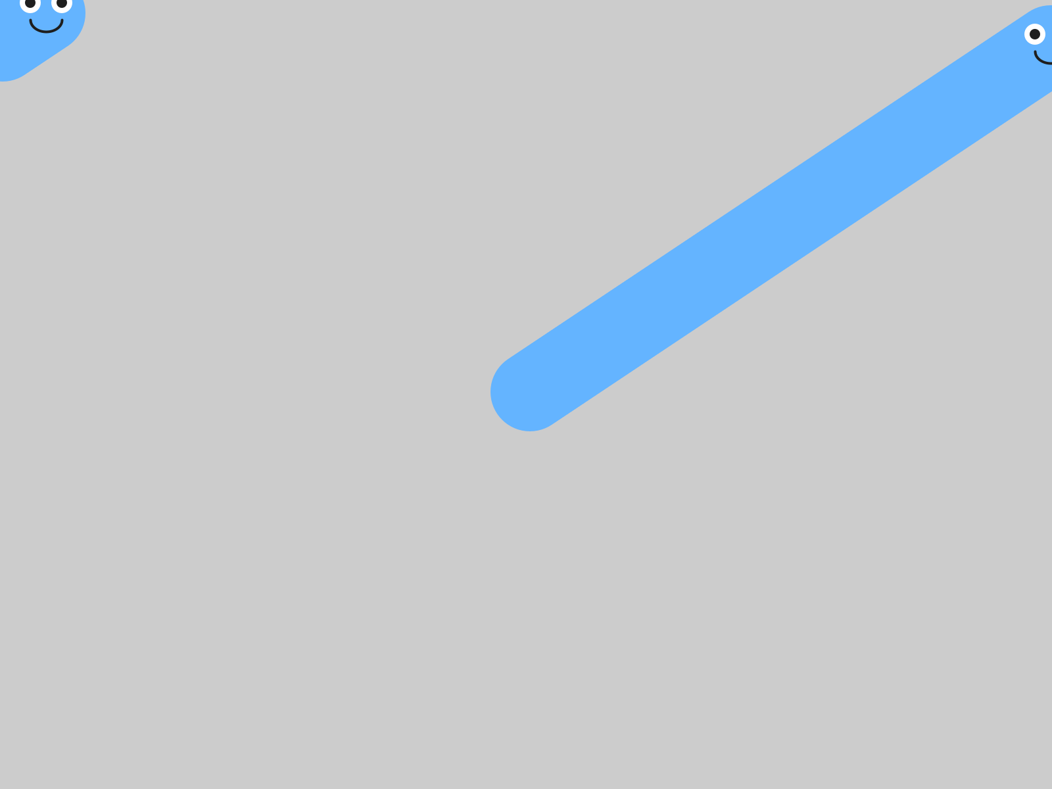
Off the right edge, back in on the left. The stripe starts over on the other side.
That's called wrapping. Off the right, back in on the left. Off the top, back in at the bottom. You didn't write that. The library does it for you, inside move().

Step 5 - Faster, slower, and which way
Keep the // in front of background for this step, so each try draws its own path.
Build it. Change the velocity to (8, 0) and run. Then (0.5, 0) and run. Fast, and slow.
Now predict before you run. Which way does setVelocity(3, 3) go? Which way does setVelocity(3, -3) go?
Check. (3, 3) heads down and to the right. (3, -3) heads up and to the right.


setVelocity(3, 3): positive y, so down.

setVelocity(3, -3): negative y, so up.
When vx and vy are the same size, the path is an exact diagonal.
Build it. Take the // off background(240), and run. The stripes are gone, and your character is one face again.

Step 6 - A different direction every run
Build it. Replace both numbers in setVelocity() with random(-5, 5):
player.setVelocity(random(-5, 5), random(-5, 5));
Press ▶ Run five times in a row.
Check. Your character takes off in a different direction, at a different speed, every time.

Aside: random(a, b)
random(-5, 5) picks a surprise number between -5 and 5, fresh every time it runs. It's usually not a whole number: it might be 2.7, or -0.4. That's fine, because velocities are floats, like positions. Put random() anywhere a number goes, and you get a different number every run.

3.3 Move first, then draw
Here's a question to think about. What happens if you call drawSprite() before move()?
void draw() {
background(240);
player.drawSprite();
player.move();
}
Make a guess before you read on.
Each frame, that version draws your character, and only then moves it. So it's always drawing your character where it used to be: one frame behind, forever.
Try it, and you'll see it looks the same. It is the same, one frame late. At sixty frames a second, one frame is too short to see. It's still a habit worth getting right now: move, then draw.
Watch out. If part of your character gets left behind when it starts moving, look at Chapter 2's Step 6. A shape drawn at plain numbers, like ellipse(388, 292, 16, 16), sits still while the rest of the face moves. Measure it from pos.x and pos.y, and it comes along.


An eye at plain numbers, left behind in the middle of the window.

Part Three - Make it yours

3.4 A speed that fits
Your turn. Tune your character's velocity until it feels right for your character. A heavy monster lumbers. A bug darts. A ghost might drift slowly up. Pick numbers, or keep random(), and run it until it looks like your character moving.
Your turn. Change the background color to set a mood. A character drifting across dark blue looks completely different from the same character on white. Three numbers from the Color Selector work here, just as in Chapter 1.

3.5 Something else alive
Your turn. Optional: add a second blob with a velocity of its own, so there's something else moving on the screen. It goes in the same three places as the friend in Chapter 1, plus the two new lines from today:
- At the top: Blob friend;
- In setup(): a new Blob(...), and then friend.setVelocity(...).
- In draw(): friend.move();, then friend.drawSprite();.
Check. Two things moving, each at its own speed. Here's one friend, slow, drifting left and a little down.


Your character, and a friend with setVelocity(-1, 0.5).
Your turn. Optional: put the // back in front of background(), on purpose. Some of the best-looking sketches leave their trails on the screen.

Chapter summary
You started with a character that could move, waiting to be asked. You end with one that slides across the screen at a speed you chose, and wraps around the edges on its own.
You built | It's an example of
player.setVelocity(3, -2) | a velocity: two numbers, across and down, per frame
a velocity and no move() | a velocity is a plan, and move() carries it out
player.move() in draw() | taking one step every frame
//background(240); | commenting out a line, and every frame on the screen at once
your character, off the edge and back | wrapping, which the library does inside move()
setVelocity(random(-5, 5), random(-5, 5)) | random(), a different number every run
move() before drawSprite() | move, then draw

New syntax in this chapter
Syntax | Where you met it
setVelocity(vx, vy) | 3.1, Step 1
move() | 3.2, Step 2
// in front of a line of code | Step 3
random(a, b) | Step 6

Vocabulary
commenting out -- putting // in front of a line of code, so Processing skips it. Take the // away to switch it back on. (Step 3)
move() -- the step. It adds your character's velocity to its position, once. It goes in draw(). (3.2)
random(a, b) -- a surprise number between a and b, fresh every time it runs. (Step 6)
velocity -- how fast something moves, and which way. Two numbers: vx, left and right, and vy, up and down. (3.1)
wrapping -- going off one edge of the window and coming back in on the opposite edge. (Step 4)

Check your understanding
- setVelocity(0, 4). Which way does your character go?
- Your character has a velocity, and it won't move. What's missing?
- Why does move() go in draw(), and setVelocity() go in setup()?
- Where did the blue stripe in Step 3 come from?
- What does random(1, 3) give you? Will it give you the same number next time?
- You call drawSprite() before move(). What's different, and can you see it?

What's next
Your character moves now, all on its own, in whatever direction you gave it at the start. Once it's going, it goes where you pointed it.
In Chapter 4 you take the controls. Your character follows your mouse, or goes where the arrow keys send it, and your game gets its player.

