Chapter 4 - You're in Control
Your character stops doing its own thing and starts doing what you tell it.
Chapter 4
Chapter 3 ended with a character that moves on its own, in whatever direction you gave it at the start. Once it's going, it goes where you pointed it.
Today you take the controls. There are two ways to do it, and you'll try both: your character can chase your mouse, or go where the arrow keys send it. Then you pick the one that fits your game.
This chapter does it in four moves.
Part | The idea
One | Two kinds of input. Some things you can ask about every frame. Some things happen once.
Two | Option A: follow the mouse. One line in draw(), and a speed in setup().
Three | Option B: the arrow keys. A new kind of function, one Processing calls for you when a key goes down.
Four | Make it yours. Pick one, tune it, and add a click.
Leave your MyCharacter tab exactly as it is. Everything happens in the main tab.

Part One - Two kinds of input

4.1 All the time, or once
Input is information coming into your program from you: the mouse, the keyboard. There are two very different kinds, and telling them apart is the real idea of this chapter.
Some questions have an answer all the time. "Where is the mouse right now?" You can ask that on every frame, and there's always an answer. That's continuous input, and it belongs in draw().
Other things happen once. "Did a key just go down?" That's an event. It has an answer only at the instant it happens, so Processing comes and tells you, by running a function you wrote for it.
Option A uses the first kind. Option B uses the second.

Part Two - Option A: follow the mouse

Step 1 - Chase the cursor
Build it. Open your sketch from Chapter 3. In setup(), set the velocity to (4, 0). In draw(), replace player.move(); with player.followMouse();:
void setup() {
size(800, 600);
player = new MyCharacter(this, width/2, height/2);
player.setVelocity(4, 0); // REQUIRED - this is the speed it chases at
}
void draw() {
background(240);
player.followMouse();
player.drawSprite();
}
Run it, and move your mouse around the window.
Check. Your character chases the mouse. When you hold the mouse still, your character slides straight to it.


The mouse held still at (650, 450), with background() switched off, as in Chapter 3, to show the path.
followMouse() pulls your character a little way toward the cursor, every frame. Since it happens every frame, it goes in draw().
Aside: mouseX and mouseY
Processing always knows where your mouse is. mouseX is how far across the window it is, and mouseY is how far down, measured the same way as everything else since Chapter 1. followMouse() reads them every frame. You'll use them yourself in 4.5.

Step 2 - The chase speed
Build it. Change the 4 in setVelocity to 1, and run. Then try 12.
Check. At 1 your character creeps after the mouse. At 12 it jumps to it.

followMouse() uses the size of your velocity as its chase speed, and ignores which way the velocity points. setVelocity(5, 0) and setVelocity(0, 5) chase at exactly the same speed.
Watch out. With a velocity of (0, 0), or no setVelocity() at all, followMouse() moves your character zero pixels, and it looks broken. When your character ignores the mouse, check setup() for a velocity first.

Watch out. Use followMouse() or move(), one or the other. followMouse() moves the character itself. With both, followMouse() pulls it toward the mouse, and move() pushes it to the right by its velocity, every frame. Your character curves over and parks just to the right of the mouse, where the pull and the push cancel out.


followMouse() and move() together. It never quite gets to the mouse at (650, 450).

Part Three - Option B: the arrow keys

Step 3 - Back to move()
Build it. Comment out the followMouse() line, and put player.move(); back, above drawSprite():
void draw() {
background(240);
// player.followMouse();
player.move();
player.drawSprite();
}
Keep the setVelocity(4, 0) in setup().

Step 4 - A function for when a key goes down
Build it. At the very bottom of your sketch, after the closing brace of draw(), add a new function:
// Arrow keys control the character
void keyPressed() {
player.keyboardControl();
}
Aside: event functions
keyPressed() is an event function. You write it, and Processing calls it for you, every time a key goes down. Its name has to be exactly keyPressed, the same way setup and draw have to be spelled exactly. There's one for the mouse, too: mousePressed() runs once, each time you click.

Watch out. Click inside the sketch window before you press any keys. Until you do, the keys go to the code editor.

Run it, and wait a second before you touch anything.
Check. Your character drifts slowly to the right on its own.


One second in, before any key.
That's the setVelocity(4, 0) from Step 1, and move() is using it, the same as in Chapter 3. Now click in the window and use the arrow keys.
Check. Each arrow sends your character that way.

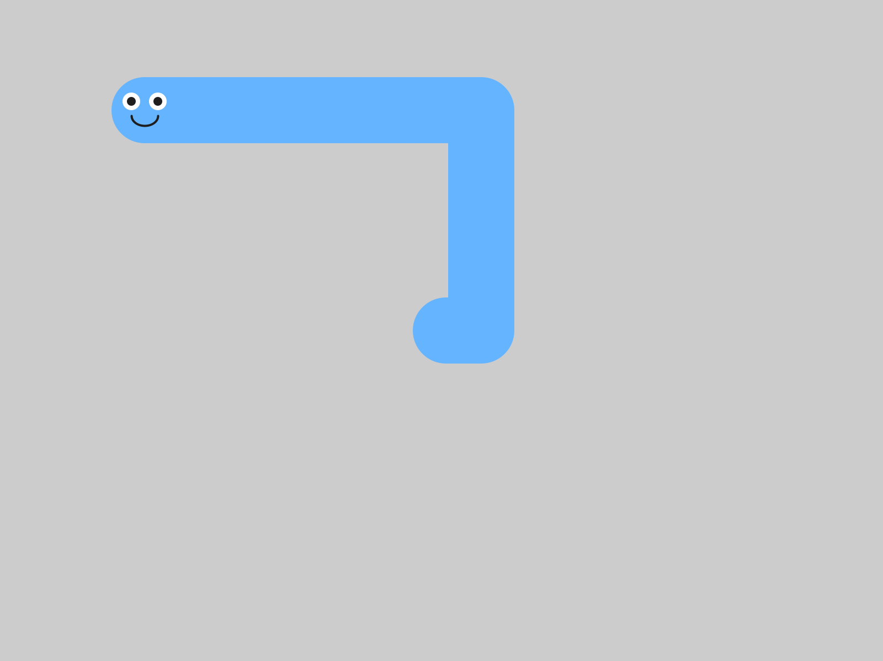
Up, then left. A trail, as before.

Step 5 - Let go
Build it. Press an arrow key, and let go.
Check. Your character keeps going.

That's how it's meant to work. keyboardControl() sets your character's velocity, and letting go of the key leaves the velocity just as it was. So your character coasts, like it's on ice. Some games want exactly that.
Now press the space bar.
Check. Your character stops dead.


Up, and then the space bar.
keyboardControl() looks at which key went down. An arrow sets a speed of 5 in that direction. Any other key sets the velocity to zero. So every key that isn't an arrow is a brake: the space bar, a letter, anything.
That 5 is fixed. Changing the numbers in setVelocity() changes how your character drifts before the first key. After that, it's always 5.

4.4 The two halves
Option B has two halves, and they're the two kinds of input from 4.1.
- keyboardControl(), in keyPressed(), runs once per key press. It changes the velocity. That's an event.
- move(), in draw(), runs every frame. It uses the velocity, to take a step.
Watch out. Switch to the keys and forget to put move() back, and your character sits still. Every key press sets a velocity, and only move() takes the step.

Part Four - Make it yours

4.5 Pick one
Argue it. Mouse or keys, for your game? followMouse() is easier and more forgiving. keyboardControl() feels more like a real game. Each one gives you something the other one gives up, and that's a trade-off. Pick one, and be ready to say why it fits the game you want to make.

Your turn. Keep the control style you picked, and comment out or delete the other one. Then tune it: the chase speed for the mouse, or how you feel about the coasting for the keys. Whatever you choose today, you can change it later.

4.6 Something extra
Your turn. Optional: add a click ability. Put this at the bottom of your sketch:
void mousePressed() {
player.moveTo(mouseX, mouseY); // teleport to wherever you clicked
}
Check. Click anywhere, and your character jumps straight there.


A click at (150, 120).
moveTo() picks your character up and puts it down at the spot you give it. It works with either control style. With the keys, it gives you a teleport.
Your turn. Optional: make the character stop when you let go of the key. Add one more event function:
void keyReleased() {
player.setVelocity(0, 0);
}
Check. Press an arrow and let go. Your character goes, then stops.


Right, and then let go.
Try it both ways, coasting and stopping. Which one suits your character?
Your turn. Optional: add a second blob that moves on its own, the way you did in Chapter 3, so there's something else on the screen while you steer.

Chapter summary
You started with a character that went where you pointed it, once. You end with one you steer, with the mouse or the keys, and a reason for the one you picked.
You built | It's an example of
player.followMouse() in draw() | continuous input, asked about every frame
setVelocity(4, 0) for the chase | followMouse() uses the size of the velocity as its speed
void keyPressed() { player.keyboardControl(); } | an event function, run once per key press
move() in draw(), with the keys | one half changes the velocity, the other half uses it
letting go, and the space bar | coasting, and a brake on every other key
mousePressed() and moveTo(mouseX, mouseY) | a second event function, and the mouse's position
mouse or keys, picked | a trade-off

New syntax in this chapter
Syntax | Where you met it
followMouse() | Step 1
mouseX, mouseY | Step 1
void keyPressed() { } | Step 4
keyboardControl() | Step 4
void mousePressed() { } | Step 4, 4.6
moveTo(x, y) | 4.6
void keyReleased() { } | 4.6

Vocabulary
continuous input -- something your program can ask about every frame, like where the mouse is. It goes in draw(). (4.1)
event -- something that happens once, at one instant, like a key going down or a click. (4.1)
event function -- a function you write and Processing calls for you when an event happens: keyPressed(), mousePressed(), keyReleased(). (Step 4)
input -- information coming into your program from you: the mouse, the keyboard. (4.1)
trade-off -- a choice where each option gives you something the other one gives up. (4.5)

Check your understanding
- Why does followMouse() go in draw(), and keyboardControl() go in keyPressed()?
- Your character won't chase the mouse. What do you check first?
- With the arrow keys, what does keyboardControl() change, and what does move() do every frame?
- Why does your character keep going after you let go of the key?
- What happens when you press the space bar, and why?
- You chose mouse or keys. What does your choice give you, and what does it give up?

What's next
Your character goes where you tell it now, across an empty grey window.
In Chapter 5 you build it a world: ground, scenery that drifts past, and a coin floating through it, waiting for Chapter 6.

