Chapter 5 - Build Your World
Your character needs somewhere to be. Today you build the place your game happens in.
Chapter 5
Chapter 4 ended with a character you can steer, across an empty grey window.
Today it gets a world: ground to stand on, a sky, clouds drifting past, and a coin floating through, waiting for Chapter 6. There's very little new code today. Most of the chapter is you, deciding what your world looks like.
The one new idea is draw order: the order of your lines decides what appears in front.
This chapter does it in four moves.
Part | The idea
One | Sketch it first. Three minutes on paper, and the one new kind of sprite.
Two | Ground, and the order you draw in. A Block for the ground, and the rule: background first, player last.
Three | Things in the world. Clouds in a tab of their own, and a coin.
Four | Make it yours. A world with a theme that's yours.
You keep everything from Chapters 1 to 4, and you leave your MyCharacter tab exactly as it is.

Part One - Sketch it first

5.1 On paper
Your turn. Before any code, sketch the world your game takes place in, on paper. What's in the background? Is there ground? Sky? What drifts past? Three minutes, then show a neighbor.
It earns its three minutes. You'll build a better world with the picture in front of you.

5.2 Block, the rectangle sprite
Your character is a Blob, and so far everything in your sketch has been one. The library has another kind of sprite for scenery: a Block, a rectangle.
A Block starts with zero velocity, so it sits exactly where you put it. That makes it good for ground, walls, a platform, a ceiling.
ground = new Block(this, 0, height - 70, width, 70, color(80, 160, 60));
Six things, in this order:
 | What it is
this | the sketch, the same as a Blob
0 | x of the top-left corner: the left edge
height - 70 | y of the top-left corner: 70 pixels up from the bottom
width | how wide: the whole window
70 | how tall
color(80, 160, 60) | its color, a grassy green
So this one fills the bottom 70 pixels of the window, edge to edge.
Watch out. For a Block, x and y are the top-left corner. For a Blob they were the center. This catches everyone once.

A Block is scenery. Your character passes straight through it, the same as it passes through everything else in your world right now.

Part Two - Ground, and the order you draw in

Step 1 - Ground
Build it. Open your sketch from Chapter 4. Add the ground in three places, the same three as every object since Chapter 1:
Block ground; // at the top, with player
// in setup(): x, y is the TOP-LEFT corner
ground = new Block(this, 0, height - 70, width, 70, color(80, 160, 60));
// in draw(), right after background()
ground.drawSprite();
Run it.
Check. A strip of green along the bottom of the window.


Ground, on Chapter 4's grey.
Watch out. Use the ground's center for its x and y, the way you would for a Blob, and the ground lands in the wrong spot. Here it is with width/2, height - 35, the middle of where the ground should be.


The corner, put where the center should be. Half the ground hangs off the window.

Step 2 - A sky
Build it. Change background(240) to a color that fits your world. The Canvas starter uses a sky blue, background(135, 206, 235). Deep space black, ocean teal, or lava red work too.

Step 3 - Draw order, on purpose
Build it. Move ground.drawSprite(); to the very last line of draw(), after your player. Run it, and steer your player down to the ground.
Check. Your player disappears underneath the ground.


Ground drawn first, and the player is in front.

Ground drawn last, and the player is behind it. Same spot.
Move the line back, right after background(), and say out loud what happened.
Processing draws like paint on a canvas. Whatever you draw later covers whatever you drew earlier. You saw it inside your character in Chapter 2, when the body drawn last painted over the face. Now it's the whole world. The order of the calls in draw() is the layering.
Rule of thumb: background first, player last.
Watch out. background() paints over the whole window, so it goes at the top of draw(). Call it halfway down, and it erases everything you drew above it that frame. Move it below your clouds, in Step 4, and the frame comes out exactly like one with no clouds in it at all.

Part Three - Things in the world

Step 4 - Clouds, in a tab of their own
Build it. Make a new tab called Cloud, the way you made MyCharacter in Chapter 2. Paste this in:
// Cloud - a second sprite class. Redesign it to fit your world!
class Cloud extends Blob {
Cloud(PApplet p, float x, float y, float speed) {
super(p, x, y, 40, color(255)); // radius 40 used for collision if ever needed
setVelocity(speed, 0); // drift slowly to the right; no vertical movement
}
void drawSprite() {
noStroke();
// Bottom puffs - the wide base of the cloud
fill(250, 250, 255);
ellipse(pos.x, pos.y, 72, 46);
ellipse(pos.x - 31, pos.y + 13, 50, 33);
ellipse(pos.x + 33, pos.y + 13, 55, 33);
// Top puffs - slightly greyer for a sense of depth
fill(235, 238, 248);
ellipse(pos.x - 13, pos.y - 17, 54, 38);
ellipse(pos.x + 17, pos.y - 11, 46, 33);
}
}
Read it against your MyCharacter tab. A class line with extends Blob, a super(...) handshake, and a drawSprite() full of shapes measured from pos.x and pos.y. You've written every piece of this already.
Two things are new, both in the constructor.
Aside: a constructor with a number of its own
Cloud(PApplet p, float x, float y, float speed) takes a fourth thing, the cloud's speed. Then the constructor uses it: setVelocity(speed, 0). So every cloud sets its own velocity when it's made, right in its own constructor.

Build it. In the main tab, add two clouds, in the same three places:
Cloud cloud1; // 1. declare it at the top
Cloud cloud2;
cloud1 = new Cloud(this, 150, 90, 0.5); // 2. create it in setup()
cloud2 = new Cloud(this, 520, 60, 0.8);
cloud1.move(); // 3. move and draw it in draw()
cloud1.drawSprite();
cloud2.move();
cloud2.drawSprite();
The move-and-draw lines go right after background(), before the ground. Clouds are far away, so they're drawn first.
Run it.
Check. Two clouds drift slowly to the right, each at its own speed, and wrap around like everything else.


Sky, two clouds, ground, and your player.
Watch out. Make a cloud in draw() by mistake, and it freezes. The new Cloud(...) line runs every frame, so the cloud is built again at its starting spot sixty times a second. Making things goes in setup().

Each cloud is its own variable. Want a third? Declare cloud3, create it, move it, draw it. If you find yourself wanting fifty of something, ask your teacher about Bonus D.

Step 5 - A coin
Build it. Add a coin. Declare Blob coin; at the top. Create it in setup():
// A coin drifting through the world. You collect it in Lesson 6.
coin = new Blob(this, random(width), random(100, height - 150),
14, random(1, 2.5), random(-1.5, 1.5),
color(255, 220, 50));
Aside: a Blob with seven numbers
This Blob gets seven things where Chapter 1's got five: the sketch, x, y, the radius, then two more, its velocity, and then its color. It's the same as making a Blob and calling setVelocity() on it, in one line. Every number here except the radius and color is random(), so the coin starts somewhere different, going a different way, every run.

Move and draw it in draw(), after the ground and before the player. Run it.
Check. A gold coin drifting through your world. Steer your player into it. Nothing happens. That's Chapter 6.

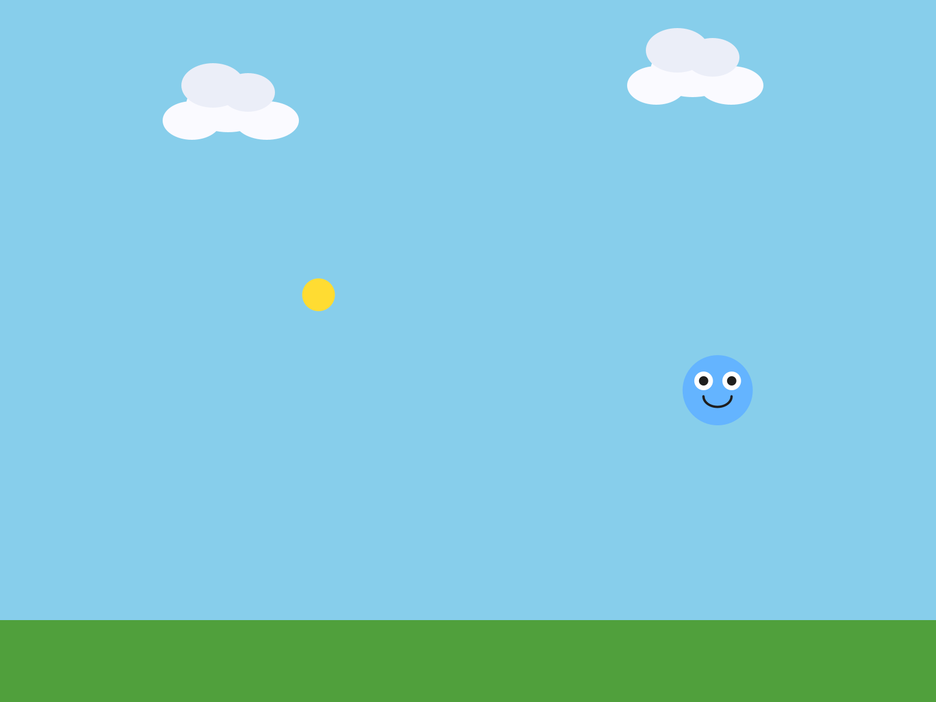
The finished world, as the Canvas starter builds it. Your coin will be somewhere else.
Here's the whole draw(), back to front:
void draw() {
background(135, 206, 235); // 1. sky - furthest back
cloud1.move(); // 2. clouds drift behind everything
cloud1.drawSprite();
cloud2.move();
cloud2.drawSprite();
ground.drawSprite(); // 3. ground in front of the sky
coin.move(); // 4. things in the world
coin.drawSprite();
player.followMouse(); // 5. player last, so it is always in front
player.drawSprite();
}
If you drive with the arrow keys, your step 5 is player.move(); instead.

Part Four - Make it yours

5.5 A place
The rest of the time is yours. Play your world as you go. Does it look like a place? Keep going until it does.
Your turn. Give your world a theme. Space? Underwater? Lava? A cave? A candy world? Start with the background.
Your turn. Make everything belong together. A gold coin in a space world looks wrong. Make it a star, or a gem, or an asteroid.
Your turn. Redesign the Cloud tab completely: a star, a bubble, a bird, a fish. Rename the class if you like. Or write a brand-new decoration in a new tab, a Tree, a Rock, with the same extends Blob pattern as your character.
Your turn. Add more Blocks: a platform, a wall, a border around your scene. Pick where each one goes in draw().
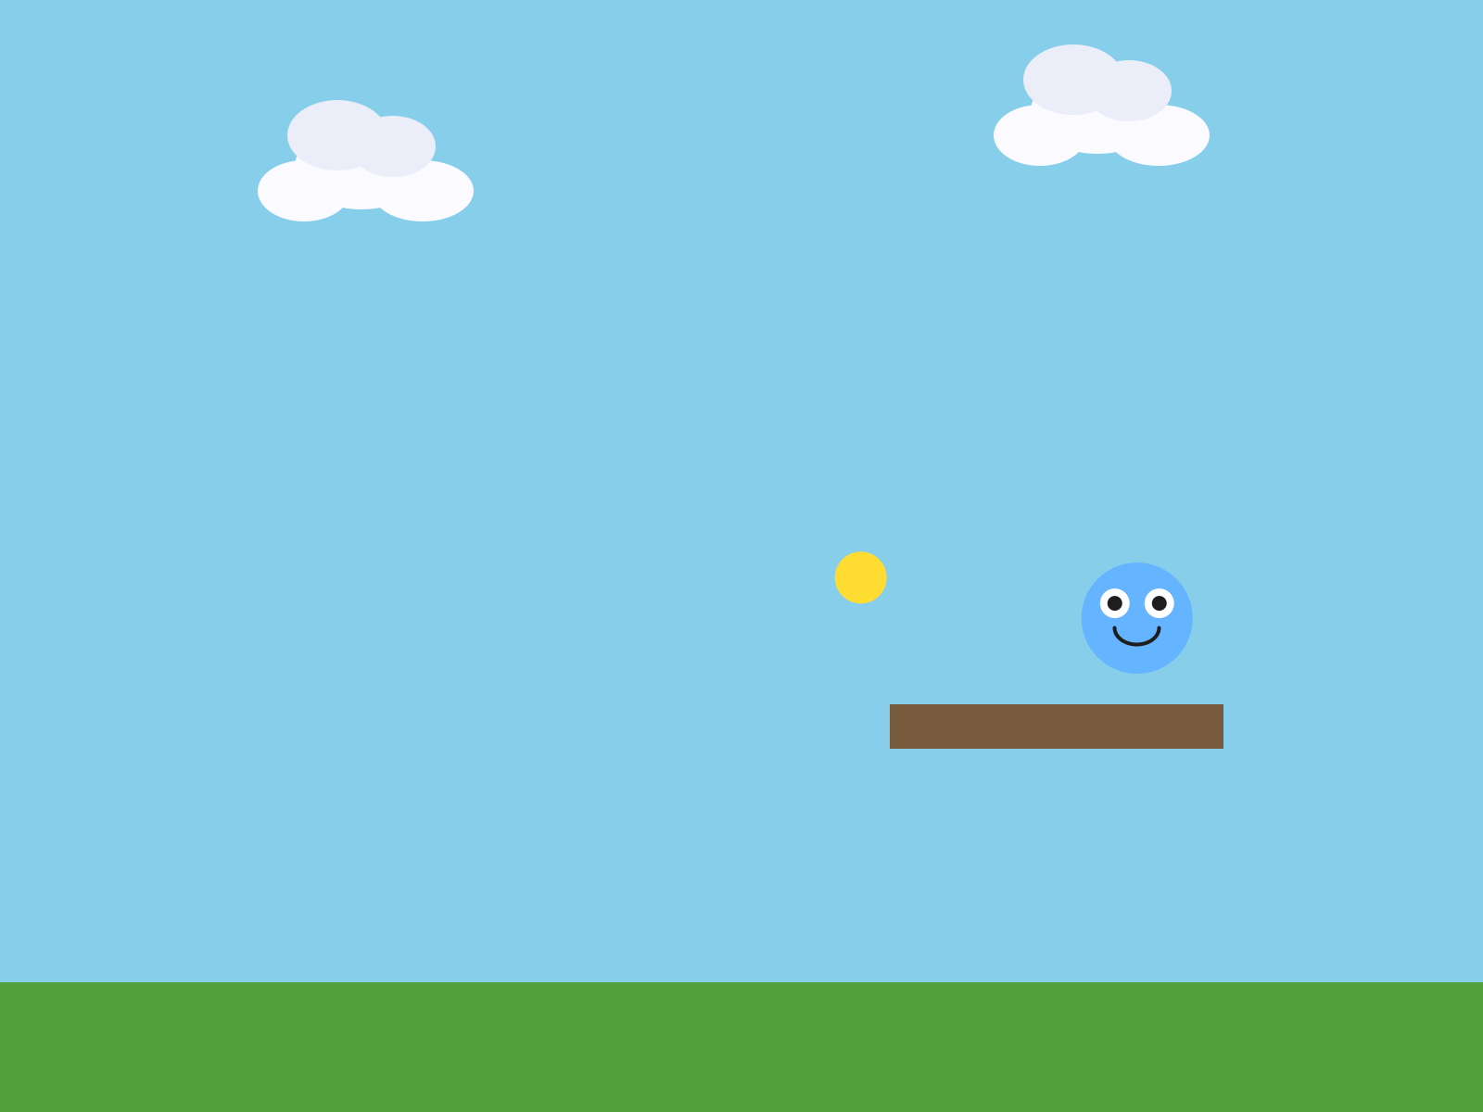
A platform, new Block(this, 480, 380, 180, 24, color(120, 90, 60)).
Your turn. Make far-away things look far away. fill() and color() take a fourth number, alpha, for how see-through something is: 0 is invisible, and 255 is solid. In your Cloud tab, try fill(250, 250, 255, 180).

A solid cloud in front of a block.

The same cloud with an alpha of 180. You can see the block through it.
Speed does the same work. A world feels deep when the far-away things move slowly and the close things move fast. Ground sits still. Clouds drift. The coin darts. Your player goes wherever you send it.
Your turn. Optional: build a real parallax effect. Three clouds at three different speeds: the slowest one faintest and drawn first, the fastest one solid and drawn last. It's the oldest trick in 2D games, and it still works.

Chapter summary
You started with a character in an empty window. You end with a world: a sky, ground, things drifting past, and a coin, all in the order you chose to draw them.
You built | It's an example of
new Block(this, 0, height - 70, width, 70, ...) | a Block: a rectangle, placed by its top-left corner
the ground drawn last | draw order: later covers earlier
background first, player last | the order of draw() is the layering
the Cloud tab | a second class, built exactly like your character
Cloud(PApplet p, float x, float y, float speed) | a constructor with a number of its own
new Blob(this, x, y, 14, vx, vy, color) | a Blob made with its velocity
fill(250, 250, 255, 180) | alpha, how see-through

New syntax in this chapter
Syntax | Where you met it
Block, new Block(this, x, y, w, h, color) | 5.2, Step 1
height - 70 | 5.2
a constructor's own extra number, and setVelocity() inside it | Step 4
new Blob(this, x, y, radius, vx, vy, color) | Step 5
fill(r, g, b, alpha) | 5.5

Vocabulary
alpha -- a fourth number in fill() or color() for how see-through something is. 0 is invisible, 255 is solid. (5.5)
Block -- the library's rectangle sprite. Good for ground, walls, and platforms. Its x and y are its top-left corner. (5.2)
draw order -- the order you draw things in. Whatever is drawn later appears in front. (Step 3)

Check your understanding
- A Block at new Block(this, 100, 100, 50, 50, ...). Where is its top-left corner? Where is its middle?
- Your player disappears when it walks onto the ground. What do you check?
- Why do the clouds get drawn before the ground?
- Your cloud won't move. It's in the right place in draw(). Where else do you look?
- What do the seven numbers in the coin's new Blob(...) mean?
- Name one draw-order decision you made in your world, and what it changed.

What's next
There's a coin drifting through your world, and touching it does nothing. What should happen?
Chapter 6 is where your game starts paying attention. Touch the coin and score a point. Touch something dangerous, and the game ends.

