Part Three - Make it yours
Your character, your world, your rules: the second meeting.
Chapter 7 · Meeting 2 of 3
Last meeting you got one full loop playing. Today it becomes yours.
Start with five minutes of play-testing. Let a neighbor play your game, and keep your hands off the keyboard. Watching somebody else play is the fastest way to find out what's broken.

Step 4 - Replace the placeholders
Your turn. Your character, your collectibles, your hazards, your world. Every color, every name, every shape the starter marks CHANGE. Space, ocean, forest, city, a dream. Whatever your sentence from 7.1 said.

Step 5 - Your screens, in your words
Your turn. Rewrite the win and lose screens. "YOU WIN!" is the starter talking. Make it sound like you, and like your game.
Keep the textAlign(LEFT, BASELINE); at the end of each one, as in Chapter 6.

Step 6 - Tune it
Your turn. Play it. Too easy? Faster hazards, or a higher goal. Too hard? Slower hazards, or a bigger hitbox in your super(...) line.
You built your game, so you're the best player it'll ever have. That means it's probably too hard for everybody else. Your neighbor is the one to tune it for.

7.5 Three coins, three ifs
The starter has three coins and two hazards. Each one has its own variable and its own if. Yes, that's repetitive. It's also code you can read from top to bottom and change one piece at a time. That's a trade-off, and for a first game it's the right one.
Want a fourth coin? It goes in four places: declare coin4, create it in restartGame(), move and draw it in playGame(), and give it an if.
Watch out. Copy the coin3 block to make coin4, and every coin3 in the copy has to become coin4. Miss the one in moveTo(), and touching coin4 moves coin3 away. coin4 sits still under your player, scoring a point every frame, and you win the whole game in under a second. Read the copied lines out loud, name by name.

Want twenty coins? That's what Bonus D is for.

Step 7 - One thing that's your idea
Your turn. Add one thing that's your idea. Some places to start:
- Lives, from Chapter 6, in place of instant game over.
- Hazards that speed up as the score climbs.
- A special ability on a key: a speed burst, a shield, a teleport. It goes in keyPressed().
- A custom hazard, in its own extends Blob tab: a shark, a storm cloud, a meteor.
- A title screen before the game starts. That's a fourth mode.
- Bouncing. One line in setup(), right before restartGame():
Sprite.screenBehavior = ScreenBehavior.BouncyWalls; // everything bounces off the edges
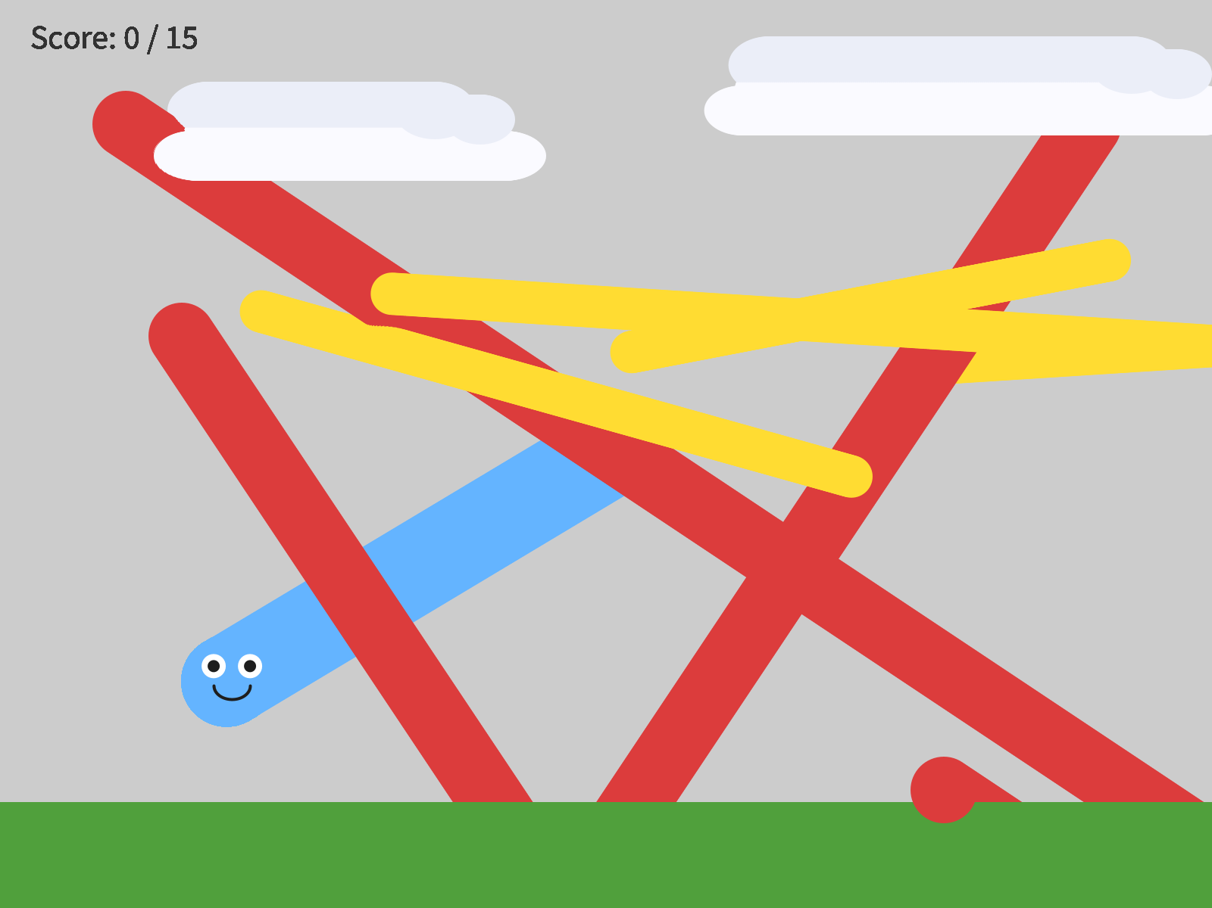
BouncyWalls, with background() switched off to show the paths. The hazards bounce off the bottom edge, behind the ground, and the coins bounce off the right.
It changes every sprite in your game at once. That's why the clouds bounce too.
- A bonus chapter. Pictures for your character (Bonus A), sounds (Bonus B), an animated character (Bonus C), or lots of coins (Bonus D). They're at the back of the book.
Your turn. Optional: a second level. When the player wins, rebuild the world harder, with faster hazards, a different background, and a higher goal, and keep the score. That's restartGame() with a level number, and it turns a demo into a game people want to keep playing.

