Bonus A - Images
Swap your shapes for actual pictures.
Bonus A
So far, everything on your screen is made of shapes you drew in code: circles, rectangles, arcs. This chapter puts real pictures in your game. A character you drew in a paint program, a tree you found online, a whole background.
You can take it any time after Chapter 4. It works well between Chapters 4 and 5, or during Chapter 7, when you're making your world look finished. It takes one meeting.
This chapter does it in three moves.
Part | The idea
One | Pictures live in a folder. The data folder, and how a sketch finds a file.
Two | Scenery: ImageSprite. A sprite that's a picture.
Three | Your character as a picture. Keep extends Blob, and draw a picture in drawSprite().

Part One - Pictures live in a folder

A.1 Your picture
Your turn. Find or draw a small picture for your character. PNG is the kind of file you want. A PNG can have a transparent background, so the world shows through around your character. You can draw a 32-by-32 character in any paint program, or find free art at opengameart.org.

A.2 The data folder
Processing looks for pictures in exactly one place: a folder called data, inside your sketch's folder.
Build it.
- Open your sketch, and choose Sketch → Show Sketch Folder.
- Make a new folder in there called data. Exactly that, all lowercase.
- Drag your picture into data.
- Write down its name exactly, capitals and the ending (.png) included.

Part Two - Scenery: ImageSprite

A.3 A sprite that's a picture
An ImageSprite is a sprite from the library that shows a picture. It has the sprite behaviors you know: move(), setVelocity(), followMouse(), drawSprite(). It takes the sketch, where its center goes, the file's name, and a size:
new ImageSprite(this, x, y, "tree.png") // 100 x 100 pixels
new ImageSprite(this, x, y, "tree.png", 80) // 80 x 80 square
new ImageSprite(this, x, y, "tree.png", 120, 80) // 120 wide, 80 tall
It has no collidesWith(). An ImageSprite is a sprite, and it isn't a Blob, so it can't collide. Save it for scenery: the things in the world your player just looks at.

Step 1 - A picture in the world
Build it. Start with the easy one. Add an ImageSprite to your sketch, in the same three places as every object since Chapter 1. Here are three trees, from the Canvas page's sample sketch:
ImageSprite tree1;
ImageSprite tree2;
ImageSprite tree3;
// in setup(). Replace "tree.png" with your own file name.
tree1 = new ImageSprite(this, 150, 420, "tree.png", 60, 100);
tree2 = new ImageSprite(this, 400, 430, "tree.png", 60, 100);
tree3 = new ImageSprite(this, 650, 415, "tree.png", 60, 100);
// in draw(), before your player: decorations go behind
tree1.drawSprite();
tree2.drawSprite();
tree3.drawSprite();
Run it.
Check. Your pictures, in your world.

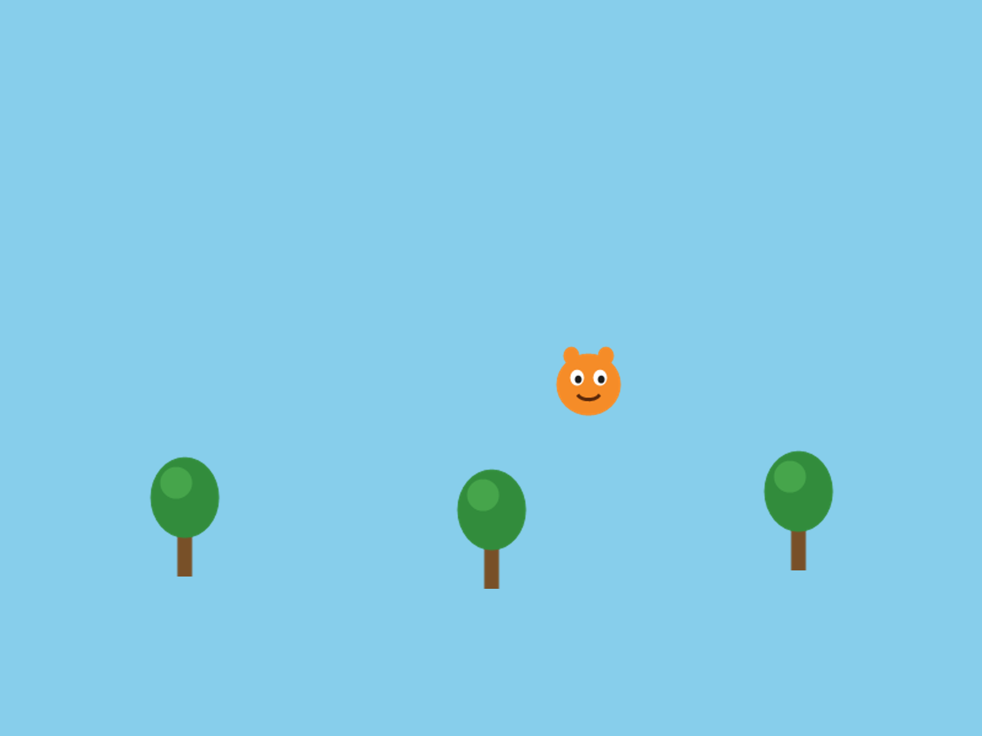
Three trees, and a picture character from Part Three. The art is stand-in art. Yours is yours.
Change the size numbers until your picture looks the right shape. A tall tree squashed into a square looks wrong.

Step 2 - When the picture doesn't show
Three things go wrong here, and each one looks different.
Watch out. The name doesn't match. Ask for "pine.png" when the file is tree.png, and Processing prints this under your code, then stops:
The file "pine.png" is missing or inaccessible, make sure the URL is valid or that the file has been added to your sketch and is readable.
Check that the file is in data, and check the name, letter by letter.

Watch out. The capitals don't match. Ask for "Tree.PNG" when the file is tree.png, and Processing stops and tells you exactly what's wrong:
This file is named tree.png not Tree.PNG. Rename the file or change your code.
Capitals count here too, the same as in your code.

Watch out. A white box around your picture. The PNG was saved without a transparent background. The picture really is a rectangle, and its background just happens to be white. Your code is fine. Find or make a PNG with a transparent background. Free tools like remove.bg can take a background out for you.


The same character, saved on a white background.

Part Three - Your character as a picture

A.4 Keep the Blob
Your player needs to collide with things, and an ImageSprite can't. So for your character, keep extends Blob, exactly as you wrote it in Chapter 2, and change drawSprite() to draw a picture in place of shapes.

Step 3 - MyImageCharacter
Build it. Make a new tab called MyImageCharacter, and paste this in:
// MyImageCharacter - like MyCharacter, but draws a picture instead of shapes.
// extends Blob means it still has collidesWith() for collision detection.
class MyImageCharacter extends Blob {
PImage img;
MyImageCharacter(PApplet p, float x, float y, String fileName) {
super(p, x, y, 30, color(0)); // radius 30 - the invisible collision circle
img = p.loadImage(fileName);
}
void drawSprite() {
parent.pushStyle();
parent.imageMode(CENTER);
parent.image(img, pos.x, pos.y, 60, 60); // drawn centered on the sprite's position
parent.popStyle();
}
}
Read it against your MyCharacter tab. The class line, the handshake, and a drawSprite(). Three things are new.
Aside: PImage and loadImage()
A PImage is Processing's kind of variable for a picture. PImage img; makes a box for one. loadImage(fileName) reads the file out of your data folder and puts it in the box. The constructor does that once, when the character is made. String is the kind of thing a piece of text is, like "hero.png".

Aside: imageMode(CENTER), and pushStyle()
image(img, pos.x, pos.y, 60, 60) draws the picture, 60 by 60. Normally a picture is placed by its top-left corner, like a Block. imageMode(CENTER) places it by its middle, so it sits on the belly button like every other part of your character. pushStyle() and popStyle() save and put back Processing's settings around it, so imageMode only changes your character's drawing.

Build it. In your main tab, make your player a MyImageCharacter in place of a MyCharacter, in the declaration at the top and in setup():
player = new MyImageCharacter(this, width/2, height/2, "hero.png");
Use your own file's name. Run it, and move your character around.
Check. Your picture, moving and colliding the way your shape character did.

Step 4 - See your hitbox
The radius in super(...) is still your hitbox. The picture doesn't change that. So it helps to see where the hitbox is while you tune it.
Build it. At the end of drawSprite(), after popStyle(), draw the hitbox as a ring:
parent.noFill();
parent.stroke(255, 0, 0);
parent.ellipse(pos.x, pos.y, 2 * radius, 2 * radius); // the hitbox
Check. A red ring around your picture. That's exactly the circle collidesWith() uses.

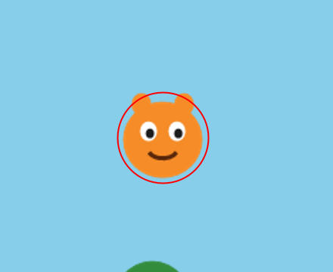
The hitbox, drawn as a ring.
Tune the 30 in super(...) until the ring fits. A ring slightly smaller than the picture usually feels fairest. Then take the three ring lines out, before anybody else plays.
Watch out. Leave out imageMode(CENTER), and the picture is placed by its corner. It sits down and to the right of your hitbox, and collisions feel broken, because they're happening where your character isn't drawn.

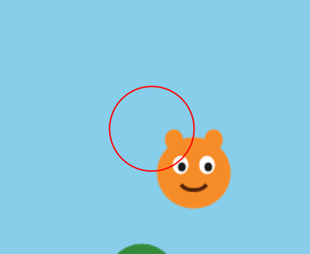
No imageMode(CENTER). The hitbox is where the character is, and the picture is somewhere else.
Watch out. player.collidesWith(tree1) stops the sketch with:
The method collidesWith(Blob) in the type Blob is not applicable for the arguments (ImageSprite)
That's Processing's way of saying a tree is an ImageSprite, and collidesWith() only works with Blobs. If your player has to touch it, make it a Blob with a picture inside, the way MyImageCharacter is.

The rule, side by side:
It needs to | Use
collide (your player, coins, hazards) | extends Blob, with a PImage inside
just look nice (trees, clouds, a background) | ImageSprite

A.5 Make it yours
Your turn. Your own character picture. A PNG with a transparent background looks best by a mile.
Your turn. Fix the size, the 60, 60 in image(), so it matches your art's real shape.
Your turn. Optional: any of these.
- A background picture, as big as the window, drawn first in draw(), right after background():
bg = new ImageSprite(this, width/2, height/2, "background.png", width, height);
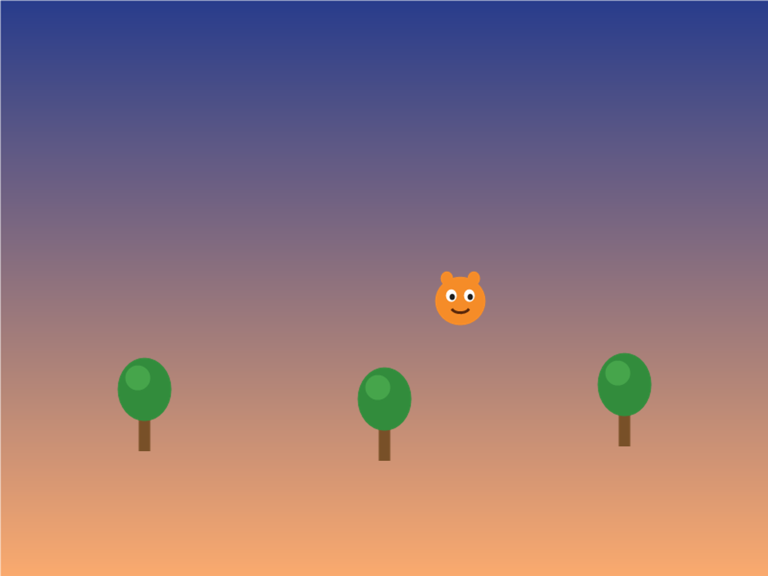
A background picture, behind the trees.
- A decoration that drifts: give an ImageSprite a velocity, and move() it.
- A tilted one: tree3.setRotation(PI/6); tips it a little. PI is half a turn, so PI/6 is a twelfth of one.
- Coins and hazards as pictures. They have to collide, so they need extends Blob with a picture inside, the same as MyImageCharacter.
- Fake an animation. Load two PImages and swap between them every few frames. That's the whole idea behind Bonus C.
Watch out. When you hand in your sketch, zip the whole folder, data and all. Without the data folder, nothing runs.

Chapter summary
You built | It's an example of
a data folder | where Processing looks for files
new ImageSprite(this, x, y, "tree.png", 60, 100) | a sprite that's a picture, for scenery
MyImageCharacter extends Blob | a picture inside a Blob, so it still collides
imageMode(CENTER) | placing a picture by its middle
the red ring | seeing your hitbox while you tune it

New syntax in this chapter
Syntax | Where you met it
ImageSprite | A.3, Step 1
PImage, loadImage(), String | Step 3
image(), imageMode(CENTER) | Step 3
pushStyle(), popStyle() | Step 3
radius | Step 4
setRotation() | A.5

Vocabulary
data folder -- a folder inside your sketch's folder, where Processing looks for pictures and sounds. (A.2)
ImageSprite -- a sprite from the library that shows a picture. It can't collide. (A.3)
PImage -- Processing's kind of variable for a picture. (Step 3)
transparent -- a part of a picture with no color at all, so whatever's behind it shows through. (A.1)

Check your understanding
- Where does Processing look for your picture?
- Why can't you use collidesWith() on an ImageSprite? What do you do when a picture has to collide?
- Your character has a white box around it. What's wrong, and is it your code?
- What does imageMode(CENTER) change?
- Why does a picture character still need extends Blob?

