Chapter 6 - Collisions: If This, Then That
Things finally touch each other, and your program decides what happens next. This is where it becomes a game.
Chapter 6 · Meeting 1 of 2
Chapter 5 ended with a coin drifting through your world, and touching it does nothing. What should happen?
Today your sketch starts paying attention. Touch the coin, and you score a point. Touch something dangerous, and the game ends.
The new idea is if: making something happen only when it's true. The library can tell when two things are touching, and that gives if something to be true about.
This chapter takes two meetings, and does it in four moves.
Part | The idea
One | Are they touching? A yes-or-no question, and an if to act on the answer.
Two | Keep score. A number that remembers, on the screen, one point per touch.
Three | A game that can end. A hazard, a true-or-false, and two screens.
Four | Make it yours. Harder, easier, and yours.
Parts One and Two are the first meeting. Parts Three and Four are the second.

Part One - Are they touching?

6.1 A yes-or-no question
player.collidesWith(coin)
collidesWith() asks one question: are these two touching? The library checks whether their circles overlap, and hands back true or false.
Your character has collidesWith() because you wrote class MyCharacter extends Blob back in Chapter 2. It's one of the things a Blob can do, so your character got it for free, and you never had to write it.
Remember the 30 in your super(...) line? In Chapter 2 you changed it, and nothing on the screen changed. This is what it's for. That number is the radius of an invisible circle around your character, called its hitbox, and collidesWith() uses that circle and only that circle. Your drawing can be any size you like.

6.2 if
An if makes something happen only when a question's answer is yes:
if (player.collidesWith(coin)) {
background(255, 220, 50); // only happens while they are touching
}
- The part in the parentheses is the condition, the yes-or-no question.
- The part in the braces is what happens when the condition is true.
- When it's false, Processing skips straight past the braces.

Step 1 - The gold flash
Build it. Open your sketch from Chapter 5. In draw(), right after your background() line, add the if above. Run it, and touch the coin.
Check. The sky flashes gold while you touch the coin, and goes back to blue when you let go.

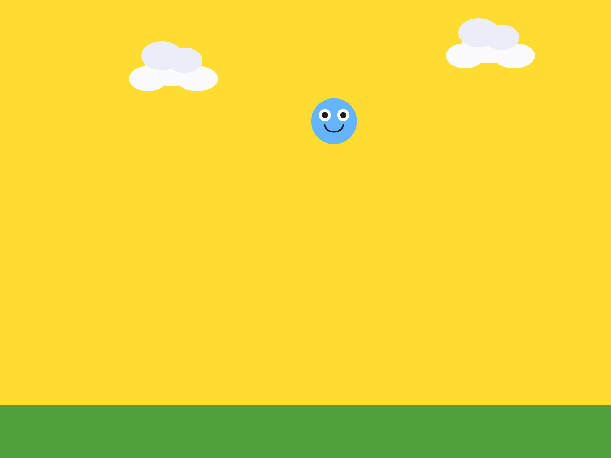
Touching the coin.
draw() runs sixty times a second, so it asks are they touching? sixty times a second. On every frame the answer is yes, the sky is gold.

Step 2 - Generous or precise
Your turn. If touching the coin feels too hard or too easy, open your MyCharacter tab and change the radius in the super(...) line. A bigger radius touches things from further away, which feels generous. A smaller one means you have to be right on top of something, which feels precise. Which do you want your game to be?

Part Two - Keep score

Step 3 - A number that remembers
Build it. Delete the gold flash. Then, at the very top of your sketch, next to your other variables, add:
int score = 0; // a whole number, starts at zero
Aside: int
int is the kind of variable that holds a whole number: 0, 7, -3. No decimal point. int score = 0; makes a box called score and puts a 0 in it, on the same line.

A score has to remember something from one frame to the next. So it goes at the very top of your sketch, outside setup() and outside draw(). Up there, every function in your sketch can see it.
Watch out. Put int score = 0; inside setup(), and the box only exists while setup() runs. draw() can't see it, and the sketch stops with:
score cannot be resolved to a variable
Move it back to the top.

Step 4 - The score on the screen
Build it. At the bottom of draw(), add three lines:
fill(50); // the text color
textSize(24); // how big
text("Score: " + score, 20, 36); // what, then x, then y
Run it.
Check. Score: 0 in the top-left corner.


The score.
Aside: text()
text() draws words on the screen. You give it what to say, then where: x, then y. The + glues the words "Score: " and the number in score together into one piece of text. Set fill() before text(), or your words come out in whatever color the last shape used.

Build it. Test it by cheating. Change int score = 0; to int score = 7;, and run.
Check. Score: 7.


The cheat.
Setting a value by hand to check that the display works is a real technique. Programmers do it all the time. Set it back to 0.

Step 5 - A point per touch
Build it. Above the three score lines, add the collision if again, this time with a point inside:
if (player.collidesWith(coin)) {
score = score + 1; // add a point
}
Aside: score = score + 1
Read it right to left. Take what's in score, add one, and put the answer back in score. The = means make this equal to that.

Run it, and sit your player on the coin. Watch the score.
Check. The score races upward, as long as you're touching the coin.


A few seconds of touching.
Why is it doing that? Make a guess before you read on.
draw() asks are they touching? every frame. For as long as you sit on the coin, the answer is yes, and every yes is a point. That's a point for every frame: sixty a second, if you sit right on it.

Step 6 - One touch, one point
The fix is to end the touch the moment you count it. Move the coin somewhere else.
Build it. Inside the same if, after the point, add:
coin.moveTo(random(width), random(100, height - 150)); // coin jumps somewhere new
Run it.
Check. Touch the coin, and you score one point, and the coin jumps somewhere new.

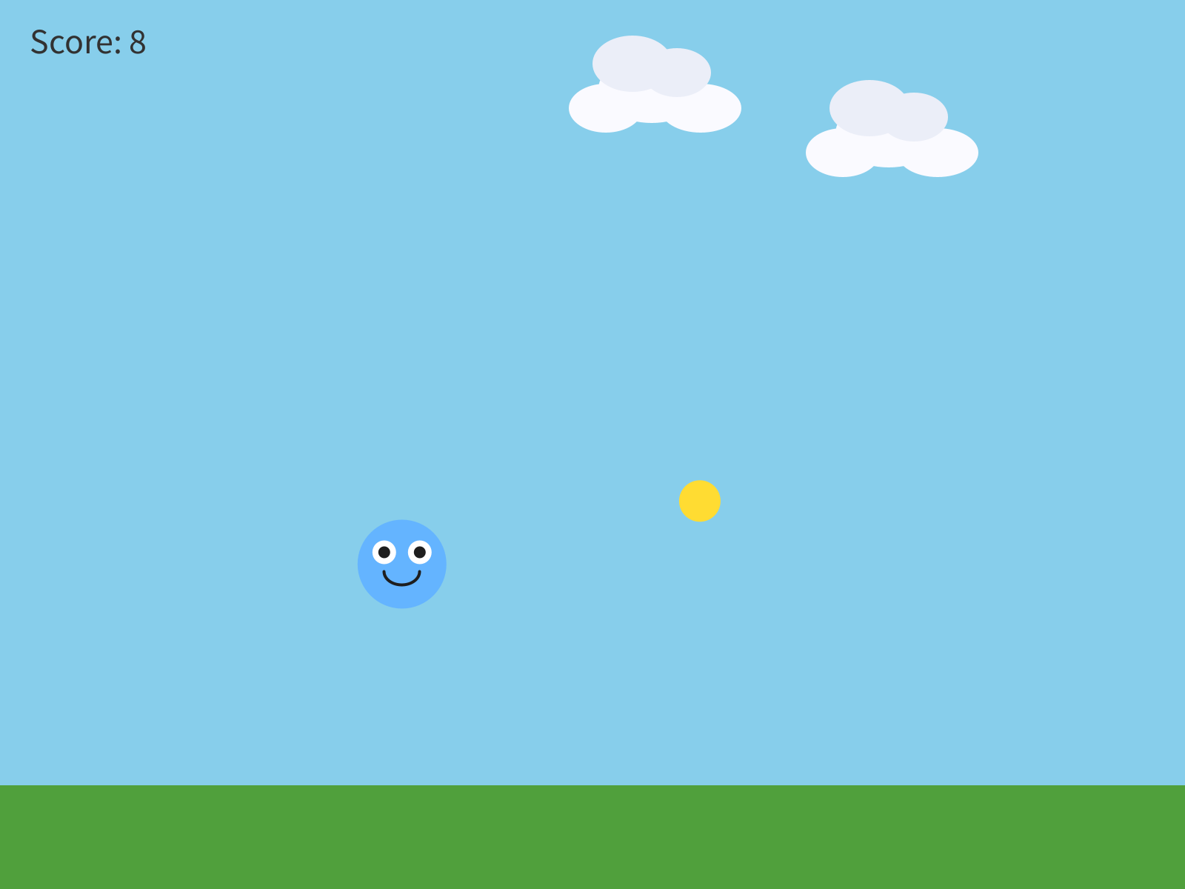
Eight coins in fifteen seconds.
You met moveTo() in Chapter 4, teleporting your character to a click. Here it teleports the coin, and random() picks the spot, so it lands somewhere new every time.
Your turn. Change the coin's speed and size, and style the score so it fits your world. The score's fill() and textSize() are yours.

