Part Three - A game that can end
Steps 7 to 10, and your own game: the second meeting.
Chapter 6 · Meeting 2 of 2
Last meeting your character started scoring points. Today it gets something to avoid, and your game gets a way to end.
If your sketch from last time is broken, the Canvas page has a Day 1 checkpoint. Paste it into your main tab, keep your own MyCharacter and Cloud tabs, and you're caught up.

Step 7 - A hazard
Build it. Add one more Blob, in the same three places as everything else. Declare Blob hazard; at the top. Create it in setup():
// The hazard starts in the top-left corner, away from the player
hazard = new Blob(this, 80, 80, 22, 3, 2, color(220, 60, 60));
In draw(), move and draw it, right after the coin.
It starts in a corner on purpose. A hazard made right on top of your player would end the game the instant it started.

Step 8 - True or false
Build it. At the top of your sketch, add:
boolean gameOver = false; // true or false, starts false
Aside: boolean
A boolean is the simplest variable there is. It's true, or it's false, and that's all. Here it remembers one thing: is the game over?

Then, after the coin's if, add one for the hazard:
if (player.collidesWith(hazard)) {
gameOver = true;
}
Run it, and touch the hazard.
Check. Nothing seems to happen. The game keeps going.

The variable changed. gameOver is true now, and nothing in your sketch reads it yet. The next two Steps give it a reader.

Step 9 - A function of your own
draw() is getting long. Before it gets longer, you're going to give the game part of it a name of its own.
Build it. Below the closing brace of draw(), make a new function called playGame(). Move into it your coin, your hazard, your player, both collision ifs, and the score display. Leave the sky, clouds, and ground in draw().
void playGame() {
coin.move();
coin.drawSprite();
hazard.move();
hazard.drawSprite();
player.followMouse();
player.drawSprite();
// Touching the coin: score a point, and the coin jumps somewhere new
if (player.collidesWith(coin)) {
score = score + 1;
coin.moveTo(random(width), random(100, height - 150));
}
// Touching the hazard: the game is over
if (player.collidesWith(hazard)) {
gameOver = true;
}
fill(50);
textSize(24);
text("Score: " + score, 20, 36);
}
In draw(), after the scenery, call it:
playGame();
Aside: writing your own function
void playGame() { ... } makes a function, the same shape as setup() and draw(). The difference is who calls it. Processing calls setup() and draw() for you. This one runs when your sketch says its name: playGame();. You can name a function anything, so name it what it does.

Run it.
Check. Everything looks exactly the same as before.

That means it worked. Moving code into a function of its own is called refactoring, and a refactor that leaves the screen exactly the same is a success.

Step 10 - Two screens
Build it. Below playGame(), add a second function, for the end of the game:
void showGameOver() {
textAlign(CENTER, CENTER);
fill(220, 60, 60);
textSize(52);
text("Game Over", width/2, height/2 - 20);
fill(50);
textSize(22);
text("Final score: " + score, width/2, height/2 + 26);
textAlign(LEFT, BASELINE); // put text alignment back to normal
}
Then, in draw(), replace playGame(); with this:
if (!gameOver) {
playGame(); // still playing
} else {
showGameOver(); // it's over
}
Aside: ! and else
! means not. So !gameOver reads not game over: still playing. else is the other half of an if. When the condition is true, the first braces run. When it's false, the braces after else run instead. Exactly one of the two runs, every frame.

Run it, and touch the hazard.
Check. The game stops, and Game Over comes up with your final score.

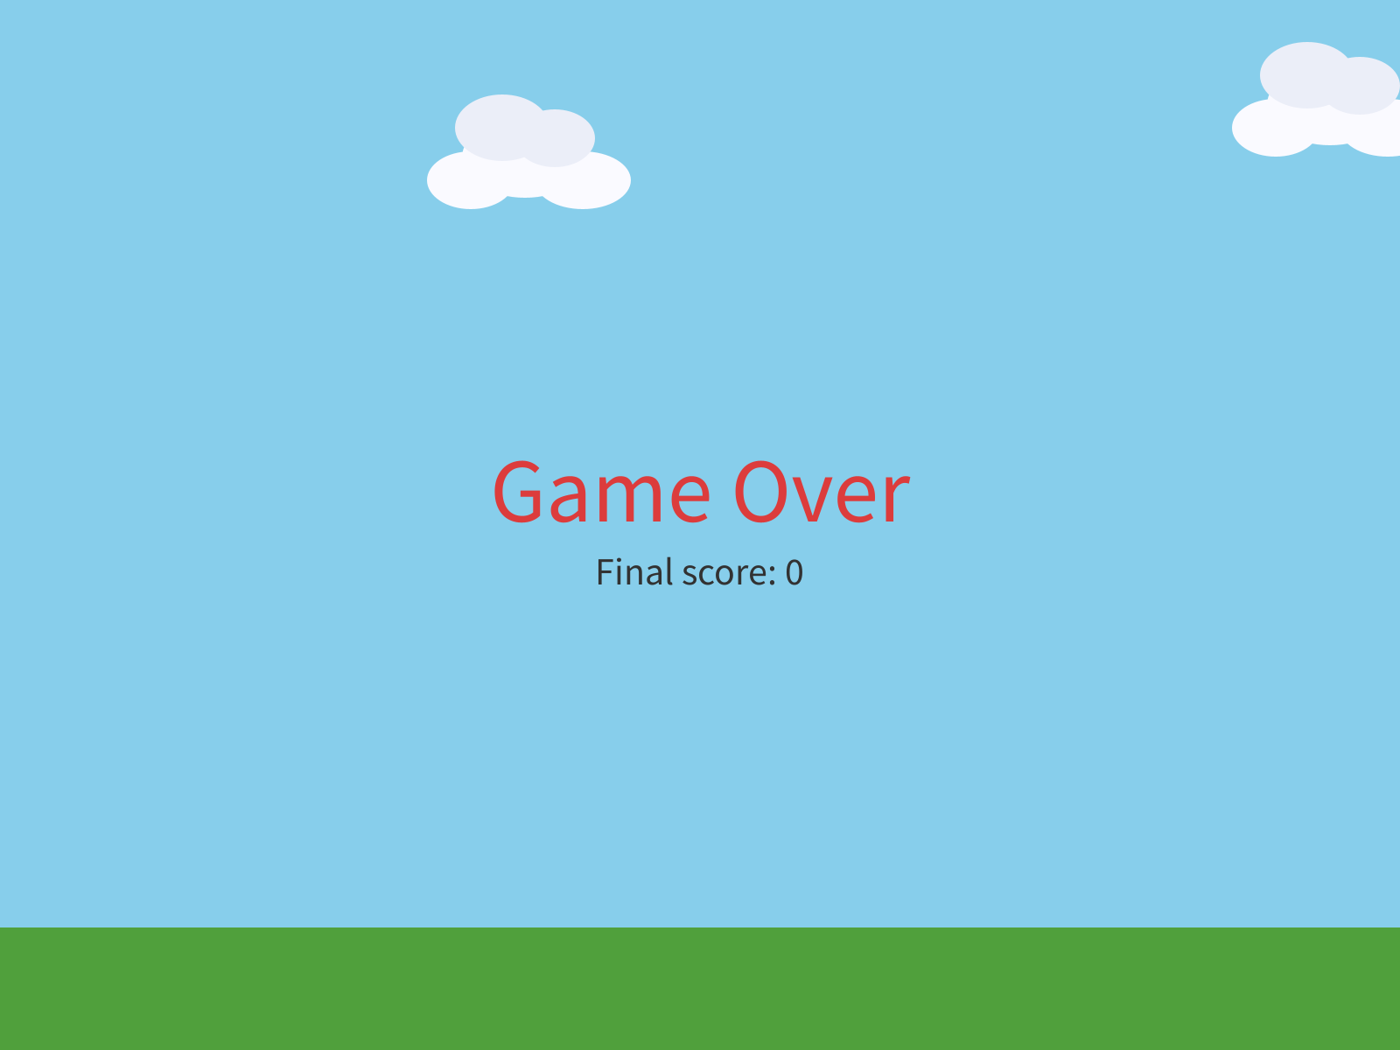
Game over. The sky, clouds, and ground are still there, because they're still in draw().
This is the big idea of today. Your game is always in a mode. Right now there are two: playing, and game over. The boolean remembers which mode you're in, and the if / else in draw() picks which one to run.
Build it. Test the other branch by cheating. Change boolean gameOver = false; to true, and run.
Check. The game opens straight onto the game over screen, with a score of 0.

Set it back to false.

6.5 Comparing numbers
A condition can compare numbers, too:
if (score >= 10) {
background(255, 0, 0); // only happens once score is 10 or more
}
You write | It asks
score > 10 | greater than 10?
score < 10 | less than 10?
score >= 10 | 10 or more?
score <= 10 | 10 or less?
score == 10 | exactly 10?
Watch out. == is a question: are these equal? A single = is a command: make this equal to that. Write if (score = 10) by mistake, and the sketch stops with:
Type mismatch: cannot convert from int to boolean
An if needs a yes or a no, and score = 10 is a command. Make it ==.

Part Four - Make it yours
Your turn. Rewrite the game over screen so it sounds like your game: different words, different colors.
Watch out. Keep the last line, textAlign(LEFT, BASELINE);. It puts text back to normal after the centered game over text, and without it every text() after it comes out centered too.

Your turn. Tune the hazard: its speed, its size, where it starts. A harder game, or an easier one?
Your turn. Optional: any of these.
- A second hazard, hazard2, with its own if. Give it a different speed or size.
- A second coin, coin2, worth more: score = score + 5;
- Change what ends the game. A hazard? Reaching a score of 20? Both?
- A background that changes as the score goes up. Stack a few ifs right after the sky, one for each score, so the later ones paint over the earlier:
if (score >= 5) {
background(255, 170, 80); // sunset
}
if (score >= 10) {
background(30, 30, 70); // night
}
Your turn. Optional: give your player lives. Start with int lives = 3; at the top. When the hazard hits, take one away, and move the hazard somewhere else, exactly like the coin. Set gameOver to true only when lives reaches 0. Show the lives on the screen, under the score.
Then play your game. This is where it becomes one, so leave time to play it.

Chapter summary
You started with a coin that did nothing when you touched it. You end with a game: a score that counts, something to avoid, and a screen that says it's over.
You built | It's an example of
player.collidesWith(coin) | a yes-or-no question, using the hitbox from Chapter 2
if (...) { ... } | doing something only when a condition is true
int score = 0; at the top | a variable every function can see
text("Score: " + score, 20, 36) | words and a number, glued together, on the screen
score = 7, then back | testing by cheating
the racing score, and moveTo() | draw() asks every frame, so the fix is to end the touch
boolean gameOver | a true or false that remembers which mode you're in
playGame() | refactoring into a function of your own
if (!gameOver) { ... } else { ... } | two modes, and draw() picking one

New syntax in this chapter
Syntax | Where you met it
collidesWith() | 6.1
if (condition) { } | 6.2
int | Step 3
fill(), textSize(), text() for words | Step 4
+ between text and a number | Step 4
score = score + 1 | Step 5
boolean, true, false | Step 8
void playGame() { }, and calling it | Step 9
!, else | Step 10
textAlign() | Step 10
>, <, >=, <=, == | 6.5

Vocabulary
boolean -- a variable that's only ever true or false. (Step 8)
condition -- the yes-or-no question in the parentheses of an if. (6.2)
hitbox -- the invisible circle that decides whether something is touching. For your character, it's the radius in the super(...) line. (6.1)
if statement -- "if this is true, do this block of code." (6.2)
int -- a variable that holds a whole number. (Step 3)
mode -- which part of the game your program is in right now: playing, or game over. (Step 10)
refactoring -- moving code around so it's easier to read, while it does exactly the same thing. (Step 9)

Check your understanding
- What does collidesWith() hand back? What decides whether two things are touching?
- Why does int score = 0; go at the very top of the sketch?
- Before you added moveTo(), why did the score race upward?
- What's the difference between an int and a boolean? Give an example of each from your own game.
- Why did touching the hazard in Step 8 seem to do nothing?
- = and ==. Which one asks a question?

What's next
Your game can end. Once it's over, though, the only way to play again is to press Stop and Run.
In Chapter 7 you finish it. A way to win as well as lose, a click to play again, and three meetings to make it a game somebody else wants to play.

