Appendix 1 - Saving and Handing In
Where your sketch lives, how to find it, and how it gets to Canvas.
Appendix 1
This part of the book is for you to come back to. Every lesson ends with the same job: zip your sketch folder and upload it to Canvas. That job happens on a Mac, in an app called Finder, and Finder windows can look different from one day to the next. This appendix walks through it one click at a time, and Part Four fixes a Finder window that looks wrong. Part One also shows how to open a lesson's example, which every chapter from Chapter 2 on asks you to do.
If you only need a reminder, the short version is first.
Part | What it covers
One | Saving, and opening. What a sketch is on the Mac, where Processing keeps it, how to save it so you can find it again, and how to open a lesson's example.
Two | Finding it in Finder. Getting from Processing to your sketch's folder.
Three | Zipping and handing in. Making a zip of your sketch folder, and uploading it to the Assignment.
Four | When something looks wrong. The strange things Finder and Processing do, and the fix for each.

The short version
To hand in a sketch called HelloBlob:
- In Processing, save: File → Save.
- Open the folder: Sketch → Show Sketch Folder. A Finder window opens.
- Step out of the folder: in Finder, Go → Enclosing Folder.
- Find the HelloBlob folder in the list, and click it once.
- Right-click it, and choose Compress "HelloBlob".
- A new file, HelloBlob.zip, appears next to the folder. That's the one you hand in.
- On Canvas, open the Assignment, click Start Assignment, upload HelloBlob.zip, and click Submit Assignment.
On a Mac, right-click means hold down the Control key and click. On a trackpad, you can also click with two fingers.

Part One - Saving

A1.1 A sketch is a folder
When you save a sketch called HelloBlob, Processing makes a folder called HelloBlob, and puts a file called HelloBlob.pde inside it. The .pde file is your code.
From Chapter 2 on, your sketch has more than one tab. Each tab is its own .pde file, in the same folder: HelloBlob.pde and MyCharacter.pde side by side. In Bonus A and Bonus B, your pictures and sounds go in a folder called data inside the sketch's folder.
So the folder is the whole sketch. When you hand it in, you hand in the folder, and everything in it comes along.
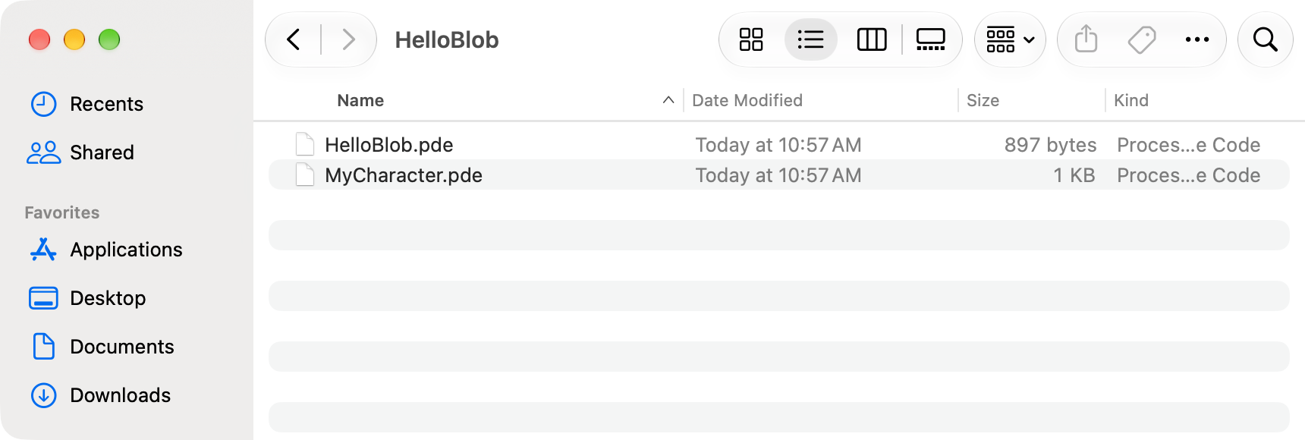
A sketch folder open in Finder. HelloBlob holds HelloBlob.pde and MyCharacter.pde.

A1.2 Where it lives: Documents, then Processing
Processing keeps your sketches together in one folder, called your sketchbook. On the school's Macs, the sketchbook is the Processing folder inside your Documents folder.
So HelloBlob lives here:
Documents
Processing
HelloBlob
HelloBlob.pde
MyCharacter.pde
libraries
The libraries folder is where SpriteGame is installed. Leave it alone. Everything in this book needs it.

A1.3 Saving the first time: File → Save As
A brand-new sketch has a made-up name, like sketch_261101a, and Processing keeps it in a temporary place you'd have a hard time finding. Saving it gives it a real name and puts it in your sketchbook. Do it before you type anything.
- Click File → Save As. A Save box opens.
- Next to Save As, type the sketch's name, like HelloBlob. Use letters and numbers, start with a letter, and leave out spaces.
- Look at Where. It should say Processing.
- Click Save.
If Where says something else, click it. A short list of folders opens. Choose Processing if it's there. If it isn't, the box has a small arrow button next to the name. Click the arrow, and the box grows into a full window, with a sidebar on the left. Click Documents in the sidebar, double-click Processing, and then click Save.
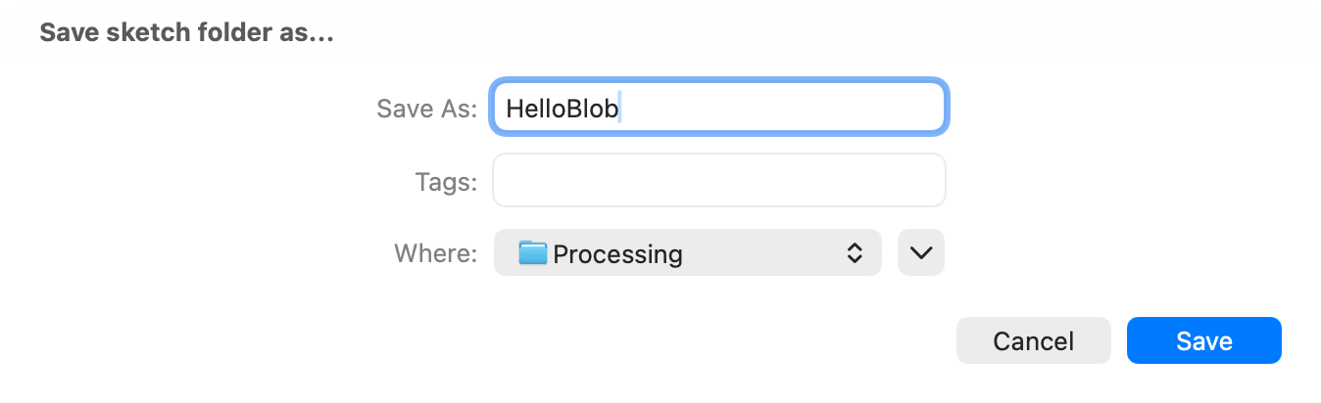
The Save box. The name is HelloBlob, and Where says Processing.

A1.4 Saving as you go: File → Save
After the first time, File → Save saves your sketch where it already is. The keyboard shortcut is Command-S: hold the Command key (it has a ⌘ on it), and press S.
Save every time something works. It takes half a second, and then a crash, a closed laptop, or a dead battery costs you nothing.
Before a big change, save a copy. Use File → Save As, and add a number to the name: MyGame2. Processing makes a new folder for the copy, and you keep working in the copy. The old version is still there, exactly as you left it.
To rename a sketch, use Save As. Processing needs the folder and the main .pde file inside it to have the same name. Renaming either one in Finder breaks that match. Save As gives both the new name at once.

A1.5 Opening it again
Three ways, from Processing's menus:
- File → Open Recent lists the sketches you opened last.
- File → Sketchbook opens a window with every sketch in your sketchbook. Double-click one to open it.
- File → Open opens a box like Finder. Click Documents, double-click Processing, double-click your sketch's folder, then double-click the .pde file with the same name as the folder.
Double-clicking a .pde file in Finder opens it in Processing too.

A1.6 A lesson's example: File → Examples
Every lesson has an example: its finished code, installed on your Mac along with SpriteGame. From Chapter 2 on, each chapter starts by asking you to open it. Run it to see where the chapter is headed. Keep it open while you work, and when your sketch does something strange, compare the two.
- In Processing, click File → Examples. A window opens with a list of folders.
- Find Contributed Libraries in the list, and click the small arrow next to it. The folder opens, and shows the libraries on your Mac.
- Open SpriteGame the same way, and then Lessons.
- Double-click the lesson you want, like Lesson03_BringItToLife. It opens in a new Processing window.
- Click ▶ Run.
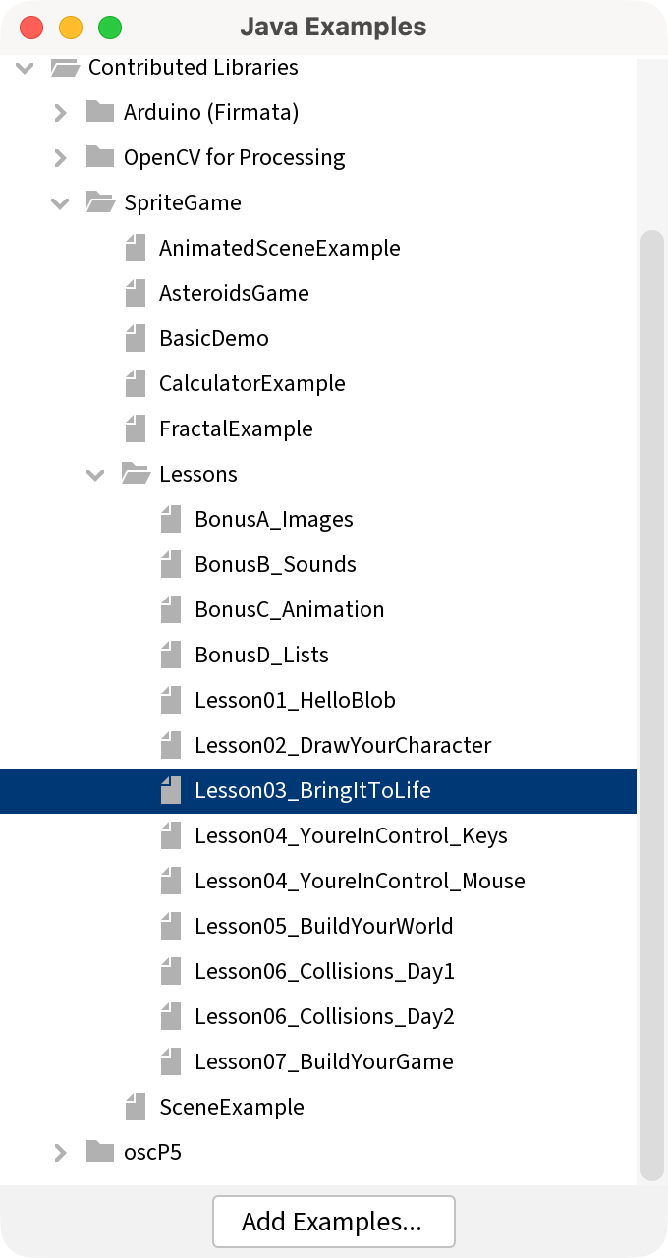
The Examples window, open to Contributed Libraries → SpriteGame → Lessons, with Lesson03_BringItToLife highlighted.
Here is each chapter's example.
Chapter | Example
1 | Lesson01_HelloBlob
2 | Lesson02_DrawYourCharacter
3 | Lesson03_BringItToLife
4 | Lesson04_YoureInControl_Mouse for Option A, and Lesson04_YoureInControl_Keys for Option B
5 | Lesson05_BuildYourWorld
6 | Lesson06_Collisions_Day1 for the first meeting, and Lesson06_Collisions_Day2 for the second
7 | Lesson07_BuildYourGame
Bonus A | BonusA_Images, for reading. It needs pictures in its data folder before it runs.
Bonus B | BonusB_Sounds, for reading. It needs the Sound library, and sounds in its data folder, before it runs.
Bonus C | BonusC_Animation
Bonus D | BonusD_Lists
Your work goes in your own sketch. The example is for running, reading, and comparing. Its character is a plain stand-in, and the sketch you hand in is the one with your character in it. So before you type, look at the name on the window's first tab. Lesson03_BringItToLife is the example. Your sketch has the name you gave it.
To compare, put the two windows side by side. Click the same tab in both, and read the same function, line by line. The example has more comments than the chapter does, so look past them to the code.
To copy a line from the example, drag across it in the example's window to highlight it, and click Edit → Copy. Then click in your own sketch where it goes, and click Edit → Paste. The shortcuts are Command-C and Command-V.
If you type in the example by accident, close its window. Processing asks whether to save the changes. Click Don't Save, and the example goes back to the way it was.

Part Two - Finding it in Finder

A1.7 Finder
Finder is the Mac's app for your files and folders. Its icon is the blue and white smiling face at the left end of the Dock, the row of icons along the bottom of the screen. Click it, and a Finder window opens.
While Finder is the app you're using, the menu bar across the top of the screen says Finder next to the Apple, and its menus (File, Edit, View, Go) are Finder's. Every Finder fix in this appendix starts in one of those menus.

A1.8 The shortcut from Processing: Sketch → Show Sketch Folder
The surest way to find your sketch is to ask Processing, because it always knows where its own sketch is.
With your sketch open in Processing, click Sketch → Show Sketch Folder. The shortcut is Command-K. A Finder window opens inside your sketch's folder. You see HelloBlob.pde, and your other tabs.

A1.9 Going up one level
To zip the sketch, you need the folder itself, and right now you're inside it. So step out: in Finder, click Go → Enclosing Folder. The shortcut is Command-Up Arrow.
Now the window shows the inside of your Processing folder, and HelloBlob is one of the folders in the list.
Turn on the path bar while you're here. Click View → Show Path Bar. A thin bar appears along the bottom of the window, and it shows where you are. It starts with Macintosh HD, then Users and your own name, and ends with Documents › Processing › HelloBlob. Double-click any folder in that bar to jump straight to it. You only turn it on once: every Finder window after that has it.
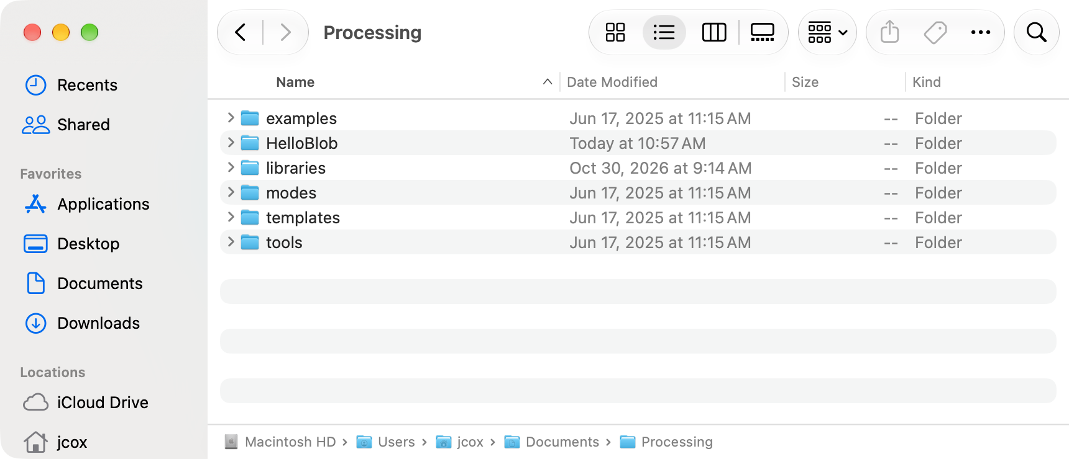
A Finder window with the path bar along the bottom. It ends with Documents › Processing.

A1.10 Getting there from Finder alone
When Processing isn't open, start in Finder:
- Click Go → Documents.
- Double-click Processing.
- Your sketches are the folders in the list.

Part Three - Zipping and handing in

A1.11 Compress the folder
A zip is one file that holds a whole folder inside it. Canvas takes one file per upload, so the folder goes in a zip. On a Mac, making a zip is called Compress.
- In Processing, File → Save. A zip holds the sketch as it was when you last saved it.
- Sketch → Show Sketch Folder.
- In Finder, Go → Enclosing Folder. Find your sketch's folder in the list.
- Click the folder once, so it's the only thing highlighted.
- Right-click the folder: hold Control and click it, or click it with two fingers on the trackpad. A menu opens.
- Choose Compress "HelloBlob", with your sketch's name in the quotes.
- A new file called HelloBlob.zip appears next to the folder.
Check. The zip's name is your sketch's name, then .zip. If it's called Archive.zip, HelloBlob.pde.zip, or HelloBlob 2.zip, something went a little wrong. Part Four says what, and how to fix it.

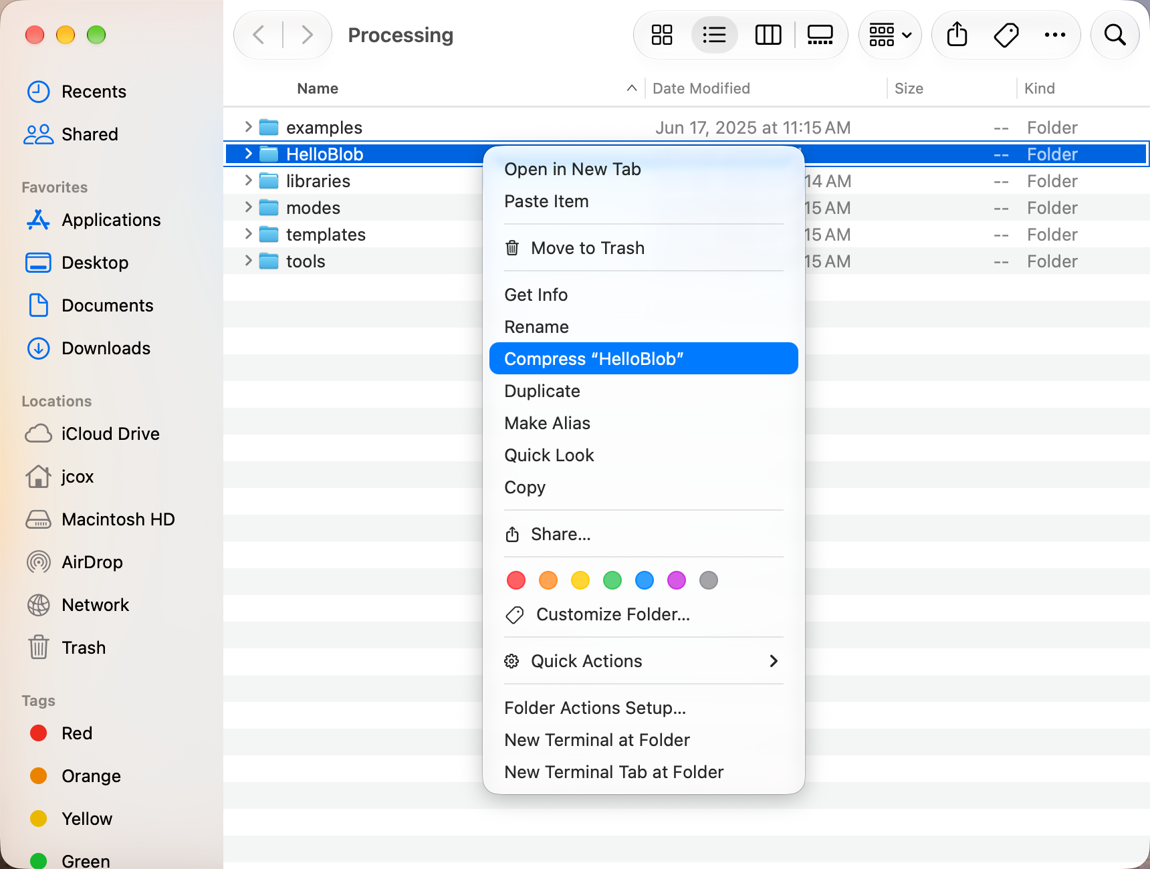
The right-click menu on the HelloBlob folder, with Compress "HelloBlob" highlighted.
Watch out. Leave the zip alone once it's made. Double-clicking a zip opens it, and Finder unpacks a second copy of your folder and names it HelloBlob 2. If that happens, drag HelloBlob 2, the one with the 2, to the Trash. Then you can't end up working in the wrong copy.

A1.12 A screenshot of your sketch
Some Assignments ask for a picture of your sketch running, too.
- Run your sketch, so its window is open.
- Press Shift-Command-4. The pointer turns into a small cross.
- Drag a box around the sketch window, and let go.
The picture is saved on your Desktop, named Screenshot with today's date and time. To get the whole window in one click, press Shift-Command-4, then the Space bar, and click the window.

A1.13 Upload it to Canvas
- On Canvas, open the lesson's Assignment.
- Click Start Assignment.
- Click Choose File. Some Canvas pages call it Upload File, or let you drag the zip straight onto the page.
- A window opens that works like Finder. Click Documents in its sidebar, double-click Processing, click HelloBlob.zip, and click Open.
- If the Assignment asks for a screenshot too, click Add Another File, then Choose File. This time click Desktop in the sidebar, and pick your screenshot.
- Click Submit Assignment.
Check. Canvas says your work is submitted, and shows the zip's name.

A1.14 Handing it in again
Every Assignment in this course can be handed in again, as many times as you like. A zip is a snapshot: it holds the sketch the way it was when you made the zip. So after you change your sketch, you need a new zip.
- Save in Processing, and open the folder that holds your sketch folder, as in A1.11.
- Drag the old HelloBlob.zip to the Trash. The new one can take the same name.
- Compress the folder again.
- On the Assignment, click New Attempt (some Canvas pages say Re-submit Assignment), and upload the new zip.
Your teacher sees the newest one.

Part Four - When something looks wrong

A1.15 When Finder looks wrong
A Finder window remembers how it was last left, and sometimes it was left strange. Find what you see in the left column. Every fix starts in Finder's menus, so click a Finder window first.
What you see | What to do
No Finder window anywhere | Click the Finder face in the Dock. If that only brings Finder to the front, click File → New Finder Window.
The window says Recents, and your folder isn't there | Recents shows files you used lately, and leaves folders out. Click Go → Documents, then double-click Processing.
No sidebar down the left side | View → Show Sidebar.
Documents is missing from the sidebar | Go → Documents gets you there now. To put it back in the sidebar, click Finder → Settings, then Sidebar, and tick Documents.
Documents is in the sidebar under iCloud | That's still your Documents folder. Your Mac keeps a copy in iCloud. Click it as usual.
No buttons or search box across the top of the window | View → Show Toolbar.
You can't tell which folder you're in | View → Show Path Bar, and read the bar along the bottom.
Big icons scattered around the window | View → as List. A list puts everything in order, by name.
You see HelloBlob.pde, and no HelloBlob folder | You're inside the folder. Go → Enclosing Folder.
The window says Searching "This Mac" | A search is running. Click the small x in the search box, or click Documents in the sidebar.
The window fills the whole screen, and the menu bar is gone | Move the pointer to the very top of the screen, and the menu bar slides down. Click View → Exit Full Screen.
The right-click menu has no Compress | You clicked the empty space, beside the folder. Click right on the folder's name or its icon.

A1.16 When the zip comes out wrong
What you got | What happened | What to do
Archive.zip | More than one thing was highlighted when you compressed. | Drag Archive.zip to the Trash. Click just the one folder, and compress again.
HelloBlob.pde.zip | You compressed the file inside the folder, and left the folder behind. | Drag it to the Trash. Go → Enclosing Folder, and compress the folder.
HelloBlob 2.zip | An older HelloBlob.zip was already there. | Drag both zips to the Trash, and compress again. Or hand in the one with the 2: it's the newest.
Processing.zip, and it's huge | You compressed your whole sketchbook, libraries and all. | Drag it to the Trash. Double-click Processing, and compress just your sketch's folder.
A new folder, HelloBlob 2 | You double-clicked the zip, and Finder unpacked it. | Drag HelloBlob 2 to the Trash. Your real sketch is the one without the 2.

A1.17 When Processing can't find it
What you see | What happened | What to do
A folder with a name like sketch_261101a | That's a sketch saved with its made-up name. | Open it in Processing, and use File → Save As to give it one.
Processing says the .pde file has to be inside a folder with the same name | The folder or the file got renamed in Finder. | Let Processing fix it if it offers, then use File → Save As from now on to rename.
Two sketches with the same name, and you don't know which one is open | A copy got made somewhere else, maybe on the Desktop or in Downloads. | In Processing, Sketch → Show Sketch Folder shows the one that's open. Hand in that one.
Your sketch isn't in Processing at all | It got saved somewhere else. | Open it with File → Open Recent, then File → Save As into Processing.
File → Examples has no SpriteGame under Contributed Libraries | SpriteGame isn't installed for your account on this Mac. | Show your teacher. Every chapter needs SpriteGame, so it's the first thing to fix.
You did today's work in the example's window | The window's first tab has the example's name, like Lesson03_BringItToLife. | Keep the window open. File → Save As, with your own name, into Processing. Now it's a sketch of yours.
If none of these match, there's a Sparky for this: the Saving and Handing In Your Work page on Canvas has a button for it. Tell it what your Finder window shows, and it walks you through the fix one step at a time. If it's still stuck after two tries, show your teacher.

