EMG4 exploratory analyses
Marijn Struiksma, Li Kloostra
2024-01-10
Table of Contents
Overview 1
Load preprocessed MLM EMG data 1
1. Embedded Ratings 1
2. Fairness ratings 3
2.1 Building the Fairness rating model 4
Post-hoc analyses 5
3. Justice score 6
3.0 Load final MLM models from the regular analysis 6
3.1 Justice score and EMG signal at morality segment 6
3.2 Justice score and EMG signal at state adjective segment 7
3.2.1 Probing the 3-way interaction 9
3.2.2 Plotting the 3-way interaction 12
3.3 Justice score and EMG signal at affect reason segment 12
3.3.1 Probing the 3-way interaction 14
3.3.2 Plotting the 3-way interaction 17

Overview
This document contains the exploratory statistical analyses of the EMG4 data combined with the embedded ratings, fairness and justice scores.

1. Embedded Ratings
Check the normal distribution of the morality responses
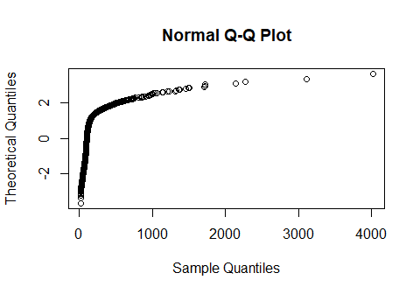
Q-Q plot to check normality om EMG results at the Morality segment.
Pearson’s product-moment correlation: embedded ratings and morality EMG signal
##
## Pearson's product-moment correlation
##
## data: embed_rating and Morality_mean_log
## t = -14.175, df = 3699, p-value < 2.2e-16
## alternative hypothesis: true correlation is not equal to 0
## 95 percent confidence interval:
## -0.2573231 -0.1962015
## sample estimates:
## cor
## -0.2269858

3. Justice score

3.2.1 Probing the 3-way interaction
We can probe the 3-way interaction, provided we choose specific values for the justice scores. The scores range from -1.2352941 to 1.4705882, so we choose the values from -1 till 1.5 with increments of 0.5.
## $justice_score
## [1] -1.0 -0.5 0.0 0.5 1.0 1.5
##
## $MoralityCondition
## [1] "Moral" "Immoral"
##
## $StateAdjectiveCondition
## [1] "Positive" "Negative"
StateAdjectiveCondition | MoralityCondition | justice_score | emmean | SE | df | lower.CL | upper.CL
Positive | Moral | -1.0 | 107.41 | 17.39 | 65.13 | 72.67 | 142.14
Negative | Moral | -1.0 | 102.79 | 17.40 | 65.27 | 68.03 | 137.54

