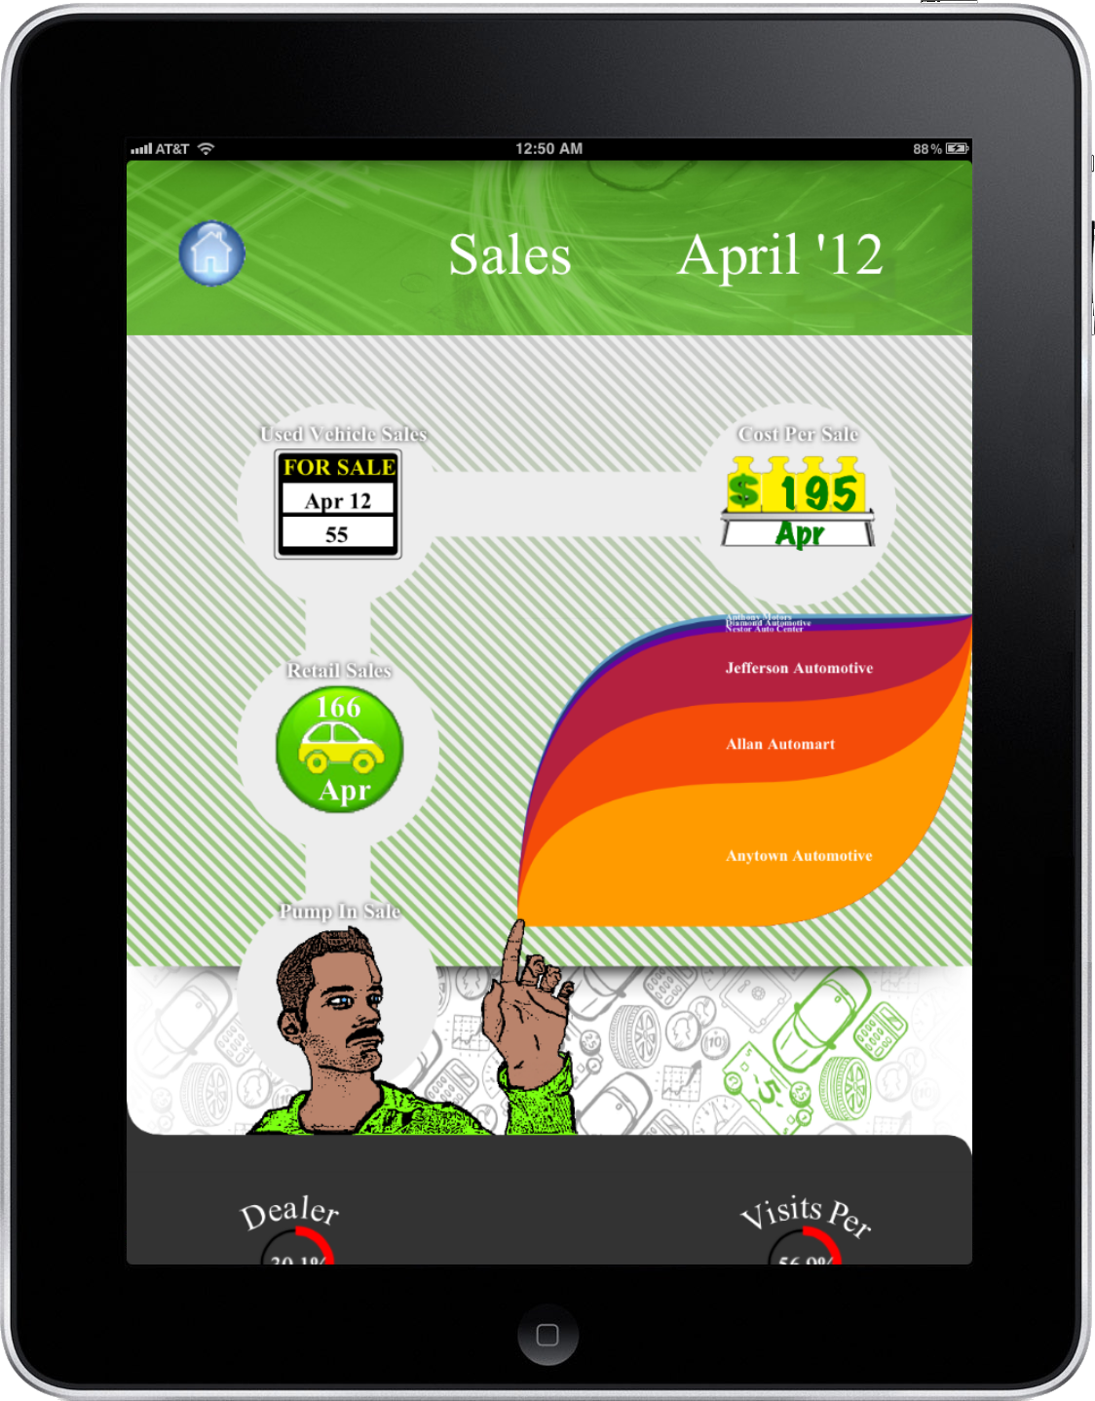
Urban Science
Infographics Generator
Urban Science
Project Sponsors
Matt Bejin
Detroit, Michigan
Greg Davidson
Detroit, Michigan
Ryan Hespenheide
Detroit, Michigan
Shannon Muldowney
Detroit, Michigan

Urban Science serves the automotive industry by improving the sales and services of its customers using comprehensive data driven analysis of key performance indicators. The results produce higher sales and better services at lower costs.
Our Infographics Generator provides an innovative way to visualize these key performance indicators, helping teams track effectiveness in their primary market areas. Our visualizations serve as a bridge, transporting users from a confusing table of numbers to a vibrant display of relevant information.
The key performance indicators are divided into three main categories: sales, lead management and service. Each category represents a major slice of business. Our drill down display provides a more in depth explanation of the information shown on the infographic.
An infographic element, a subsection of an entire infographic, can be selected to display a trend chart covering the last year of data along with a more detailed description of that element.
Our Infographics Generator is a web application designed for use on the iPad. Our web application supports typical touch gestures such as swipe gestures that one would expect on a tablet, thereby giving users the feel of a native application.
Our Infographics Generator is written using HTML5 and JavaScript. Data for the infographics generator is stored using a SQL Server 2008 database then sent in JSON format to the iPad’s local storage for fast retrieval.

Michigan State University
Team Members (left to right)
Lok Cheung
Hong Kong, China
Kevin Shreve
Brighton, Michigan
Peter Chen
Taipei, Taiwan
Louis Bodnar
Livonia, Michigan


